FAMILY WORSHIP BOOKLET

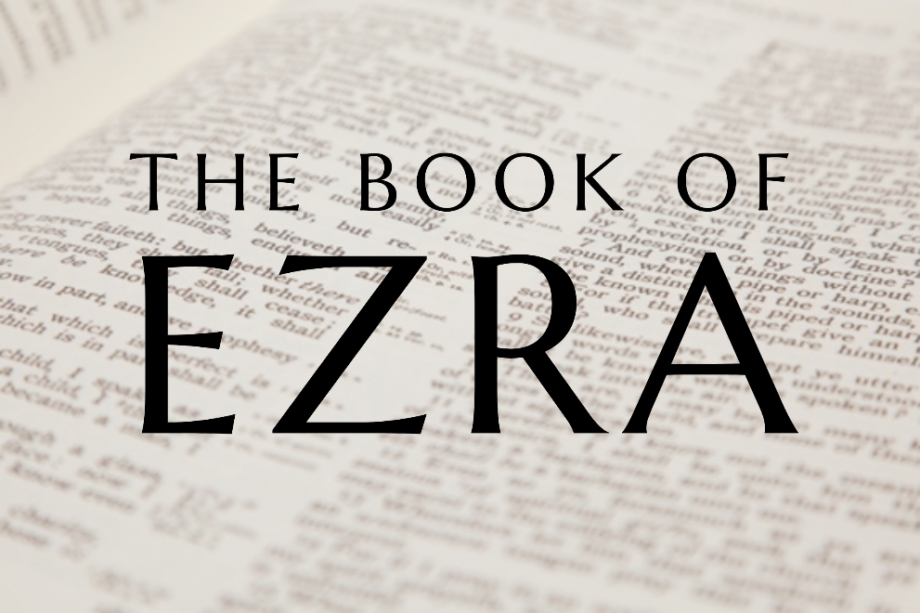

God tells us that Ezra read from the book of the Law,
day after day, and that the people of God
were filled with joy!

Doctrine for the Mind and Heart

Memory Verse of the Week

Psalm of the Week

Please pray for:
Mon -
Tues -
Wed -
Thur -
Frid -

Pray for the Holy Spirit’s help as you read and study God’s Word.

Produced by Ottawa RPC to help family worship.
These notes have been prepared by
Rev. Daniel Hempkin, minister of Hebron RPCNA.
Monday - Ezra 1:1 - The LORD's Word Fulfilled

Starting in 605 B.C. and culminating with the destruction of Jerusalem and the Temple in 586 B.C., the people of the Kingdom of Judah were taken into captivity in Babylonia (in modern-day Iraq). In Jeremiah 29:10, however, we find the LORD's promise to bring His covenant people back to the land after seventy years and to cause the Temple to be rebuilt. Through the prophet Isaiah, God had even named the man he would use to end the Babylonian Captivity - Cyrus, King of Persia (Isaiah 44:28). Thus, after conquering Babylon in 539 B.C., Cyrus issued an edict allowing any Jews who desired to return to Jerusalem and the surrounding territory to do so.

The Book of Ezra is an historical account which covers events from the Edict of Cyrus (539 B.C.) to the public ministry of Ezra, which began around 458 B.C. The book takes its name from its author Ezra, a Levite and descendant of Aaron (the first High Priest), who returned to Judah in order to study and teach the Word of God. Ezra is likely one of the last compilers and contributors who brought together the information found in the books of I and II Chronicles. The book begins where II Chronicles concludes, with the Edict of Cyrus. Ezra makes it clear that this edict was issued "that the word of the LORD by the mouth of Jeremiah might be fulfilled." Cyrus may be the earthly authority who issues this edict, but he is the instrument of the LORD who is sovereign, controlling all events and causing them to work according to the counsel of His perfect will. The Book of Ezra brims with confidence in the covenant faithfulness of God, while calling His people to remain faithful to His covenants, and to repent and reform when they have not.

Q1. Who was Ezra?
Q2. Who was Cyrus?
Q3. Why did Cyrus end the Babylonian Captivity?

Tuesday - Ezra 1:1-4 - The Edict of Cyrus

Cyrus united the Medes and Persians into one kingdom around 560 B.C. Over the following decades, he expanded that kingdom into a mighty empire. By 539 B.C., he controlled territories on three sides of the Babylonian heartland. As the LORD had declared through His prophets (including Isaiah, Jeremiah and Daniel), Cyrus conquered Babylon. It is likely that godly men, such as Daniel, then pointed out to Cyrus that, not only had these events been predicted by the prophets of Israel, but that the LORD had mentioned Cyrus by name in Isaiah 44:28 about two-hundred years earlier.

Historians and Bible scholars’ debate whether Cyrus became a worshipper of the LORD or if he merely confused Him with Ahura Mazda, the god of heaven of the Medo-Persian religion of Zoroastrianism. Whether Cyrus had a right understanding of who the LORD is, he clearly acknowledged Him as the One who had given him his empire and recognized the charge from Scripture to see that the Jews could return to Jerusalem and rebuild the Temple. Furthermore, his edict not only officially ends the Babylonian Exile, but commands that funds be provided for the work of rebuilding the House of God.

Just as the LORD used Cyrus, He can and does use the leaders of nations today, whether they acknowledge and worship Him or not. While Christians should support the selection of godly leaders in the civil government, we need not fear that even the most ungodly ones are outside of God's sovereign rule.

Q1. Which prophet called Cyrus by name before he was born?
Q2. Who made Cyrus a mighty king?
Q3. Do we need to fear that things might be outside of God's control?

Wednesday - Ezra 1:5-11 - A New Exodus

Nearly nine centuries before the events recorded in this passage, the LORD had rescued the Israelites from bondage in Egypt. In Exodus 12, we learn that (as God had previously promised) the Egyptians not only sent the people of Israel on their way, but gave them great wealth in gold, silver, jewellery, and clothing. Following the Edict of Cyrus, the Jewish people prepared for a new Exodus - a return from the Babylonian Captivity. As in the days of Moses, according to Cyrus' command, the neighbours of the Jews gave them treasures and supplies, both to finance their journey and resettlement, and to prepare for the reconstruction of the Temple of the LORD. Moreover, Cyrus returned the treasures of the Temple plundered by Nebuchadnezzar, King of Babylon. These were carefully counted and entrusted to the oversight of Sheshbazzar, who was probably the governor Cyrus appointed over the region of Judah.

Again, the theme of God's sovereignty is presented to us. We also see that He chooses to use means to accomplish His will. Just as God had "stirred up the spirit of Cyrus", he now stirs up the spirits of the heads of the clans of the tribes Judah, Benjamin, and Levi (including priests) to make the journey from Babylonia to Jerusalem, in order to rebuild the Temple. God used Cyrus to end the Babylonian Captivity according to His promises, and, also according to His promises, He made sure that there were men and women with the will to return and build a new house for His Name.

Q1. How is the Return from the Babylonian Captivity like the Exodus of Moses' day?
Q2. What means did the LORD use to accomplish His will in this passage?

Thursday - Ezra 2:1-2 - Zerubbabel and Jeshua

Today's reading lists eleven leaders of the Jews returning to Jerusalem and Judah from the Babylonian Exile. While little is known concerning most of these men, two of them, Zerubbabel and Jeshua, will be key figures in the rebuilding of the Temple. (We should note that the Nehemiah and Mordecai listed here cannot be the same as the men of those names who appear in the books of Nehemiah and Esther, as those books cover later periods.) Zerubbabel is a descendant of King David. His name means "offspring of Babylon" because he was born during the years of the Captivity. Because of the curse on Jehoiachin, Zerubbabel's grandfather, pronounced in Jeremiah 22, Zerubbabel will never hold the office of king. Nevertheless, the LORD will call him His "signet ring" - His chosen symbol of His power - in Haggai 2:23. Zerubbabel stands in the honoured line of ancestors of Jesus Christ (the curse on Jehoiachin being by-passed by the virgin conception. Jesus was not a bodily descendant of Jehoiachin, but, as the acknowledged heir of Joseph, had a legitimate claim to the throne of Israel).

Jeshua is a descendant of Aaron and will be the High Priest when Temple worship is re-established. Like Zerubbabel, Jeshua is highly favoured by the LORD. The prophets Haggai and Zechariah, who ministered in Jeshua's lifetime, praise him as a great servant of the LORD. In a vision recorded in Zechariah 3, the Angel of the LORD - the pre-incarnate Christ - appears alongside of Jeshua to protect him from Satan and clothe him in clean vestments representing Christ's perfect righteousness. This is a picture of salvation. All who trust in Christ are clothed in His perfect righteousness, and therefore are able to stand in God's holy presence, despite whatever accusations Satan may bring against them.

Q1. Who were Zerubbabel and Jeshua?
Q2. What do Jeshua's clean clothes represent?

Friday - Ezra 2:1-34 - Returning Israelites

Today's reading is one of those which readers in our time may find "dry" or "dusty." This is largely because the names of people listed here have little meaning for us. We do not know these people, and, for the most part, we can find out little or nothing about them from the rest of the Bible or any other ancient source. Verses three through twenty give us the numbers of people from various families who were leaving Babylonia to settle in Judah. Verses twenty-one through 34 give us the numbers of those returning exiles who were descended from the populations of various Israelite towns and cities.

While passages like this one may seem boring to us, it is a great blessing that the Bible contains this kind of information. First of all, these helped the Israelites re-establish themselves in the land, aiding with things like property claims. Secondly, they show us that the ancient Jews kept good records, particularly in regard to ancestry. This is important as we labour to give answers to the world's objections to our faith. Some critics of Christianity say we have no reason to believe Jesus was rightfully the heir to the throne of Israel. However, it is helpful to remember that no one ever claimed Jesus was not a son of David until after the destruction of the Temple in A.D. 70. Why not? Because until that time, records were kept in the Temple of every family line. A Jew in Jesus' day could trace his ancestry to the Babylonian Exile and beyond. When Jesus was on earth, there was no challenge to His claim to be the son of David because that claim was clearly established by the records in the Temple.

Q1. Why would a passage like this be important in Ezra's day?
Q2. Why is it important for us?
Q3. Why did no one in Jesus' time challenge His claim to be the Son of David?

