FAMILY WORSHIP BOOKLET

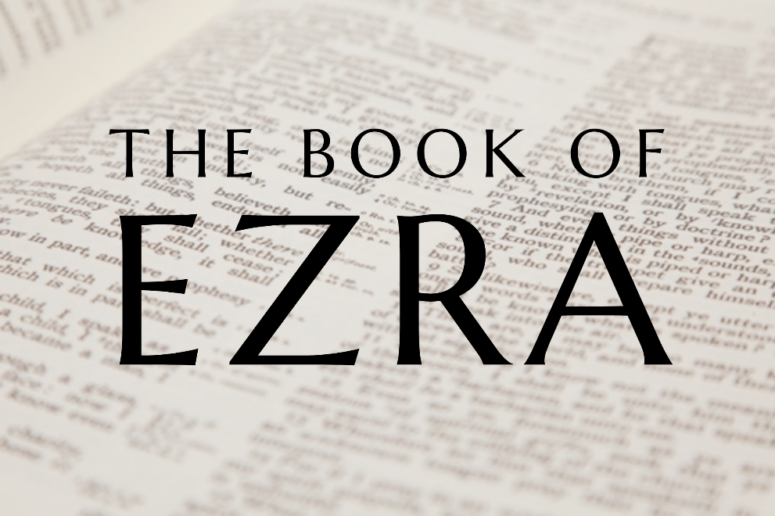

God tells us that Ezra read from the book of the Law,
day after day, and that the people of God
were filled with joy!

Doctrine for the Mind and Heart

Memory Verse of the Week

Psalm of the Week

Please pray for:
Mon -
Tues -
Wed -
Thurs -
Fri –

Pray for the Holy Spirit’s help as you read and study God’s Word.
Produced by Ottawa RPC to help family worship.
These notes have been prepared by
Rev. Daniel Hempkin, minister of Hebron RPCNA.

Monday - Ezra 10:1-5 - Broken Faith; Answered Prayer.

Chapter nine concludes with Ezra's prayer, in which he confessed the sins of the people and sought the LORD's forgiveness, correction, and restoration. In today's reading, we find that his prayer has an almost immediate and powerful effect. As Ezra weeps and prays before the Temple, a huge crowd gathers around him. Seeing Ezra's distress and hearing his prayers moves them to weep over the sins of Israel. This is more than a mere commiserating with Ezra. This is conviction of sin from the Holy Spirit, for a leading man among them, Shecaniah, confesses that they have broken faith with the LORD and suggests a means of restoration. The LORD is already answering Ezra's prayer. According to Shecaniah's suggestion, Ezra obtains an oath from the leaders of the priests and Levites, that they would make preparations for a public covenant.

Repentance involves confession of sin, but it does not stop there. Once we have recognized our sins and acknowledged them before the LORD, we must turn from them. Such a course of action may be difficult. Our sinful decisions may have put us in a situation from which there is no easy escape, but, easy or not, we must turn from sin. Covenanting - renewing our commitment to serve God according to His commandments - is an appropriate expression of our determination to be obedient servants, and a great aid in keeping us obedient when we are tempted to stray.

Q1. How was Ezra's prayer answered?
Q2. What does repentance involve?

Tuesday - Ezra 10:6-8 - Church and State.

With so many already convicted of sin and demonstrating a desire for repentance, we might think Ezra would rejoice. However, realizing that many are not in Jerusalem and, thus, are not among those who have already mourned at their sins, and recognizing that repentance takes more than words of confession, Ezra continues his fasting and mourning over the sins of Israel. Meanwhile, a proclamation is made that all the Jews of the land should gather at Jerusalem for a time of public covenanting. Anyone who refuses to take part in this will be considered an outsider to Israel, unable to hold property and, even more importantly, cut off from participation in the worship and covenant blessings of God's people.

While we must never take a rash oath, and no one has the authority to force us to sin, in yesterday's reading (verse 5) and in today's passage, we find that it is appropriate for the lawful authorities to compel oaths or covenants of us when the situation requires it. (Think of courts of law in which testimony is only accepted if the witness has sworn to tell the truth. A witness who is called must testify, but cannot testify unless under oath. Therefore, the oath must be compelled.) In this case, both the authority of the State and the Church (to use modern terminology, influenced by the New Testament) come to bear. The State's power of the sword will be used to confiscate the property of the disobedient. By the Church's power of the keys, offenders will be excommunicated from the religious life of Israel, as well.

Q1. Why does Ezra continue to fast and mourn?
Q2. Is it ever appropriate for lawful authorities to compel us to take an oath?

Wednesday - Ezra 10:9-11 - A Call for Repentance.

Within three days of the summons, the people gather at Jerusalem for a time of public covenanting. The remarkable character of this event is illustrated by the fact that this takes place in the middle of the ninth month (which overlaps December and January on our modern calendars), during the cold and rainy season. The people tremble both because of the seriousness of the situation and because of the cold, wet weather.

Ezra declares to the men of Israel that they have been unfaithful to the terms of the LORD's covenant by marrying foreign women. He calls upon them to obey God's covenant command to be separate from the idolatrous peoples around them and not to intermarry with them. Disobedience to God's commandments has "increased the guilt of Israel". He calls upon them to confess this sin to the LORD, and to turn away from their sinful marriages.

On the surface, this may seem like a violation of Biblical principles of marriage. Certainly, God's people are not supposed to marry unbelievers - but what if the marriage has already taken place? In I Corinthians 7:12-16 we are plainly told that the believer should remain married to an unbelieving spouse unless the unbeliever voluntarily leaves. Does Ezra's call not violate that principle? Did God require a different moral standard from people in the Old Testament period than He does from us now? In fact, there is more to this story than may be obvious to us from a surface reading of Ezra. In Malachi 2:10-16 we find that, in order to marry these heathen wives, the men of Israel have divorced Israelite wives. Thus, these marriages to foreign wives are illegitimate. According to what Jesus teaches in Matthew 5:31-32, these so-called marriages are, in fact, adultery. Ezra calls upon the men of Israel to end their adulterous affairs.

Q1. What had the men of Israel done in violation of God's Law?
Q2. What made these marriages sinful?

Thursday - Ezra 10:12-17 - Public Covenanting.
Over the last few days, there have been references in our lessons to the concept of public covenanting. Public covenanting occurs when churches, societies or nations commit or recommit themselves to obey God's commandments. Often, this has been in response to a particular challenge to godly living that has arisen in a specific time and place. Only God can set forth the terms of His covenants. We do not have the right to make up new moral systems, determining for ourselves what is right or wrong. However, throughout history, God's people have periodically recognized their failures to obey Him and their need to re-consecrate themselves to His service. As new challenges arise, it is wise to make public statements applying Biblical principles to the current situation, and committing ourselves to live out those principles. In today's passage, the people commit themselves anew to obedience to the LORD in the matter of marriage. Understanding the obstacles in their way, they determine a reasonable course of action. Elders and judges will be appointed in every city to make sure the men have followed through with the obedience to which they have recommitted themselves. Only a very few of the men of Israel oppose this covenant. The rest declare, "It is so. We must do as you have said".
Once a covenant is made, it is the responsibility of the parties who have committed themselves to obedience to follow through with what they have promised. This is exactly what the men of Israel do. As we have seen before, and as will be reiterated in verse 44 in tomorrow's reading, some of these illegitimate marriages had produced children. Provision would have been made for their care, but these children of pagan women would not have been allowed into the assembly of God's people (unless, of course, they were to separate themselves from idolatry and commit themselves to the LORD as any foreigner could, thus becoming Israelites by profession of faith as we saw in 6:21). We are part of a church which has a wonderful heritage of public covenanting and it is our responsibility to understand and fulfil those covenants. Each of us who are members of a local congregation have covenanted to obey the law and order of the church, and that is something we must strive to fulfil.

Q1. What is public covenanting?
Q2. Why is it appropriate that public covenanting occur?
Q3. What responsibility comes with covenanting?
Friday – Ezra 10:18-44 – Conclusion.

The book of Ezra ends with the sad problem of illegitimate marriages, and the great lengths to which Ezra and the people had to go to resolve it. Nevertheless, Ezra is not a gloomy book. As we have seen, it is a book brimming with confidence in the faithfulness of the LORD. The theme of God's sovereignty has been displayed throughout the text. The LORD fulfilled His plan to end the Babylonian Exile by means of Cyrus. The LORD blessed and protected Zerubbabel and Jeshua. He sent Haggai and Zechariah as His prophets, bringing about the completion of the second Temple with the support of Persian king, Darius. The LORD blessed Ezra's plan to migrate to Jerusalem in order to teach the Law, moving King Artaxerxes to aid him. He protected Ezra and the expedition he led on the arduous and dangerous journey from Mesopotamia to Jerusalem. He used Ezra mightily for the reformation of His people as He brought about repentance and restoration through Ezra's preaching and prayers.

Just as God used all of these means to accomplish His redemptive plan, so He uses the Church, individual Christians, and even unbelievers today to bring about His good purposes, for His glory and the good of His people. A study of the Book of Ezra should bolster our confidence in the great and good God we have, and cause us to praise Him all the more.

Q1. What major theme do we find in Ezra?
Q2. How might this book encourage us?

