FAMILY WORSHIP BOOKLET

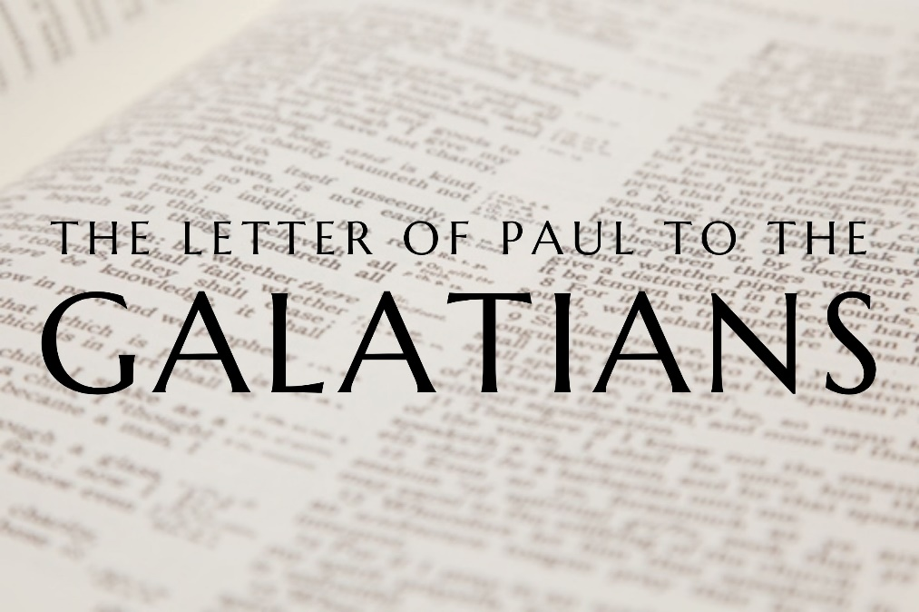

God tells us that Ezra read from the book of the Law,
day after day and that the people of God
were filled with joy!

Produced by Ottawa RPC to help family worship.

Doctrine for the Mind and Heart

Memory Verse of the Week

Psalm of the Week

Please pray for:
Mon -
Tues -
Wed -
Thur -
Frid -

Pray for the Holy Spirit’s help as you read and study God’s Word.

Monday – Acts 18:23; Galatians 1:1-5 - Introduction to Galatians
For the next few weeks we are going to be looking at the book of Galatians. We will be relying on Rev. Matthew Henry’s commentary for these notes. The book of Galatians is written by the apostle Paul and unlike his other letters it is not directed to a church or churches of a single city, but to the country or province of Galatia. Probably these Galatians first became Christians under the preaching of Paul when he visited their country as we read about in Acts 18:23. But after Paul left, some false teachers got in amongst them and told them that in order to be saved they not only had to have faith in Christ, but they also had to follow the ceremonial laws of the Jews, specifically, that in order to get to Heaven, they needed to be circumcised. They also attacked Paul’s authority, saying that he wasn’t a real apostle or at least he didn’t have the authority that the other apostles had. Paul is writing Galatians to defend his authority and to remind them that salvation is by faith in Christ alone.
Paul starts this letter making it clear that he is an apostle, commissioned not by men but by Jesus Christ and God the Father. Paul also states that he is writing on behalf of the other Christians who are working with him. So, even though he has the authority to speak on his own, he’s telling the Galatians, ‘It’s not just me saying this, but other Christians as well’. Grace is God’s good work towards us and in us; and peace is that contentment that comes with grace. There can be no true peace without grace. This present world is an evil world, and it has become so by the sin of man. But Jesus Christ has died to deliver us from this present evil world, not to remove His people out of it, but to rescue them from the power of it, to keep them from the evil of it, and in time to bring us to a new and better world. All of this is according to God’s will and for His glory.
Questions:
- Who wrote the book of Galatians & who was he writing to?
- Why did he write this book?
- What did the false teachers add to the gospel?
- Who gave Paul his authority?
- Why did Jesus Christ die?
Tuesday – Galatians 1:6-9 – Deserting the Gospel
Paul is really surprised and saddened by the Galatians turning away from the true Gospel. Several things make the actions of the Galatians worse.
- First, they are turning away from the God who has called them through His kindness and mercy.
- Second, they are turning away from the grace and mercy found in Christ Jesus and all the blessings and benefits of being reconciled to God and having eternal life, things that Christ has purchased with His blood.
- Thirdly, Paul is surprised that they turned from the Gospel so quickly.
- Finally, Paul is saddened that they turned to another Gospel that is no true Gospel. Paul calls the beliefs of the false teachers another Gospel because it opens up a different way of salvation - a way where you are saved not by faith but by works. But Paul makes it clear that this is not the true Gospel, and that anyone who thinks they have found a different way is sadly mistaken. Even though Paul is rebuking the Galatians, he does understand that they have been led into sin by the false teachers, so he speaks with compassion as well.
Notice how confident Paul is that the Gospel he has preached to them is the only true Gospel. He is so persuaded of this, that he pronounces a curse upon those who pretend to preach any other Gospel. Paul is speaking against all who try to put their good works in place of what Christ has done on the cross.
Questions:
- Why is Paul surprised?
- Why does he call the beliefs of the false teachers ‘another Gospel’?
- What show us that Paul is confident there is only one true Gospel?
- What is the true Gospel?

Wednesday – Galatians 1:10-24 – Called by God
In these verses, Paul defends both his calling and his message as being from God. Paul starts by saying that the purpose of his ministry is not to please men but to please God. It is God to whom he is accountable. He makes the very good point that if he wanted to please men, he would not be the servant of Christ. Those two things are incompatible - no one can serve two masters. So, even though he isn’t out to offend anyone, he can’t please men at the expense of being faithful to Christ. So, from his purpose, Paul shows that he is a true apostle of Christ. We learn here that the great purpose of ministers is to bring men to God and that they are not to seek to please men, but to be approved by God as faithful servants of Christ. Paul goes on to prove his apostleship from the way he received the Gospel that he preached to them. It came from heaven. Apostles were unique because they were called and instructed by Christ Himself.
Paul is showing in these verses that, no matter what his enemies say, he too has been called and instructed by Christ. Paul reminds them of his Jewish education, he reminds them that he was a fierce persecutor of Christianity. But he was appointed to be a Christian and an apostle before he came into the world, or had done either good or evil. He was called by the grace of God, and Christ immediately and specially revealed Himself to Paul, so that Paul could preach Christ to the Gentiles. Paul then explains how he didn’t go to the other apostles for instruction and authority - he didn’t need to. Christ had already revealed to Paul what he needed to know and had given him authority, and the churches in Judea glorified God for this.
Questions:
- What is the purpose of Paul’s ministry?
- To whom is Paul accountable?
- When was Paul appointed to be a Christian?
- From whom did Paul learn about the Gospel?

Thursday – Galatians 2:1-10 – Another Trip to Jerusalem
Paul is defending his apostleship again in these verses and showing that he is not beholden to the other apostles either for his knowledge of the Gospel or for his authority as an apostle, but that they approve of him as having a calling equal with them.
Fourteen years after his first brief trip to Jerusalem, Paul returns with Barnabas and Titus. By taking Titus, he shows that he is not ashamed to be seen with Gentile Christians. Paul makes the point that he is specifically told to go to Jerusalem by God. Paul gives the church there a free and fair account of what he has been preaching all along to the Gentiles, and what he is still determined to preach - salvation by faith in Christ alone, not by faith plus fulfilling the Jewish ceremonies. He knows some there will not like what he has to say, but he is not afraid to lay it all out before them and let them judge whether or not it is the true Gospel of Christ. Paul also uses prudence and caution for fear of giving offense. He chooses to speak in a more private way, to the apostles themselves and the other leaders of the church. Why? Because he does not see the need to unnecessarily stir up opposition against himself and obstruct his future work. So, he concentrates on finding out what the apostles and leaders think of his teaching.
Paul practices what he preaches and despite opposition from false Christians, refuses to have Titus circumcised. The apostles and leaders of the church agree with what Paul is teaching, and they add nothing to either Paul’s knowledge or his authority, and they acknowledge him as a fellow apostle.
Questions:
- Do the other apostles approve of Paul’s calling to be an apostle?
- Why does Paul take Titus with him?
- Who told Paul to go to Jerusalem?
- What does Paul tell the church in Jerusalem?
- How does Paul show prudence in how he speaks to the church?
Friday – Galatians 2:11-21 – Justified By Faith
When Peter visits Antioch, he has no qualms about eating with the uncircumcised Gentile Christians, but when some Jewish Christians from Jerusalem show up, Peter is embarrassed and withdraws from the Gentile Christians. Other Jewish Christians, seeing his example, do the same. But Paul sticks to the truth of the Gospel and is unafraid to rebuke Peter for his hypocrisy, showing he is not inferior to any of the apostles.
Paul now goes on to speak of the fundamental truth of the Gospel - that justification (being made right with God) is only by faith in Christ, and not by the good works of keeping the law. Paul makes the point that the Jewish Christians themselves find it necessary to be justified by faith in Christ. These are the very people that keep the law, but even they see that it will not save them - they need Christ. That does not mean of course that justification by faith alone negates the necessity to obey the Law of God.
Paul says that he is dead to the Law - he knows that there is no hope of justification in the keeping of the Law. The very nature and purpose of the Law means that we cannot look to it for salvation - that path is dead. But that does not mean we live any way we want. Paul has been saved, so that he might live for God. His old sinful self has been crucified with Christ, and now Christ lives within him and enables him to live a new life. To teach anything else is to belittle the grace of God and the death of Christ.
Questions:
- What does Peter do which draws a rebuke from Paul?
- What is the fundamental truth of the Gospel?
- What is the purpose of the law?
- How should we then live?

