FAMILY WORSHIP BOOKLET

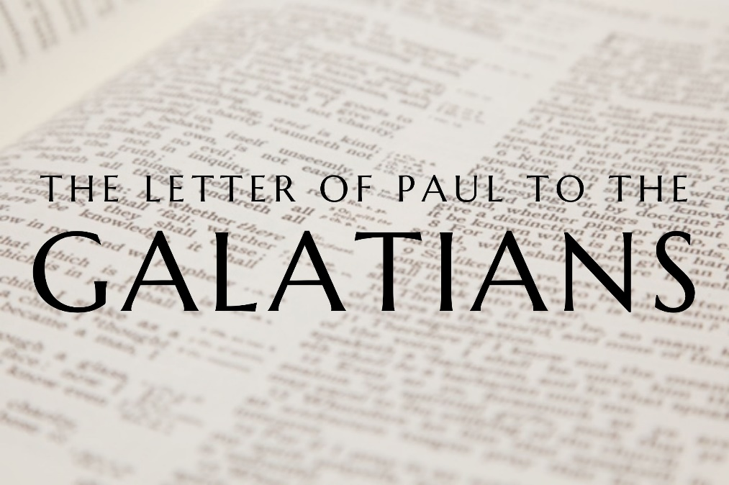

God tells us that Ezra read from the book of the Law,
day after day and that the people of God
were filled with joy!

Produced by Ottawa RPC to help family worship.

Doctrine for the Mind and Heart

Memory Verse of the Week

Psalm of the Week

Please pray for:
Mon -
Tues -
Wed -
Thur -
Frid -

Pray for the Holy Spirit’s help as you read and study God’s Word.

Monday – Galatians 2:1-10 – Another Trip to Jerusalem

Paul is defending his apostleship again in these verses and showing that he is not beholden to the other apostles either for his knowledge of the Gospel or for his authority as an apostle, but that they approve of him as having a calling equal with them.

Fourteen years after his first brief trip to Jerusalem, Paul returns with Barnabas and Titus. By taking Titus, he shows that he is not ashamed to be seen with Gentile Christians. Paul makes the point that he is specifically told to go to Jerusalem by God. Paul gives the church there a free and fair account of what he has been preaching all along to the Gentiles, and what he is still determined to preach - salvation by faith in Christ alone, not by faith plus fulfilling the Jewish ceremonies. He knows some there will not like what he has to say, but he is not afraid to lay it all out before them and let them judge whether or not it is the true Gospel of Christ. Paul also uses prudence and caution for fear of giving offense. He chooses to speak in a more private way, to the apostles themselves and the other leaders of the church. Why? Because he does not see the need to unnecessarily stir up opposition against himself and obstruct his future work. So, he concentrates on finding out what the apostles and leaders think of his teaching.

Paul practices what he preaches and despite opposition from false Christians, refuses to have Titus circumcised. The apostles and leaders of the church agree with what Paul is teaching, and they add nothing to either Paul’s knowledge or his authority, and they acknowledge him as a fellow apostle.

Questions:
1. Do the other apostles approve of Paul’s calling to be an apostle?
2. Why does Paul take Titus with him?
3. Who told Paul to go to Jerusalem?
4. What does Paul tell the church in Jerusalem?
5. How does Paul show prudence in how he speaks to the church?

Tuesday – Galatians 2:11-21 – Justified By Faith

When Peter visits Antioch, he has no qualms about eating with the uncircumcised Gentile Christians, but when some Jewish Christians from Jerusalem show up, Peter is embarrassed and withdraws from the Gentile Christians. Other Jewish Christians, seeing his example, do the same. But Paul sticks to the truth of the Gospel and is unafraid to rebuke Peter for his hypocrisy, showing he is not inferior to any of the apostles.

Paul now goes on to speak of the fundamental truth of the Gospel - that justification (being made right with God) is only by faith in Christ, and not by the good works of keeping the law. Paul makes the point that the Jewish Christians themselves find it necessary to be justified by faith in Christ. These are the very people that keep the law, but even they see that it will not save them - they need Christ. That does not mean of course that justification by faith alone negates the necessity to obey the Law of God.

Paul says that he is dead to the Law - he knows that there is no hope of justification in the keeping of the Law. The very nature and purpose of the Law means that we cannot look to it for salvation - that path is dead. But that does not mean we live any way we want. Paul has been saved, so that he might live for God. His old sinful self has been crucified with Christ, and now Christ lives within him and enables him to live a new life. To teach anything else is to belittle the grace of God and the death of Christ.

Questions:
1. What does Peter do which draws a rebuke from Paul?
2. What is the fundamental truth of the Gospel?
3. What is the purpose of the law?
4. How should we then live?

Wednesday – Galatians 3:1-5 – Go On As You Began

Paul is dealing with those in Galatia who are Christians, but who think they must add something to their faith in Christ in order to be saved. They have been foolish and have been deceived. They have not been sticking to the way of salvation which they were taught. It is not enough to know the truth, and to say we believe it, we must obey it too. Jesus Christ and His death have been clearly taught to the Galatians, but they are turning away from it.

Paul appeals to the work of the Holy Spirit. He asks them why the Holy Spirit came into their lives. Is it because they kept the Law? They are Gentiles - they have never kept the Law before in their lives. Or is it because they hear that salvation is through faith in Christ and by the grace of God they believe.

Paul tells them to look at how they acted in the past and how they are acting now and see that they are being unreasonable. They have embraced faith in Christ and have begun well, but now they are turning to the Law and adding it to their faith in Christ in order to be saved. They are trying to undo what has been done in their lives. These Galatian Christians have suffered much for believing in Christ, but if that belief was not sufficient, their suffering was all in vain. The doctrine that is preached to them and confirmed by miracles and the work of the Holy Spirit is not justification by works but justification by faith in Christ.

Questions:
1. What error are the people in Galatia making?
2. Why did the Holy Spirit come into the lives of the Galatians?
3. How are the Galatians behaving differently now compared to when they first believed?

Thursday – Galatians 3:16-18 – Justification By Faith

Paul is trying to prove to the Galatians that justification, being made right with God, is by faith not by works. First, he uses the example of Abraham’s justification. Abraham believes what God says and what God promises, and it is because of his faith in God that he is declared righteous. God tells Abraham that all the nations of the earth will be blessed in him. This is a prophecy of the Gentiles coming to faith in Christ, the seed of Abraham. It is through faith in the promise of God that Abraham is blessed, and it is only in the same way that others are also blessed.

Paul then shows that the Law condemns us. God says everyone who does not keep his law perfectly is cursed - and who has ever kept it perfectly? In order to have eternal life by the Law, we must have perfect, personal, and perpetual obedience, and for every failure we are cursed. But there is a way to escape this curse and be restored to God, and that is through faith in Christ. Christ takes the curse we deserve, and through faith in Him, we become the people of God.

Paul quotes from Habakkuk 2:4 which says, But the righteous shall live by his faith. It is only through faith that men become righteous, are accepted by God, enabled to lead obedient lives, and inherit eternal life.

Finally, Paul explains that the covenant God makes with Abraham is not done away with by the giving of the Law to Moses. God has made promises to Abraham and his seed, and because Christ is the seed of Abraham, these promises are always going to be in effect, and we can inherit them if we belong to Christ. What are these promises? That through Christ we can be made right with God, that He will be our God, and we will be His people.

Questions
1. What example does Paul use to prove that justification is by faith not by works?
2. How does the law condemn us?
3. What is the way of escape?
4. Who is the seed of Abraham?
5. What are the promises God made to Abraham?
Friday – Galatians 3:19-29 – The Purpose of the Law

Paul goes on to teach the Galatians the purpose of the Law. The Law was given to restrain God’s people from their sin, to keep them from being as sinful as they possibly could be. The fact that they could not keep the Law perfectly was purposeful and designed to help them realise that they were sinners and in need of a Saviour. The required offering of repeated sacrifices, presented the truth that sin could not be dealt with by any other than the Messiah. The one who would offer a once for all sacrifice.

Paul uses a word that the ESV translates ‘guardian’, but it can also be translated schoolmaster. The Law today continues to teach how sinful man is, how God views sin, and how incapable man is of obeying. In doing so it also shows both man’s need of a Saviour and the fact that our sin can only be paid for and be forgiven, through the sacrificial death of the Lord Jesus Christ.

The Law therefore, rather than being the antithesis of faith, actually points people to faith in Christ Jesus.

Paul closes his arguments by telling us the privilege we have in Christ. We are the children of God by faith in Christ Jesus. We are not servants but sons and daughters of God. Baptism is the sign and seal of admission into the church just like circumcision was for the Jews. In our baptism we state that we are followers of Christ and will serve Him faithfully. This privilege of being children of God and by baptism devoted to Christ is enjoyed by all real Christians. The old divisions are gone, and we are one in Christ Jesus and are children of Abraham.

Questions
1. What are the purposes of the law?
2. What privileges do we have in Christ?
3. What does our baptism signify?

