FAMILY WORSHIP BOOKLET

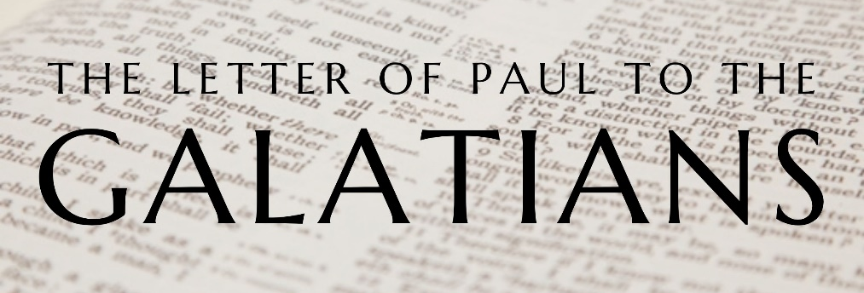

God tells us that Ezra read from the book of the Law,
day after day and that the people of God
were filled with joy!

Produced by Ottawa RPC to help family worship.

Doctrine for the Mind and Heart

Memory Verse of the Week

Psalm of the Week

Please pray for:
Mon -
Tues -
Wed -
Thur -
Frid -

Pray for the Holy Spirit’s help as you read and study God’s Word.

Monday – Galatians 4:12-16 – From Friends to Enemies
Paul tells the Galatians of the love they used to have for him. He calls them his brothers and wants them to lay aside any resentment they might have. He tells them that he has no quarrel with them. He has spoken strongly about what they have done, not because he is personally offended, but because he must defend the truth of the Gospel, and he is genuinely concerned about their welfare. If we ever need to reprove people, we need to be sure that it is not done out of a personal resentment, but out of concern for the glory of God and the good of the other person.
Paul reminds the Galatians of the difficulty under which he worked when he first came among them. We do not know what Paul’s bodily ailment is, but whatever it is, it does not bother the Galatians. They do not despise or reject Paul for it, but they receive him as a messenger of Christ. Notice how quickly and strongly these Galatians have changed in their opinion of Paul. This should remind us to seek acceptance from God not from men, because men change like the weather.
Paul then goes on to say, ‘what happened?’ Why have they changed towards Paul? They once were happy in receiving the Gospel, why have they turned from that? Paul, who once was their favourite, has now become their enemy. Is it because he told them the truth? Often when we are just faithfully telling the truth of salvation, we can make enemies. But that should not stop us. Again, we need to find our approval in God not in other people. If we really care for others, like Paul cares for these Galatians, we must speak the truth in love to them.
Questions:
- What does Paul call the Galatians?
- How did the Galatians initially receive Paul?
- Why do you think the Galatians now view Paul as their enemy?
Tuesday – Galatians 4:17-18 – False Teachers
Paul is describing to the Galatians the character of those false teachers who have made it their business to draw the Galatians away from the Gospel. These false teachers are men who are looking out more for themselves than for anybody else. They pretend to show a lot of love to the Galatians, but they are not sincere. Their goal is to get the Galatians not to follow Christ but to follow them.
Sometimes people or ideas may seem very exciting and enthusiastic, but they are not true or sincere. False teachers often try to make people agree with them by being nice to them. But usually, no matter what they say, they really care more about themselves than about others.
Paul gives the Galatians and us a good principle to apply in situations like this. He says that it is good to be made much of, it is good to be zealous for a good thing. It is alright, it is good to be excited and enthusiastic about something good. But if you are excited and enthusiastic about something bad - the result is disastrous. And on the flip side - you should make much of something that is good. You should be zealous, excited, enthusiastic for what is good, for the truth. This zeal should be constant and steady, not here today and gone tomorrow, and present even when your leaders are not around. This is part of what it means to be a whole-hearted Christian.
Questions
- What do we know about the character of the false teachers?
- What is the goal of the false teachers?
- What is a tactic false teacher often use?
- What should we be enthusiastic about?

Wednesday – Galatians 4:19-20 – Paul’s Love for the Galatians
Paul is here telling the Galatians of the great love and concern he has for them. Their change in attitude towards him has not affected how he feels about them. He still has the same respect and love towards them that he had when he was living among them. He is not like their false teachers, who pretend to love them, but in reality, are just looking out for themselves. Paul genuinely cares about what is best for them. They are quick to think of Paul as their enemy, but he assures them that he is their friend, and not just a friend, but a parent. Paul is in anguish that he compares to childbirth. And for what? Why is Paul in such anguish? He is not in anguish over whether or not they love him, he is in anguish to see Christ formed in them, that they might live as Christians, strong in the faith of the Gospel.
Faithful ministers like Paul have a great love for those to whom they minister, and their chief desire is to see men and women come to faith in Christ and grow in that faith. They want to see the congregation be made into the image of Christ, strong and fruitful disciples. To desert or dislike a minister like this is foolish. We also learn from these verses that men do not grow in Christ until they stop trusting in their goodness and rely only upon Christ and His righteousness.
Paul wishes he was with the Galatians. At the minute he does not know what to make of them, but if he was with them, he might find that things are better with them than he fears, and he might have reason to commend them rather than rebuke them.
Questions
- How does Paul feel about the Galatians?
- Why is Paul in such anguish over the Galatians?
- What is the chief desire of a faithful minister?
- Why does Paul want to be with the Galatians?

Thursday - Psalm 4 - Confident Trust.
The previous Psalm is considered to be a morning Psalm, and this one an evening Psalm. In the previous Psalm, David rejoiced that he had been able to lay down and sleep because the Lord had sustained him, and now, in this Psalm, he looks forward with confidence to the future and states, 'I will both lay down and sleep'. His previous experience of the goodness of the Lord enabled him to face what lay ahead with trust and assurance.
The Psalm begins with a prayer for the righteous God to be gracious to His servant. Because David had experienced the help of God in the past, he had great confidence that the unchanging God would listen to him again. God's help for His people is always based upon His grace and mercy, and never on what they deserve. David here shows something of the true heart of the child of God, for he does not seek vengeance on those who oppress him, but rather attempts to give them advice and show them how they can get right with God. The best way to take the hatred out of the heart of the enemies of the faith is to preach the gospel to them, that they might be saved.
In the midst of all of his trials, and even with the defeatist attitude of some of his friends who were saying 'who will show us any good?', David demonstrates an amazing confidence in God. He shows the same attitude that was present in the apostle Paul, in Philippians 4:11-12, when he says that in both plenty and in need, he had learned the secret of contentment. Confident trust in the Lord brings gladness, peace and safety, no matter how difficult the circumstances of life may be.
Questions:
- Why could David be confident in the future?
- What is the secret of contentment?

Friday - Psalm 5 - Prayer.
This is another morning Psalm, and it begins in a very proper and necessary way with prayer. As the Psalmist contemplated the difficulties that he would face during the day, he cries out to God for help. He is so confident that God will answer his prayer that he says that he will eagerly watch for the answer that God would give him. That would suggest that his prayer was specific. It is difficult to look for answers to general, non-specific prayers, and so it is important in prayer to ask for definite things, and then to look confidently for answers.
The confidence that the Psalmist had in prayer was based very particularly on the relationship that he had with God, and his concern to walk uprightly before God. He speaks in verse 7 of going to worship God because of His loving-kindness or grace, and describes his attitude of reverence and worship as he comes into the presence of the Lord. It is when the believer has a living relationship with the Lord, and seeks by His grace to live according to the teaching of the word of God in godly fear and reverence of a holy God, that he will have great confidence that God will hear and answer his prayers.
The Psalmist was aware that he needed the guidance of the Lord because he had to deal daily with the deceitfulness and flattery of wicked men, and he needed the wisdom of God to be able to navigate a straight pathway. It is often more difficult to live godly in the midst of flattery and deceit, than it is in the face of hostility and anger.
Once again, the Psalmist finishes with an exultant song of triumph and joy, for the assurance of God's presence, protection and blessing.
Questions:
- What does the Psalmist do when he thinks of his difficulties?
- Why is the Psalmist confident that God will hear his prayers?

