FAMILY WORSHIP BOOKLET

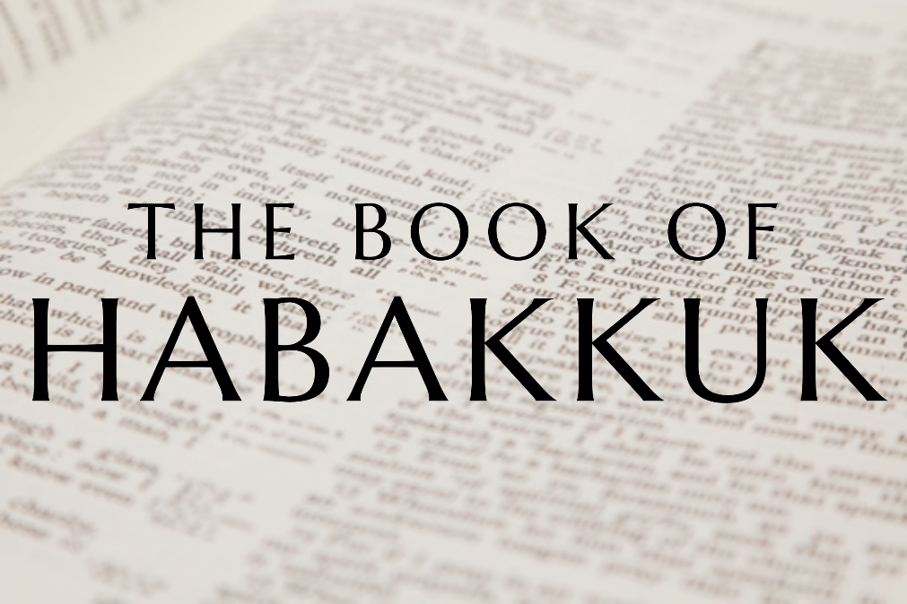

God tells us that Ezra read from the book of the Law,
day after day and that the people of God
were filled with joy!

Doctrine for the Mind and Heart

Memory Verse of the Week

Psalm of the Week

Please pray for:
Mon -
Tues -
Wed -
Thur -
Frid -

Pray for the Holy Spirit’s help as you read and study God’s Word.

Produced by Ottawa RPC to help family worship, using notes previously written by Rev. Gary Gunn, Meadville RPCNA,
with some slight amendments.
Monday – Habakkuk 1:1-11; Jeremiah 5:1-5 - Judgement

The prophet Habakkuk lived during the greatest decline that Judah had experienced. The state of God’s people had degenerated gradually, sometimes turned around by faithful kings like Hezekiah or Josiah, but by the time Habakkuk and Jeremiah were called it was terminally bad. God actually asks Jeremiah (5:1) to search the whole of Jerusalem and see if he can find even one righteous man! In God’s eyes the whole nation had fallen so low that judgement was the only remedy. He tells Jeremiah that the ‘sins of Judah are written with an iron pen, with the point of a diamond’, in other words they are stark and permanent.
This must have been hard for Habakkuk, knowing that judgement was certain. Maybe he wanted revival, maybe it pained him thinking that with warnings like these the people would obviously change, but it seemed to get worse and worse.
But God has a purpose, even when the stream of His plan is dark, murky, and mysterious. He will come and shake Judah, take her to Babylon, and show through it all that He is still Glorious, Gracious, and the God of Salvation. It is natural to question God in such a situation, and we might wonder why we were not born during a time of great blessing, rather than a time when there is a great falling away. But like Habakkuk, we will see that even through unbearable judgement- we can find the Lord and trust that what He is doing is good, and He is working towards a restoration for His faithful people. God often lets a situation degenerate to unimaginable levels- to bring about a more long-term restoration. As Habakkuk discovers - judgement is God’s strange work- but He is still gracious.

Questions:
1. During what era did Habakkuk live?
2. What is God’s purpose in his judgement of Judah?
3. What should our response be during times of judgement?

Tuesday – Habakkuk 1:1 – A Prophet Burdened

The opening of the book says that this is the ’burden’ or ‘oracle’ which Habakkuk saw. When prophets received a message from God it was often a burden to them, and weighed heavy on them. This was true even of Jesus, when He knew God would destroy Jerusalem.
This is true of us as Christians and our ministers who are burdened by the Word of God and by the message of the Gospel. When they must preach that God will separate the sheep from the goats, and that men and woman must all appear at the judgement seat of Christ, this is a great burden, and we should pray for them to be given grace to speak in God’s name like Habakkuk did.
We may be burdened in seeing God judging our own nation or in longing for the conversion of those we know in our families and in our lives. Paul said in Romans 9:1-2 that he was in continual sorrow for the conversion of his countrymen the Jews. We should take encouragement that when we carry these burdens we can go to God and pray over them, and He will help us carry them.
Habakkuk carried this message as a burden, because it showed the Lord’s hand was coming in severe judgement. Jeremiah found it hard proclaiming his message and admits that he began to keep it in, because no one was listening to him. But he said it was like a fire in his bones, and he became weary of holding it in. It built up inside him, and it was not until he spoke God’s Word that it was lifted. If we are witnessing for Christ, we may become so tired of the message being rejected that we hold back Christ’s claim as Lord and Judge over the sin of our land. In the end the burden will become so heavy that we must speak it, and He promises that He will give us the words to say and even give us His peace. Habakkuk was burdened but, in the end, he found peace.

Questions:
1. Why is Habakkuk burdened?
2. How should we be praying for our ministers?
3. When does God lift the burden?
Wednesday – Habakkuk 1:1-4 – How Long?

This is a very real question that Habakkuk feels, ’How long shall I cry, and You will not hear?’ He is crying out to God to intervene in the situation in Judah and feels that his prayers are going nowhere. This happens to all believers, though we know in our head that God hears spiritual prayer, when we see no obvious answer we can feel very alone and discouraged. It seems to us as though God is not hearing us.
The Psalms we sing show that this is common to God’s people, they often ask ’How long?’. We are encouraged by Christ to persevere in prayer, because God often delays His answer to teach us to pray, to expand our faith, to bring us closer to Him. In Luke 18 He says that we ought ‘always to pray and not lose heart’ and gives the example of a woman who keeps asking an unjust judge to help her. In the end he helps her because she is wearying him! Jesus says if the unjust judge did that, will God not avenge His own elect who cry out day and night to Him? These are beautiful words to assure us that God is willing to hear His children. Jesus then says that God ‘bears long with them’ in prayer. This means that He does not answer right away, but at the right time He answers ‘speedily’. Just like Habakkuk, it is not wrong to cry out ’how long?’, and we will discover that God is building us up by making us wait.
Habakkuk has this genuine prayer, and God’s answer is that He will not intervene but will bring judgement on Judah - and that is final. God has not abandoned Habakkuk’s prayer, though He will not spare the people from judgement, He will rather give strength to the believers to be taken through the judgement and upheld. Though God must judge - He will keep His own people safe through it all.

Questions:
1. What three reasons are given for why God often delays answering our prayers?
2. What example of persistence does Jesus give in Luke 18
3. What is God’s answer to Habakkuk’s prayer?

Thursday – Habakkuk 1:5-11 – God Announces a Judgement is Coming

The LORD promises here that He is about to act in a fearful way and on a national scale. He tells the prophet "Be utterly astounded" v5.
He will inflict upon them an amazing punishment. It will be so astonishing that God says when it is seen, it will not be believed (v5). The reason it will be so severe is because they were such a privileged people - they had the truth of God’s Word but had completely abandoned it. In fact, they were so sure that they were safe that Jeremiah tells us that even though God was warning the nobility, the priesthood, the princes of the coming judgement - they did not listen. They kept saying ’the temple of the Lord, the temple of the Lord, the temple of the Lord’. They were oblivious to the seriousness of it all! They gloried in the temple and God’s favour to them in the past and thought ’God will not judge us!’
When we are used to things for generations, we foolishly think these things are mountains which cannot be moved. We can look to relationships, material possessions or forms of culture and think they will always be the same, they will provide stability for us. But these things are not so. In 2008, the entire western financial system was rocked to its core by the banking scandal of sub-prime mortgages, and look how our lives have been affected in the past year by COVID 19.
As the people of God let our only security be our love for Christ and our relationship with God. His judgements may come in large and amazing ways, and like Habakkuk our hope should be in God alone (3:18)

Questions
1. How does God promise to act?
2. Why is the judgement going to be so severe?
3. Why did the people fail to heed the warnings of coming judgement?
4. What is our only security in this life?
Friday – Habakkuk 1:5-11 – Judgement

The Babylonian armies and king were in God’s hand, and He is about to use them to invade and capture the land. He tells Habakkuk that He must now bring a judgement.

Habakkuk sees this judgement is going to come suddenly and quickly, the Babylonians are a ‘hasty nation’ (v6) and their horses are swifter than leopards (v8). And God can work in such a sudden way - Paul says in 1 Thessalonians ‘when they say peace and safety, suddenly destruction shall come upon them’. Christ warned us that He comes ’like a thief’. God can act extremely quickly in nations and churches, so suddenly we can barely believe it when it comes.

God continues to describe the people who are coming to judge Judah. They will come for violence (v9), they scoff at lesser kings, and gather captives (v10), they overthrow strongholds easily (v10), and when they do all of this, they ascribe it to their gods (v11), if they have no gods, they ascribe it to themselves.

Questions
1. How is God going to bring judgement on Judah?
2. How is this judgement going to come?
3. Who will the Babylonians claim is responsible for the destruction that is coming?

