FAMILY WORSHIP BOOKLET

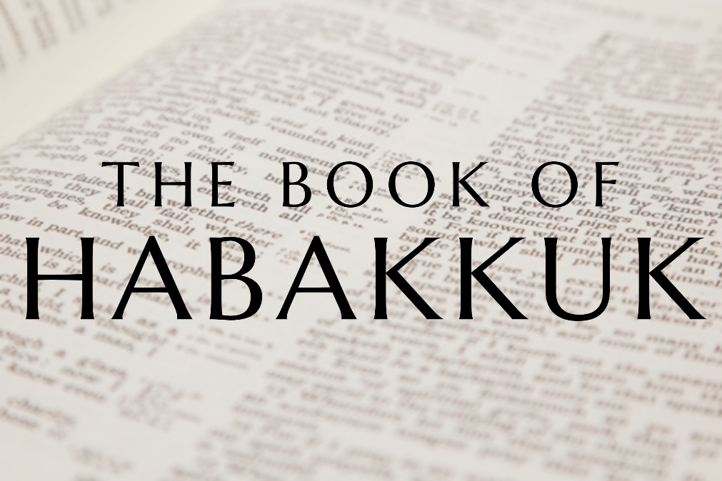

God tells us that Ezra read from the book of the Law,
day after day and that the people of God
were filled with joy!

Doctrine for the Mind and Heart

Memory Verse of the Week

Psalm of the Week

Please pray for:
Mon -
Tues -
Wed -
Thur -
Frid -

Pray for the Holy Spirit’s help as you read and study God’s Word.

Produced by Ottawa RPC to help family worship, using notes previously written by Rev. Gary Gunn, Meadville RPCNA,
with some slight amendments.
Monday – Habakkuk 1:7-11; Jeremiah 23:1-7 – God Uses Calamity to Bring True Deliverance

The world is unstable, and though much of it is kept under control by God, when He lets mankind develop without Him their actions and ambitions can be ruthless. The Babylonian attack will be brutal and destructive. But God, amazingly for His people, will channel the destructive power of the world for a greater and glorious end. We must remember that God is judging Judah here with a view to salvation at the end of it. God does these things with the church in mind, He brings the gold into the furnace to purify it! God says beautifully in Jeremiah’s prophecy that the faithful will return from Babylon saying ‘THE LORD OUR RIGHTEOUSNESS’ and that they will say “‘as the LORD lives who brought us up and led the descendants of the house of Israel from the north country and from the countries where I had driven them’ And they shall dwell in their own land." He is doing this to restore a better Judah!

The unbelieving world is opposed to Christ’s kingdom, just as Babylon was (v5-11). They may be intimidating, they may be aggressive and scoff at the stronghold of the church (v 10-11), yet it is a call for us to trust in God and to return more wholeheartedly to Him. If we run to God in this situation, He will show us that the battle is His, and that He has a purpose in bringing it into our lives.

Questions:
1. What is God’s purpose in judging Judah?
2. How does the unbelieving world act towards the church?
3. Who does the battle belong to?

Tuesday – Habakkuk 1:12-2:4 – God Does Not Change

After hearing the announcement of judgement Habakkuk is perplexed. How can an evil nation be allowed to ravage Judah? Habakkuk lifts up his soul and goes straight to God - he fixes his heart on who God is. Though he is perplexed about the coming Babylonian attack, he reminds himself that God has a covenant bond with His people that is the back-drop to all He is doing. This is faith - he focuses on God being ’everlasting’ ’the Holy One’- so He does not change His covenant love, and because He is holy He will always do what is truly good. Habakkuk questions how an ungodly nation like Babylon can be allowed to succeed by God (v12). But he knows God is good, holy, and wise - so though he does not understand, he knows God cannot be wrong. When circumstances look perplexing and difficult, it is helpful to look first at God’s character, not the circumstances. God is holy, perfect, and wise. Once we have that in our heart- we will view the circumstances differently. Take Joseph as an example. If he had weighed his life up based on the circumstances, he would have been completely despondent! Yet he dwelt first upon the character of God, and then looked at his circumstances. This is exactly what Habakkuk is doing, he is glorifying God’s character first, before he says anything else!

Habakkuk then comforts himself in thinking of the purity of God, that He will not suffer iniquity to be left undealt with. He may use the ungodly and allow them to flourish for a while, but He will deal with ungodliness at a later time. He will not ignore the lifestyle of the Babylonians!

Questions:
1. What perplexes Habakkuk?
2. What does Habakkuk do when he is perplexed?
3. What does Habakkuk know about God’s character?
4. What brings Habakkuk comfort?

Wednesday – Habakkuk 1:13-17 – The Righteous Are Afflicted

Habakkuk then compares the ungodly power to men fishing, which he must have been familiar with. He feels the Babylonians would think no more of killing his countrymen than someone would of easily pulling fish out of the sea. He envisions the Chaldean army coming and asks if God will allow them to easily gather up men in a net like fishermen and keep coming back for more! How can God hold His tongue when the ungodly are surrounding the righteous? What about faithful men like Daniel, Hananiah, Mishael, Azariah, Jeremiah, Baruch, and Ezekiel? They were all young when the Babylonians came and invaded. Will God allow the Babylonians to attack, without considering them?

This has happened through history; God’s people have been pursued and stricken. The biography of the redeemed is Hebrew 11! There they were in the caves and dens of the earth, in goatskins, in great afflictions. They have had to take up their cross and follow Christ outside the camp! In the relative comfort of the modern western world, we have been left untouched by such trials. But even less than 100 years ago, armies went throughout Europe, and the truths of eternity, life, death, true evil, and the urgency of the Gospel were better understood. Those events seem unthinkable now, but we have no reason to think so. Christians, in less Christianised countries, are regularly arrested in the middle of the night, attacked, their churches bulldozed to the ground, disowned or even killed by parents. Habakkuk asks the Lord of wisdom and mercy- how can this be? How can the wicked prosper?

He prays and leaves the matter with God, waiting for an answer.

Questions:
1. What word picture does Habakkuk use to describe the Babylonians?
2. What does history tell us about how God works?
3. What action does Habakkuk take?

Thursday – Habakkuk 2:1-4 – God’s Answer Always Necessary

Habakkuk’s natural questions will receive an answer. Will the brutality of the enemy go on forever? He voices his perplexities and expects God to speak and even correct him. This shows us that in confusion, it is best to spread the matter out before God, hoping even that He will correct our perplexing thoughts. Habakkuk also takes the right position by not attempting to resolve everything in his own mind; but asks for the mind of God instead! ’I will stand my watch, set myself on the rampart, and watch to see what He will say to me’. This is vibrant faith!

When things are confusing, and we see much in our own heart and circumstances which seem out of control, and even seem a contradiction to the grace of God, we need God to speak into the confusion. We automatically want to weigh up the details, the what if’s, the why’s, we want to connect all the parts together to try to make sense of it all - but our minds are overcome by this. God sees the end from the beginning, He sees all eventualities, He sees all people in the world at once with their thoughts, hearts, decisions: we cannot see any of that in any extent. We soon realise in difficulty we barely understand our own emotions and thoughts. Like the prophet, if we cry out with our whole heart for God to un-tangle all of this, He will speak. God made our hearts, and He can un-tangle it all.

Habakkuk waits for God then to speak and compares himself to a man on a tower watching for a messenger. It is as important to watch for answers to prayer as it is to pray itself! Why speak to someone and then not listen for their response? If we pray to the Lord we are to stand on the tower like Habakkuk and wait for Him to answer! Being on the tower gives the idea of being high up, eagerly looking at the horizon for a signal. He will answer in the Word, in the Spirit, in His governing providence.

Questions
1. What is our best course of action when perplexed?
2. After Habakkuk prays to God, what does he do?
Friday – Habakkuk 2:2-4 – A Vision of Hope

The Lord’s response to the prophet’s questions comes in the form of a vision, which the Prophet is to write down for future generations. How can God fulfil His loving promises to Israel when they are just about to be devastated? God tells him to get ready to write down the beautiful solution to this, to write it plainly so it can be easily read, and easily proclaimed by messengers which are to ’run’ with it. God is about to sum up the whole of His word in a short saying - and it is this: "Behold, his soul is puffed up; it is not upright within him, but the righteous shall live by his faith." (vs 4)

This means that when the judgement or difficulty comes, the ’just’ will be carried through it by God - because they really have faith. Faith is what separates the just from the unjust. The believers in Judah will continue in loving obedience to the Lord, prayerful, expectant, and right with Him - even if carried to Babylon. Others may abandon God, blame God, saying they did enough works for God so that this should not happen to them. The faithful however carry what God has given them and humbly embrace His sovereignty. Is that you? Having faith that God is doing what is perfect and right for the glory of His name, and for your own ultimate salvation! Abraham had faith God would provide him a son, Joseph had faith that God continued to love him in Egypt - so whether Jew or Gentile - Christians (the justified) have always lived by faith. God tells Habakkuk that in Judah there are the ’proud’, and the ’just’ who shall live by faith, so they have hope in God. This saying is so important it is quoted in Hebrews 10:38 & Romans 1:17 to show that it is faith in Christ which makes us right before God, not anything else. Habakkuk says the proud, on the other hand, will eventually be cast down by God.

Questions
1. In what form does God’s response come?
2. What is Habakkuk instructed to do with this response?
3. What separates the just from the unjust?
4. How will we know who are the just?

