FAMILY WORSHIP BOOKLET

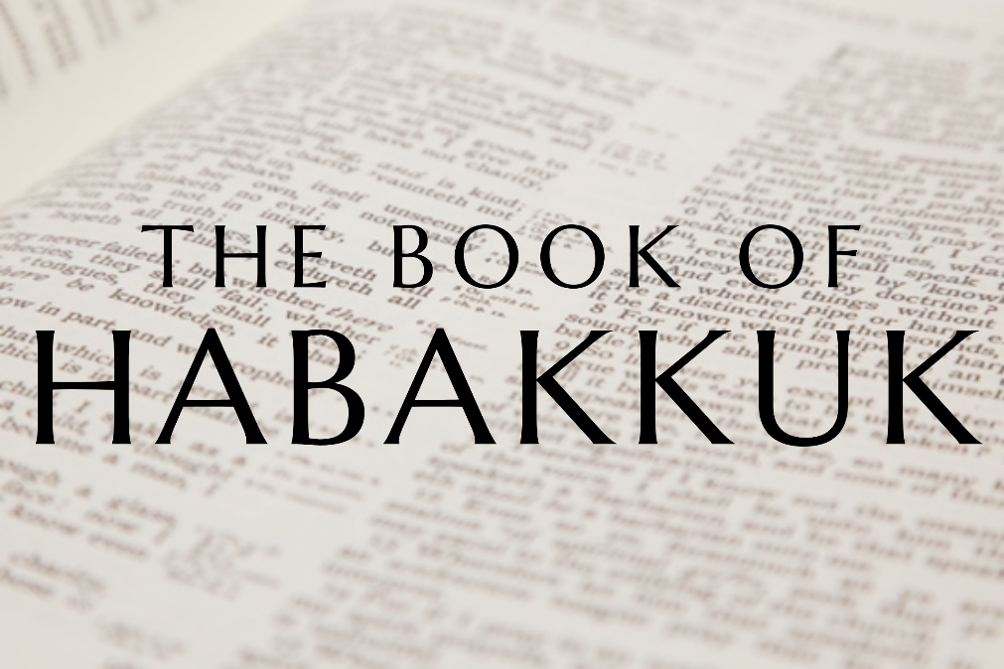

God tells us that Ezra read from the book of the Law,
day after day and that the people of God
were filled with joy!

Doctrine for the Mind and Heart

Memory Verse of the Week

Psalm of the Week

Please pray for:
Mon -
Tues -
Wed -
Thur -
Frid -

Pray for the Holy Spirit’s help as you read and study God’s Word.

Produced by Ottawa RPC to help family worship, using notes previously written by Rev. Gary Gunn, Meadville RPCNA,
with some slight amendments.
Monday – Habakkuk 2:5-20 – Woes to the Proud

Once God shows how the faithful will be kept by Him through the judgement, He shows us then what the fate of the ’proud’ is. To be proud is to think you are right in yourself. Unfortunately, as Christians we can often feel and act that way ourselves, and the Lord has to correct it!

The proud are summed up by God and five woes are announced against them. God says the proud are:
- Controlled by extravagance and sensuality, especially with wine v 5, 15
- They are covetous and greedy, they do not stay at home but love to go far and wide consuming as much as they can, heaping up more wealth v 5-8
- They want to bring attention to themselves and have security in this life "that he may set his nest on high" v 9.

Questions:
1. What does it mean to be proud?
2. How does God categorize the proud?

Tuesday – Habakkuk 2:5-20 – The Proud

As Christians we should not live for the pleasures of this world or set our nest on high and glory in our homes or finances. We ought not to advertise ourselves saying ’look at me- am I not wonderful?’. That is the proud, and it shall all be cast down by Christ. The awful thing is that God says the proud are actually sinning against their own souls in this, it actually damages the soul and corrodes it (vs 10). If we live without God, feasting on the things of the world, which the devil controls, we will destroy our own soul - with sensuality, drunkenness, entertainment. Man does not live by bread alone ’but by every word which proceeds from the mouth of God’.

This, according to Habakkuk, is all vanity and a waste of life (v13-14) - it is a life that labours and wearies itself in vain- because none of it will last. What really matters is that soon the ends the earth will be filled with the knowledge of the glory of the Lord, as the waters cover the sea (vs14) - and that alone is worth living for. If we build our house on the sand of the world and a material life, at the end of time our house will crash down; if we build on the rock, on Christ’s word and take up our cross for His sake when the earth is filled with the glory of the Lord we will be given an inheritance there. The proud and the just could not be more different!

Questions:
1. What will Christ do to the proud?
2. If we live without God, what will happen to our soul?
3. What really matters in this life?
4. What is the rock on which we should build our lives?

Wednesday – Habakkuk 3:1-2; Zechariah 12:10-14 – Asking to Be Revived

Habakkuk’s soul is loosened slightly from his perplexity after hearing the Lord’s voice. He is moved by God’s declaration of the just living by faith, the proud utterly falling, and is in awe at the LORD in His holy temple. He is so moved he composes a psalm in response! "I heard Your speech and was afraid.’ He is filled with awe in meeting God.
Habakkuk asks God to ’revive’ his work in the midst of the years, and in wrath to ’remember mercy’. What a prayer! Though the judgement is definitely coming, he asks that through it the LORD would revive, restore the church, and in the wrath, that God’s mercy would come too and even crown the wrath in the end.
How much this should be the prayer of the Lord’s people today! The situation for Jeremiah, Daniel, and Habakkuk was no different! When we think of God’s power and Him sitting in might and glory on His Throne - we must be moved to ask for Him to act and make Himself known. He has all power in His hand, He can revive His work. So, how many of our prayers are a heartfelt cry for God to revive, and in His just wrath against national unfaithfulness or church unfaithfulness, that He would remember His mercy! Cry out like Habakkuk did!
Revival always comes when the heart of a man or woman experiences God in such a clear way that they are moved to pray and pour out their souls to Him in thirst and hunger. When the Spirit of grace and supplication is poured upon the church, our prayers take on an urgency and clarity that they somehow lacked. As T.V. Moore said of the prayers of God’s people ’prayer is the gauge of the church’. Check the temperature of prayer, and that is the temperature of the church. Habakkuk knows he cannot revive the work, only the LORD can.

Questions:
1. What does Habakkuk ask God for in his response?

Thursday – Habakkuk 3:3-11 – The God of Power and Redemption

After asking God to revive in power, the prophet encourages himself by remembering great displays of that power and deliverance in the past, especially the exodus from Egypt. That was when ’God came from Teman, The Holy One from Mount Paran’. He dwells upon God’s appearance at Mount Sinai when He showed the glory of His power. God then appeared in light and shook the earth and mountains, and the nations trembled (v 3-5). Habakkuk then thinks of God measuring the land of Canaan, and dividing the waters of the Red Sea and the Jordan (v 6-10), and leading the people.
It is good for us to think upon what God has done in redemption in the past and also in our own salvation. At some point in our life, He brought ’us’ out of the house of bondage, He parted the Red Sea for us to go through, He gave us water from the Rock, Jesus Christ, in the wilder- ness. Though the adversary would tell us differently, Habakkuk says that if God was willing to begin this good work of salvation - then He will definitely complete it. Our redemption is based on deep love - and nothing can separate us from the love of Christ - tribulation, distress, persecution, famine, nakedness, peril, or sword, not things present or things to come, shall be able to separate us from the love of God which is in Christ Jesus. If God became Israel’s redeemer, He will continue to be so. If God has become our redeemer, He will continue to be so.
Habakkuk looks back to be encouraged by God’s track record. He was doing what the Psalms tell us to do, "I will remember the works of the Lord; surely I will remember Your wonders of old" (Ps. 77:11-12). He did not redeem us to allow us to be destroyed - so even in judgement, we must hope in His power and mercy.

Questions
1. How does Habakkuk encourage himself?
Friday – Habakkuk 3:12-16 – The Anointed Conquers the Land

As the prophet’s song comes to a climax something else encourages him. He recalls the Lord driving out the ungodly people of Canaan to give Israel an inheritance in the land. God ’marched through the land in indignation’. He mentions this completed their salvation, and that it was a salvation ’with Your Anointed’ (vs12-13). This ’anointed’ is a reference to the ’Messiah’, who all the kings of Israel pointed to.
God had promised in Genesis that the plan of salvation would lead to the coming of the Messiah, and that He would rule over the land of Israel - in righteousness and peace. This is a great statement of faith from Habakkuk - he has turned from trouble to hope that the people will return to the land, and ultimately the Messiah will come and rule over them. He even mentions that the Messiah will ’strike the head from the house of the wicked’ a reference to the cross, when our King crushed the head of the enemy as promised in Genesis 3:15.
With all that we go through in this life - failure, fear, trials, captivity - we are freed from these distresses by seeing a far wider picture like the prophet did. Our pain and anguish may be necessary right now, but ultimately our hope is the same as Habakkuk - there is a land to inherit. Though we walk through valleys of judgement and opposition, though we see many fall - if we battle against sin and live by faith in this life, He will lead us through it all, and we will be brought to the land of inheritance - heaven itself. The land of Canaan was always a picture of the new heavens and earth, and Habakkuk knows that though the church is being brought through a furnace of affliction, the people of God are to have a land divided among themselves and be fully saved with the Anointed One! He is driving out the dross in the land, as King, and will reign over His spotless Bride in the end.

Questions
1. What is Habakkuk, and our, ultimate hope when facing judgement?

