FAMILY WORSHIP BOOKLET

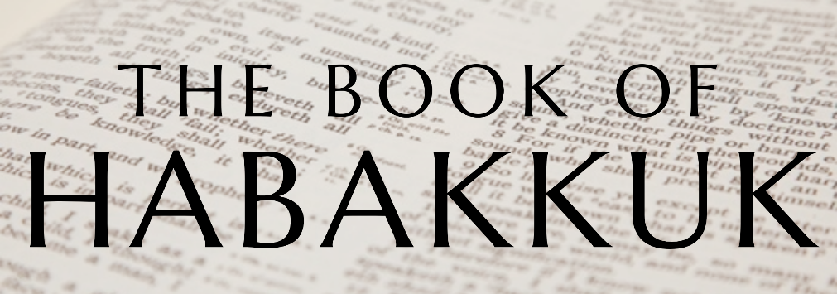

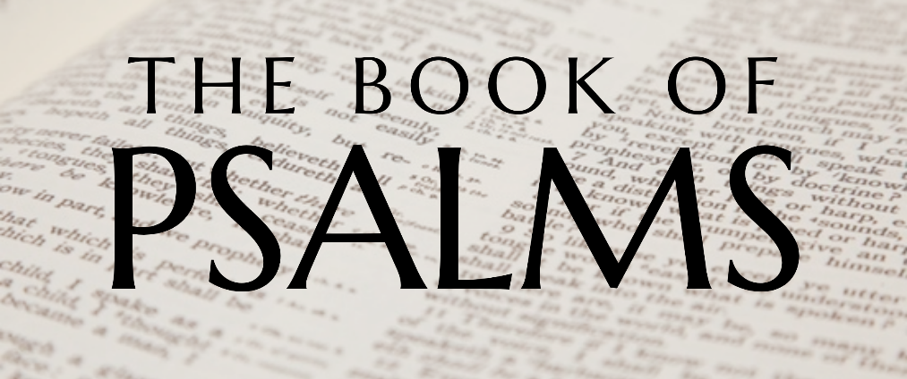

God tells us that Ezra read from the book of the Law,
day after day and that the people of God
were filled with joy!

Doctrine for the Mind and Heart

Memory Verse of the Week

Psalm of the Week

Please pray for:
Mon -
Tues -
Wed -
Thur -
Frid -

Pray for the Holy Spirit’s help as you read and study God’s Word.

Produced by Ottawa RPC to help family worship, using notes previously written by Rev. Gary Gunn, Meadville RPCNA, for Habakkuk and by Rev. Dr. Thomas Donachie for Psalms,
with some slight amendments and questions added.

Monday – Habakkuk 3:16-19 – Habakkuk Rests in God

Habakkuk knows now that the judgement is certain, and Judah will be shaken and sifted in Babylon. He knows it will be a time of great trouble and distress. He begins to close his song saying ’my body trembled, rottenness entered my bones’. Any Christian will feel that way when they see God in judgement, and the church passing through a great furnace. Habakkuk, though troubled, turns his heart to God and sees Him as the ultimate source of joy and strength.

He describes how he cannot rely on the fruit of Israel for his joy - the fig tree will not blossom, no fruit will be on the vine, the olive trees will fail, the fields may be empty, there will be no herd in the stalls. But Habakkuk will rejoice in God Himself.

This lack of fruit can be taken spiritually. He is really saying ’though Israel becomes barren, and bare and gives no refreshment and gladness - I will rejoice in God!’ Micah said in his day, ’there is no cluster to eat’. Christ compares the Kingdom to fields and vines. When days of spiritual adversity come, we struggle to find fruits and harvests. We may feel very alone, fellowship may be dry, there may be a lack of conversions. These people would go to the vineyards to make wine, which is a symbol of feasting and joyfulness; Habakkuk is saying Judah will not be a house of feasting through this trial - but his house of feasting will be God Himself! He can go to God in secret, and feast with Him in prayer and communion, finding his joy in the Lord alone!

Questions:
1. What does Habakkuk know is going to happen?
2. What does Habakkuk do next?
3. What is the reality of how days of spiritual adversity may look?
4. What remains constant in days of adversity and days of blessing?
Tuesday – Habakkuk 3:16-19 – Rejoicing in the Lord

’I will rejoice in the LORD, I will joy in the God of my salvation.’

God will be the source of our joy in the most empty of times. What He has done in our salvation, taking us from bondage, leading us through the wilderness, promising an inheritance in the city of God. God is our fellowship, God is our Beloved, God is our Father, God is the giver of every good and perfect gift - He is enough. That is the message of Habakkuk - God is enough. This gave him strength to continue.

’The LORD God is my strength; He will make my feet like deer’s feet, And He will make me walk on my high hills.’

When God is our joy - we can walk through this life, onto the high hills of a heavenly inheritance.

Questions:
1. What is Habakkuk’s source of joy?
2. What is the main message of Habakkuk?
3. What does God enable us to do?

Wednesday – Psalm 1 – Happiness

We live in days when boredom, depression and other forms of unhappiness seem to be very common indeed and happiness is often thought to be found in things that only bring temporary relief. Many would question whether true and lasting happiness can ever be enjoyed. In this first psalm we are given a key principle that can give true happiness. The first word of the psalm is translated 'blessed', but it could equally be translated as 'happy' and so the psalm could be entitled, 'The Truly Happy Man'.

There is a contrast in the psalm, not just between the happy and the unhappy, but between the righteous and the unrighteous and here we see the difference between God's perspective and that of man. Righteousness is often associated with being miserable and wickedness with 'having a good time'. Yet here it is the righteous that enjoy a life of happiness on earth and eternal bliss in heaven, whilst the ungodly have an unfulfilled life on earth and eternal misery after death. The blessedness or happiness spoken of is to be achieved by a rejection of certain ways of life and an acceptance of others. He is to reject the 'wisdom' of the world; he does not base his life on the advice of 'celebrities' or life-style gurus. He does go where the people go who do not know God. He does not join in with them, especially with those who make fun of his Lord. His delight is not in wickedness, but in the 'law of Lord'. His guidance for life is found through his regular study of the word of God.

Such a way of life is only possible for the one who has had his sins forgiven through the Lord Jesus Christ.

Questions:
1. What is an alternate translation for the word ‘Blessed’?
2. What two contrasts are made in this Psalm.
3. Where does the psalmist find his guidance?

Thursday – Psalm 2 – All Will Bow

Matthew Henry comments on the first two Psalms that Psalm One is moral and shows us our duty, and Psalm Two is evangelical and shows us our Saviour. There is no indication as to the occasion that gave rise to the writing of the Psalm, but it has been almost universally accepted as a Psalm that very clearly points to the coming Messiah.

This is a Psalm of great comfort to the child of God, especially when it seems that the cause of God and truth is being attacked on every side and it appears as though it is going to be overwhelmed. The nations do rage against God; they do seek to overthrow Christ and his church, and they ridicule the idea that the Lord Jesus Christ is king and must be submitted to in all things. Godless scientists and immoral philosophers may be highly regarded by a wicked world and applauded as they pour scorn upon Christ and his church, but this Psalm gives the proper response: The Lord shall have them in derision! When atheists come out with their bile against Christ and his church, just remember that the Lord in heaven is laughing at his foolishness.

It is not man who has the final say, with all his cleverness and power, God has placed his own beloved Son as the King over all the nations, and it is his will that will be done and his purposes that will be carried out. Those who oppose his will, no matter how powerful they may seem to be, will be forced to bow the knee and acknowledge Jesus Christ as King of kings and Lord of lords. The important thing to remember is that all men will bow to Christ, either in repentance and love whilst here on earth, or in terror and despair when he comes again.

Questions
1. What does Psalm 2 show us?
2. How does this Psalm bring comfort to the child of God?
3. What do we need to remember when the nations rage?
Friday – Psalm 3 – Safe With God

It is a common experience of the people of God that life brings its trials and disappointments. It is hard to imagine how King David felt when his own son Absalom, whom he dearly loved, rose up in rebellion against him and caused him to flee for his life. It is a sad fact, as William Plumer comments, that the best of parents may have the worst of children for grace is not hereditary. God is sovereign. How urgently must we seek God's grace for the children of believing parents that they may not turn out like Absalom.

Looking back on the rebellion of Absalom, David reflected that his situation was absolutely dire and there appeared to be no hope for him. Not only had many rebelled against him, they believed that he had been abandoned by God. In this awful situation however, David had not lost his faith and trust in God. Even when the situation looked hopeless David knew that he was in the hand of his God and even surrounded by his enemies he was enabled to lay down and sleep.

To know that the Lord watches over his people is a great comfort to the believer in time of trouble. To know that Lord cares, protects and provides enables the child of God to face situations that would otherwise overwhelm him. As Daniel walked into the den of lions knowing that God was with him and would work out his purposes, so the child of God can face difficulty and danger because it is the same God who watches over him.

Although it is true that Salvation belongs to the Lord, God expects his people to use the means of grace provided for them, and so David prayed for God to do for him what he firmly believed he would.

Questions
1. What situation is David in when writing this Psalm?
2. What enables David to lay down and sleep?

