FAMILY WORSHIP BOOKLET

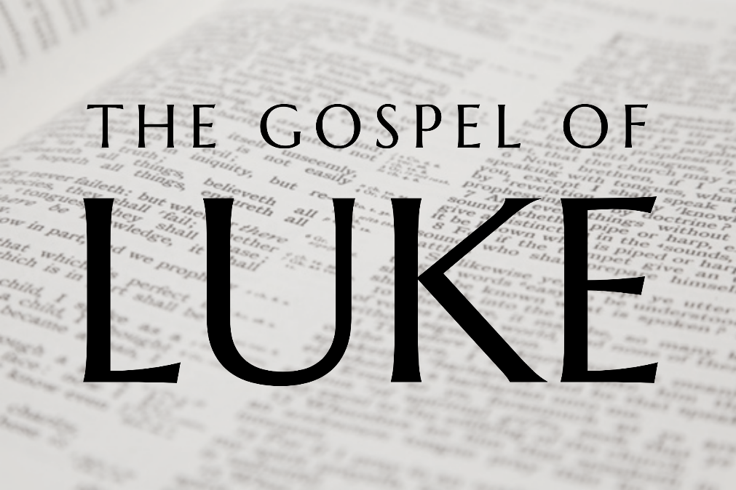

God tells us that Ezra read from the book of the Law,
day after day and that the people of God
were filled with joy!

Doctrine for the Mind and Heart

Memory verse of the week

Psalm of the Week (words on page 8)

Pray for:

Mon –
Tues –
Wed –
Thurs –
Fri –

Produced by Ottawa RPC to help family worship,
These notes have been prepared by Rev. Dr Andrew Quigley
Monday – Luke1: 1 - 7 - Zechariah and Elizbeth introduced.
Christianity is a religion based on facts. That in itself is a simple but important fact, because it means that we can lay hold of those facts in our minds. So, we can ‘know’ about Jesus Christ because of what we have written about him in this historically accurate gospel. Which means that our faith in Jesus Christ is based in reality. That’s important not in terms of proof but our sanity.
Luke writes that the gospel, is a narrative of the things that have been accomplished among us. But who are the us? If you turn to Philemon v24 you will get some idea of who they are.
Luke begins with a statement about the immediate national context of Jesus’ life. He tells us that Herod is King of Judea. Then he introduces us, not to Jesus’ parents, but to another couple. The man’s name is Zechariah, he is a priest and his wife is called Elizabeth who also is from the line of priests. Luke says she is ‘from the daughters of Aaron’. Who was Aaron and what was his significance? Well, Aaron was Moses brother and he and his descendants were appointed by God to serve Him as priests (Genesis 28:1). So, this couple by their individual ancestry have a strong heritage in the people of God. But in addition to that Luke describes them as being righteous before God, walking blamelessly in all the commandments and statues of the Lord. So, Zechariah and Elizabeth didn’t just have the heritage they lived the life of godliness. And yet there was a sadness in their lives because the Lord had not blessed them with a child. This is a reminder of the fact that whilst the Lord does bless our delight in and obedience of His Law there is no way we can tell how that blessing will come.

Questions:
1. Who is the author of this account of the life of Jesus and how does he describe what his approach to writing this gospel?
2. Who was the King?
3. What are the names of the couple we are introduced to and what does Luke tell us about them?

Tuesday – Luke 1: 8-17 – Serving and Praying

Zechariah, Luke tells us, is serving as a priest in the temple. He had a formal role as an appointed priest to do, but you don't need a role to serve in the church. To serve, you need two things, first a willingness to see what needs to be done, and then a desire to do it. Serving is about the heart. Such willingness, arising from the heart, comes from an understanding that the church is about Christ, and others. See Luke 6:38, Galatians 5:13, and 1 Peter 4:10
The other point Luke highlights is that the whole multitude of people, at the temple, were praying. This was the Old testament church at prayer, and that desire to pray flooded into the New Testament church as it was given life by God the Holy Spirit. (Acts 2:42, 4:23-31, Acts13:1-3). This shouldn’t surprise us of course because, God expects and desire that we should speak with Him in prayer. As we know from Matthew’s gospel, Jesus begins his teaching in the Lord's prayer with the statement, ‘When you pray… but when you pray... and when you pray' Matthew 6:5,6,7. He then tells us in Matthew 7:1, to ask, seek and knock, and the promises are clear, when we do, we will we receive and we will find. The apostle Paul was clear in his exhortations that we are to continue steadfastly in prayer, and that we are to pray without ceasing. (Colossians 4:2, and I Thessalonians 5:17).

So, praying is part of your life and mine; as individuals, as families and as a church. And what a wonderful privilege and blessing it is to us.

Questions:
1. What words does Luke use to describe what Zechariah is doing?
2. Is there something you could do to serve God and His people in the church?
3. What were the people doing while Zechariah is serving in the temple?

Wednesday – Luke1:8-17 – Do not be afraid

In these verses, we read of the encounter between an angel of the Lord and Zechariah. The ministry of angels is a study in itself. It is worth noting, though, that around the time of Jesus' coming to earth, his incarnation as it is called, the number of appearances made by angels increases dramatically. As we shall see in our study of this gospel, the angels clearly take a deep interest in the earthly life and work of the Lord Jesus. They are present at all the critical moments in his life and offer him all the help he needs to fulfill his responsibilities as Saviour. Their interest in his work is evident with the joy they express when one sinner is saved (Luke 15:10).
Zechariah's was clearly very afraid when he saw the angel? He was the only person to be afraid when confronted by such a holy creature We read that Daniel was afraid when sees the vision of a man in Daniel 10:7; when Gabriel visits Mary later in this chapter, she also is afraid and as are the women who visit the tomb of Jesus in Matthew 28:8 when the angel speaks to them. Why is this the case? It is the human soul can feel nothing but guilt felt in the presence of holiness and its that guilt that produces the fear. Whish should lead us to think what it will be like for those who do not have their sins forgiven to stand in the presence of the risen gloried Son of God on the day of judgement.
The angel tells Zechariah not to be afraid and explains that his prayers for his wife Elizabeth to have a child have been heard and will be answered. Which is wonderful encouragement for us to remember that God always hears our prayers and whilst it may seem His answer is slow in coming, the fact is it will come and be perfect when it does. Luke 18:1-8 speaks very powerfully to this point. (See also 1 Thessalonians 5:16-18.)

Questions:
1. What is Zechariah's response when he saw the angel? Why is he so afraid?
2. What did the angel tell Zechariah is going to happen?

Thursday – Luke 1: 8-17 – John is announced

The angel tells Zechariah that he is to call the child John. The angel also tells Zechariah that John will be great before the Lord being filled with the Holy Spirit even before he is born.

The birth of a child can only be surpassed when that child professes and gives genuine evidence of saving faith. Nothing in the world compares with it. It is a work of God’s grace second to none. That being said, it is also incumbent upon those of us who are parents, even though we fail daily, to consciously think about the example we are setting out children and to teach them the God's commands of God (Deuteronomy 6:6). That and praying for their salvation must rank at the among the top of our priorities in life.

As for John’s career, again the angel is specific, he will be used mightily of God in the ‘turning’ of many Israelites to God. He will also have the incredible role of preparing the way for the coming Messiah. For every Hebrew father the prospect of their son being the promised Messiah was something beyond their wildest expectations, and if that was not to be the case then surely the next astonishing thing would be for your son to be the one who would prepare the way for the coming Lord. Tomorrow we shall find out how Zechariah responded to this astonishing news.

Questions
1. What name does the angel tell Zechariah to call his son.
2. What did the angel of the Lord say about the child who would be born to Zechariah and Elizabeth, who would fill him?
3. What did the angel say John will do and what will his role be?

Friday – Luke 1:18-23 – Zechariah is sceptical

Zechariah is skeptical of what the angel has told him citing the reasons of his age and the fact that Elizabeth is an older woman and by implication past the age of having a baby. It’s a reaction that we probably would not have expected from someone in his position. Which begs the question, ‘Why does he not believe what the angel is saying?’ He is, after all, not only a priest but a man who is genuinely godly and is committed to serving the Lord in the Temple. How could this have happened? We are not told the reason why, but could it have been that he had just gotten used to fulfilling his religious responsibilities without being personally engaged with God? He did have after all, have the examples of the miraculous births of Isaac, Samson and Samuel to draw on. (Genesis 18:11-14, 21:1-3, Judges 12:2-3, 1 Samuel 5:19). This shows the importance and of the necessity of nurturing a living and vibrant faith in with God regardless of who you are or your role in the church.
In response the angel tells Zechariah who he is, and where he has come from. Why? Because he is leaving Zechariah in no doubt about the reality of what he is telling him.
However, note that Zechariah’s expression of unbelief, does not go unnoticed. Zechariah is struck dumb and as we shall find out, God willing next week, his dumbness lasted until John was born. What a daily reminder, during the full term of his son John's unborn life, of his unbelief. A warning to us all.
The people waiting outside wondered what had happened to Zechariah, obviously he had taken much longer than usual. Luke tells us that when he does appear and they seen that he cannot speak that they deduce that he has seen a vision in the Temple, which speaks to their spiritual awareness.

Questions
1. How does Zechariah respond to what he hears?
2. Who does the angel say he is, and where has he come from?
3. How does God deal with Zechariahs unbelief?

