FAMILY WORSHIP BOOKLET

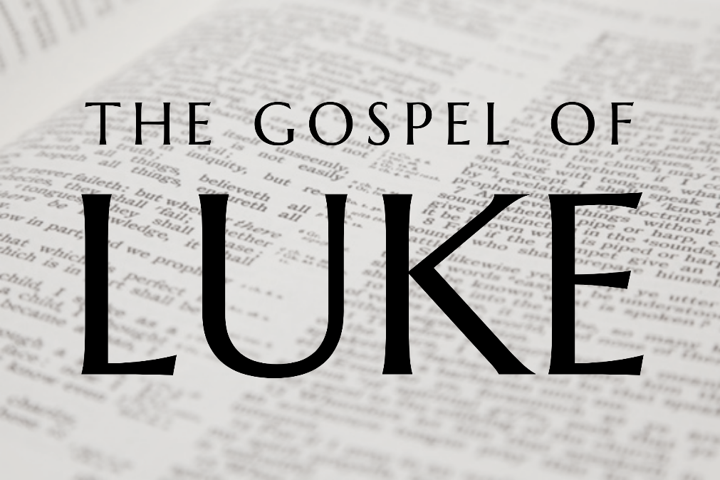

God tells us that Ezra read from the book of the Law,
day after day, and that the people of God
were filled with joy!

Doctrine for the Mind and Heart

Memory Verse of the Week

Psalm of the Week (The words are on page 8)

Please pray for:
Mon -
Tues -
Wed -
Thur -
Frid -

Pray for the Holy Spirit’s help as you read and study God’s Word.

Produced by Ottawa RPC to help family worship.
These notes have been prepared by Rev. Dr Andrew Quigley.

Monday - Read Luke 6:39-40. Leadership is of the utmost importance.
V39. Again, we come to find a saying which is part of our everyday language, "the blind leading the blind". It shows just how much the Word of God impacted the English language in the 17th and 18th Centuries. But what does it mean? In a sense, it's self-explanatory. When a blind person tries to lead another blind person, no one gets very far. So, it is in the Christian life. If the man leading his family or the church cannot 'see' any further than those he is called to lead, where will they go? By 'seeing', it means understanding, knowing, and being wise. That's why dads and mums have to be ahead of the game when it comes to leading their family spiritually.
V40. Jesus commented on this relationship several times and in different ways during his public ministry; Luke 22:27, Matthew 10:24, John 13:16. What is his point? Well, there are two points. First, it means that the student is only going to go as far as the teacher’s knowledge and ability to teach. Second, I think Jesus is also talking about 'attitude'. The idea of being fully trained can’t be just about attainment of knowledge, it must also include the development of the correct attitude to make profitable use of the knowledge. So, teaching is more than simply communication of information. The good teacher will communicate through their words, tone, and attitude that they want those they are teaching to know the information because it will be beneficial to their life. Jesus is saying to his disciples that it is this attitude of understanding both the ‘what and why’ that is really important.
Leading our families, if we have a family, in worship, is not merely a matter of communication of truth to their lives; it also involves the communication of a passion to their minds and hearts – a passion for God himself. That passion will come across as we invest in these times. That doesn't mean you have to spend a long time doing it. The investment I am referring to is one of desire, of hunger, to come before God. If our family’s sense that being with God and worshiping Him is important, then that attitude will convey itself to them. APPLICATION TO PARENTS - It is not easy; I know from personal experience. After a hard day working, it can be difficult to raise oneself to convey such a hunger, but please, for the sake of those you love, ask God for His help. Then, lead your family into His presence as though it were the most important thing in your day. Keep it simple; keep it straightforward; but above all, keep it filled with love for God. Do it knowing that it will reap an uncalculatable reward for you and those you love, both in time and eternity.
Tuesday - Read Luke 6:41-42 - The speck and the beam.

V41,42. In Matthew's gospel this parable follows immediately after the instruction on judging, i.e., Luke 6:37. Jesus is talking here about something that is important, but it is interesting how humorously he expresses it. Speaking of a beam in one’s own eye while looking for a beam in someone else's. Possibly a deliberate response to the cold, rigid, and unengaging teaching of the Pharisees and scribes? It certainly would have left the hearers remembering his point. And what was that point? Well simply put, don't go telling other people their faults until you have looked into your own heart and seen what it is producing.

Of course, that does not mean that we should be slow or hesitant to address a brother or sister living in public sin, James tells us that if anyone brings back a wandering sinner, they will save his soul from death and cover a multitude of sins (James 5:19,20).

Our problem, of course, is that the perceiving and then verbalising to a few the faults of others, is something that comes all too easy to us; while the addressing of actual public sin is something we all too easily shy away from.

I think a read of James 3:5-12 would do us no harm. "So, also the tongue is a small member, yet it boasts of great things. How great a forest is set ablaze by such a small fire! And the tongue is a fire, a world of unrighteousness. The tongue is set among our members, staining the whole body, setting on fire the entire course of life, and set on fire by hell. For every kind of beast and bird, of reptile and sea creature, can be tamed and has been tamed by mankind, but no human being can tame the tongue. It is a restless evil, full of deadly poison. With it we bless our Lord and Father, and with it we curse people who are made in the likeness of God. From the same mouth come blessing and cursing. My brothers, these things ought not to be so. Does a spring pour forth from the same opening both fresh and saltwater? Can a fig tree, my brothers, bear olives, or a grapevine produce figs? Neither can a salt pond yield fresh water."

Wednesday - Luke 6:43-45 – The Fruit tells you!
The parallel passage in Matthew 7:15-20 sets the context as that of identifying false teachers but the truth is also applicable to anyone who professes saving faith in Christ.
V43, 44. Jesus speaks of two species or kinds of tree. There is a good tree that produces fruit, which is literally 'excellent fruit', and there is the bad tree that produces that which is 'worthless fruit'. You can't get it much simpler than that. There are no hybrids here, no mixed species, no half good and half bad trees. It is one or the other. But how can you tell the difference? The quality and the nature of the tree is seen in the fruit the tree produces.
Jesus uses four pictures to drive this point home. The symmetry and balance are perfect. The first thing we see is the separation. Why is that important? It is important because it gives the basis for assessing whether the work, and therefore life, of a minister or the profession of a Christian is genuine. In the case of the minister this is so important for the protection of the Bride. God’s people need to know, notwithstanding the occasional genuine mistake, that they can trust what they are hearing as God’s truth, delivered from a godly heart, following honest labour, marked by integrity.
V45. The fruit. The good minister/believer will produce good fruit and they will do so because of a God-given godly heart. The ungodly wither; a minister or a person who professes to be converted will not produce good fruit. They can’t, and they won’t, because their heart is not right before, and desirous of, God. No matter how much they try to mimic being a godly minister or being a Christian, the fruit of their lives will speak to the reality. Note the term 'evil' is not reserved for those who are grotesquely heinous in what they do. So-called 'good’ men and women, people whose lives are inconsistent with God's will, are evil in God’s eyes.
If a minister is in Christ, then the fruit of his life will be evidently good. His preaching will, by the power of the Holy Spirit, lead God’s people into a greater measure of holiness, and Christ will draw others into His flock through it. The godly minister's love for, and diligent presence with, the flock, will be clear to all, Acts 20:18-27. And come the day of judgement his labours will not be burnt up as hay and stubble, 1 Corinthians 3:11-15; they will be proven genuine and he will have no need to be ashamed before God, 2 Timothy 2:15.
Just as this test stands for ministers, so for all of us as professing Christians, we are not to live as ‘performers’ of the faith. The Word of God is to dwell in us richly, Colossians 3:16, and the overflow of that into our lives will bear much good, genuine fruit to the Father's glory. As we abide in Jesus, many good things will come from our hearts, John 15:1-17, Proverbs 4:23. It truly is out of the abundance of the heart that the mouth speaks, and that God-glorifying obedience is seen for what it truly is.
Thursday - Luke 6:46-49 - Are you being honest?

V46. In Matthew's gospel (Matthew 7:21-23), we have a fuller account of what Jesus says; Luke picks out one sentence. “Why do you call me ‘Lord, Lord’ and not do what I tell you?”

People who profess to be Christians, but who are not producing good fruit, may be eager to call Jesus their Lord, but it's clear that they are not willing to submit to his authority. Because of their spiritual blindness they don’t understand what it means to call Jesus my Lord. For them it's just a saying, when in reality to say 'Lord, Lord', means that Jesus rules over all of my life, that his Word is the most important thing in my life, and the delight and joy of my life is in doing what he commands. To live one's life saying ‘Lord, Lord’ and then not to live it, is what? It's worse than denying Jesus. It's worse than saying that you despise him and will not do what he says. At least doing that is living a life marked by a modicum of integrity. But, to present yourself as an all-in lover of Jesus, and then be a half-hearted, ‘do it when it suits me’ observer of Jesus’ commands, is reprehensible. We simply cannot call Jesus our 'Lord', that is the one to whom we will submit our lives, and then do as we please. Paying lip-service to some form of routine religion won't cut it. Why not? Because Christ desires, and will have; authenticity, honesty, integrity from us. Why? Because that is who he is, that is what marked his life, from the cradle to the Cross. Jesus didn't come to earth, presenting himself in one way, and then live his life in a way that was different to that. No, he lived his life on earth being who he said he was, and in the process, he endured the ridiculing, the reviling, the mockery, and the shame right to death itself, in obedience to the Father. So how can people think that they can call him their Lord and then just live as it suits them to avoid the difficulties that come directly from living in obedience to God. Therefore, we simply cannot say we love Jesus and will do as he says, and then not do it.

It is no wonder that Jesus ends this teaching in Matthew with the warning that on the Day of Judgement he will say to them, "I declare to them, 'I never knew you; depart from me, you workers of lawlessness.'" Matthew 7:24. Sobering words indeed.

Friday - Luke 6:46-49 - The Solid Foundation.
V47. Jesus paints the picture, via a parable, of what happens when to us; when we do what we say and when we don't. Matthew's account and Luke's differ in that Matthew tells us the types of sites the two men choose to build on, one on the Rock, the other on sand (Matthew 7:24-27); whereas Luke tells us how they go about laying their respective foundations.
Luke says that the first man applies himself diligently to the task of laying a good foundation. There is digging involved, honest hard work. And it is a lot of digging. The man doesn’t just dig out a few shovelfuls; he is at it continuously for days, maybe even weeks. He is taking care to do the job right. It's not a hobby for him. It's not a casual enterprise which he engages in for a bit of fun or downtime. No, this is important to him. Why? Because this is his home. This is where he, his wife and family, will live, and it has to be able to stand whatever comes its way. And so, when the floods do come, when life's issues break over his home, what happens? It doesn't shake, it doesn’t move. It stands secure where he has built it. How? Because of the hours, days, weeks, months, even years he spent digging to get the foundation laid right.
What of the second man's approach? Well, he just turned up one day and started laying the brick, and by the time he had finished, it looked good. In fact, observers probably thought as they watched the first man toil away, digging out day after day, that if they were going to build a home, they'd follow the second man's approach. Why bother with all that work underground when all you see is what is above ground? Why waste all that energy, time and money going down to the bedrock. Would it not be better to use those resources, and build a bigger house? Why take seriously the things Jesus tells you to do when you don't really have to. I mean, what difference does it make? No one sees the digging, the careful, thoughtful, intelligent study leading to honest obedience. All they see is that you turn up at church on a Sunday, and that's it. The 'digger' turns up at church; the 'non-digger' turns up at church. They sing the same songs, listen to the same prayers, hear the same sermon, leave from the same parking lot, and go home. What's the point of the 'digging' – doing what Jesus says? The point is that when the floods come (the trials in your life), and you can be sure they will, your home (your life) won’t fall down around your ears (your life won’t fall apart). And notice, it doesn't take a huge flood to destroy the unfounded or poorly founded structure. Jesus says, "when the stream broke against it, immediately it fell"; and what of the consequence – "the ruin of that house was great."
On the other hand, and when the tidal waves hit the Christian, the one who genuinely hears and does what Jesus says, their lives, and often as a consequence the lives of those around them, will stand firm because they are built on the Rock.

