FAMILY WORSHIP BOOKLET

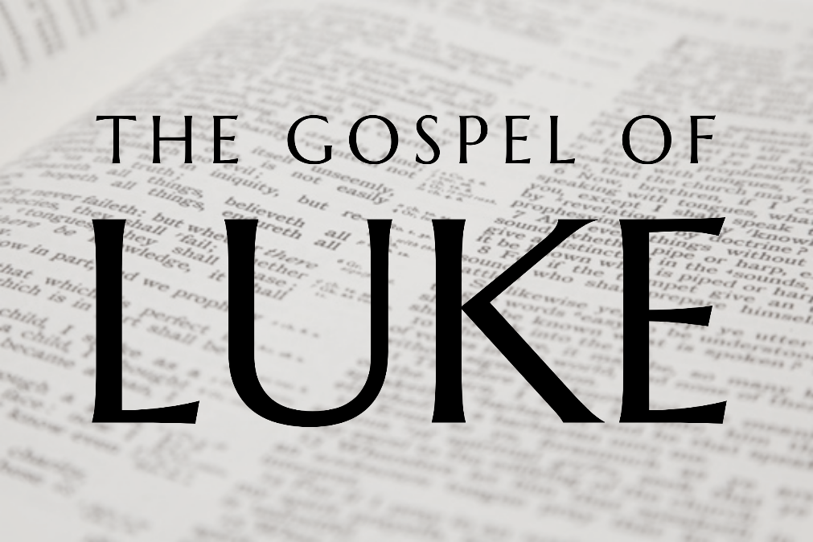

God tells us that Ezra read from the book of the Law,
day after day and that the people of God
were filled with joy!

Doctrine for the Mind and Heart

Memory verse of the week

Psalm of the Week (words on page 8)

Pray for:

Mon –
Tues –
Wed –
Thurs –
Fri –

Produced by Ottawa RPC to help family worship,
These notes have been prepared by Rev. Dr Andrew Quigley
Monday – Luke 1:23- 25 – Responsibility and Joy.
v23 Zechariah didn’t go home and communicate what had happened to him immediately. He fulfilled his duty at the Temple and then returned home. It is interesting that the fulfilment of his responsibilities took precedence over sharing the exciting and good news with his wife.
We live in an age when communication of news, any news, is more important than doing the simple thing that we are supposed to be doing. And there is a reason for this, the devil delights in distraction and chaos, whereas the way of God is constructive order.
V24 What the Lord promises to do, He always does. Elizabeth who was well beyond the age to have children, became pregnant. What a joyful experience that must have been. But it would also have been a daunting one in many ways, because this was a child promised from the Lord and that would inevitably have created its own particular thoughts. Could this be the reason why Elizabeth ‘hid’ herself for five months, I don’t know, but obviously she was conscious of something.
V25 Clearly though, she was filled with joy. The fact that she talks about the Lord removing her reproach speaks to the depth of that joy. For her, pregnancy marked the end of the feeling, created by the culture, that she had failed to fulfilled her role in life. The general perception being that the couple must have done something to warrant God’s displeasure. Obviously, an incorrect view of God’s providence in a women’s life and one that imputed a lot of unwarranted emotion into what was already a difficult situation.
We need to take care not to voice our view of what God might be doing in another person’s life and why He might be doing it.

Questions:
1. What did Zechariah do as soon as he heard the news that he was going to have a son?
2. Did God keep his promise?
3. What did Elizabeth do?

Tuesday – Luke 1:26 - 33 – Gabriel Comes to Mary.

In these verses we read an announcement like the world has never heard before. It is the announcement of the incarnation and birth of our Lord Jesus Christ. It is an announcement that should stir us with wonder, love, and praise every time we read it. We should stop and think about what it is actually saying - God coming to earth in the form of a man.
V26 Elizabeth has been pregnant for six months’ when Gabriel, the same angel who had appeared to Zechariah, is sent to an obscure village town in Galilee, called Nazareth. Nazareth was so obscure, that it was seen as a place where nothing good came from. Thirty years later when invited by his brother Philip to come and see Jesus, Nathaniel said to him, “Can anything good come out of Nazareth?” John 1:46. God could have chosen very different circumstances for Jesus to have been born into, but he didn't. As Paul would later write to the church at Corinth, “For you know the grace of our Lord Jesus Christ, that though he was rich, yet for your sake he became poor, so that you by his poverty might become rich” 2 Corinthians 8:9.
V27 We’re now introduced to Joseph and Mary and we need to be clear about the facts of who she was. Roman Catholicism is wrong in its teaching that Mary was conceived free from original sin; that she should be venerated as an object of worship; and that we can pray to her as a mediator between God and man. These teachings are wrong, but we must have a deep love and respect the mother of our Saviour. Remember how the Lord cared for his mother even from the cross, John 19:25-27.
Note also the relationship between Joseph and Mary – they are betrothed, which means they had solemnly agreed to marry. This was a legal agreement so binding that a divorce was necessary to break it.

Questions:
1. Who appeared to Mary and where?
2. What does the Bible tell us about Nazareth and its importance?
3. How should we view Mary, the mother of Jesus?

Wednesday – Luke 1:28-38 – The Announcement

V28 The news Gabriel shares with Mary is astonishing. Mary is favoured by the Lord and the Lord is with her. Why Mary was chosen we are not told, but she is greatly troubled at what she hears and tries to work out what it means. The fact that she does so is an indication of her belief in what she is being told. See how gentle Gabriel is with her, how he speaks to her heart before he tells her what this will mean for her life. He does this to carefully put her at ease. We should always try to be conscious of the concerns of others, especially so in these days. We need to be aware of the signs of anxiety, and fear, and talk with one another in a gentle and appropriate way.
V30-33 Gabriel repeats the fact that she is favoured and then goes on to tell her what that will mean. The long-awaited Messiah is coming and Mary will be his mother. Look and consider what he tells her about Jesus. In these astonishing statements Gabriel is announcing the fulfilment of many Old Testament prophesies about the Lord Jesus.
V34 Mary responds to this announcement by asking a question. So, she does what Zechariah did when Gabriel came to him. Yes and no. Yes, like Zechariah, Mary asks a question but her question doesn’t arise from a heart of doubt but one of faith. Which is both remarkable and very encouraging in that you don’t have to be a certain age or have a role in the church to exercise faith. Mary believes what she has been told but can’t understand given her circumstances how it is going to happen. She isn’t going to engage in an intimate relationship with a Joseph so how will she conceive? Gabriel’s response is one of reverent reserve which makes it clear that Mary’s conception will be the result of divine activity.
V38 In her simple and clear response Mary declares that she is the Lord’s servant. It is an expression that conveys immediate and complete acceptance. There is no asking for time to get a second opinion. Remarkable given all the implications of what will unfold, not only in terms of what her parents and Joseph will think, but what others will say, and then she will have the responsibility of raising this child.

Questions:
1. What two things does Gabriel say Jesus is going to be? What is God going to give to Jesus? (v32)
2. What is Jesus going to do? How long will he reign for? (v33)
3. How does Mary respond to this phenomenal news?

Thursday – Luke 1:39-45 – Mary and Elizabeth

V39-41 Mary, without delay, goes and visits Elizabeth. Elizabeth, also filled with the Holy Spirit, pronounces a blessing upon Mary. In that blessing she says that she knows that the baby in Mary’s womb is the Messiah, for she addresses Mary as ‘the mother of my Lord’. What a beautiful expression of faith.
V44 Elizabeth now shares with Mary how her greeting had caused the baby in her womb to leap for joy. Isn’t that astonishing, the unborn John, filled with the Holy Spirit, responds with joy to the presence of the Messiah in his mother’s womb. Note the complete absence of any awkward questions or jealousy on the part of Elizabeth to Mary. This is interesting given that Elizabeth was older than Mary, she was married to a priest, and was descended from the line of Aaron. Elizabeth is just thrilled for Mary and, by the help of the Holy Spirit, accepts the Lord's hand in this supernatural pregnancy. Sometimes we just need to joyfully accept that God really is in control, and does things that we cannot understand, for His own glory.
V45. Evidently, in their conversation, Mary shared with Elizabeth her experience with Gabriel. That would have included her statement of humble submission to the Lord, which leads Elizabeth to call Mary ‘blessed’. Such humble sharing of faith, and a willingness to obey the Lord, is a healthy and good thing, and should be done more often. Interaction with other believers, is always a blessing. One of the signs of true conversion is a genuine desire for fellowship with other Christians. In fact, it is impossible to be a Christian and not delight in the fellowship of other Christians because of our union in Christ and the shared indwelling of the Holy Spirit in our lives.
This is what the Old Testament prophet Malachi said how the Lord observes our times together, "Then those who feared the Lord spoke with one another. The Lord paid attention and heard them, and a book of remembrance was written before him of those who feared the Lord and esteemed his name." Malachi 3:16.

Questions:
1. What does Mary do soon after her encounter with Gabriel?
2. What does the baby in Elizabeth’s womb do when Mary greets Elizabeth?
3. Why does Elizabeth call Mary 'blessed'?

Friday – Luke 1:46-56 – The Song of Mary

These verses contain Mary's famous song of praise at the prospect of becoming the ‘mother of our Lord’. It is a song is full of expressions from the book of Psalms. In one sense, not a surprise because the Psalms provide us with everything, we need to express ourselves whatever the circumstances of life, both in times of need and of joyous thanksgiving. What is remarkable though, is that Mary has these Psalms in her memory and is able to draw on them so easily. It says something about what she was putting into her mind and heart each day as a child and young woman. But it wasn't just her knowledge of the Psalms that she was drawing on because as you read the song, you see that there are definite overtones of the song of Hannah (1 Samuel 2) so she was familiar with that as well.
v46,47. Even though Mary has just been chosen by God to become the mother of the Messiah, she speaks of her own 'humble estate', and acknowledges her need of a 'Saviour.' So, the Word of God was not merely in her head as memorized knowledge, by God’s grace it was also in her heart.
It is a wonderful privilege to learn God’s Word but as we do so let’s make sure to always ask God to apply it our heart, otherwise it will lead to pride which is not good.
v48,49 Note how Mary repeatedly expresses her thankfulness to God. She sings that her ‘soul magnifies the Lord’ and that her ‘spirit rejoices in God my Saviour.’ How that the ‘mighty one has done great things for me.’
It is good to thank people for their acts of kindness, and we do, but maybe we need to be more consistent in being thankful to God. This season of relative deprivation that we have all gone through, hopefully has given us an opportunity to reflect on, and be increasingly thankful for what God does give us e.g., family, food, health, friends, communion with Him, and fellowship each other.

Questions?
1. Which book of the Bible does Mary quote a lot from?
2. How does Mary speak of herself and what does this tell us?
3. What is Mary’s attitude towards God?

