FAMILY WORSHIP BOOKLET
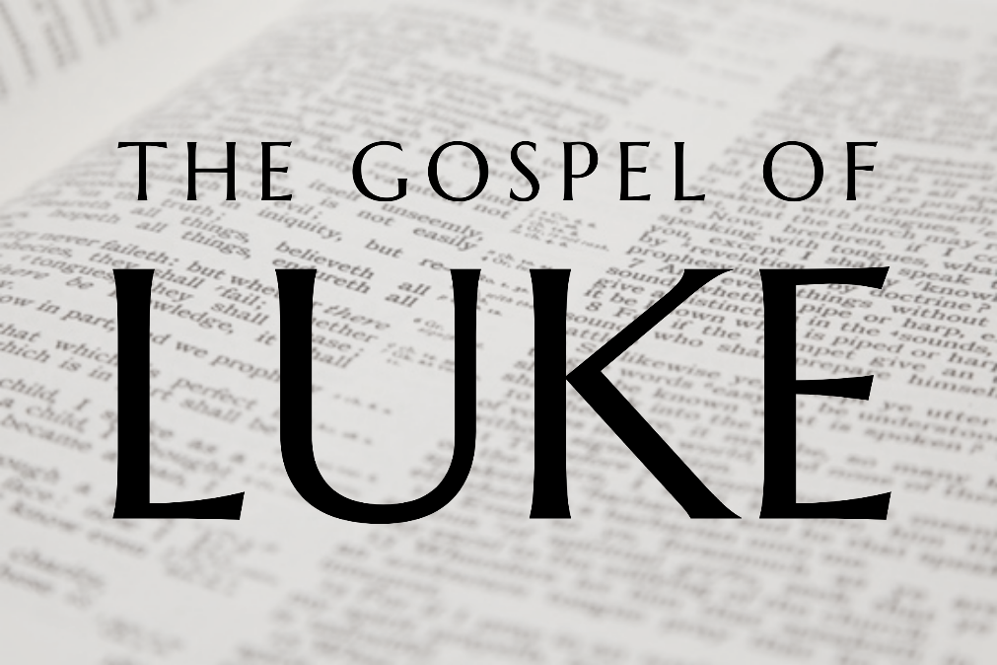

God tells us that Ezra read from the book of the Law,
day after day, and that the people of God
were filled with joy!

Doctrine for the Mind and Heart

Memory Verse of the Week

Psalm of the Week

Please pray for:

Produced by Ottawa RPC to help family worship.
These notes have been prepared by
Rev. Dr. Andrew Quigley.

Monday - Luke 9:18-22 - Who is Jesus?
We now come to one of the most staggering events in the New Testament. It as though Luke cannot wait to get to it because he jumps ahead, omitting a number of things that happened, see Mark 6:45-8:26.
Matthew tells us that Jesus and the Apostles are near Caesarea Philippi (Matthew 16:13), which is a Gentile region where the worship of the pagan god Pan dominates. They have left behind the huge crowds that had been engulfing Jesus and are entering a season when Jesus will be instructing and preparing the Apostles for his death, which will take place in about a year’s time.
Luke sets the immediate context – Jesus is on his own and he is praying. Luke is the only one of the gospel authors (Matthew, Mark, Luke and John) who notes Jesus’ praying, except for when Jesus is praying in the Garden of Gethsemane. (Refs in Luke to Jesus praying - Luke 3:21; 5:16; 6:12; 9:28-29; 11:1; 22:41; 23:34,46.) It might be a good idea to take a couple of minutes to look these verses up and read them. They will help you come to a better understanding of seeing how important praying was to Jesus. I think that it was this communion with the Father that actually enabled Jesus to cope with the daily demands on his life and, as we have seen, they were unrelenting. It begs the question – how can you and I, live without listening to and speaking with God? Yes, we can breathe and go about the human affairs of life, but we cannot live as we are called to, without the breath of God upon our lives. Take a moment and thank God for the blessing He has given you in having the desire to be with Him.
The question as to who Jesus is has been asked before, by the Pharisees in Simon’s house (Luke 7:49), by the disciples (Luke 8:25), and by Herod (Luke 9:9), but now Jesus asks the disciples, "Who do the crowd say that I am?" When they respond, Jesus then asks them, “But who do you say I am?” Why? Well, it's not that Jesus is living in a cocoon and doesn't know what the crowds who have surrounded him for the previous two years have been saying about him, he is making these men think. Just as he had done with the test on the mountain, when he had asked them to feed the 5,000, so now, he is inviting them to think about who he is. They have been with him for two years at this point. They have heard his authoritative teaching. They are witnessing incredible miracles, but what impact is it having on their thinking? How are they engaging mentally with who he is?

Q1. What does Jesus do? Why do we need to pray?
Q2. What does Jesus ask the disciples? Why?
Tuesday - Luke 9:18-22 - Who is Jesus?

V20. In asking the twelve disciples, "who do you say that I am?” Jesus is saying, ‘it is time for you to say what you know about me’. All three of the Synoptics, Matthew, Mark and Luke, have the 'you' in the emphatic, so this is a very direct and personally applied question. The strong expectation is that it must be answered. Peter speaks first and his response is startling, shocking, unbelievable in many ways. He says, "The Christ of God." None of the others contradict him, nor show any sign of disagreement. Please don't miss this significance of this. Peter has just said that Jesus is the Messiah, the Anointed One, the Son of God, sent from God to be the Saviour of His people. The One whom generations of Jews have been waiting for; Peter has just said – you are the One.
How did they come to this conviction? By observation, by human discernment? No, it was by Divine revelation. Matthew tells us that Jesus said to Peter, "Blessed are you, Simon Bar-Jonah! For flesh and blood has not revealed this to you, but my Father who is in heaven." (Matthew 16:17). Peter and the other Apostles came to an understanding of this by the power of God. The only way a person can come to see who Jesus is, is for God to reveal it to them.
You and I need to be constantly asking God to reveal to us who Jesus is, both as our Saviour and as our Lord. It must be a constant request, and as we ask, we must also ask for the work of the Holy Spirit in our lives to enable us to understand more of who Jesus is. We must also ask God to reveal Jesus to those whom we know and love around us, that they too will see Him for who He truly is.
This question was timed to shock the world. The answer certainly did, even if the world did not take notice of either the question or the answer at the time. Matthew tells us that it was during this exchange that Jesus said to Peter, "And I tell you, you are Peter, and on this rock I will build my church, and the gates of hell shall not prevail against it." (Matthew 16:18). A statement which, of course, has been grossly abused by the Roman Catholic system, but one which has been of phenomenal impact on the world during the past two thousand years. And it will continue to do so, until the Mediator King and Head of his Church returns.

Q1. Why does Jesus ask the disciples who they think he is?
Q2. What should we be asking of God?

Wednesday - Luke 9:18-22 - The Son of Man must suffer and be killed.
Peter’s declaration that Jesus is the Messiah is a startling revelation, and one that would surely have generated a great deal of excitement. The thought that the one whom the Jews had been waiting on for generations, was now standing in their midst, must have been astonishing. How would Jesus respond? We sort of expect to read Jesus saying, 'I have been with you men for two years, and it is great to see that you now know who I truly am'. Jesus does respond to Peter's declaration, but not as we’d expect. He tells them that they are not to breathe a word of this to anyone. What a shock that must have been to the Twelve. Surely now was the time to press on, the time to let everyone know that the Messiah King is here, and to get on with the task of building the Kingdom.
Why does Jesus, immediately and forcefully as we are told, shut down this exciting news? Because this Kingdom would not be the type of kingdom that generations of Jews perceived it to be. There would be no establishment of a grand and glorious earthly empire, involving phenomenal, territorial expansionism. The nation of Israel was not going to be transformed into a global power, with all the material wealth and dominance that would bring. Yes, the Kingdom of this Messiah would be of epic proportions, the scale of which something the world would never experience throughout its entire history, but it would be of an entirely different order. Hence, the command not to breathe a word until the time was right to lay the foundation stone for it. And that’s what Jesus follows up with, the account of how that foundation stone would be laid.
The suffering, the rejection, and ultimately the killing of the Messiah, would all take place at the hands of the Jewish elders and chief priests, but we also remember that Peter would later declare on the Day of Pentecost that it would take place, “according to the definite plan and foreknowledge of God," Acts 2:23. And when it was finished there would be the grave, but then on the third day there would be the resurrection.
Luke doesn't tell us how the disciples reacted, but Matthew does. Peter, we read, took Jesus aside and began to rebuke him, saying, "Far be it from you, Lord! This shall never happen to you." To which Jesus responded, "'Get behind me, Satan! You are a hindrance to me. For you are not setting your mind on the things of God, but on the things of man.'" (Matthew 16:22,23). Now there is a statement to sober the heart. But, let us not be quick to judge. I know how long it has taken me to learn some things that God has told me more than once.
Q1. How did Jesus respond to Peter’s initial declaration?
Q2. What did Jesus say to Peter when Peter rebuked Jesus?
Thursday - Luke 9:23-27 – Denying, Cross-bearing and Following Jesus.
Christians like to talk about what it means to follow Jesus. I haven’t seen them for a while, but the ‘WWJD’ (What Would Jesus Do) wristbands used to be common. Jesus is very clear about what is required for someone to follow him. He presents three parts, first there is the denying part, then the cross carrying part and thirdly the following part.
To ‘deny’ literally means to refuse companionship, to disown, and the person we are to disown is ourself. We are to put an end to those thoughts, desires, and wants (sometimes perceived as needs) that stand in the way of our doing what God commands. It requires thought, resolve and an intensely focused approach towards our own person. Others cannot ‘deny’ for us; you and I can only deny ourselves, for ourselves; no one else can do it for us.
The second part of following Jesus involves taking up our cross daily, again not a particularly pleasant and inviting picture. The idea of bearing a cross doesn’t engender a great deal of enthusiasm. We tend to be averse to suffering. Even a hint of the possibility of suffering is often met with strident protection measures, and of course I am not suggesting that we should be reckless in our approach to life. But as we consider what this means, let’s be careful not to acquaint it immediately with all the suffering we encounter in life. The ungodly experience many sorrows, but none of them can be described as ‘crosses’. What Jesus is speaking of here is the specific things we endure because of the world’s response to the fact that we are bound by grace in union with Him. As they hated Him, so they will hate us, and that hatred will manifest itself in many ways, and those are the crosses we have to bear daily.
The third part is the following part. After we have denied ourselves, put to death the sin in our hearts, and endured the reviling and scoffing of the world, then we have to apply ourselves to the glorious but challenging task, nonetheless, of following Christ in his ways. What does that involve? It requires us to know the commands of God, to consider them, mull over them, think about how we can apply them with thought to our lives, and then resolve to do so.
These issues of denying oneself, bearing one’s cross and following after the Lord aren’t optional for the genuine lover of Christ, they are simply ‘must do’ things.

Q1. What does it mean to deny oneself?
Q2. What is cross-bearing?
Q3. How do we follow Jesus?
Friday - Luke 9:23-27 – The ‘Will’ is the key thing!
When someone dies, they leave a last ‘will and testament’ of what they want done with their material possessions. But we don’t have to wait until we die to express what we want the outcome of our lives to be, in fact we do it every day. Every decision we make communicates what we want for and from our lives. Jesus’ teaching is simple and clear. Those who want to save their lives, by doing what they want to do, will be lost come eternity. On the other hand, those who willingly, with the humility that comes from a true understanding of life’s total dependence upon God, choose to deny themselves, bear their cross daily, and follow the Lord Jesus because of the saving faith they have in him, they will be saved for all of eternity. Choices matter, even the little seemingly innocuous ones. What we do, each day God gives us life, matters. It really does matter.
And what lies behind each one of our choices? Our view of who Jesus is, whether it be about who he is as a person, or about the words he has spoken which are recorded in the Scriptures. It really is as simple as being about whether or not we delight in Him and His words, or whether we are ashamed of them.
Our covenanting forefathers in Scotland had this clearly thought through and owned what denying, cross bearing, and following meant. The revisionist historians of the late 19th and early 20th Centuries tell us that the Covenanters of the 17th century died for ‘civil and religious liberty’. That the estimated ‘18,000 who suffered death, or the utmost hardships and extremities’ during the “Killing Times” of 1685-1688, lost their lives and experienced the terrible things they did, because they wanted to defend the rights of men. It’s not true; these men and women, young people and children endured the traumas they did and died, solely for the Crown Rights of King Jesus. It was about ‘Christ’s Crown and Covenant’, nothing more and nothing less. One 19th century writer correctly says of the Rev. James Renwick, the last martyr to be put to death in the Grassmarket in the centre of Edinburgh that – “Though he ever testified boldly against the defections of the times…. His darling themes were salvation through Christ and the great matters of practical godliness. With wonderful enlargements and attractive sweetness, he unfolded the covenant of grace – the matchless person and love of Christ.” Here is an extract from one of Renwick’s conventicle sermons on the Songs of Solomon 1:7 – “Love Him, and you shall not come short of the enjoyment of Him hereafter. Oh, what shall I say, Love Him, Love Him! Ye cannot bestow your love so well. Turn others to the door, and take in the Beloved. Here I make offer of Him unto you, here I present Him unto you! Lift up your heads, O ye doors, that the King of glory may come in. I present a glorious Conqueror this night to be your guest. O cast ye open the two folding doors of your hearts, to wit, that ye may receive Him… For, eye hath not seen, nor ear heard, neither hath it entered into the heart of man to do the things that the Lord has prepared for them that love Him!”
Here is the heart of self denial, cross-bearing, and following through: not being ashamed of Jesus’ person, words, and work. May God give us all the grace to stand on this same ground, if the day ever comes when we need to.

