FAMILY WORSHIP BOOKLET

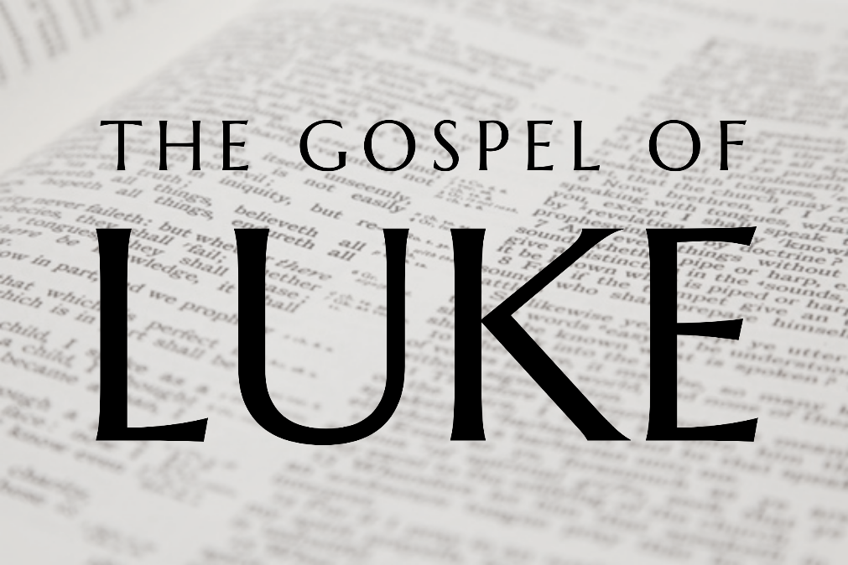

God tells us that Ezra read from the book of the Law,
day after day and that the people of God
were filled with joy

Produced by Ottawa RPC to help family worship,
These notes have been prepared by Rev. Dr Andrew Quigley

Doctrine for the Mind and Heart

Memory Verse of the Week

Psalm of the Week. (The words are on page 8.)

Pray for:
Mon -
Tues -
Wed -
Thur -
Fri -

Monday – Luke 1:57-66 – Joy at new life and his name is John.
v57,58 Every pregnancy is unique, and the birth of each child is a gift from God. That is why, when we hear the wonderful news of a pregnancy, we pray for God's mercy on both the mother and child. And why we, like Elizabeth’s family and neighbours rejoice when the child is born healthy and well. The command is appropriate therefore to "rejoice with those who rejoice, weep with those who weep." (Romans 12:15.)
v59-66 The requirement in Old Testament Law was that a male child should be circumcised on the eighth day of his life (Genesis 17:12 and Leviticus 12:3). It is important to note there is no such time constraint for the baptism of a covenant child in the New Testament.
The suggestion from the family and friends is that they call the boy after his father Zechariah, understandable, but Elizabeth is adamant in stating that he will be called John. It’s a response, that doesn’t go down well. So, they turn to Zechariah. It's funny isn't it that they make signs to Zechariah. We know that he wasn’t able to speak, but he could still hear. Its strange what people will do when they are excited. It is interesting that Luke includes this little piece of apparently irrelevant information, but it is this type of observation that gives authenticity to his account.
Zechariah is just as adamant as Elizabeth was. After all he had had nine months of muteness to think about it, time when he probably had engaged with God a lot in his heart. So, he takes the writing tablet and declares his belief in every Word that Gabriel had spoken to him by writing ‘His name is John’. For the first time in nine months Zechariah is enabled to speak and he praises God. Such trials in our lives truly are for our good, (James 1:2-4) and for the good of those around us, as is the case here.
v66 ‘The hand of the Lord was with him’. What a wonderful thing, something that parents and the church should pray for, for every child the Lord blesses us with.

Q1 How did the relatives and neighbours respond to the news of the birth of the child and what did they want to call him?
Q2 How did Elizabeth react? What does Zechariah do? How happens then?

Tuesday – Luke 1:68-80 – God's promises fulfilled.
V68-71 When he got his speech back, Zechariah prophesied. People talk today about 'inspired' songs, but the inspiration of the Holy Spirit ended with the completion of the canon of Scripture in the book of Revelation. So, the simple fact is there can be no Holy Spirit inspired songs beyond the Word of God.
As in the case of Mary, Zechariah's opening refrain of “Blessed be the Lord, the God of Israel” shows his awareness of the Psalms, e.g. Ps. 41:12, Ps. 72:18, Ps. 106:48, to cite just a few. At the heart of Zechariah's thanksgiving is the coming, or visiting, of God to the earth to redeem his people (v68) according to his foreordained plan (v70). Note his use of the past tense although he is addressing the future. Which tells us that it is seen as already having taken place; such is the certainty of God's promises.
Having a front-row seat in the fulfilment of the oldest promise in the Old Testament, the promise of a Saviour, must have been a phenomenal experience for Zechariah. For this promise, was what Old Testament believers lived on and yet Zechariah’s experience is nothing in comparison to ours. Unlike him we know far more about Christ's life, his death, resurrection, exaltation, and ascension and His work today as Prophet, Priest and King than he would ever have been able to glean, even from the extensive Old Testament prophesies about the Son of God. We know from Peter that the prophets who prophesied concerning salvation, searched the Scriptures and enquired carefully about it, and that even angels 'long to look' into these things, (1 Peter 1:10-12). There is a good reason, therefore, for saying that our praise and thanksgiving to God should far exceed that of Zechariah's. Our issue is our need to rest on, and embrace, the promises which God has given us. Maybe what we have been through in the past year will have helped us to do so in a new way.
v72-75. Central to the oath which God swore to Abraham is the salvation of his people. But it is not just deliverance from their enemies; it is about a new kingdom, the Kingdom of the Messiah, in which the people of God will serve him ‘without fear in holiness and righteousness all their days.' This is about us for we “are Abraham's offspring, heirs according to promise." (Galatian 3:29)
v76-80. Zechariah now turns to praise God for his son John who he states will be a prophet of the Most High. And his message will be to declare the ‘knowledge of salvation’. A message of repent and believe for the forgiveness of sins. The good news of God's grace and mercy, and God prepares John for his life's work, by taking him into the quiet of the wilderness where he will learn what it means to be alone with his Creator.
Q1. What lies at the heart of Zechariah's thanksgiving?
Q2 What does he say John will be called? What will John's task be?
Q3. Where does God take John?

Wednesday – Luke2:1-7 – The birth of the Son of God.
These verses are astonishing, for they tell of the birth of the Son of God. Every birth of a living child is a wonderful event. It brings into being a soul that will never die. But never in the history of the world had there been a birth like this one, for here God, is literally manifest in the flesh.
It had been prophesied that Jesus would be born in Bethlehem in Judea (Micah 5:2), but Joseph and Mary are living 90 miles away in Nazareth. Luke probably uses the word 'betrothed' because their marriage had not yet been consummated (Matthew 1:24,25). How is this going to be sorted? Simple, God leads Caesar Augustus, the first Roman emperor, to make a decree 'that all the world should be registered'. God effectively moves hundreds of thousands of people around the Roman empire, to fulfil 'one' prophesy. At the very time when the Jews thought that all was lost and they were coming under the dominion and taxation of a new global power, God was using that foreign power to lay the foundation of His new eternal kingdom. A kingdom, before which all the rulers of the world will one day bend the knee (Ephesians 1:19-22). So, Joseph being of the line of David, travelled with his young, heavily pregnant wife to Bethlehem, the city of David, to be registered and God kept His Word.
We need to take care not to jump to too many conclusions about what is happening in the world. There are two things going on in the world, that which we see, and that which God is doing. The closer we get to God, the more the first fades and the clearer the second one becomes. Let us rest in the promise that our 'times are in God's hand' (Psalm 31:15). That nothing can happen in the world that has not been eternally decreed by Him, "whatever the Lord pleases, he does in heaven and on earth, in the seas and all deeps." (Psalm 1356:6). So be careful not to become over-anxious about world events. God knows what he is doing and why he is doing it. "Therefore, do not be anxious about tomorrow, for tomorrow will be anxious for itself." (Matthew 6:34).
v7 - The birth itself was a normal natural birth. The fact that Mary wrapped the child in strips of cloth herself, begs the question - was she alone at the birth? The child being laid in a manger has often been taken to mean that the birth took place in a stable, but it may have been a home where a family and their animals dwelt under the same roof. Whatever the case, the circumstances of the birth speak of poverty and obscurity.
It is incredible that the Son of God "who, though he was in the form of God, did not count equality with God a thing to be grasped, but emptied himself, by taking the form of a servant, being born in the likeness of men. And being found in human form, he humbled himself by becoming obedient to the point of death, even death on a cross." (Philippians 2:6-8). And for what? So that we could be redeemed, made alive, and dwell with him in the glory for all eternity. "For you know the grace of our Lord Jesus Christ, that though he was rich, yet for your sake, he became poor, so that you by his poverty might become rich." (2 Corinthians 8:9)

Q1 Where did the prophesy in Micah say where Jesus would be born?
Q2 How did Joseph and Mary come to be in Nazareth?
Q3 What does this tell us about who is in control of everything in the world?

Thursday – Luke 2:8-14 – The Shepherds are the first to see Jesus.
v8,9. The birth of a prince is usually an occasion for fanfare and public rejoicing. But the announcement of the birth of the Prince of Peace was made quietly at midnight, without any fanfare. It was the local shepherds keeping watch over their flocks. These men tend to be portrayed as gentle, pastoral characters - they were anything but; in general, shepherds had a bad reputation. Their job made it difficult for them to keep the requirements of the ceremonial law, so they tended to be men who hadn't much interest in religion. One commentator writes that they had the "unfortunate habit of confusing 'mine' with 'thine' as they moved about the country. They were considered unreliable and were not allowed to give testimony in the law courts."
The appearance of an angel of the Lord frightened the life out of them. The angels speaks and his first two words, “Fear not”, are said to calm them down. Then he tells them that he has “Good news of great joy”! For over four thousand years, people had been waiting on the promise of a Saviour, first made in Genesis 3:15, to be fulfilled and now the day had come.
v10,11 The angel gives the shepherds a “sign” as to where this baby is. The unspoken directive is that the shepherds should go and find the baby, for they will be the first to attest to his birth. Incredible that this privilege would be given to a group of hardened, untrustworthy 'thieves'. This shows us the willingness of God to engage with those who are religiously uncouth and morally bankrupt.
v12-14. As soon as the angel finishes speaking to the shepherds, the heavenly host, an army of angels fill the night air with their words of praise to God. Note the order; it is glory to God and then peace on the earth through the child just born.

Q1 Who appeared in the night sky and what did they do?
Q2 What type of men were these and what does this tell us about God?

Friday – Luke 2:15-19 – Mary treasured these things in her heart.
v15-18 The hearts of these shepherds’ men are stirred. The usual lethargy of the night was no impediment to what they had just seen and heard. There is no doubt, no questioning, no hesitation; with “haste” they go in search of Mary and Joseph, and they search Bethlehem until they find them. There is urgency and marked determination resulting in their simple faith receiving a rich reward. For they have the incredible privilege of being the first to see the new-born Messiah with believing eyes, and they return to the fields, "glorifying and praising God for all they had heard and seen, as it had been told them."
We must ask God to give us such urgency and determination in to seek Jesus, and we will experience the same joy in our hearts.
v19 What a beautiful thing it is to read that Mary ‘treasured all these things in her heart’. The ability to treasure in one's heart the good things God does for us and gives to us is one the most blessed gifts we have from God. To be able to dwell upon and ponder his love for us in Christ Jesus. To mull over the blessings of his grace in our lives. This is the richness of life; not the possessions we may own, or the idols we sometimes fall into cherishing. They will all pass and amount to nothing, but it is our relationship with God in Christ that is eternal and worth treasuring.

Q1. What did the shepherds do?
Q2. What was Mary’s attitude towards God?

