FAMILY WORSHIP BOOKLET

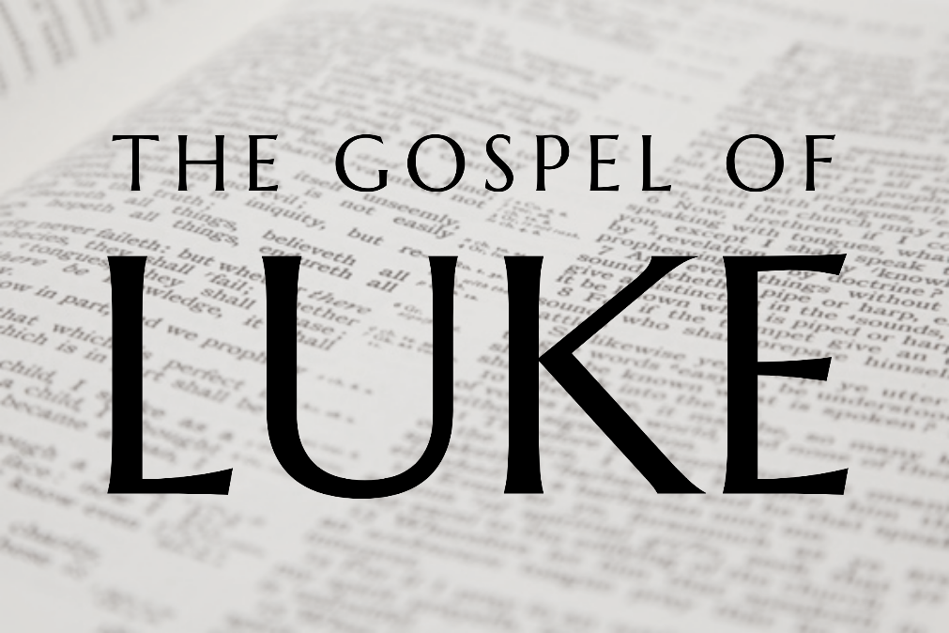

God tells us that Ezra read from the book of the Law,
day after day and that the people of God
were filled with joy!

Doctrine for the Mind and Heart

Memory Verse of the Week

Psalm of the Week. (The words are on page 8.)

Pray for:
Mon -
Tues -
Wed -
Thur -
Frid -

Produced by Ottawa RPC to help family worship,
These notes have been prepared by Rev. Dr Andrew Quigley

Monday – Luke 2:21-24 – The presentation of Jesus at the Temple

v21 – Circumcision on the eighth day, a sign of God's covenant blessing of grace upon his sinful people, was a requirement of God's Law. (Genesis 17:12). But why did the perfect Son of God have to be circumcised? Jesus was circumcised to show that he was "born under the law to redeem those who were under the law". (Galatians 4:4). Without it, he would not have fulfilled the Law's requirements as a Jew. He also needed to be circumcised to be accepted as a rabbi, teacher, in Israel. Without it, he would have been barred from teaching in lawful Jewish assemblies and from participating in Jewish ordinances. In essence he would been considered no better than an uncircumcised Gentile.
The name Jesus means "Saviour," is the same word as "Joshua" in the Old Testament and declares the remarkable reason for Jesus’ coming to earth.
v22-24 Two ceremonies are involved here; there is the presentation of the child, and the purification of the mother.
The presentation of the first-born male child was required for that child was called “holy to the Lord”. The quotation is a summation of the sense of several Old Testament passages, Exodus 1:2,12,15 and Numbers 18:15. It was usual that five shekels were paid to redeem the firstborn. (Numbers 18:15ff). Although not in our reading today, Luke does tell us in v27 that Jesus’ parents brought him to the temple "to do for him according to the custom of the Law." Which shows that they would have fulfilled this financial obligation.
The Levitical Law stated that after the birth of a son, a woman would be unclean for seven days leading up to the circumcision and that she should then keep away from holy things for thirty days after that. (Leviticus 12:1-5, for a daughter the time was doubled.) Thereafter, she would bring a lamb, and a dove or a pigeon as an offering to the Lord. If she could not bring a lamb, i.e., she couldn't afford one, she could bring a second dove or pigeon. (Leviticus 12:6-13). It is an indication of just how poor the home was that Jesus was born into that Mary could only do the latter. Poverty was something that marked the entirety of his life. As he would say of his adult life, "foxes have holes, and birds of the air have nests, but the Son of Man has nowhere to lay his head." (Luke 9:59). Something we should consider in our affluent society.
Q1. What sign did Jesus receive on the eighth day of his life? Why?
Q2. What name was the child given and who choose the name? What does the name Jesus mean?

Tuesday – Luke 2:25-35 – Simeon meets Jesus.
v 25-27, This is the first and only time Simeon is mentioned in the Bible. While we're not given his age, verses 26 and 29 seem to indicate that he was an older man. He is described as 'righteous' which speaks to his moral character and as 'devout' which indicates the seriousness of application to his faith. The fact that Simeon responds to the leading of the Holy Spirit to go to the Temple shows his sensitivity to the work of God in his life. This wasn’t common since religion in Israel was at a very low ebb when Christ was born. The focus on outward ‘doing’ in the teachings of the Pharisees and Sadducees rather than having an inward relationship with God had influenced many. Something we need to be careful to guard against in our own lives.
v28,29, When Jesus’ parents bring him into the temple Simeon takes the baby in his arms and blesses him. Then he speaks of the peace he has when contemplating his death. It is the unique blessing of the Christian, to be able to look at their death and not be fearful. The Apostle Paul spoke of his longing to be absent from the body and present with the Lord. (2 Corinthians 5:8). We do not greet the last enemy, death (1 Corinthians 15:26), with open joy-filled arms, but we do not fear it either, for it is the means by which our souls will be made perfect in Christ and immediately we will be with him. It is the experience of the godless to grieve without hope. (Philippians 1:23, I Thessalonians 4:13).
v30-32, Simeon speaks of the salvation that Jesus will bring. It will not only to be for his own people the Jews, but also for the Gentiles. This shows that there were Old Testament saints who did study the Scriptures and discerned to some degree the nature of the Messiah’s work.
v33-35, We read that Joseph and Mary marvelled at what Simeon said. It is good to stop on occasions and marvel at what God says. What Simeon says to Mary, it could either be referring to the salvation of men who by God's grace fall on their pride, confess their sin, believe in Jesus, and are raised to new life. Or it could be speaking of the division that Jesus would bring between those who would reject him and experience eternal separation from God, and those who would receive him and be raised in eternal salvation. Both of these are doctrinally correct. What is clear is that Jesus would be opposed throughout his life. Men who disagreed on everything, would unite in their hatred of him. He would be a man despised, rejected and hated by men, (John 15:18ff)
Note how the Lord’s death would affect his mother, ‘and a sword will pierce through your own soul also’. A hard thing for mother to hear when your child is only a few days old.
Simeon's final words speak to the fact that the thoughts of all about the Lord will one day be revealed in His presence. A challenge to all of us.

Q1. What is the name of the man we are introduced to here and how is he described?
Q2. Who leads Simeon into the temple and what does he reveal to Simeon?
Q3. How do Joseph and Mary respond to what they have Simeon says?

Wednesday – Luke 2:36-40 – Anna meets Jesus
v36 Just like Simeon, whom we met yesterday, Anna appears only once in the Bile and it’s here in the Gospel of Luke. It is interesting that the two witnesses to the fact that the Messiah has been born, are a man and a woman. God views men and women equally, even though He has appointed them to different roles in the home and the church.
Anna was evidently a woman of beautiful character. Her husband had died when she was a young woman; they had only been married for seven years. It's hard to say from the text whether Anna was eighty-four years old, or if she had been a widow for eighty-four years; if that is the case, then she would have been well over 100 years old at this point.
v37 Whilst being in the temple would have been a place to meet other people, there is no doubt, from her continual fasting and prayer, that Anna was there to meet God. This woman's heart desired to be with God. For her, the words of Psalm 84:2, "My soul longs, yes, faints for the courts of the Lord!" were a testimony of what was precious to her. Anna fits well the description of a godly widow depicted by the Paul, "She is truly a widow, left all alone, has set her hope on God and continues in supplication and prayers night and day." (1 Timothy 5:5). An example to all who profess to be lovers of God.
v38 How many observed this young married couple bring their infant child to the Temple on that day and thought nothing of it? After all, the performing of what was required by the Law would have happened many times a day. Anna though, like Simeon, is given an insight into who this baby is and elated, expresses her thanksgiving to God and then goes out and tells others who shared the same anticipating faith as herself.
This is the type of reward that comes from close communion with God. We are given insights into things that other people will look at and see nothing special in. What an encouragement to be constant in our communion with God. As we do so, one of the beautiful consequences is the maturing of our conversations with brothers and sisters in Christ about the Lord Jesus, his person, his work, his second coming, the judgement and eternal life.
v39,40. Obedience to God’s Law began from the start with Joseph and Mary. Parents, who begin well, generally see the work of God in their children’s lives. Putting off the active nurture and admonition of one’s children in the things of God until they are a little older seldom bears good fruit.
So, Joseph and Mary return to Nazareth where Jesus will spend the next thirty years of his life. While we don’t know much about these years they nonetheless happened. And this is something we should share more often with our children and young people, to encourage them that they have a Saviour who actually experienced what they are going through, and can relate to them as they pray to him. Finally, let us be constant and earnest in our praying for our children and young people, that the favour of the Lord would be upon them.
Q1. Who do we meet in this passage and what are we told about her?
Q2. What was Anna doing every day at the Temple?
Q3. How does she respond to meeting the baby Jesus?

Thursday – Luke 2:41-52 – Jesus at the Temple when he is 12.
We know nothing of Jesus' boyhood apart from this one incident, which only Luke tells us about.
V41. Male Jews were required to observe the three Feasts; Passover, Pentecost and Tabernacles, (Exodus 23:14-17) that were held annually at the Temple. Many men, because of the distance involved would make the journey once a year to Jerusalem to observe one of the Feasts. Joseph, joined by Mary, made the trip to observe the Passover, the feast that commemorated the deliverance of the nation from slavery in Egypt. It was about a 150 km journey and would have involved being away from home for at least two weeks, which would have been a notable cost to a relatively poor family. But God had given Israel a command, he had appointed an ordinance for their spiritual good, and Joseph and Mary observed it together as a family.
V42. Jesus is twelve when he goes with his parents. When a Jewish boy was thirteen, he would become a 'son of the law,' a full member of the synagogue according to rabbinic literature, i.e., not Biblical law.
V43. When the Feast is over, Joseph and Mary set off for home but Jesus isn’t with them. Parents will relate to the situation well. With friends and family, the children are playing together and everyone is enjoying each other's company. Time passes, the day goes quickly and then it is 'where is ….?' Not being able to find Jesus, Joseph and Mary conclude that there is only one place he can be - back in Jerusalem, so they return to the city. All the time, their minds would have been churning with; 'how could this have happened?', 'why did I/you/we not check?', 'how is he going to cope by himself?', 'are we going to find him?' Remember, Jerusalem would have been teaming with people from all over the Roman world attending the festival. V46,47. It takes them three days to find Jesus in the Temple sitting among the teachers of the Law, listening and asking questions. We need to be praying that our children, as they are taught, will learn and process for themselves what they are being taught about God and the way of salvation.
V48. Joseph's and Mary's reaction shows that they were ordinary parents. Jesus’ response shows that he was no ordinary child, even at 12, had a sense of the special relationship he had with God the Father and a clear understanding of the importance of service to God. This was something that his parents couldn't initially grasp, but they would come to understand it over time.
V51. The statement 'he went down with them to Nazareth and was submissive to them' seems so simple and yet it is very powerful. Remember this is the pre-incarnate Son of God, yet he was obedient to his parents even though he knew and understood more than they did about God and his truth; why? Because he was obedient to his Father in heaven. And, again we find, as she did on the night he was born, Mary treasuring these things in her heart.
What a wonderful statement Luke makes in v52 when he says that Jesus increased in wisdom and in stature and in favour with God and man.
Q1. What age was Jesus when he went to the temple? What did he do? How long did it take His parents to find? Where did they find him? What was he doing?
Q2. How did his parents react? What does Jesus say?

Friday – Luke 3:1-6 – John the Baptist called and commissioned by God.
V1. Luke begins with a specific date. Why? Because it marks the beginning of the recommencement of prophecy. God had been silent for 400 years; now, he speaks again through John the Baptist. Luke dates the period by naming the current world and regional leaders. Tiberius Caesar was the Roman Emperor; Pontius Pilate was the Roman governor of the region, i.e., Judea. Herod was Herod Antipas, son of Herod the Great, who became tetrarch of Galilee and Perea (ruler of one of three provinces in the area) on the death of his father in 4BC and held office until 39AD. We are going to come across these men later in Jesus' life. The other rulers mentioned are Herod's brother Philip who ruled in one of the provinces, and Lysanias; information about him isn't clear. Luke cites these men for historical accuracy because it dates when John the Baptist and Jesus lived.
The one thing that characterised each of these men is their godlessness. So, John didn't begin his ministry in a wholesome, welcoming environment, which is an encouragement to us.
Luke also adds references to Annas, the Jewish high priest AD 6-15, and Caiaphas, Annas' son-in-law, high priest AD 18-36. Again, these are two men who will play a key role in Jesus' life.
V2. God calls and commissions John from God. Every man who would hold office in the church must receive such a call and commission from God that is why Jesus encourages His Bride, the Church to "pray earnestly to the Lord of the harvest to send out laborers into his harvest." (Matthew 9:38.)

V3-6. Unlike Matthew and Mark, Luke tells us nothing about John's appearance nor what he ate; but he does say where John will undertake his ministry, namely in and around the Jordan Valley, and then he goes straight to his message. John preached the necessity of repentance and baptism for the forgiveness of sins. It was a message that pointed to the inability of outward observance of the Law to provide salvation, and so revealed the need for a Saviour. One who would make atonement for the breaking of the Law and provide the basis for forgiveness.
It is interesting that while all four Gospels quote the words of Isaiah's prophesy about John in Isaiah 40:3, only Luke includes Isaiah 40:4,5. Amazingly, this prophecy was written about 780 years before, and now it is going to unfold exactly as written. It is another proof that God keeps his Word without fail.
Q1. How did John come to be in the job he did?
Q2. What was his message? What does it mean?
Q3. How did Isaiah characterize John? How did Isaiah describe the result of John's work?

