FAMILY WORSHIP BOOKLET

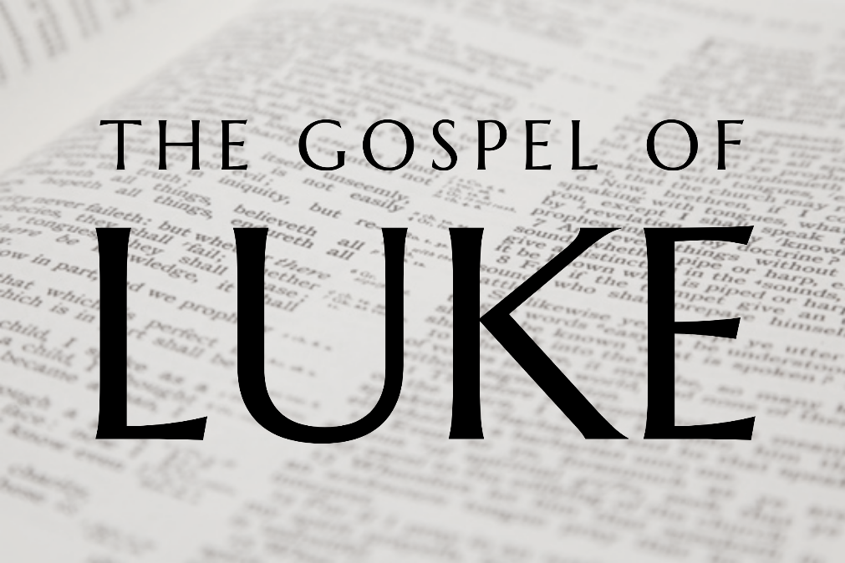

God tells us that Ezra read from the book of the Law,
day after day and that the people of God
were filled with joy!

Doctrine for the Mind and Heart

Memory Verse of the Week

Psalm of the Week. (The words are on page 8.)

Pray for:
Mon -
Tues -
Wed -
Thurs -
Fri -

Produced by Ottawa RPC to help family worship,
These notes have been prepared by Rev. Dr Andrew Quigley

Monday – Luke 4:1-8 - The Second Temptation
There are a few differences between the account Luke gives and the one we have from Matthew. One example, the second temptation in Luke, is cited as the third temptation in Matthew's account. These differences do not speak to inconsistency but authenticity. No two people giving their perspective of the same situation will ever express it in exactly the same way.
V5-7. Satan shows and offers to Jesus the ‘right’ to all the kingdoms of the world if Jesus will worship him. The question is - was Satan in a position to offer Jesus the kingdoms of the world or not? It’s not an easy one to answer. If he couldn't stand by his offer in some way, then surely such a colossal lie, even for the father of lies, would have been easily called out by Jesus? Could Satan have so misread Jesus' vulnerable mental state, due to his forty days without food, to have thought that he could tempt Jesus with an offer of something so ludicrously untrue? Then there is the fact that the apostle John says in his gospel that Satan was, in some sense, ruler of the world; speaking of the day of judgement (John 12:31, John 14:30, 16:11, Ephesians 2:2, Revelation 12:9).
Given that, I think Satan was offering some form of a role to Jesus as a ruler of the kingdoms of the earth. It was a mimicking of what he believed the Father had already promised Jesus. Of course, what was on offer was nothing like what was awaiting Jesus at the reward for his obedience. Satan was offering the vision of an empire, albeit one far greater than the then-current empire of Rome, but nonetheless an empire composed solely of earthly kingdoms. God was guaranteeing an anointing for his Son as Mediator King over all creation. And one that was eternal in the new heavens and earth.
How could Satan have rationalised that his offer would appeal in the slightest to Jesus? Because it came with the sales tag of ‘no suffering required’. No taking the penalty due to the elect for their sin. No Cross. No death. What was being proposed was one simple, painless act – 'just bow down and worship me, and you can have all this in a heartbeat'. Satan constantly offers us the same deal.
V8. Jesus responds by quoting from the Old Testament book of Deuteronomy, chapter 6. His point? God gave the land of Canaan to his people on the understanding that, as they lived in it, they would keep his commands. The important thing was not their ownership of the land, but their relationship with God. Satan was offering ownership of a vast empire (albeit wholly insignificant by comparison), but one without God. Jesus' point is that the kingdoms on offer, without the presence of the Father, are worthless.
Life is all about knowing the worth of things. The key is to realise that that does not depend on the value men place on it, but rather on how much God's presence indwells it. Mark 8:36, Luke 9:23.

Q1. What does Satan show and offer Jesus? What does he say Jesus has to do to get what he is offering?
Q2. How does Jesus respond? What does this teach us about life?

Tuesday - Luke 4:1-12 - The Third Temptation.
In the first temptation, it was 'since you are the Son of God save yourself because God is letting you die here'. In the second temptation, it was 'take the easy path; you can get what you want without the pain'. It truly was a case of turning the saying 'no pain no gain' on its head.
V9-11. Today's temptation confronts us again with the issue of whether or not there was a vision involved or a literal transportation of Jesus. John Calvin writes, "The matter is uncertain, and there is no harm in admitting ignorance. Hence I prefer to leave it with judgement suspended rather than give a loophole for contentious disputation." I'll happily stand with Calvin on this one.
Satan now shifts his line of approach slightly. He says to Jesus, 'here is the perfect opportunity for you to show me you are a man of faith, and for God to show us both that he can be trusted. When it's done, you can walk away knowing that your Father really does love you. What better way to begin your ministry than to be confirmed by the love of God? And what better place to do it than at the epicentre of the Jewish world, the holy temple in the holy city.' It sounds plausible enough; what possible harm could there be in it?
Satan uses Psalm 91:11 to 'support' his suggestion, which shows that he knows the Bible and is willing to come at us masquerading as an angel of light. But note his use of the verse is partial and incorrectly applied. This verse doesn’t speak of an open-ended test/challenge but rather a conditional promise, i.e., conditional on obedience being rendered. Many godly people have taken decisions, which have led to serious life long consequences based on an incorrect or inappropriate use of God's Word. A misquote is not a quote.
V12. Once again, Jesus takes Satan to God's Word - Deuteronomy 6:16, and via that to Exodus 17. To where God’s people had grumbled and tested the Lord by saying, “Is the Lord among us or not?" Exodus 17:7, because they had no water. Astonishing, given their deliverance from recent Egypt through the Red Sea. Jesus' point is clear; ‘I don't need to test the already proven love of God.’ Jesus knew that his Father loved him. He had just come from his baptism, and the words "This is my beloved Son" were still ringing in his ears. He wasn't going to take those words and say, 'yes, Father, I hear what you have said, but now I need you to show me that you mean it'.
The life of faith in God is simple; it is founded on trust, Hebrews 11:1. Faith does not become faith when it has tested God, and proven its worth. Faith is faith because it trusts what God has said. Yes, we are to ask God for help in our lives, in

fact, we are commanded to do so (Matthew 7:7), but that is very different from asking God to do something to prove His love for us. That is testing God. When Satan comes to you, and says you need to give God the opportunity to show his love for you, take him to I John 4:9.

Q1. Where does Satan take Jesus to and why? What is Satan saying to Jesus?
Q2. How does Jesus respond?
Q3. When Satan asks us to test God, how should we respond?

Wednesday - Luke 4:1-13; Matthew 4:10,11 - Be Gone Satan and Angels Come.
Luke does not tell us that Jesus commands Satan to leave, we get that from Matthew 4:10. Though ravaged with hunger and exhausted, Jesus musters enough strength to tell Satan, through chapped lips and with a dry, parched tongue, to leave. Satan has to do what he is told. He has no option. He is not in control. He can only do what he is permitted to do. Nothing more, no matter how much he wants to. And so, he leaves until “an opportune time”, that is, until he is given leave to once again take up this battle that he is doomed to lose.
It is important for us to understand that. Sometimes Christians can use the devil’s name to explain what they have done in their lives, in order to garner a degree of sympathy. There are occasions, though, when the ‘roaring lion’ can unleash his desire to ravage one who has become isolated from the community, and it is important to both understand and remember that he can only do so within the limits that God permits, Luke 22:31. He is not all powerful, he is a created being and cannot be everywhere all the time. And whilst his ways and wiles are real, he exists and operates with the modicum of freedom that he does, only because God permits him to do so, until the day of Judgement.
The Angels Came. Matthew 4:11 - Again, Luke doesn't tell us, but Matthew does, that "behold the angels came and were ministering to him". Matthew 4:11. This is an important event and one worth considering.
Here is our Saviour, the Son of God, and he has faced everything that Satan has thrown at him in an attempt to get him to deny his Father, to test his Father, and to take the painless route avoiding the cross. He has withstood it all, but why? For whose benefit? Yours and mine. We are the recipients of the reality of eternal salvation that would be purchased through the Lord’s death, three years after this encounter in the wilderness.
And now having wielded nothing more than the Word of God, his body and mind are on the verge of every possible breakdown known to man; physical, mental, and emotional. What happens next is both amazing and beautiful. God
the Father sends angels to minister to his Son. What these angels must have been
thinking when they are being sent to Jesus. And when they come to him and see him in the distressed state, he would undoubtedly know how their hearts must have gone out to him. Lovingly cared for him. They ‘ministered to him’ essentially, they nursed his mind and body back to strength, so that he could go again into the battle for our eternal salvation.
How does that make you feel about the Lord and his fight for you in the wilderness?

Q1. What does Jesus tell the devil to do? How does the devil respond?
Q2. Who is sent to help Jesus? Why is this necessary? What do they do for him?
Q3. What do you think about this?

Thursday - Luke 4:14-22 - The Ministry of Jesus in Galilee.
V14. People could clearly see the power of God the Holy Spirit in Jesus. It is the Holy Spirit, who alone can bring new life to the unconverted and teach believers how to live for God’s glory. We must pray for His power in our lives, that a report might go out into this community about what God is doing among us.
v16. Jesus’ ministry starts in the Synagogue in Nazareth. It would have been his weekly practice to go to there for the public worship of God on the Sabbath. He stands to read the parchment of Isaiah which shows both his and his hearers respect for the breathed-out words of the living God. But note, he doesn’t just read any passage - he knows the specific passage he wants to read from. There was an intentionality about everything Jesus would do in his ministry, including his use of the means of grace. We live in an age when so-called spontaneity is considered an absolute necessity for worship to be appealing and attractive to people. We are told that it shows evidence of the Spirit's leading. Nonsense, I am not saying that the Holy Spirit is not essential in worship. He is. We are told to pray for the illuminating work of the Holy Spirit that we will understand God’s Word as it is read and preached. (1 Corinthians 2:14.) But Jesus was filled with the power of the Spirit, Luke 4:14, 18, and the evidence of that is seen in his thoughtful, prepared, disciplined, focused and orderly approach. That Jesus reads from two passages is further proof, if any were needed, of both his knowledge and understanding of God's Word and the predetermined nature of his approach.
Both passages speak of Jesus, for he is the Messiah. He is the one who has been sent to proclaim ‘good news’, to proclaim ‘liberty’, to bring healing and liberty to those who desperately need it; the poor, the captives, the blind, and the oppressed. Which begs the question - who are these people? They are men and women like we were, dead in their trespasses and sins. Those who are the poor in spirit, who are blind to the truth, captives to sin, and oppressed by sin and Satan. Jesus is the one who has come to proclaim the good news of new life and liberty in and through himself.
V19. Note, the reference to the year of the Lord's favour does not mean a calendar year; but the year of salvation that has now dawned with the commencement of Jesus’ earthly ministry.
V20. Jesus then sits down. Why? Because he was tired or just didn’t want to stand any longer? No, it was because sitting down was the formal posture for a teacher in eastern culture. In sitting down, Jesus was saying; I am now going to expound/explain this passage to you. That is why Luke tells us that all are fixed on him. They are looking to hear what Joseph’s and Mary's son is going to say.

Q1. How does Jesus begin his public ministry?
Q2. Which book or scroll, as the case was, did Jesus read from?
Q3. What does the passage say the Messiah would do? To whom would this message of good news be intended for?
Q4. What does Jesus do after he has finished reading?

Friday - Luke 4:14-22 – It’s About Faith.
V21. Jesus tells those listening in the synagogue that 'Today, this Scripture has been fulfilled in your hearing’. Is this significant? Yes, it's important because Jesus' contemporaries would not have doubted that God's kingdom would come someday, but Jesus is saying 'Today' it has come. God is acting now; the future is here. We must crave the acting of God in our lives, in the lives of our children, in the lives of our brothers and sisters in the church – now, not in the future.
How is this Scripture fulfilled, or where has it been fulfilled? It is in the hearing of God's Word that it is fulfilled. As Paul would later write to the church at Rome, "So faith comes from hearing, and hearing through the word of Christ." Romans 10:17. That is why it is so vital that we take every opportunity presented to us to be in public worship. There is something that happens when the Word of God is publicly read and preached that cannot be replicated anywhere else. Our private and family worship is critical to our lives, for it brings us in to dwell in the Word of God, and it is through this daily communion with God that we are enabled to abide in the person of Christ. The fact remains though, God the Holy Spirit is at work in a peculiar way during the public means of grace on the Lord's day, morning and evening. And it is for that reason that we need to be exposed to the in-person hearing of Christ's voice and the power of the Holy Spirit in that unique way. (That is said in the understanding that exceptional circumstances may prevent some from being able to do so.)
V22. The response of those who have seen Jesus stand up and read is interesting, for they cannot deny what Jesus has just read and said, so clearly and powerfully.
In fact, they are astonished by it. But then what happens? They say, 'it's not possible'. This is Joseph's boy; he can't be the Messiah. Doubt governed by 'sight' drives out the potential for life generated by 'faith'. They may have been astonished by what they had heard, but their hearts were not open to pondering it. They didn't have the attitude Mary had at Jesus' birth, Luke 2:29, and at the subsequent temple encounter, Luke 2:51.
We need to take care not to be astonished by what we hear from God's Word and then respond with 'sight-governed’ doubt. We need to ask God to give us believing hearts, hearts governed by the principle of faith.

Q1. Why is the word ‘Today’ significant?
Q2. How do we grow in our faith?
Q3. How do his neighbours, those who had watched him grow up, respond?

