FAMILY WORSHIP BOOKLET

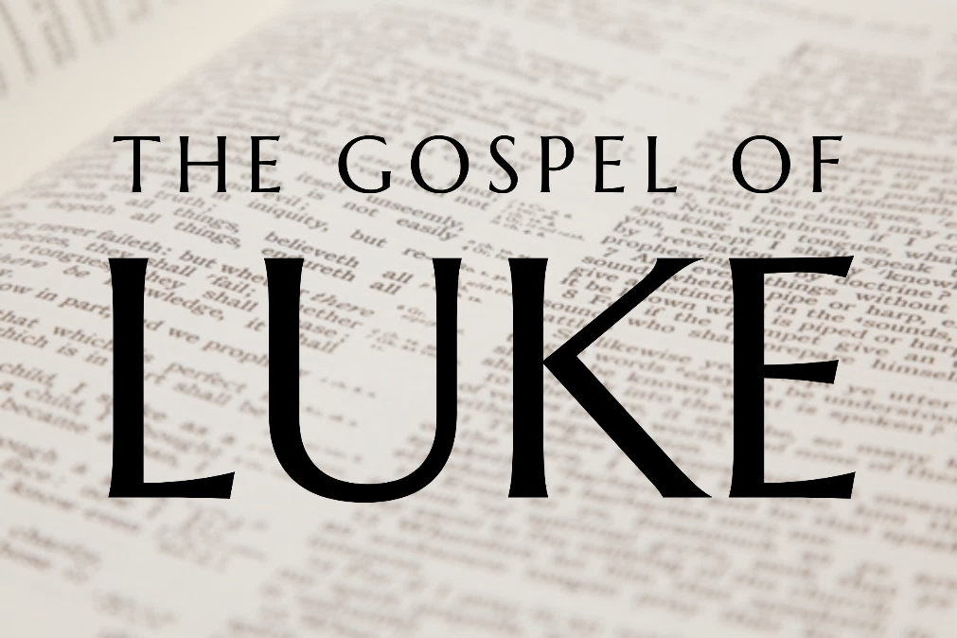

God tells us that Ezra read from the book of the Law,
day after day, and that the people of God
were filled with joy!

Doctrine for the Mind and Heart

Memory Verse of the Week

Psalm of the Week

Please pray for:

Produced by Ottawa RPC to help family worship.
These notes have been prepared by
Rev. Dr. Andrew Quigley.
Monday – Luke 10:38-42 – What is the more important thing?

We considered last week how Jesus reached out to speak to Martha’s heart; but it is also important to understand that, even though Jesus’ words are marked by tender gentleness, they still contain a reproof. Yes, what Martha desires to do is a good thing, but she needs to take care not to become so distracted and caught up in what she thinks needs to be done, that she doesn't see and hear God's Word. There is “one thing” that is truly necessary, and Mary has found it. That is why Jesus draws Martha's distracted attention to what Mary is doing, as she sits listening to him speak. It is not that food preparation and serving are not necessary; of course, they are. But this “one thing” of listening to him should take precedence. Martha was concerned about food for the physical body; Mary was looking for food for the soul. It's not that the former is not important; it's that the latter must have prominence in our lives. So, Jesus tells Martha that he is not going to do as she asks. Mary will not be deprived of what she has chosen. It will not be taken from her by sending her to do what Martha wants. Jesus' intention is not to deprive Martha of the help she needs, but rather to help Martha see the pressing need of the hour – time at his feet, listening to his words.

I wonder what Martha did. Did she continue to scurry around trying to get things ready regardless? We are not told, but if I were to hazard a guess, I think she probably sat down beside her sister and listened to Jesus.

There are many necessary things we must do. There are demands upon our lives every day that that are important, but it is the prioritizing of the things that are important that is critical. As you prioritize your day, continue to put yourself at the Lord's feet and listen to the words He speaks to you through His Word.

Q1. What was Jesus’ point to Martha about what Mary was doing?
Q2. What can you learn from this?

Tuesday – Luke 11:1-4 – Jesus is praying again!
As we have seen, Luke doesn't always tell us when and where things happened. He is more focused on what took place, than on some of the details. Sometimes it is good to focus on what is most important and not get bogged down in details. The account begins with Jesus praying. This is the fourth time he has done so – Luke 3:21; 6:12; 9:18, 28. While the disciples must have been nearby, I think it is fair to assume, based on his previous practice, that Jesus was alone when he was praying. The fact that Jesus felt the need to be in prayer is challenging. Surely, if ever there was anyone who could have gone through life without praying, it would have been Jesus. But no, he needed communion with the Father to be able to live life, and he did whatever it took to have that communion.
I think our problem is that we don't see the need - our need of being in communion with God. What do you think lies at the root of much prayerlessness? Is it the act of seeing, understanding, and appreciating our real needs in life?
Although separate from the disciples, Jesus was still within earshot. And when he had finished praying, he is approached by one of the disciples who, having been stirred by what he has just heard, asks, "Lord, teach us to pray". This request that has been the subject of much. The question that is raised relates to the relationship between what Luke writes here and what is recorded in Matthew 6:9-13. Is Luke referring to the same incident but citing it later in Jesus’ ministry? In other words, is Luke lifting Jesus’ teaching from the Sermon on the Mount, which took place early in his ministry, and putting it in here in the last year of Jesus' ministry? Or is Luke recording another occasion when Jesus taught the same thing? I think it is the latter. Every minister has an emphasis in his ministry that will result in him teaching the same things over and again. It is just the way it is, even if a man faithfully preaches his way through the Word of God and is constantly seeking to stay fresh in his relationship with Christ as he does so, his preaching over the years will be characterised by dominant themes. It underscores the fact that the Word of God comes through the personality of the man Christ has chosen to be his under-shepherd in a particular location, at a given time, and for a specific reason. It is how Christ, the Head of the Church, develops different parts of his Bride to undertake his work in the world.

Q1. What was Jesus doing?
Q2. Why do we find it so difficult to be consistent in prayer?
Wednesday – Luke 11:1-4 – Lord teach us to pray.

What lay behind the request – “Lord, teach us to pray”? Was it a request to be taught how to pray regularly? I don't think so because the Jews were well versed in the habit of praying. We see that especially from the activity of the Pharisees. Jesus is being asked here 'what should we pray for?' This disciple, possibly not one of the twelve, maybe one of the seventy-two, having heard Jesus pray, was probably left feeling that his praying didn't come anywhere near what he had just overheard.

Jesus understands that it is a genuine request. It is not a test. It is a request devoid of any trap, and Jesus responds accordingly. The first word he utters takes us directly to what prayer is – communion with God, our Father. It is astonishing that we can speak the word 'Father' with respect to God. It is only possible because of His grace and adopting love. The use of the word 'Father' means that only those truly in Christ can pray. If there is no God-given new life, if there is no relationship through Christ with the Father, then the only prayer that can be prayed that will be heard is: 'God, be merciful to me a sinner'. While the prayer of the godly will avail much (James 5:16), the praying of the unbeliever avails nothing unless it is the plea for God's mercy and grace in salvation.

Hallowed be your name.
To hallow or to sanctify means to set apart from everything that is marked by sin. It means to prize highly, to honour, to have reverence for, to adore, and much more. The hallowing of God's name doesn't mean that we make it holy or add to its holiness; rather, we recognize the greatness of God in His absolute holiness. God's name is more than just His name; it speaks of His entire majestic being and all His glorious attributes. It is this gulf between God and us that we must be ever mindful of, as we approach our Father in heaven in prayer. A fact which merely makes the reality of prayer all the more astonishing.

Q1. What did the disciple ask Jesus and why?
Q2. Can anyone pray to God and speak to him as their Father in heaven?
Q3. What is the only prayer that an unconverted person can pray that God will hear?
Q4. What does it mean to ‘Hallow’ God’s name?
Thursday – Luke 11:1-4 – Your Kingdom Come.

Your Kingdom come. The Kingdom of God is the reign and rule of the Mediator King, through the gospel of grace in the world. It is both a present, and yet to be fulfilled, reality. Jesus preached that the Kingdom of God is at hand. He had sent the twelve and the seventy-two out to preach that the Kingdom of God is at hand. So, where Christ is, that is where his Kingdom and his rule is. In praying for God’s Kingdom to come, we are asking that the work of Jesus, the Mediator King, be seen every day in the world until he returns, and the fullness of his work is revealed in its entirety.
Give us our daily bread. Our lives are consumed with the constant demand of meeting our physical and material needs. We work hard to provide for ourselves and others, and that is a good thing. We are not to be lazy when it comes to these things. But we must take care that, in all our labouring, we do not forget that it is the Lord who gives, and it is the Lord who takes away. A grasp of that simple fact will both enable us to seek the Lord regarding our needs and maintain balance in our pursuance after material things. It will also enable us to experience satisfaction with what God has given us, and rest content, free of the endless frenetic cravings of the world for more.
Forgive us our sins, for we ourselves forgive everyone who is indebted to us. In this petition, there is the request to 'send away as far as the east is from the west' our debts, not financial for they cease when we die, but spiritual. There is only one way this 'sending away' can happen, and what a way it is – through the death of God's only begotten Son on the cross at Calvary. Only Christ's finished work can make atonement for sin, but it can and will do so. Those, who, by God's grace, repent of their sin and believe in Christ, with the gift of faith granted to them, know their sins to be forgiven. Having experienced this forgiveness for our sins, from the merciful hand of a Holy God, we have no option but, by God's grace, to forgive those who, by their words and actions, sin against us. It is inconceivable not to do so. But we must ask God for His help to enable us to do so. This wonderful privilege of treating others as God has dealt with us is something we must give ourselves to.

Q1. When we pray, ‘thy Kingdom come’, what are we praying for?
Q2. What does praying for our daily bread do for us?
Q3. What must we do if we are going to forgive others?
Friday – Luke 11:1-4 – And lead us not into temptation.

And lead us not into temptation.
From past sins, Jesus moves to teach his disciples and us how to pray about the possibility of future sin. James 1:13 makes it clear that God cannot tempt us to sin. From James 1:2-4 and 1 Peter 4:12,13, we see that temptation is inevitable in your life and in mine. In 1 Corinthians 10:13, God tells us how He will answer this request. It is a request that faces the reality of temptation and accepts God's provision to guard us from sin. It is a request that faces down presumptive thinking and pride. It stands on the arrogance of the heart, grasps the seriousness and badness of sin, and seeks God's providential protection.

Luke 11:5-13 – Persevere in prayer.
Whether this next passage is a parable, or an illustration, has been the subject of much discussion; I take the view that it's a story that illustrates Jesus' point of perseverance in prayer.

V5. A man comes to a home. He has been travelling, is hungry and tired. The homeowner doesn't have any food to give him, it's midnight, and no shops are open. So, the host goes to a neighbour's home, a person he knows, and asks for three loaves. But the people in the household he has gone to are all in bed. The man asking for the bread sees this, but, undaunted, he keeps knocking on the front door to get what he needs. His neighbour hears the knockings, gets up, but doesn't open the door. Instead, he shouts through the door, saying that he can't do anything for him. But the man needing the bread isn't going to take no for an answer, so he just keeps on knocking, until eventually, the man inside the house gives him want he wants.
The lesson is simple – don't give up when asking God for His work in your life or the life of another; He will respond.

Q1. What are we asking for when we pray ‘Lead us not into temptation’?
Q2. What does the man who comes to his neighbour seeking bread do?
Q3. What lesson is to be learned about praying from this man?

