FAMILY WORSHIP BOOKLET

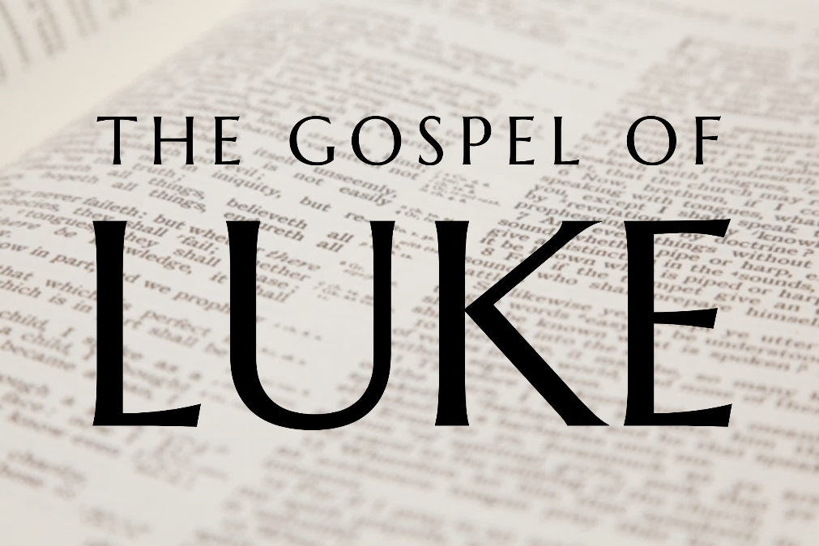

God tells us that Ezra read from the book of the Law,
day after day, and that the people of God
were filled with joy!

Doctrine for the Mind and Heart

Memory Verse of the Week

Psalm of the Week

Please pray for:

Produced by Ottawa RPC to help family worship.
These notes have been prepared by
Rev. Dr. Andrew Quigley.

Monday – Luke 12:1-3 – The leaven of sin.
Unlike other chapters, where Luke frequently moves from one event to another, the contents of this chapter happen at the same time. To quote one commentator, “The whole chapter is a consecutive whole.”
How many people were gathered around Jesus? I ask the question because we don’t always pay attention to what is actually being said. The Greek uses the term, ‘myriads of the multitude’. So, we are talking about a huge number of people. In fact, it is so huge that people are in danger of being trampled upon because of the confined space of the streets.
Jesus speaks with his disciples who, as always, are in close proximity. His words are words of warning – “Beware”. There are things in life that we do need to ‘beware of’. Things that pose a real and serious threat to us and to those whom we love. Top of the list, by a long way, is ‘Sin’, because, by far, it poses the greatest threat to us. Sin is real and sin is bad. Failing to grasp just how bad is sin, is not only unwise, but also incredibly dangerous.
In this instance, Jesus tells the disciples to beware of the ‘leaven’ of the Pharisees. What does that mean? Well, bread makers will know that to get the dough to rise, you need to add a little yeast or ‘leaven’, and the important word is ‘little.’ You only need a little yeast to make the dough rise up and change from a flat bread into a loaf. It is the same with sin; you only need a little sin to affect the whole of one’s life. That’s why sin cannot be played with. It offers pleasure, thrill, escapism, on the false premiss that it’s just between you and sin. It is never just between you and sin; don’t believe that lie. It is between you and sin, but that’s only the start of it, and it never, ever ends well.
Jesus underscores this fact when he focuses on one of the Pharisees well-known sins – “hypocrisy”. Hypocrisy is the sin of saying one thing, but believing and doing another. It is a sin that has dogged the church from her inception. People saying they love Jesus with all their heart, soul, strength, and mind, but actually believing and then doing things that show they don’t. It is the reason why people used to say they wouldn’t touch
religion. Now, admittedly, it was often used as an excuse, but not always. There were godless people whose sense of honesty and integrity meant they couldn’t stomach the hypocrisy of many so-called Christians. ‘Christians’ who would live like them during the week, and then dress up and go to church on a Sunday. It’s not as big an issue today. Why? Because Christians today are more honest, less hypocritical? No, it’s because many churches have become so aligned with the world and its social agendas that the gulf between the church and the world is barely noticeable. Which means that the charge of hypocrisy is no longer needed or relevant. Of course, I’m not advocating for a return to hypocrisy; what is needed is a biblically radical godliness. One that will call the world to repent of its sin.

Q1. Were there many people who followed Jesus to hear him preach and heal?
Q2. What is the impact of yeast in bread and is much needed?
Q3. What is hypocrisy?
Tuesday – Luke 12:1-3 – Behold, your sins will find you out.
Yesterday, we read of Jesus speaking to the multitude about the hypocrisy of the Pharisees. The point about hypocrisy, as with all sin, is that it can never be hidden. It just can’t. No matter what steps you take to cover your tracks, “be sure your sin will find you out,” (Numbers 32:23). The Pharisees were masters at the art of concealment. They knew the laws to use to play the system, and had a close circle of friendships that made it possible, in terms of encouragement, to participate and provide plausible, collective denial. So, they would discuss and devise ways in which they could avoid some of the demands of God’s Law, whilst retaining their air of religiosity, with all its external accoutrements of ostentatious praying, tithing for show, etc. These discussions were entered into openly and freely among themselves because they were convinced that they would never be aired. How could they be, they were all in it together. No one was going to break their code of silence. It’s like the Mafia’s throttle hold on New York in the 1970s and 1980s. If you spoke, you died; simple as that. Impenetrable? Yes and no. For years the FBI got nowhere, but then following a two-year investigation in the mid 1980’s a trial was held, and each of the crime bosses was sentenced to 100 years imprisonment and a fine of $240,000. The fine was symbolic, they had been raking in millions; the point was that their freedom was over. That which was supposedly impossible to do, had just been done. That which was covered, hidden, said in dark places, whispered in private rooms, was brought into the light, and proclaimed around the world. No matter what steps you take to cover your tracks, “be sure your sin will find you out,” (Numbers 32:23).
We often sing Psalm 51, a Psalm written from a contrite heart, which speaks of sin owned, then confessed, and the grace of repentance sought. It’s a psalm written because of the events recorded in 2 Samuel 11. If David had only stopped to think when he looked and saw Bathsheba, ‘be sure my sin will find me out’, then how different his life would have been, and the lives of those who were affected by his actions. What about you; have you engraved the truth “be sure your sin will find you out,” into your heart and mind? If you have, then, by the work of the Holy Spirit, it will be a great aid to waging war upon the entrance of sin into your life. It is too late when it’s in there, even if it’s only a little bit. Jesus is brutally clear here in verse 2, “nothing is covered up that will not be revealed or hidden that will not be known. Therefore, whatever you have said in the dark shall be heard in the light, and whatever you have whispered in private rooms shall be proclaimed on the housetops.”
Having said that, please remember that when you sin, and inevitably it is found out and proclaimed from the housetops, you can confess with it your lips and seek the grace of repentance, and God “is faithful and just to forgive us our sins and to cleanse us from all unrighteousness.” (1 John 1:9.) You will be set free to continue your life in Christ. Forgiveness is real.

Q1. What can we not do with hypocrisy or any sin?
Q2. What does God say will happen about our sin?
Q3. Can all sin be forgiven?
Wednesday - Luke 12:4-7 - Who do you fear?

This is the only time in the Synoptic Gospels - Matthew, Mark, and Luke - where Jesus calls the disciples “friends”. It’s interesting because many in the church today want Jesus to be their friend, someone who will be there for them when they need him, regardless of what they do. John, in his only use of the term 'friends', writes in John 15:14 that Jesus said, "You are my friends if you do what I command you." So, for Jesus, friendship with him was conditional on doing what he said, not because he wanted it all his own way, but because he spoke the words of eternal life and they need to be obeyed.

Having spoken about hypocrisy Jesus now raises the issue of ‘fear’. Which, when you think about it, is a logical follow-on. Why do people behave hypocritically? Well, it can only be one of two things, either they don’t really understand the truth, or, if they do know the truth, they crumble out of fear when faced with opposition. Fear, after all, is one of the critical drivers in our decision-making process in life. And it all comes down to who we fear, either we fear man, or we fear God.

Jesus' point is that you have to decide who you are going to fear the most. How do you and I make that decision? Well, we’ve got to work out who we should fear the most. In other words, should what men do to us engender more fear in us than what God can do? To answer that question, we have to ask another one. Namely, what is the worst that can happen to us? Well, we can be killed. True, but is that the worst thing that can happen to you and me? Remember, when we die, however that happens, our souls stay alive, and, by the way, everyone’s soul stays alive, regardless of whether they have faith in the Lord Jesus God. So, the question becomes, who has the power over our souls? Fearing those who can kill the body is understandable, but fearing the one who determines the destination of our souls, well that is in a different league altogether. In fact, the difference is so huge, that when it comes to making decisions in life, the choice is simple; we need to fear the one who has the authority to determine the soul's destiny.

Q1. Who does Jesus say are his friends?
Q2. What is the worst that man can do to us?
Q3. What is the most important thing about our existence?

Thursday - Luke 12:4-7 - Here is why you should fear God.
Yesterday we looked at the question ‘who should we fear’ and reached the conclusion that we should fear the one who has power over our eternal destination. Rev. Ted Donnelly, in his excellent book Heaven and Hell, makes the following points about Hell.
- Hell is a real place created by God for the just, terrible, and everlasting punishment of the devil, his angels and the unsaved; Revelation 4:11, Luke 12:47,48, Matthew 11:21-24, Revelation 20:10, Jude 6, Luke 8:31, and Revelation 21:8.
- A place of absolute poverty because it involves everlasting separation from the goodness of God; 2 Thessalonians 1:9.
- A place of agonizing pain; Isaiah 66:24, Matthew 8:12, Matthew 18:8, Mark 9:46 and Revelation 21:8.
- A place ruled by God where His presence is active for His glory; Nahum 1:6, Hebrews 10:31, 12:29 and Revelation 14:10.
Ultimately, Hell is an appalling prospect. Donnelly writes, "The fire is everlasting, the punishment everlasting and the destruction an everlasting one. Matthew 18:8, 25:46, 2 Thessalonians 1:9, Revelation 20:15.” Donnelly quotes from Johnathan Edward's famous sermon, ‘The Eternity of Hell Torments’. Here is a link to the sermon transcript:
https://www.biblebb.com/files/edwards/eternity.htm
V5. Yes, I tell you, fear him. Jesus' words should leave us in absolutely no doubt. God is to be feared. And as God is feared, so the fear of man will be driven out. I know seventeenth-century Scotland seems a long way off, but it might be an encouragement to see that it can be done by reading some of the accounts of those who, out of reverent fear of God, stood for the crown rights of Christ and were killed for doing so. Just do a search for 'Covenanters'. Remember, they were ordinary people, living ordinary lives. There was nothing special about them, other than they feared God more than they feared man.

V6. Comprehend God's love. We are to fear the Lord for what He can and will do to the souls of men, but we must also know how much God cares for those He loves. Sparrows were traded for almost nothing. So valueless
were they, that it was hardly worth the transfer of money. Matthew prices them at two sparrows for a penny (Matthew 10:29), so if you bought four for two pennies, you obviously got another one thrown in for free. And yet not one of those almost worthless little sparrows is forgotten by God. Incredible, and then the points – 'you are of more value in the sight of God than many sparrows.' "Why, even the hairs on your head are all numbered." So, fear God, not man, and as you do so, have no fear because God knows and loves you intimately.

Q1. Is Hell a real place and if it is, who created it?
Q2. What does God tell us about Hell in the Bible?
Q3. What do we know about God and His love for us?

Friday - Luke 12:8-12 - Confessing the name of Jesus.
V8. Confessing the name of Jesus. "And I tell you" – this is a continuation of Jesus' teaching about the need to fear God and not man. Jesus is now laying out what happens when you fear God more than man, and what happens when you do not.
Confessing the name and work of the Lord Jesus is the central tenet and cardinal activity in the Christian's life. While it does includes taking vows before God when one enters into communicant membership of Christ’s Church, it is much more than that. Acknowledging Jesus daily in our thoughts, words, and deeds, is the essence of a Christian's life. Of course, there is a cost to doing so, for some it can be a matter of physical life or death.
At the heart of this confessing is the owning of a relationship with the Lord. Read the biographies of those who have suffered for confessing the name and work of the Lord Jesus, and the one thing that always stands out, dominates, is their love for the Lord Jesus himself. The reality is that, if the confessing of Christianity is nothing more than the keeping of religious tenets or observation of religious activities, it will amount to nothing and withstand nothing. True heart love confessing on the other hand will bear much good fruit to the Father's glory, and nothing will prevent it from doing so, even physical death. For the honour of confessing Christ before men is rewarded with an incredible promise – that Christ will confess our name in front of the angels of God in heaven. Although not stated, this will take place on the Day of Judgement. As one commentator writes, "What a prospect to see Jesus calling my name and confessing me as his very own before the eternal angel world!" Stop, and think about this. The foolishness we so often get into of denying Christ, and for what? Nothing. We hold back from saying what we should, and when we do speak, we frequently do our best to soften the blow for the unbeliever. Why do we do it? Because we fear man more than God. What do we gain from it? A fleeting, momentary acknowledgement from a godless human being, that we haven't embarrassed them in their rejection of God. Not only that, but we have also withheld from them the 'good news' of salvation in Christ, by presenting him less than the glorious Saviour and Mediator King that he is. Yes, Jesus does tell us that we are not to throw our pearls before pigs (Matthew 7:6). That means that we are not to give ourselves endlessly in sharing the gospel with those who openly ridicule and reject the Lord. But that's an entirely different scenario from the one Jesus is envisaging here. Jesus is speaking here of our daily interactions with others; this is where such confessing of him is to take place routinely.
Continual, repeated denying of Jesus tells us one thing – the person does not love Jesus. Such a person will be rewarded for their rejection of him. Christ will deny them come the Day of Judgement. Matthew cites the very words that Jesus will use on that day – "depart from me you workers of lawlessness." (Matthew 7:23). It's emphatic. And it won't be whispered in the ear; it will be declared before the angels of God in heaven. All will know it. It's quite surreal, isn't it, that is, if it weren't true.
Q1. What does it mean to confess the name of Jesus?
Q2. What will be the reward for those who profess the Saviour’s name

