FAMILY WORSHIP BOOKLET

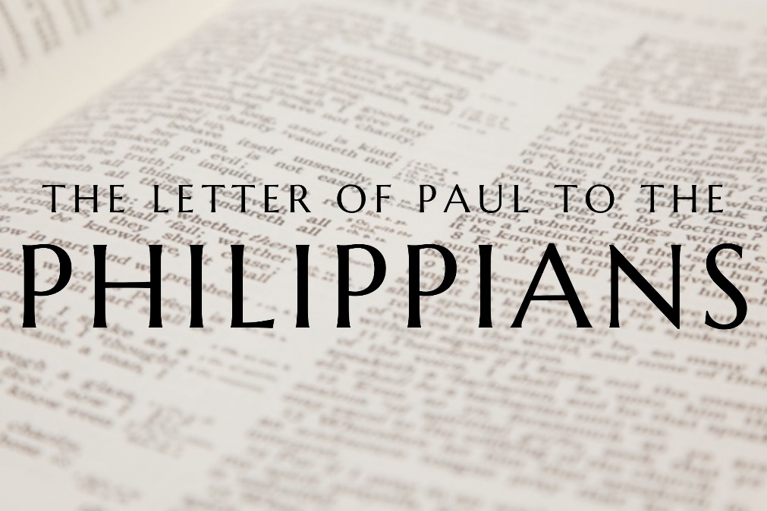

God tells us that Ezra read from the book of the Law,
day after day, and that the people of God
were filled with joy!

Produced by Ottawa RPC to help family worship.

Doctrine for the Mind and Heart

Memory Verse of the Week

Psalm of the Week

Please pray for:
Mon -
Tues -
Wed -
Thur -
Frid -

Pray for the Holy Spirit’s help as you read and study God’s Word.

The notes in this series written by Rev. Philip Dunwoody (RPC).
They have been slightly modified.
Mon – Please Read Philippians 2:1-4: Joyful Unity

It is very humbling to consider that one of the things that Jesus prayed for his church was that we would be one (see John 17:20). This is something that local congregations have to take very seriously. In these verses Paul describes the power for unity. He mentions both Jesus and the Holy Spirit in chapter 2:1. If we are alive in Christ by faith, then the Holy Spirit provides us with the power we need to stay united together: "encouragement", "comfort", "affection", "sympathy". Put simply, this is showing a greater concern for the needs of others than for ourselves.
This isn't something that human beings have by nature: we are born selfish sinners, with a "me first" attitude. Paul warns this against this attitude in verses 3-4. He makes clear that our selfish nature is one of the greatest threats to the unity of the church. To counter this threat, Paul uses a key New Testament word in verse 3, a word which we will think about much more next week - humility. Rather than do things with a "me first" attitude, Paul says that "in humility", we are to consider others "more significant" than ourselves.
Humility is the key to unity. Someone has described humility not as thinking less of yourself (i.e. a sort of false modesty, claiming you have no real gifts) but rather thinking of yourself less. Perhaps I like the thanks and praise I get for doing three or four jobs in the church, but Person X became a member a year or two ago, and they have the gifts to do one of these jobs. Humility prompts me to give it to them. Or Person Y was chosen as an elder or deacon instead of me. Humility prompts me to accept the decision of God's people, and serve the church in other ways, gladly and whole-heartedly.
Humility doesn't come naturally to us, but the Holy Spirit can give it to us - particularly if we often fill our minds and hearts with thoughts of Jesus' humble sacrifice on the cross, in our place, for our sins.

Questions:
What did Jesus pray for His church?
What attitude does Paul warn us against?
What does Paul say is the key to unity?
How can we become more humble?

Tues – Please Read Philippians 2:5-7: Our Humble God.

It is no exaggeration to say that these passages are among the most important of the whole Bible. We should pay close attention and think reverently and carefully about what we find here concerning the person and work of Jesus. We saw last week that Paul wants the Philippians to be humble Christians who put the needs of others ahead of themselves. Now, he gives the greatest example of this imaginable.
Notice the description of who Christ is (verse 6). Paul says Jesus "was in the form of God"; other translations say Jesus, "being in very nature God…". Our minds struggle to understand this, but before Jesus was the baby in the manger he was God from all eternity. Jesus had no beginning. Father, Son and Holy Spirit were there before the earth itself existed.
Notice also the position Christ gave up (Verses 6-7). Paul says that Jesus "did not count equality with God a thing to be grasped" - in other words, Jesus didn't try to cling on to his rightful place as God to avoid doing an unpleasant job; he sacrificed his authority, the highest place in heaven, to come down into the misery and darkness of this sin-cursed world. Sometimes we try to excuse ourselves from difficult or unpleasant tasks because we think we're too important for them. Someone else can talk to that strange new neighbour; someone else can clean up after the big event; someone else can serve in that way in the church. We avoid these things perhaps thinking we are too important to do them.
But Jesus Christ, the second Person of the Trinity, didn't cling on to his rightful place as highest, greatest, most significant; he gave it up - "made himself nothing, taking the form of a servant". We will consider tomorrow what Jesus the Servant did for us. But for now, consider this: the most important Person who ever lived came to earth and took the lowest position on offer. He came to serve, and to save. Yet, should we not remember the heights of glory in which our God dwells; and the depths of service to which he was willing to stoop?

Questions:
How does Paul describe Jesus?
What did Jesus give up?
What did Jesus take up?

Wed – Please read Philippians 2:8: Our Humble Saviour

Paul has described Jesus' humble willingness to let go of his exalted status as God and come down into the world, "being born in the likeness of men" (verse 7). But more was to come. Consider the utter humiliation of Jesus (verse 8). Paul says he "humbled himself". In the New Testament, humility is an action word. You don't sit still and "be humble"; you do things. Jesus humbled himself by "becoming obedient" - that is, obedient to the will of his Father.
Paul is almost shocked to write the words, but he says, "obedient to the point of death - even death on a cross!" In 2020 we tend not to appreciate the full impact of those words, even if we are Christians. The utter shame and torturous brutality of crucifixion is something we cannot fully grasp. The word "excruciating" comes from the word "crucifixion": a whole new category of pain needed a whole new word. Yet, for Jesus, alone on the cross, the worst pain was not physical, but spiritual. The perfect Son of God, sinless in every way, had God's holy wrath against sin poured out upon him. This was pain that no nail, thorn or whip could inflict. The unnatural darkness that descended on Calvary that day symbolised the dark suffering of our humble Saviour. This was hell itself.
Jesus was despised, rejected, by both God and man. He hung on the cross, as one writer says, "suspended between earth and heaven, and rejected by both". The One who deserved all the praise, worship and service we could give, received all the hatred, anger and mockery that our sins deserved. It is only through this utter humiliation of Jesus that our sins can be forgiven. If our sins were not mocked and punished in him on the cross, then they will need to be mocked and punished in the eternal darkness of hell. Jesus humbled himself to be the outcast, the scapegoat, so that we don't have to be. Is your trust in this humble Saviour? Do you love him? Then thank him for his sacrifice.

Questions
How did Jesus respond to the commands of God?
What did he become obedient to?
What did that mean for him?
What did Jesus actions achieve for His people?

Thurs – Please read Philippians 2:9-11: Our Exalted King

To humble yourself is to go down; to be exalted is to be brought up. Having told us what Jesus willingly did for us (verses 5-8), Paul tells us about what God (the Father) did for Jesus in response to his perfect obedience and sacrificial death. Firstly, we see the position Jesus was given (verse 9). God has "highly exalted" him. Jesus has been placed on the highest, grandest, greatest throne in the universe. He is where he belongs: the ruler of heaven and earth, the King who deserves to sit where he is, and who will have this highest position forever. Paul also says that there is a name that Jesus has been given (verse 9): "the name that is above every name". Most preachers and commentators believe that this "name" is the one Paul mentions in verse 11: "Lord", or "Yahweh" from the Old Testament, the special name of God (usually translated as "LORD" in block capitals in our English Bibles). Jesus is in the highest position and he bears the greatest name: the name of God Himself! Prime Ministers come and go. The position of President of the United States is still considered one of the most powerful in the world - but it is a position that can only be held for a maximum of two terms i.e. 8 years. Someday, even the long reign of Queen Elizabeth II will end. But Jesus' obedience to the Father means he will keep his place in highest authority over all peoples, nations and tribes forever.
Lastly, Paul describes the worship Jesus will receive (verse 10). Paul says a day is coming when "every knee" will bow before Jesus - meaning everyone will worship him as God and Lord and King. How we long for this as Christians! As our country grows more wicked, more than ever we look forward to the return of Jesus, when people will finally humble themselves before him. While we wait for that day, we should freely and gladly worship him now. We do so out of thankfulness for our salvation, and as witnesses to our neighbours that they must get ready for the King.

Questions
What did God the father do for Jesus in response to His obedience?
The name of Jesus – how important is it?
How will Jesus be worshipped?

Fri – Please read Philippians 2:12-18: The Christian's Workout

We have spent this week looking at a deeply important passage, which sets out crucial truths to know about the Lord Jesus. Now, in verse 12 onwards, Paul shows us how knowing this humble and exalted Jesus should change our lives. Paul says here that we have a spiritual workout to go through, verse 12: "work out your own salvation with fear and trembling". He immediately adds: "it is God who works in you". If we are Christians, it is because God the Holy Spirit has changed our lives. He has given us faith to believe in Jesus and a heart inclined to obey God. But the Christian faith is like exercising a muscle: our faith only grows and stays strong if we work at it. Thankfully, we work with the power God's Spirit provides.
What does it mean to "work out" our salvation with "fear and trembling"? Paul gives some examples in verses 13-18. He says we are to "do all things without grumbling or questioning". Simply not being grumblers will mark us out from the world, because the world is full of grumbling! To be content, joyful, thankful is a mark of the Holy Spirit's work in us.
Paul also says we are to "shine as lights" in a dark world. Christians have hope for those suffering with illness, addiction, loneliness or grief. In a world of darkness and confusion we can be guiding stars, leading people to the glorious light of the Lord Jesus Christ.
Finally, Paul urges the Philippians to continue "holding fast" - clinging on - to "the word of life" - the Scriptures, the gospel. No workout can be completed without the right equipment, and no Christian will grow detached from God's Word. Paul says in verse 17 that even if he loses his life for his own Christian witness, it will be worth it if he knows that the Philippians are "holding fast" in theirs.
There are no shortcuts to holiness: it takes work and effort. But God has given us the power of the Holy Spirit, so that we can complete a spiritual workout each day. How's yours going right now?

Questions
What does it mean to work out your salvation with fear and trembling?
What does it mean for a Christian to shine as a light in the world?
What are we to hold fast unto and why?

