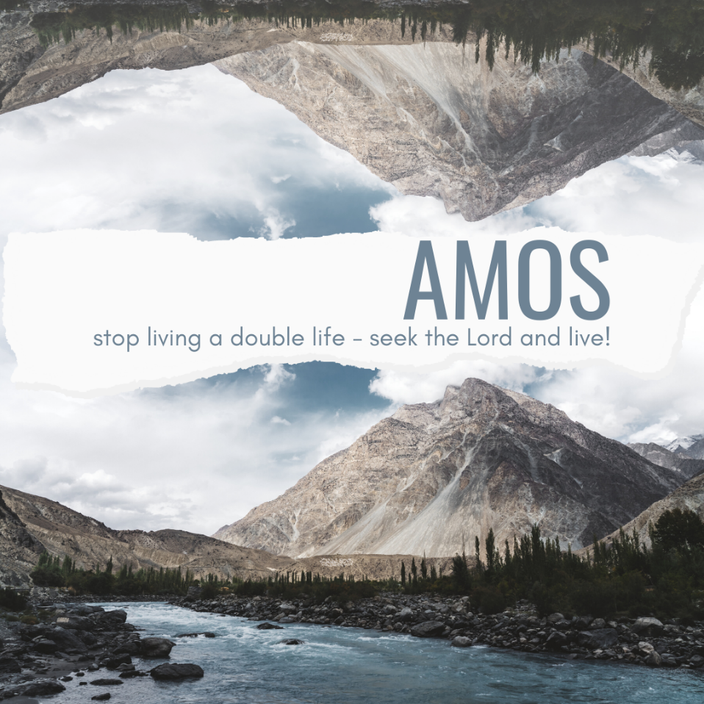

FAMILY WORSHIP BOOKLET

God tells us that Ezra read from the book of the Law,
day after day, and that the people of God
were filled with joy!

Westminster Shorter Catechism

Memory Verse of the Week

Psalm of the Week:

Please pray for:

Pray for the Holy Spirit’s help as you read and study God’s Word.

Produced by Ottawa RPC to help family worship.
These notes have been prepared by
Rev. Lee Hutchings of Trinity Church PCA in North Canton, Ohio.

Monday – Amos 1:1-2 – Meet Amos.
The message of Amos is primarily a message of judgement. God’s covenant people, particularly in the northern kingdom of Israel, lived in a time of great prosperity and ease, which manifested itself in an empty and godless religion. Worship of Yahweh at that time was more concerned with merely “going through the motions”, than true devotion and obedience to God. Sadly, this is a reality for many in our own day as well. We will see through this book how God had been extremely patient in the face of corruption, greed, injustice, idolatry, and immorality. However, His justice demands satisfaction, and Israel’s consequences for her sins are soon to come. But like most prophetic warnings, Amos also offers the hope of new life and salvation for all who will turn to the Lord.
Amos comes from a village about ten miles southeast of Jerusalem called Tekoa. All we know about this minor prophet is what is mentioned in this book. He was a shepherd, or farmer, as well as a self-described “dresser of sycamore trees” (7:14). Although God calls Amos to serve and prophesy in the northern kingdom of Israel in the middle of the eighth century B.C., Amos is from the nation of Judah. He has no background in any religious training or special skills that would equip him to serve as a prophet, other than the only prerequisite that truly matters: God called him.
For almost two centuries the kingdom of God’s people had been divided into two nations - Israel in the north and Judah in the south. Israel was ruled by Jeroboam II (786-746 B.C.) and was enjoying, what it thought was, its golden years. Great wealth in the hands of a select few had cultivated a culture of oppression of the poor, greed for material possessions, all kinds of moral debauchery, and a violation of God’s covenant with His people in the pollution of Sabbath worship. The first King Jeroboam had erected altars, with golden calves to represent God, to make it unnecessary for his people to travel to the rival nation in the south, where the temple was located and where God had commanded His people to worship. Many other sins and covenant violations followed, in both the northern and southern kingdoms. It was to this spiritually anemic culture that Amos was called. One commentator writes, “Empty ritual is the natural currency of man-made self-justifying religion and that is why God gives no place to it and calls for worship that is in spirit and in truth.”
Amos begins with the prophetic announcement, and a series of poetic oracles, that reminds its audience of God’s sovereign reign and holiness. We are told that “the LORD roars from Zion” (1:2). As the author of Hebrews says, “It is a dreadful thing to fall into the hands of the living God.” (Heb.10:31). Amos has been sent by God to declare specific judgements upon particular nations. And each divine indictment builds with suspense and intensity, until finally culminating with Israel’s own judgment as having broken covenant. It’s not accidental that God reminds His people of His covenant name (Yahweh) in the opening. It's a sobering harbinger of what’s to come.
Q1. Who was Amos?
Q2. What is the spiritual danger of merely “going through the motions” in worship?
Q.3 What qualified Amos to prophesy?
Tuesday –Amos 1:3 to 2:3 - The Whirlpool of Judgement.
The message of Amos can be startling and challenging. Not only because of its poetic and prophetic formulas, but because its message is essentially one of doom. At least upon the surface. Each specific judgment from God begins with the same formula: “This is what the Lord says: for three sins…even for four, I will not turn back my wrath...”.
Many commentators refer to this refrain as a “whirlpool of judgement”, in which during each national indictment of surrounding people groups, God’s gaze and intervention draws ever closer and closer to Israel, both geographically and spiritually, a progression of nations that seems circular. It’s formulation and flow traced out and viewed on a map of Israel in 750 B.C. looks like the weather graphics for a hurricane! Each nation is judged in terms of its relationship to Israel, God’s chosen people (with the sole exception of Moab). It's worth noting, however, that in the context of God’s judgement there is a strong statement of redemption towards His covenant people. How is God saving His people (as He promised He would)? By judging the surrounding nations. This foreshadows and reminds us that God’s divine activity often involves both condemnation and redemption. Although Amos may be commonly seen as a prophet of “doom”, there is always the prospect of salvation. The warnings themselves, not unlike the prophecy of Jonah, hold out a refuge of hope to those who would turn from their sin and repent before God.
The formula itself of “three and four sins” are a way of saying that the cup of wickedness and injustice has been filled up. No longer will God withhold His wrath against sin. Another commentator says, “God stays his wrath to remember mercy, but his slowness to anger is sometimes taken by wicked men as proof of his non-existence and as a license to continue in sin.”
A catalogue of sin and the following retributions are unfolded by Amos. God will not turn back His wrath against any of them. Syria (Damascus) is condemned for the atrocities against Gilead (in Israel). Philistia (Gaza) is guilty of slavery, having sold God’s people to Edom. They will be extinguished. Phoenicia (Tyre) has broken a peace treaty with Israel and sold God’s people into slavery. She too will perish. Edom was a descendant of Esau and shared in the heritage of bitterness towards God’s chosen people. They were racists. Ammon was bloodthirsty for growth and imperialism, and murdered mothers and unborn children. This nation too must fall. Moab has desecrated the dead and cremated the corpse of a king to use for mortar of a building.
God clearly is concerned for national affairs, not just individuals. Even in the church today we can become too individualistic in our faith or morality. What Israel will soon find out is that it too had become like the world around it, and must be reformed as God’s witness and light. The witness of the church, then and now, is to call men, as well as nations, to submit to Christ’s Lordship and biblical principles.
Q1. How can judgement still offer hope?
Q2. What should the judgments against other nations have instilled in God’s people?
Q3. What is the calling of God’s people?
Wednesday - Amos 2:4-16 - Covenant Breakers.
If Amos had stopped preaching at the end of v.3 of ch. 2, he would have been hugely popular! It’s a sad reality of our sinful hearts that we can be guilty of loving to listen to what God has to say to other people, especially when they are in trouble. One commentator says, “It is easier to hear about the world outside and all that is wrong with it than to face the ‘world’ in our own hearts.”
Amos so far had prophesied about outsiders and foreigners, not God’s people themselves. Yet these judgements and indictments upon the surrounding peoples have only served to “tighten the noose”, as it were, upon Israel’s own sin. Amos has been setting up Israel for a dramatic revealing of their empty and desperate state.
Israel and Judah had been given the words and law of God. They had been sustained by his sovereign power throughout generations. God had delivered them and bound them into an everlasting covenant. They knew this truth and yet they had sadly rejected it. Four aspects of their covenant violations are brought out by Amos against Judah:
- “They have rejected the law of the LORD” - The bible is the only authoritative rule of faith and life, and Israel had disregarded it. They are guilty of what Paul says in Romans 1, “they exchanged the truth of God for a lie and worshipped created things rather than the Creator”.
- “They.. have not kept his statutes” - God’s people did what was right in their own eyes, not in God’s eyes. Sound familiar? They modified worship to suit their own preferences and needs. They even redefined what they considered sinful and evil.
- They have been led astray by lies - They turned to idolatry. They found functional gods and saviours in other places. Everyone worships someone or something, and without the Lordship of Jesus Christ, men will follow something else in His place.
- They followed traditions instead of God’s word - Canaanite religious practices were included and adopted within the worship of the Jewish people, which God had forbidden.
Israel would then be judged after Judah and guilty of many similar spiritual realities. Like the southern kingdom, the northern kingdom was guilty of these sins as well as the corruption of the poor - it had almost become a national sport. Sexual immorality was commonplace (2:7), along with the profaning of the worship of God (2:8). God then reminds Israel (2:9-16) that much of what He had done in their past had been done out of covenantal love and grace. But the ten tribes of the north had broken that covenant. And although there is a faint echo of grace, the message is unmistakable: Israel, as a nation and a people, is done. Their wickedness will be put to an end.

Q1. Why do we love to listen to what God has to say about “them” instead of “us”?
Q2. How is our modern-21st Century church like God’s covenant people of old? Are there similarities and parallels you can think of?

Thursday - Amos 3:1-8 - Israel’s Guilt and Punishment.
The judgements announced to Judah and Israel left no doubt as to their condition and standing before the Lord. The people of God’s entire national history were bound by a covenant: a spiritual marriage that both kingdoms had mocked and broken with their egregious sins. In verses 1 and 2, God speaks to the entire family of God, both north and south. He reminds them that he has “known” or chosen them. This verb speaks of the intimacy which surrounded His favour and grace to them for generations. They were His people - loved and chosen among all the nations of the earth. But they have exhausted the patience of their faithful God. What should have come as no surprise (though admittedly we are too amazed by justice and holiness, when we should instead be amazed and surprised by God’s mercy towards sinners like us) was when God announces He will punish them for their sins.
The Lord, through Amos, then leads the nation of Israel through a series of rhetorical questions in order to interrogate and indict. All these questions lead to one vital question, namely, “Is God being fair, to bring such punishment and judgement?” The answer, of course, is yes. V.4 says, “Does a young lion cry out from his den, if he has taken nothing?” He is growling and crying out because he is devouring his prey. Israel is being awakened to the spiritual reality that what she supposes are blessings (i.e., material prosperity, comfort, lack of strife from foreign enemies) are actually devouring her. Our modern context would do well to remember this danger in a consumer driven society. As Neil Postman posed the warning over 30 years ago, “we are amusing ourselves to death.”
As we consider all these calamities and frightening thoughts (3:6), it is an opportunity for us to remember that our whole history is only rightly understood when we see it as an act of God’s providence. Accidents don’t happen. “History” as one author suggests, “is the unfolding of God’s purpose for man at every level of experience.” These experiences include both good and bad. National tragedies are often occasion for sober reflection upon the fragility and beauty of life. While many become stuck in the endless cycle of asking “why”, the believer is encouraged to remember that our lives are ones for which we will have to give an account. Judgement and warning are essential components of gospel ministry. That is a part that is often neglected in many churches. Warnings of the consequences of eternity without Christ’s mercy are substituted for admonitions and recommendations to have a better life, a better spouse, a more secure financial future, etc. But just as Amos was called to warn God’s people of the wrath to come, so is the church under the New Covenant tasked to give witness to Jesus Christ in order to flee the wrath that is to come.

Q1. Despite understandable grief and heartache, what purpose can national tragedies serve in God’s providence?
Q2. What is the role of the church and its witness to the world?

Friday - Amos 3:9-15 - Sobering Truth.
As we mentioned yesterday, Israel thought herself rich and wealthy, having need of nothing, and so was lulled into a false sense of security. Her self-deception now faces the continued judgement of Yahweh as Israel’s sins are exposed to the nations surrounding it. Israel is not unlike the church at Laodicea centuries later who believed herself to be thriving, when in reality she was “wretched, pitiful, poor, blind and naked.” (Rev. 3:17).
Amos unfolds his message in this passage in three distinct points:
- Israel’s sin will be revealed to the whole world (3:9-10) - The prophet imagines a scene where messengers are sent to the rooftops to call out the sins of God’s people. Imagine if someone were to do that for you, or for your family or nation. Soon the whole world, which Israel thought themselves better than, will know that moral corrosion has rotted the fabric of God’s covenant people. It’s a terrible tragedy when the wickedness of God’s people exceeds that of the world around it. God’s people are called to be righteous and holy examples. Israel had become an example of apostasy.
- A remnant will be left to bear witness of God’s chastisement (3:11-12) - If God’s people will not listen to His prophets, they will definitely pay attention to the swords of their conquering enemies. But not all Israel will be destroyed. We usually are comforted by this fact when we see God sparing a remnant. But here the remnant is highlighting the reality that God really has judged and punished His people. These verses speak to the scope of God’s judgement. Why does Amos compare Israel’s catastrophe with the pieces of sheep retrieved by a shepherd? In the ancient world, and in the book of Exodus in particular, a shepherd would need some evidence that a neighbouring animal had indeed been lost rather than sold to someone else, thereby clearing himself from any suspicion of wrongdoing. God, as the shepherd of Israel, is demonstrating that Israel has brought devastation upon themselves. He has not sold them out to anybody. This remnant serves as a witness to God’s judgement, but we cannot ignore the fact that God’s ultimate dealings with His people, even in allowing their consequences to fall upon them, have their ultimate salvation in view.
- God is using the world to destroy this wicked nation (3:13-15) - False religion will be swept away. God will no longer tolerate it. And so, its national history is coming to an end. The altars will be swept away (3:14), the houses of ivory, so decadent and palatial, will be reduced to ashes (3:15). Even the horns of the altar, which were symbols of mercy to be clung to, will all be no more.
This section in the prophecy of Amos highlights the truth of Proverbs 14:34, “Righteousness exalts a nation, but sin is a disgrace to any people.” God will use pagan nations to purge the land. But later on, He will also use pagan nations (Cyrus and Persia) to restore the land as well. Judgment and mercy; they are more tied together than many realize.
Q1. How does the hopelessness of Israel’s national condition reveal the character of God?
Q2. How does God’s use of foreign nations to judge His people speak to His own authority over all things?

