FAMILY WORSHIP BOOKLET

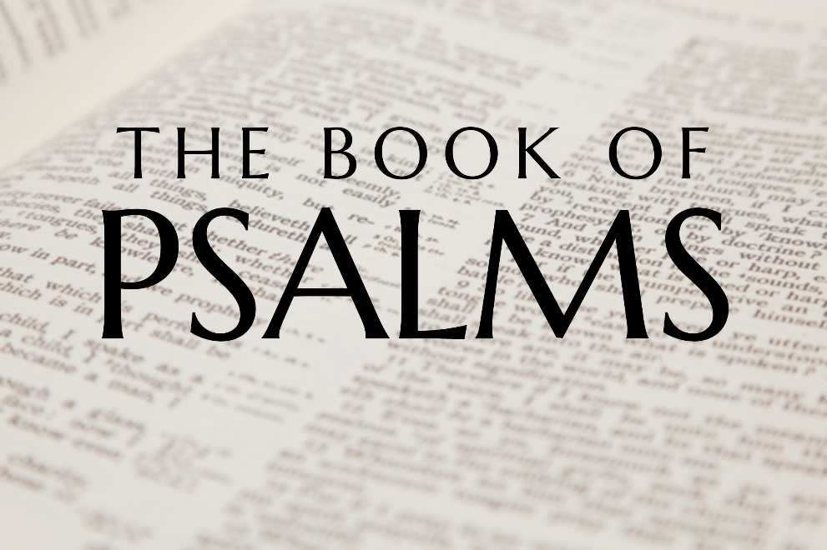

God tells us that Ezra read from the book of the Law,
day after day, and that the people of God
were filled with joy!

Doctrine for the Mind and Heart

Memory Verse of the Week

Psalm of the Week

Please pray for:

Pray for the Holy Spirit’s help as you read and study God’s Word.

These notes have been prepared by
Rev. Tim Donachie, retired RPC minister.

Monday - Psalm 1 – Happiness.

We live in days when boredom, depression, and other forms of unhappiness seem to be very common indeed, and happiness is often thought to be found in things that only bring temporary relief. Many would question whether true and lasting happiness can ever be enjoyed. In this first Psalm we are given a key principle that can give true happiness. The first word of the Psalm is translated 'blessed', but it could equally be translated as 'happy', and so the Psalm could be entitled, 'The Truly Happy Man'.

There is a contrast in the Psalm, not just between the happy and the unhappy, but between the righteous and the unrighteous, and here we see the difference between God's perspective and that of man. Righteousness is often associated with being miserable, and wickedness with 'having a good time'. Yet here it is the righteous who enjoy a life of happiness on earth and eternal bliss in heaven, whilst the ungodly have an unfulfilled life on earth and eternal misery after death. The blessedness or happiness spoken of is to be achieved by a rejection of certain ways of life and an acceptance of others. The righteous man is to reject the 'wisdom' of the world; he does not base his life on the advice of 'celebrities' or life-style gurus. He does go where the people go who do not know God. He does not join in with them, especially with those who make fun of his Lord. His delight is not in wickedness, but in the 'law of Lord'. His guidance for life is found through his regular study of the word of God. Such a way of life is only possible for the one who has had his sins forgiven through the Lord Jesus Christ.

Q1. Where can true happiness be found?
Q2. How can we find this happiness?

Tuesday - Psalm 2 - All Will Bow.

Matthew Henry comments on the first two Psalms that Psalm One is moral and shows us our duty, and Psalm Two is evangelical and shows us our Saviour. There is no indication as to the occasion that gave rise to the writing of the Psalm, but it has been almost universally accepted as a Psalm that very clearly points to the coming Messiah.

This is a Psalm of great comfort to the child of God, especially when it seems that the cause of God and truth is being attacked on every side, and it appears as though it is going to be overwhelmed. The nations do rage against God; they do seek to overthrow Christ and his church; and they ridicule the idea that the Lord Jesus Christ is king and must be submitted to in all things. Godless scientists and immoral philosophers may be highly regarded by a wicked world and applauded as they pour scorn upon Christ and his church, but this Psalm gives the proper response: The Lord shall have them in derision! When atheists come out with their bile against Christ and his church, just remember that the Lord in heaven is laughing at their foolishness.

It is not man who has the final say, with all his cleverness and power; God has placed His own beloved Son as the King over all the nations, and it is His will that will be done and His purposes that will be carried out. Those who oppose His will, no matter how powerful they may seem to be, will be forced to bow the knee and acknowledge Jesus Christ as King of kings and Lord of lords.

The important thing to remember is that all men will bow to Christ, either in repentance and love whilst here on earth, or in terror and despair when he comes again.

Q1. How does this Psalm show us Christ?
Q2. What will all men do one day?

Wednesday - Psalm 3 - Safe with God.

It is a common experience of the people of God that life brings its trials and disappointments. It is hard to imagine how King David felt when his own son Absalom, whom he dearly loved, rose up in rebellion against him and caused him to flee for his life. It is a sad fact, as William Plumer comments, that the best of parents may have the worst of children, for grace is not hereditary. God is sovereign. How urgently must we seek God's grace for the children of believing parents, that they may not turn out like Absalom.

Looking back on the rebellion of Absalom, David reflected that his situation was absolutely dire and there appeared to be no hope for him. Not only had many rebelled against him, they believed that he had been abandoned by God. In this awful situation however, David had not lost his faith and trust in God. Even when the situation looked hopeless, David knew that he was in the hand of his God, and, even when surrounded by his enemies, he was enabled to lay down and sleep.

To know that the Lord watches over His people is a great comfort to the believer in times of trouble. To know that the Lord cares, protects and provides, enables the child of God to face situations that would otherwise overwhelm him. As Daniel walked into the den of lions knowing that God was with him and would work out his purposes, so the child of God can face difficulty and danger, because it is the same God who watches over him.

Although it is true that Salvation belongs to the Lord, God expects His people to use the means of grace provided for them; and so, David prayed for God to do for him what he firmly believed He would.

Q1. What did David know about God, even in trouble?
Q2. How can we face difficulty and danger?

Thursday - Psalm 4 - Confident Trust.

The previous Psalm is considered to be a morning Psalm, and this one an evening Psalm. In the previous Psalm, David rejoiced that he had been able to lay down and sleep because the Lord had sustained him, and now, in this Psalm, he looks forward with confidence to the future and states, 'I will both lay down and sleep'. His previous experience of the goodness of the Lord enabled him to face what lay ahead with trust and assurance.

The Psalm begins with a prayer for the righteous God to be gracious to His servant. Because David had experienced the help of God in the past, he had great confidence that the unchanging God would listen to him again. God's help for His people is always based upon His grace and mercy, and never on what they deserve. David here shows something of the true heart of the child of God, for he does not seek vengeance on those who oppress him, but rather attempts to give them advice and show them how they can get right with God. The best way to take the hatred out of the heart of the enemies of the faith is to preach the gospel to them, that they might be saved.

In the midst of all of his trials, and even with the defeatist attitude of some of his friends who were saying 'who will show us any good?', David demonstrates an amazing confidence in God. He shows the same attitude that was present in the apostle Paul, in Philippians 4:11-12, when he says that in both plenty and in need, he had learned the secret of contentment. Confident trust in the Lord brings gladness, peace and safety, no matter how difficult the circumstances of life may be.

Q1. Why could David be confident in the future?
Q2. What is the secret of contentment?

Friday - Psalm 5 - Prayer.

This is another morning Psalm, and it begins in a very proper and necessary way with prayer. As the Psalmist contemplated the difficulties that he would face during the day, he cries out to God for help. He is so confident that God will answer his prayer that he says that he will eagerly watch for the answer that God would give him. That would suggest that his prayer was specific. It is difficult to look for answers to general, non-specific prayers, and so it is important in prayer to ask for definite things, and then to look confidently for answers.

The confidence that the Psalmist had in prayer was based very particularly on the relationship that he had with God, and his concern to walk uprightly before God. He speaks in verse 7 of going to worship God because of His loving-kindness or grace, and describes his attitude of reverence and worship as he comes into the presence of the Lord. It is when the believer has a living relationship with the Lord, and seeks by His grace to live according to the teaching of the word of God in godly fear and reverence of a holy God, that he will have great confidence that God will hear and answer his prayers.

The Psalmist was aware that he needed the guidance of the Lord because he had to deal daily with the deceitfulness and flattery of wicked men, and he needed the wisdom of God to be able to navigate a straight pathway. It is often more difficult to live godly in the midst of flattery and deceit, than it is in the face of hostility and anger.

Once again, the Psalmist finishes with an exultant song of triumph and joy, for the assurance of God's presence, protection and blessing.

Q1. What does the Psalmist do when he thinks of his difficulties?
Q2. Why is the Psalmist confident that God will hear his prayers?

