FAMILY WORSHIP BOOKLET

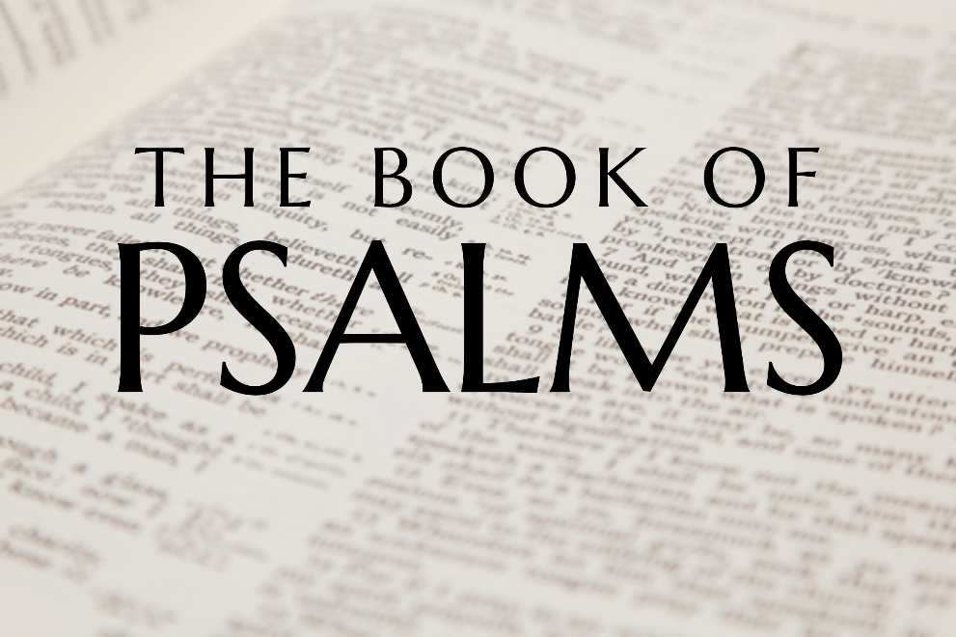

God tells us that Ezra read from the book of the Law,
day after day, and that the people of God
were filled with joy!
Westminster Shorter Catechism

Memory Verse of the Week

Psalm of the Week:

Pray for the Holy Spirit’s help as you read and study God’s Word.

Produced by Ottawa RPC to help you in your family worship.

Monday - Psalm 11 – A Tested Faith
This psalm is a psalm of faith: faith that God is righteous, and faith that God will protect the righteous and judge the wicked. It shows faith in a world that discourages such faith.
When we say that we have faith in God, how does our faith measure up in time of trial? David lived a life of trial when his faith in God was severely tested, by Goliath (1 Sam.17:45ff), by Saul (1 Sam. 19-31), by warlike Philistines (II Sam. 5), and by a rebellious son (II Sam. 13). These trials proved David's faith, for an untested faith is an unproven faith. Trust in God means that in time of trial the believer runs to God even although others may urge him to 'flee as a bird to your mountain'. The situation was undoubtedly serious, for it seemed that David was surrounded on every side by enemies who were out to kill him, and the very foundations of society seemed to be shifting (vs 2-3).
David, however, responded by looking to the only true and solid foundation, not his kingdom nor his army, but the Lord in heaven. He sees beyond the present situation and sees the unseen hand of God and hears the unheard voice of the Lord.
The two locations mentioned are very significant: The temple was where God met with man and where men had access to God. Our temple is Christ, through whom we have access into the presence of God. The heavenly throne was a reminder that God reigned. He is the one who observes men and examines them and is the one who punishes the wicked and saves the upright. It is those who have been accepted as righteous through faith in the Lord Jesus Christ who, at the end, 'will behold his face'.

Q1. Where should we go in times of trial?
Q2. What is our temple?

Tuesday - Psalm 12 – The Power of Words
It is not just with weapons, such as guns and knives, that men and women can be wounded. Sometimes the deepest and most long-lasting wounds can be caused by words. James knew that very well when he spoke of the tongue as 'a world of iniquity' and something which 'defiles the whole body' and is 'a restless evil and full of poison' (James 3:5-12). Harmful and destructive words have often been used against the Lord's people, as they were, indeed, against the Lord Jesus Christ. Here the psalmist finds himself at a very low ebb. Like Elijah, he could say 'I only am left and they seek my life to take it away'(1 Kings 19:10). He felt very much alone and disillusioned with the flattery, falsehood, and deceit that he heard all around him (vs 2-4).
In contrast to all the deceitful and false words and promises that he heard, the psalmist turns for consolation and assurance to the words and the promises of God, which are pure and without error. He knew that God had promised to preserve and keep His people, and that everything he said could be absolutely relied upon. This psalm comes with two very clear messages for the people of God in every age. Great care must be taken with regard to how we use the wonderful gift of speech and language that God has given to us. Do our words always build up and encourage, do they always speak the truth in love, and do they always glorify our Father in heaven? How greatly we should treasure the pure words of God preserved for us in the pages of Scripture. Do we read them, study them, and put them into practice in our daily lives? It may be that we cannot always trust what every man says to us, but when it comes to the words of God they are 'silver tried in a furnace'.

Q1. How should we use our speech?
Q2. How do we treasure God’s Word?

Wednesday - Psalm 13 - Wait on the Lord
Psalm 13 is another psalm concerning David in the midst of trouble. In his life David experienced a multitude of difficulties; some caused by his own sin and some from external sources, and thus he is in a perfect position to speak to the people of God in whatever circumstances they find themselves passing through.
One of the most difficult things for the child of God to do, especially when passing through trials, is to wait upon the Lord. We are so impatient and think that God should act according to our timetable, but God's timing, unlike ours, is always perfect. Here David cries out to God in despair; four times he cries out 'How long, O Lord'? In his trouble he did not turn away from God, but rather sought the answer from God. It seemed as though his trouble was never going to end, that God had forgotten him, that his constant searching for solutions was getting nowhere, and that his enemies were continually triumphing over him; and so he asks God 'How long?'
When we do not understand the workings of God, it is good to do what David did, he cried to the Lord for deliverance. He asked that God would 'consider' or 'look' on his situation. It is always a great comfort to know that God sees and cares about our situation. He asked God to answer his prayer. Is it not sometimes the case that we do not have because we do not ask? He prayed for understanding. Trials are easier to bear if we understand why they have come. He prays that wickedness may not triumph.
Although David was not immediately delivered from his trouble, his prayer was answered, for he was enabled to remember God's goodness to him in the past and thus be assured of his deliverance from his present trouble, and to acknowledge that the Lord had 'dealt bountifully' with him. This knowledge caused him to 'sing to the Lord'.

Q1. What should we do when we are going through a trial?
Q2. Why is it good to remember what God has done in the past?

Thursday - Psalm 14 - Wise or Foolish
There is a common perception that most people are good and are only made bad by their upbringing or environment. This psalm shows how fundamentally wrong such a perception really is, and demonstrates the universal depravity of mankind and its cause. When the Lord looks from heaven upon all the children of men, and this refers to all men and not just Israel, He finds no-one who seeks God, no-one that does good, no-one who is not corrupt and filthy. This is a great shock to the pride of man, for nobody likes to think of himself in those terms, and yet that is how even the best of people appear in the sight of a holy God. This is what theologians call 'total depravity'. That does not mean that every person is as bad as they could be, it simply means that every part of man's being, his mind, his emotions, his will, his desires, is corrupt and depraved.
Not only does the psalmist point out the depravity of man, he also highlights the reason for it; 'the fool has said in his heart, There is no God'. This does not just apply to those high-profile atheists who parade their hatred of God for all to see, it also applies to those respectable, sometimes religious people who live without submitting their lives to God through the Lord Jesus Christ.
The only solution for the foolishness of man, in his refusal to acknowledge God, is found in the Saviour that God would send 'out of Zion', His beloved son, the Lord Jesus Christ. There are only two kinds of people in the world; the foolish, who live without God and without hope in the world, and the wise, who have been enabled by the Holy Spirit to repent of their sins and trust Jesus Christ as their Lord and Saviour.
The most important question in the world is 'are you wise of foolish?'

Q1. What is the true nature of man?
Q2. What are the two types of people in the world?

Friday - Psalm 15 - The Character of the Godly
It is very appropriate that this psalm, which describes the character of the godly, should follow immediately a psalm that details the characteristics of man as he is by nature.
The psalm begins with a very important and necessary question - what kind of person does God accept into His presence? There is no doubt that there would be many different answers to that question if it were to be posed in a survey of the public. The only answer that needs to be taken account of, however, is the one that God Himself would give, and that is what we find in this psalm. There are three positive things that are said: he is said to 'walk uprightly', that is somebody who has a whole-hearted commitment to God and complete integrity in his dealings with other people; he 'works righteousness', in other words, what he does pleases a righteous God; and he always speaks the truth and uses his tongue to build up and not to destroy. None of these characteristics can be found in the natural man, but were seen in their fullness in Jesus. It is only as men and women are found 'in Christ' that they can begin to demonstrate these characteristics.
As well as the positive aspect, there are also negatives. The one who is acceptable to God does not seek to hurt his fellow man, he does not broadcast his neighbour's faults, he does not gossip, he does not praise or magnify the ungodly, but rather praises those who are faithful to the Lord, neither does he break his promise, even if it costs him dearly to keep it. His concern is always to be just and honourable, and he will never take advantage of his fellow man.
If the heart is right with God, through faith in the Lord Jesus Christ, it will be seen in the way that the life is lived before men.

Q1. What are the positive characteristics of the Godly man?
Q2. What are the negative characteristics?

