FAMILY WORSHIP BOOKLET

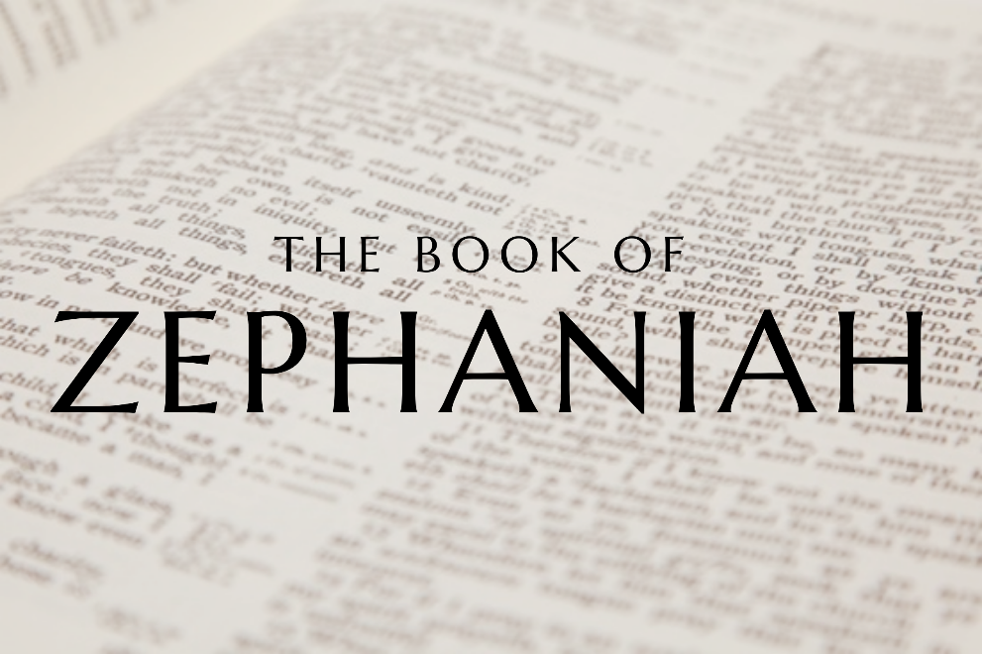

God tells us that Ezra read from the book of the Law,
day after day, and that the people of God
were filled with joy!

Westminster Shorter Catechism

Memory Verse of the Week

Psalm of the Week:

Pray for the Holy Spirit’s help as you read and study God’s Word.

The notes on Zephaniah by Rev. Craig Scott (RPCNA)
have been slightly modified, with questions added.
Produced by Ottawa RPC to help you in your family worship.

Monday – Zephaniah 1:1; 2 Chronicles 34 – Introduction.

Today we start a new study in the Prophecy of Zephaniah using notes by Rev. Craig Scott minister in the Grand Rapids RPCNA congregation.
This is a book you may not have read before, but it is one that will hopefully challenge and cause you to think about your own Christian walk. The book brings us a message about the dangers of worldliness and the need to have a strong desire for holiness? It presents what happens when the people of God drift into a place where God is not foremost in their lives.
Zephaniah lives during a testing period as the church is recovering from idolatry. 100 years previously Northern Israel was punished by God for her sin and was taken captivity by the Assyrians in 720 BC. The Southern Kingdom of Judah seems to be heading the same way as the two previous kings in Manasseh and Amon lead the church into idolatry. Josiah is crowned King at 8 years of age and commences a period of reformation as he exhorts the people to follow God's Word once again.
It is during this reformation where Zephaniah prophesises to the Church. The book is split into two sections. Section 1 (1:2-3:8) warns the church of the Day of the Lord. The Day of the Lord is when God will judge sin and pour out His wrath. Temporally this was fulfilled in 587 BC where Jerusalem fell and was exiled to Babylon under Nebuchadnezzar. Ultimately though, the Day of the Lord is the last judgement where God judges all peoples. In section 2 there is a message of hope. Zephaniah proclaims mercy and salvation to those who repent and turn to the Lord.
Zephaniah teaches that God will chastise His people if they are not holy and devoted to Him. We see these warnings both in Zephaniah and in John’s prophesy to the seven churches in the book of Revelation. It is a blessing to be made aware of such waning that we may think about and pat heed to them in our own lives and congregation.

Questions
1. Who is Zephaniah?
2. Which nation is Zephaniah speaking to?
3. What is the background to Zephaniah’s prophesy?
4. What is the Day of the Lord?

Tuesday – Zephaniah 1:1-3 Universal Judgement

As we tread the path of Zephaniah, we now realise we are on holy ground. Many Christian books like to start off with a lighthearted story to attract the reader lest they be put off by another ‘serious book about religion.’ We see no such fear as Zephaniah opens with the solemn judgement of God. In His wrath He will ‘utterly sweep away everything from the face of the earth.’ This is universal judgement; all things will be consumed. This is due to the sin of mankind. This world was created as a habitat for man to glorify God, but when we fell in Adam the whole world suffered too. It is our fault that there is sickness, violence, pain, and death. It is also our fault there are earthquakes, tsunamis, and natural disasters. Death and destruction only came into the world because of sin.

The modern world views God as some ‘grandfather in the sky’ figure but see here who performs the judgement. It is God Himself for He says ‘I will’ four times. The warrior-king is coming, and He will ‘sweep away’ all things. ‘Sweep away’ means utter destruction and is used three times, there is no escape. The temptation is to tone done the horror of this passage with a note on love. God is love, but here there is no hope until chapter 3. We must realise how holy and just our God is, He hates sin with all His being and will punish. Because of my sin and yours, the whole earth will be consumed. This is even the language of Jesus Christ in Matthew 13:41 ‘The Son of Man will send his angels, and they will gather out of his kingdom all causes of sin and all law-breakers.’

Let us grieve the sin we commit every day and know its true power and sinfulness. Such is the effects of sin that God will universally ‘sweep away everything’ because of lawlessness. Let us also praise God who is holy and just, for unlike men in this world He always does what is right.

Questions:
- How does Zephaniah open this book?
- Who is at fault?
- Who does the judging?
- How are we to respond to God?

Wednesday – Zephaniah 1:4-6 Judgement on Judah
After the warning of universal judgement, Zephaniah now turns to his first port of call, the Church! The people of God are those who profess the name of Christ and their covenant children. When we are brought up in a Christian home we have the privilege of hearing God’s Word every week, and so there are no excuses. This is why Christ warns us in Luke 12:48 ‘Everyone to whom much was given, of him much will be required.’ The judgement starts at the house of God and in Zephaniah’s day they are judged because they do not ‘seek the Lord.’

It is important to notice that the judgement of wrath here will be poured upon those who do not follow God. True believers receive mercy and grace, but everyone else receives judgement. Despite knowing the things of God they do not follow Him, instead they follow idols. They do not look to the Bible for guidance but ‘the host of heaven.’ They look to horoscopes in the papers rather than prayer. God hates this, and all forms of idolatry. But notice the greatest act of idolatry is in the context of worship. Judah is not going to the Temple, but to Baal for worship. The Priests do not confess the True God alone, but God and ‘Milcom.’ The worship of God is the most important aspect of the Christian life. We are to worship Him as He commands and worship Him alone. Christ alone, is the way of salvation, it is not Christ and Mohammad, nor Christ and Buddha, but Jesus Christ alone.

When we are baptised, whether in childhood or profession, we enter the covenant of grace. This means we have the covenantal duty to profess Christ as Lord. When we fail to do so, we are judged according to this covenant. While we refrain from giving our hearts to Christ we will be ‘cut off’ from His blessings and presence. May we all see that we as the church will be the first to be judged and turn from idolatry and trust in God alone.

Questions:
- Who is Zephaniah audience?
- What specific sin is Zephaniah addressing?
- What is the most important aspect of the Christian life?
- How will we be judged?

Thursday – Zephaniah 1:7-9 Judgement is Near

What do you think about when you enter the presence of God? How do you feel when you come to Him in prayer or just before worship? Some answers may be ‘boldly’ for He sits on a throne of grace, or with joy because I love my God and Saviour. These are both good, but lest there is also a sense of awe and fear, then we forget whom we worship. He is the Almighty God who will judge all, therefore ‘Be silent before the Lord.’ We should never forget Isaiah before His throne: ‘holy, holy, holy is the Lord of Hosts’ as he confesses ‘woe is me, for I am undone.’ Silence is a sign of reverence for our Lord.

Here silence is called for because ‘the day of the Lord is near.’ For Judah it was coming very soon, for mankind it will come as a thief in the night. When the warrior-king returns, judgement will commence. God declares that He will ‘punish the officials and the king’s sons.’ Josiah was a godly king, but His court was full of false believers. God will judge the ministers in government and the church as they teach and lead by example. For Judah, they have failed and three sins are mentioned:
1. ‘Foreign attire’ represents adopting lifestyles, customs, and moral behaviour that are of the world and not God.
2. ‘Leaps over the threshold’ demonstrates a respect for religious superstition. The Philistines once had the Ark of the Covenant in their possession and when their Dagan statue broke, they started a new superstition by not walking over the threshold (1 Samuel 5:5).
3. ‘Violence & Fraud’ is having statues of gods in one’s home. This causes harm to the healing trust in God and whosoever does this commits fraud, or is deceitful, in the name of God.
Our Lord is a jealous God and He will consume all who practise idolatry. Judgement will come in the ‘day of the Lord’ and this day is always ‘near’. Let us have awe and fear as we reverence the One who has all power and authority to judge you and me.

Questions:
- How should we approach God?
- Who is Zephaniah addressing in this passage and what are their sins?
- When will the judgement come?

Friday- Zephaniah 1:10-16 - Judgement on God’s People

Throughout the ministry of our Lord Jesus Christ, He taught repeatedly that the church of Christ contains both wheat and tares, wise and foolish virgins, sheep and goats, true and false believers. It is in this context of a mixed church where God will also judge. It doesn’t matter whether we are labourers and fishermen (Fish Gate), or work in finance (Mortar is the financial district), every person from every aspect of society will hear the judgement call.

God knows our inner most thoughts and will search all of us as He proclaims: ‘I will search Jerusalem with lamps.’ The warning is to those who are ‘complacent.’ The idea here is of undisturbed wine thickening in the dregs, it is useless. Here it is speaking about professed Christians who are lethargic. They attend church, never miss a Bible study, but there is no real spiritual life and urgency. Often they have a blasé view of God: ‘The Lord will not do good, nor will he do ill.’ Their attitude is ‘God does not mind if I do such and such’ or ‘I can go anywhere I want, God is forgiving.’ They do not truly know the Lord for if they did, they would know about His holiness and law. They are so busy in the world enjoying their worldly pleasures and entertainments that they are blind to the fact the Lord will judge them (2 Cor. 5:10).

The reality is, the ‘great day of the Lord is near, near and hastening fast.’ There needs to be urgency in the Christian: urgency in prayer, Bible reading, holiness, good works, and evangelism. We are to treat every day as a time to grow in Christ. For when that Day comes, there will be no second chances, no what ifs. It will be a ‘day of wrath… of distress and anguish, a day of ruin and devastation.’ We are to take God seriously, and one way we do this is having Christ as Lord over every aspect of our lives and living accordingly

Questions
- Who is in the church?
- Who is this warning directed at?
- How and why are we to take God seriously?

