FAMILY WORSHIP BOOKLET

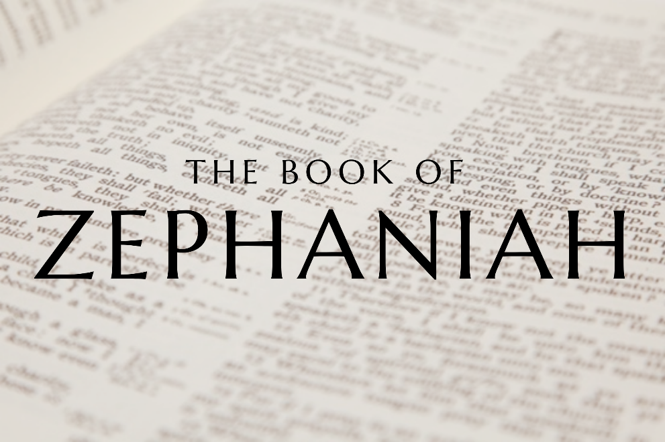

God tells us that Ezra read from the book of the Law,

day after day, and that the people of God

were filled with joy!

**Westminster Shorter Catechism**

**Memory Verse of the Week**

**Psalm of the Week:**

*Pray for the Holy Spirit’s help as you read and study God’s Word.*

*The notes on* Zephaniah *by Rev. Craig Scott (RPCNA)*

*have been slightly modified, with questions added.*

Produced by Ottawa RPC to help you in your family worship.

**Monday – Zephaniah 2:12 - Judgement to the South**

The shortest statement in this list of prophecies is reserved for Cush. It is important again to note who the direct spokesman and executioner is: 'You also, O Cushites, shall be slain by my sword.' The Cushites are to be identified as the remote Ethiopians, possible the most southerly people known to the Hebrews. It is probably the remoteness of this nation that makes them the most perfect example to set before the people of God. if even the wicked in Ethiopia are not safe from the judgement of God, what hope is there for a disobedient covenant people? Too often covenant children and adults who do not profess can fall into some kind of religious comfortability. They can fall into a subconscious belief that they are better than outright pagans in other lands and that God will be 'merciful' to them. The truth is the opposite, for our Lord Christ says in Matthew 10:15 'Truly, I say to you, it will be more bearable on the day of judgment for the land of Sodom and Gomorrah than for…' those who know the truth yet do not profess His name.

But why is this statement in Zephaniah so brief? It may be to highlight the immediacy of Ethiopia's devastation; no sooner is it identified than it is destroyed. God will yield His own sword by His own hand and destroy all who act so wickedly. Read Deuteronomy 32:39-42 to see this solemn truth. This short verse tells us how jealous God is for His own holiness. No sin can stand in His sight. This should cause to further see how God is to be reverenced. He is our holy God. if we are to have the mind of Christ, we should have the same mentality towards our sin. we should seek out the spiritual Ethiopians of our lives and pray that God gives us the grace to slay sin with the power of God's sword. What sins are we actively committing today? Seek it out and put it to death (Colossians 3).

**Questions**

1. Who are the Cushites?
2. What warning does this judgement of Cush hold for us?
3. What do we learn about the character of God from this verse?
4. What should be our attitude towards our own sin?

**Tuesday - Zephaniah 2:13-15 - Judgement to the North**

Lastly, we reach the final judgement of the nations. God proclaims that 'he will stretch out his hand against the north and destroy Assyria.' The great northern empire of Assyria is a well-known foe of God's people throughout the Bible. Over a century before, Assyria was God's instrument in pouring His wrath upon the covenant breaking northern kingdom. Such will be the devastation upon Assyria; that her capital will be utterly destroyed. Instead of standing tall with her glorious standing walls, Nineveh will face such a demolition that 'Herds shall lie down in her midst.' She will be inhabitable for humans; the only sign of life will be that of wild animals finding new homes in a wasteland of ruin. This prophecy was soon fulfilled in history as Assyria was demolished by Babylon in 612 BC. God always keeps His promises!

The particular sin that kindled the wrath of God is given, Assyria says 'in her heart, "I am, and there is no one else."' She is full of pride and self, she exalts her own name and capabilities rather than bow down before the one true God. O how glorious and proud we all feel when things are going our way. Like Nineveh, we can often flourish in this life. We may gain wealth, earn respect, and have plenty of possessions. But what often happens in such circumstances is that we start to live upon our own strength and wisdom. God is jealous for His own glory, so when nations, and we, do not give Him the glory and humbly accept His provision, His judgement is only around the corner.

In chapter 2 we have seen the Almighty wrath of God upon the nations. There is no person, no culture, and no country that will avoid the judgement. Let us come before God with true humility and by His grace seek out and destroy pride and arrogance in our lives.

**Questions:**

1. What was the relationship between Israel & Assyria?
2. What will be the punishment for this nation of Assyria?
3. What particular sin is God punishing in Assyria?
4. What is our response to hearing about such punishment?

**Wednesday - Zephaniah 3:1-5 - Judgement on Jerusalem**

In chapter 2 we saw Zephaniah prophesying what would come upon the nations surrounding Israel: to the west (the land of the Philistines, 2:4-7); to the east (Moab and Ammon, 2:8-11); to the south (Cush, 2:12); and to the north (Assyria, 2:13-15). Chapter 2 showed the almighty wrath of God upon the nations. There is no person, no culture and no country that will avoid the judgement.

In chapter 3, we now return to Jerusalem. The Psalms tell us that Jerusalem is 'the city of our God' (Psalm 48:1), and that 'God is in the midst of her' (Psalm 46:5). This city Zephaniah speaks of in chapter 3 has 'the LORD within her' (v5). How could a place that enjoyed so much grace become so corrupt and vicious? One aspect Zephaniah highlights is the failure of the leading men in it: 'her officials ... her judges ... her prophets ... her priests' (v3-4).

As we've already seen (in 1:4-6), Zephaniah turned to the church first (after his initial and more general warning of judgement). Are we, the Church today, listening yet? His Church - yes, even the City of God - contains both wheat and weeds, wise and foolish virgins, sheep and goats, true and false believers. It is in this context of a mixed church where God will also judge. Judgement begins at the household of God (1 Peter 4:17).

It's hard to believe these verses speak of Jerusalem, the holy city! What a mess the church can fall into when: 'she does not draw near to her God' (v2) and when men who should lead actually do her harm instead (v3-4)!

**Questions:**

1. What city is being spoken of in these verses?
2. How did this city become so corrupt?
3. What warning do these verses hold for the church?

**Thursday - Zephaniah 3:96-8 – Jerusalem’s Refusal to Repent**

God had set before the eyes of His own people, Jerusalem, unmistakeable signposts of His justice. In His mercy, He had warned them: 'I have cut off nations ... I have laid waste their streets ... their cities have become desolate ... I said, 'Surely you will fear me; you will accept correction'' (v6-7). Most notably, the northern kingdom (Israel, ten of the tribes) had been punished by God over 100 years previously, by being taken captive by the Assyrians. Yet the southern kingdom (Judah, the two tribes) seems to continue unwaveringly in the same direction.

Yes, it could be said that enemies or other nations brought this judgement about. But God says (v6) - I cut them off! However, even in this, God is merciful. He intends these to serve as warnings to His people - to put them off their sinful ways! Surely they will not continue to sin like other nations when they have seen the ruin sin brings on them! One old preacher compares it to seeing your neighbour's house on fire but not realising that yours is in danger! Have you seen the ruin sin brings - in your own life, or in the lives of people close to you, or in your community? What warnings is God sending into our lives?

V8 says: 'Wait for me, declares the LORD'. Without doubt, the same verse ends speaking of God's indignation, burning anger, and consuming holy jealousy. Yet there is hope in this 'Wait for me'! Something more wonderful is coming in Zephaniah 3. This hope-filled longing and looking ahead runs all through the Old Testament.

**Questions:**

1. How did God warn the nation of Israel?
2. What is God’s intent in punishing the nations?
3. What hope does God offer in v8?

**Friday - Zephaniah 3:9-10 – The Conversion of the Nations**

We have seen the first of the two main sections of the book of Zephaniah (1:2-3:8). Zephaniah has warned of 'the Day of the Lord', when God will judge sin and pour out His wrath. The immediate fulfilment of this prophecy was the fall of the city of Jerusalem in 587BC and God's people being carried off into exile in Babylon by Nebuchadnezzar. The further fulfilment spoken of by 'the Day of the Lord' is the last judgement, when God judges all people.

The tone of the book of Zephaniah changes now, however, as in 3:9 we come to the second of the two main sections of the book. Now we have an announcement of the redemption that will follow God's judgement. Zephaniah's prophecy so far has been dominated by the imagery of judgement, but it is not without hope. In this closing section of his prophecy, Zephaniah describes another coming day, a day of hope and restoration. He declares that there will be a day when people from all nations will worship God (v9-10).

Although we still await the fullness of this new day (in Jesus' perfect kingdom in heaven), we see glimpses of it now in this period of time between Jesus first coming and His second coming. One aspect we can look forward to is the growing diversity of His Church, incorporating people from all nations - that is, not only does Zephaniah speak of a coming judgement for all the nations (as we saw in 3:8), but also the promise that worshippers will come from all the nations!

**Questions**

1. When did the fulfilment of the prophecies in the previous section of Zephaniah?
2. How does the tone change in this next section of Zephaniah?
3. What hope does Zephaniah hold out in v9-10?
4. How do we see a partial fulfilment of this hope in our day?