FAMILY WORSHIP BOOKLET

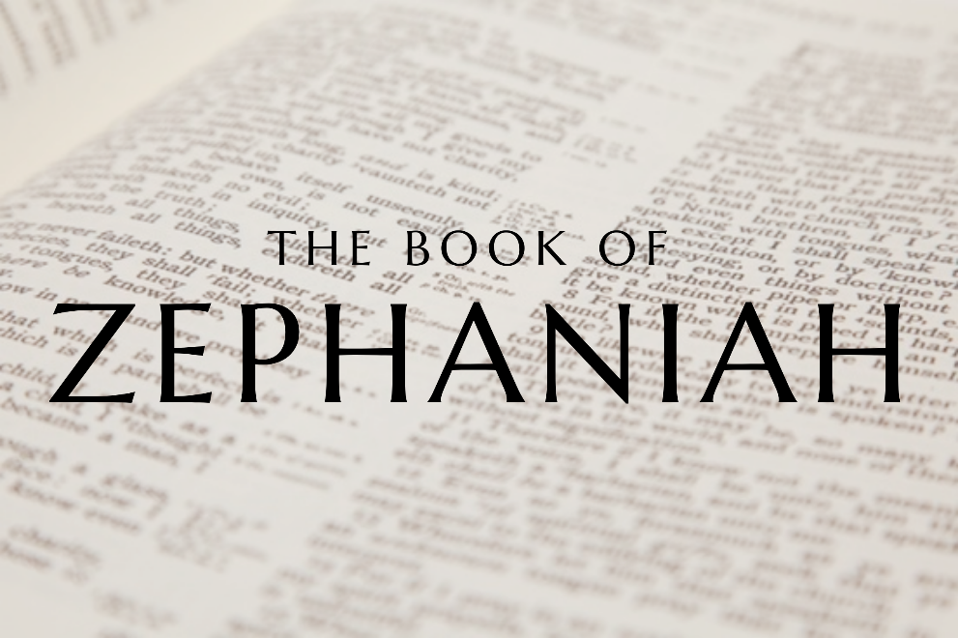

God tells us that Ezra read from the book of the Law,

day after day, and that the people of God

were filled with joy!

**Westminster Shorter Catechism**

**Memory Verse of the Week**

**Psalm of the Week:**

*Pray for the Holy Spirit’s help as you read and study God’s Word.*

*The notes on* Zephaniah *by Rev. Craig Scott (RPCNA)*

*have been slightly modified, with questions added.*

Produced by Ottawa RPC to help you in your family worship.

**Monday – Zephaniah 3:11-13 – The Transformation of the Nations**

In these verses, Zephaniah looks ahead to a day when God's people will be marked by humility and holiness. First, it is promised that the church will one day be marked by humility: 'I will remove from your midst your proudly exultant ones, and you shall no longer be haughty in my holy mountain. But I will leave in your midst a people humble and lowly. They shall seek refuge in the name of the LORD, those who are left in Israel' (v11-12).

This promise is pointing us, ultimately, to Jesus - who through His humble birth, lowly life of service, and submissive death has set an example of humility for all of His people to follow. Philippians 2 sets this example before us and commands us to: 'In humility count others more significant than yourselves' and to look 'to the interests of others' (Phil. 2:3-4). One clear mark of a Christian is humility - we won't display it perfectly in this lifetime, but it should still be a distinguishing mark.

Second, it is promised that one day God's people would possess holiness: 'They shall do no injustice and speak no lies, nor shall there be found in their mouth a deceitful tongue' (v13). Christians do continue to struggle with sin, but it is no longer our master. The Bible regularly refers to God's people, even in this world and in this lifetime, as holy! This is what is meant by the word 'saints', which is so often used in the New Testament to describe Christians. Again, like humility, it is not complete in this lifetime, but it should still mark us out as His people.

**Questions**

**1.** What characteristics does Zephaniah use to describe God’s people?

2. To whom is this promise pointing us?

3. What should be the two distinguishing marks of a Christian?

4. What does the word ‘saints’ mean?

**Tuesday - Zephaniah 3:14-17 – Rejoicing!**

What a difference from the opening two and a half chapters of the book! What magnificent notes this book draws to a close with! Sing! Rejoice! Exult! (v14) 'The LORD has taken away the judgements against you' (v15) - what a clear and powerful description of what God does for the one He saves.

The book of Zephaniah is placed towards the end of our Old Testaments. Soon the New Testament will open and there we read even more clearly about 'the LORD your God ... in your midst, a mighty one who will save' (v17). John is one of the writers who tells us about Jesus, and one of the first things he says is: 'The Word became flesh and dwelt among us' (John 1:14). Or, as Zephaniah foretold: 'The LORD your God is in your midst' (v17). What a truth to make our hearts sing!

Amazingly, though, it isn't only the Church that is rejoicing and exulting (v14). It is also God Himself (v17), rejoicing over and exulting over and delighting in us - His Church, His Bride. What an astonishing truth! Our hearts should be singing today.

Zephaniah's prophecy speaks of two contrasting days: a day of judgement and a day of restoration. Jesus is the Lord of both of these days. It is your relationship to Him that will determine how you experience both of them. If you are not trusting in Jesus as Saviour, you will be caught by surprise and you will know the fear and terror of the Day of the Lord. If you are trusting Him as Saviour, then you will experience the rejoicing of the new day. Read again v14 and v17!

**Questions:**

1. What does God do for those he saves?

2. How is the prophecy in v17 fulfilled?

3. Who is doing the rejoicing in v17?

4. What determines how you will experience the day of judgement and the day of restoration?

**Wednesday - Zephaniah 3:18-20 - Restoration!**

As we noted yesterday, Zephaniah's prophecy speaks of two contrasting days: a day of judgement and a day of restoration. For us today, this new day of restoration has already dawned with the first coming of Jesus. However, that new day has not come in its fullness. Jesus has not finished saving people from every nation. Christians do not currently display perfect humility, nor do they display perfect holiness in their actions. The new day has partially come, but much more remains to be fulfilled. There is an 'already' aspect to the new day, but there is also a 'not yet' aspect to it. In this present age, Christians will continue to have trials and sufferings, but God promises that one day He will gather us and bring us home. Three times in today's section - once in each verse (v18, v19, v20) - God speaks of 'gathering' us!

There will be mourning (v18) before that day comes. Those whom - as we saw yesterday - God will rejoice in (v17) and who He will cause to rejoice (v14) will, before that day comes in its fullness, still have sorrow. Before we reap in joy, we will often sow in tears (Psalm 126:5-6). But God will make His Church to be 'renowned and praised among all the peoples of the earth' (v20). We have seen glimpses of this in our own land and also throughout history. But ultimately this will be fulfilled on that great day when the universal church of Jesus Christ is 'gathered' to Him and is admired and glorified before angels and men.

**Questions:**

1. What are the two aspects to the day of restoration?

2. What promise is repeated multiple times in these verses?

3. What should we expect while we wait for this day?