Family Worship Booklet
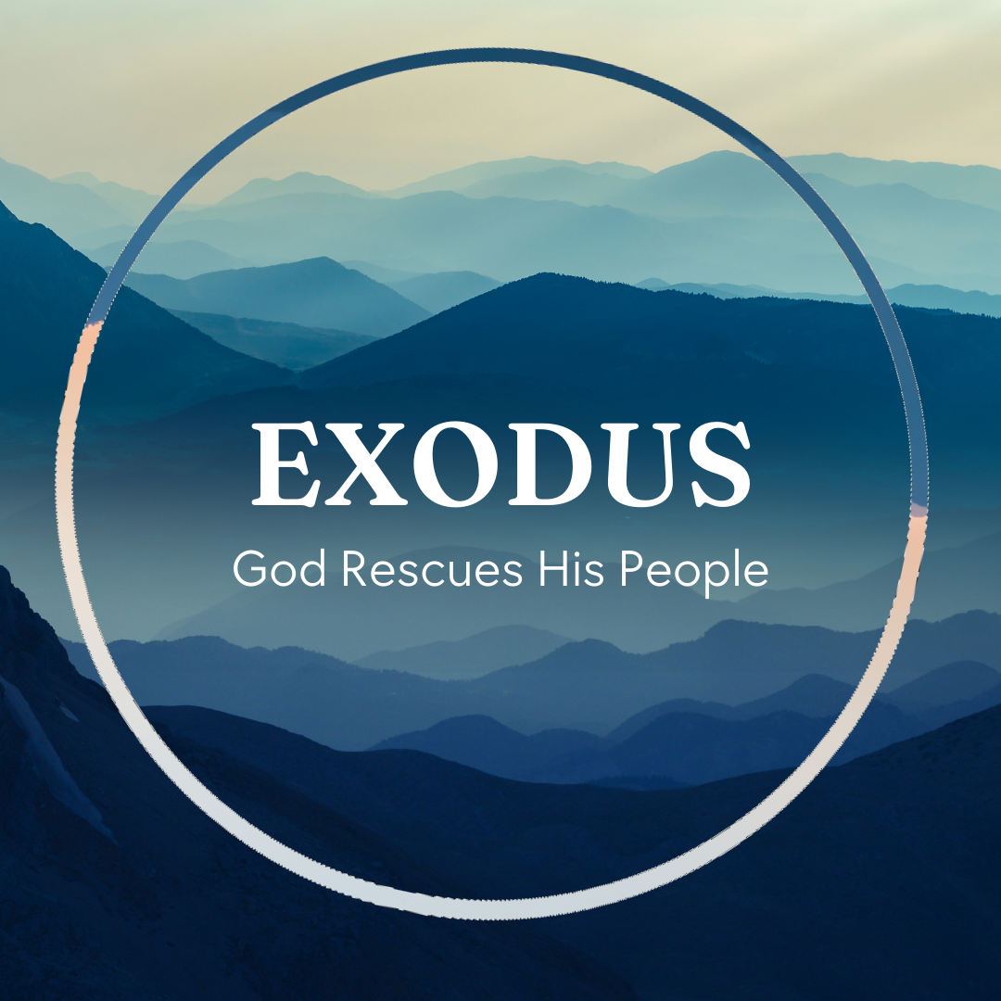

God tells us that Ezra read from the book of the Law,
day after day, and that the people of God were filled with joy!

These notes have been prepared by Rev. Philip Moffett, Cullybackey RPC Ireland.
Monday - Exodus 1:1-7: God's Covenant Promises Continue

Exodus chapter 1 verse 1 is a continuation of the Genesis account. The book of Genesis finished with Jacob, his sons, and their families having come down to Egypt. But this raises a serious question - "what has happened to the promises of God?" Will God keep His promise when it looks like all is lost? What we find is that Exodus is more than just the continuation of the story of a family, but it is the continuation of God's continued dealing with His Covenant people. God's promises to Abraham are still being fulfilled. Exodus is a continuation of what God is doing in saving a people for Himself.
Verses 1-7 show us that God is continuing to keep His promise of blessing His people. Just over 100 years have passed since these 70 people came down to Egypt until the time when a new king rose over Egypt who did not know Joseph. But during these years, we are told in verse 7, the people of Israel were fruitful and increased greatly; they multiplied and grew exceedingly strong, so that the land was filled with them. This was part of the covenant promise given to Abraham in Genesis 12 and 17, where God said He would make him into a great nation, he would have descendants as numerous as the stars in the sky. In Genesis 35:11 God said to Jacob, "I am God Almighty; be fruitful and multiply. A nation and a company of nations shall come from you, and kings shall come from your own body". God continues to keep His covenant promises, even when His people are living in a foreign land. But this is also going to set up for us the great deliverance that God will bring to His people. God is going to set them free.
Wonderfully, this also makes Exodus our history. This is the account of God's people, His church. God has worked these events for us that we might better understand and know for sure how we have been saved through Jesus Christ. Exodus, through its language and pattern, is going to prepare us for the greater deliverance that we have in Jesus Christ.

Q1. In what ways has God kept His promises to you, even while you have been in difficult situations?
Q2. What should we be looking forward to most as we see God faithfully keep His promises?
Tuesday - Exodus 1:8-16: Opposition to God's People.

Just because God is faithful in keeping His promises does not mean that everything will be plain sailing. We are given a short but foreboding sentence in verse 8. "There arose a new king who did not know Joseph." The past deliverance that God brought to the land of Egypt all those years previously has now been forgotten. The new Pharaoh sees the increasing number of Israelites, and he fears that they might take over, or enter into an alliance with a foreign power and bring down Egypt's superpower status. To Pharaoh, God's people are a threat, so he opposes them. They are put into forced labour (verses 10,11,13). There is bitter hostility between Pharaoh and God's covenant people. To make matters worse, Pharaoh will have an additional plan (verses 15-16). He calls two of the Hebrew midwives to a meeting where he tells them they are now responsible for taking any sons born to the Hebrew women and murdering them. This plan will ultimately fail, so Pharaoh will then call on the whole of Egypt to enact this awful attack (verse 22).
Where does this type of opposition come from? Was it just that the Egyptian king didn't know what Joseph had done for Egypt? Did it stem from his fear that the number of Hebrews could mean Egypt would lose power? Or does the answer go even deeper? The answer is found in the one at work in this present dark age. Satan is at enmity with the seed of the woman. Back in Genesis 3:15, after the Fall, God pronounces the curse, and we are told that there are two kingdoms at war. The kingdom of the promised seed will be in opposition to the kingdom of the serpent. Christ's kingdom and Satan's kingdom are in opposition.
As God's people, we should not be surprised at the opposition we face as we live in a fallen world. The world hates us because they hate Jesus. But we also know that God keeps his promises and delivers those that He has set His love upon.

Q1. What kinds of opposition do you face?
Q2. What great hope do we have as we go through opposition (Genesis 3:15)?

Wednesday - Exodus 1:15-22: God Provides for His People

There are two surprising heroes in this first chapter, and their names are remembered and recorded in God's Word: Shiprah and Puah. Notice that we don't have the name of the Pharaoh! Pharaoh is a title, like Caesar or king. Whereas this powerful Pharaoh is just recorded for us by his title, God has forever recorded the names of these midwives. This is because God provides these two Hebrew midwives to frustrate the plans of the powerful Pharaoh, and ultimately the plans of Satan. Shiprah and Puah, who are familiar with delivering babies, will be used by God to help deliver a nation. Even though they were under Pharaoh's orders Shiprah and Puah served another king, a greater king, the Covenant God. They feared God, and so they were obedient to God. In refusing to obey Pharaoh, they say to him that the Hebrew women are strong and have very short labours, so the sons are born quickly, before they get there! These women are commended for their obedience to God and in return God blesses them. As we saw earlier, God's promises are in force, but what we must do is trust and obey, even when it is difficult. God is keeping the Covenant promises made to Abraham, and God will not break His Covenant promises, so He provides these two deliverers for His people.
Shiprah and Puah also point us to the truth that God is going to provide a deliverer. There will be one who comes from among the people, one who will deliver the people of God from the place of slavery. The offspring of the woman will crush the head of the evil one. Exodus points us firstly to Moses, the one God provides to bring His people up out of Egypt, but ultimately it is pointing us to Jesus Christ. He is the greater Moses, the greater deliverer. The nature, the pattern, and the language of deliverance is here to prepare God's people for Jesus. God the Father has provided one to deliver us from slavery, from opposition, and from death. Not even the efforts of the evil one can destroy God's plans.

Q1. What encouragement is there in knowing that God knows all about our serving King Jesus?
Q2. What comfort is there in knowing that God's plans cannot be overthrown?

Thursday - Exodus 2:1-10: The Protected Saviour
In chapter 2, a son is born. A child is born into the house of Levi, a priestly family. Yet he is a son born under oppression, a son born under a death sentence! Also, in verse 2, we are told that he is a fine child. In Acts 7:20, we are informed that this means that he was beautiful in the sight of God. Here is a child on whom God's favour rests. This is no ordinary child, but one for whom God has a special purpose. God is raising up a saviour for His people. And God is going to protect this saviour.
In Hebrews 11:23 we are told that, by faith, Moses was hidden for three months by his parents, because they saw that the child was beautiful, and they were not afraid of the king's edict. They trusted that God had a plan and purpose for Moses, and so they protected their son. After three months, they then made a little ark, placed their son in this ark, and then set him out among the reeds in the River Nile. These are parents of faith who trusted that God would protect this child.
In God's providence Pharaoh's daughter goes down to this very part of the Nile to bathe. The edict of Pharaoh, that all Hebrew boys are to be thrown into the Nile, is to be obeyed by all, which includes Pharaoh's daughter. But, she has compassion on this child. God so worked in the Pharaoh's daughter's heart that she felt pity for what was most certainly a Hebrew boy. Moses' sister, Miriam, who has been nearby, comes out of her hiding place and wisely asks the princess if she would like her to fetch a nurse maid, someone to feed and care for the child for her. Wonderfully, she agrees and Miriam brings her own mother, who has her son restored to her, and even receives payment for looking after him. Moses is now under the protection of the royal household of Pharaoh. God is protecting His servant. Every detail and every moment is planned out.
Already in this chapter, we see that we are being prepared for a greater Saviour. God, in raising up Moses, is preparing us, and pointing us to Jesus Christ, the true Saviour of God's people, who was protected in his earliest days.

Q1. In what ways was Jesus a favoured son, born under oppression and born under a death sentence?
Q2. How do we see God's providence in protecting Jesus Christ as an infant?
Friday - Exodus 2:11-22: The Prepared Saviour
Moses has been with his own family as his mother cares for him. He is taught about the God of Abraham, Isaac, and Jacob, and is instructed in the covenant promises of God. We can't be sure at what age he goes to live in the palace, but we do know that Moses knew exactly where he was from. Exodus 2:11 tells us that he went out to his people. Acts 7:23 comments on this, "it came into his heart to visit his brothers, the children of Israel." Moses knew he was from the covenant people. But he is also educated in all things Egyptian. He grows up in the palace and he is taught as an Egyptian. Again Acts 7:22, "And Moses was instructed in all the wisdom of the Egyptians, and he was mighty in his words and deeds." He has a position of privilege and wealth.
And so, Moses has a choice to make; either be an Egyptian prince and inherit the throne, or identify with the covenant people, God's people. Hebrews 11:24, "By faith, Moses, when he was grown up, refused to be called the son of Pharaoh's daughter, choosing rather to be mistreated with the people of God than to enjoy the fleeting pleasures of sin. He considered the reproach of Christ greater wealth than the treasures of Egypt, for he was looking to the reward." At the age of 40 Moses considered the covenant promises of greater worth than all the treasure of Egypt, so he identified with Christ's people, even though it would mean suffering for a time. But Moses had to learn that the salvation of God's people would not be brought about in his own strength and timing. He needed to learn that the people were not ready, and that he wasn't ready. Moses has to be prepared further. In Midian, God will continue to prepare Moses for the task of delivering God's people; 40 years of learning to be a shepherd; feeding and taking care of thousands of sheep.
God doesn't waste time. His deliverer will come at just the right time. Prepared and ready for the task given to him. In the fullness of time, God sent forth his Son, born of a woman, born under the law, to redeem those who were under the law, so that we might receive adoption as sons.

Q1. How was Jesus prepared for the task that the Father had set for him?
Q2. In what ways might we have to trust God's timing in our lives?

