Family Worship Booklet
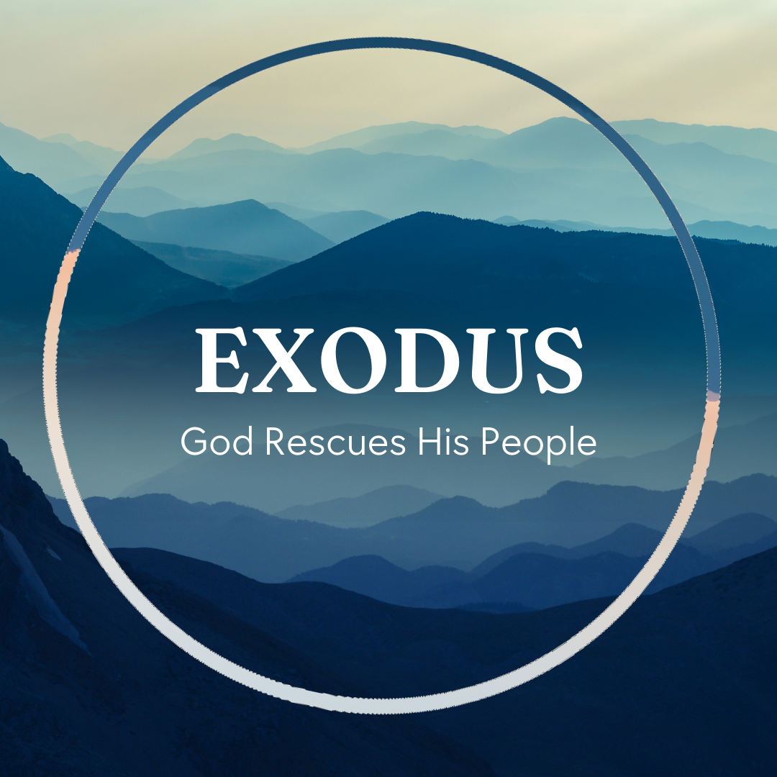

God tells us that Ezra read from the book of the Law,
day after day, and that the people of God were filled with joy!

These notes have been prepared by Rev. Philip Moffett, Cullybackey RPC Ireland.
Monday - Exodus 2:23-25 - The Purpose of the Saviour.

Chapter 2 ends with wonderfully comforting words. Did you also notice that this is the first time God is mentioned in this chapter! Although this is the first mention of God, we know that God has been working in His providence. Now, we are clearly told that God hears, God remembers, God sees, and God knows. These are covenant terms. God hears the cry that comes up from oppressed people. He is the God who hears His children. The Father is listening. What a great help this is to people who are suffering and under oppression. There is one who is in heaven, and He hears the cries of His people. God remembers. He remembers the Covenant promises He has made. He will bless us, He will make His family great, He will give us an eternal home, a resting place. This God, who keeps His covenant with His people, has promised salvation. The word ‘remember’ does not imply that God forgot and has only just now remembered. Rather, God is now bringing into action what He has said He will do. This is now the allotted time when God has promised to act. God sees and God knows. This is immensely comforting. He isn't just aware of us but is intimately involved. This is why He raises up a Saviour. The covenant God has compassion on His people and sends a Saviour to bring them up out of slavery.

All of this points us to our greater Saviour. The one who is our great high priest, who came to earth, who had the favour of God the Father on him, born into oppression, and more than just born under the threat of death, but born under the certainty of death. He is the one protected, brought down to Egypt and then back up out of Egypt. He grew in wisdom and stature. He was mighty in word and deed. And he identified himself with his people. He left the glories of heaven. The royal son made himself nothing, taking the form of a servant. He identified with his people so that he might deliver us and set us free. All of this was in God's perfect timing. God hears, remembers, sees, and knows. And He has provided a Saviour for us - Jesus Christ.

Q1. What was the purpose of God in sending Moses? What is the purpose of God in sending Jesus Christ?
Q2. Why is it good to remember that God hears our cries, remembers His covenant, sees His people, and knows?
Tuesday - Exodus 3:1-12 - Revelation, Reluctance, and Reassurance (1).

Moses, God's chosen deliverer, is far away in Midian and seems to be very reluctant to return to Egypt. And so, God makes himself known to Moses in a conversation that runs from verse 1 of chapter 3 down to end of verse 17 in chapter 4. On this particular day, Moses is up on Mount Horeb, which is also called Mount Sinai, and he sees an unusual sight. A thorn bush is burning, but it isn't being consumed by the fire. We are told that this fire is the very appearance of the LORD. Out of curiosity, Moses moves closer when he hears a voice calling him, then God says, "Do not come near; take your sandals off your feet, for the place on which you are standing is holy ground." Moses meets God. Or, perhaps more accurately, God makes himself known to Moses.

God reveals to Moses that He is holy. The word holy means set apart or pure. It is holy ground and fire often symbolizes God's brilliant perfection, His unapproachable light.

God reveals that He is gracious. The fire is raging, but the bush is not being burnt up. God is a consuming fire, but the bush is still living. And the same can be said for Moses. He is before the holy God, but he is not consumed. God has been gracious and given access to Moses.

God reveals that He keeps his promises. Verses 6-7. God sees, hears, and knows. The LORD, the Covenant God, is going to fulfill the promises He has made.

God reveals that He is the saving God. Verse 8. He will save a people for Himself. He is the God who delivers His people. But Moses is reluctant. In verse 11, Moses makes his first excuse, "Who am I?" So, God reassures Moses in verse 12, "But I will be with you." What great reassurance as God calls on His deliverer to fulfill the task of bringing the people of Israel out of Egypt. God will go with him. And just as God has promised, so He will do. Jesus Christ willingly was sent as the one, true deliverer, and in Jesus Christ we too are sent to bring the Good News to others. Just as God has made known who He is to us, so He sends us with the Good News. Let us not be reluctant like Moses, but willing like our Saviour.

Q1. What kinds of excuses can we make to God?
Q2. Why is it reassuring to know that God is with us?
Wednesday - Exodus 3:13-22 - Revelation, Reluctance, and Reassurance (2).

Moses is still reluctant. This time his excuse is that he doesn't know the name of God.

God reveals Himself as the Covenant God, the LORD. When we read the name LORD in the Bible, this is referring to the name Yahweh, the special name of God as the God of promise. Repeatedly in this section we are told that the LORD is God of Abraham, Isaac, and Jacob. God is saying, I am still keeping that promise. God calls himself "I AM WHO I AM." This the name that is connected to the name LORD in capital letters, or Yahweh. God is the eternal God who always is, the living God, the God of promise. This promise is reaffirmed in verse 17, "I will bring you up out of the affliction of Egypt to the land…flowing with milk and honey"
.
God reveals Himself as the sovereign and all-knowing God. In verses 19-22, God tells Moses that He knows the king of Egypt will not let the people go, unless he is compelled to do so. God knows that His people will be set free after the plagues. God knows that they will not leave Egypt empty handed. But how can God know all these things? The answer is because He is in control. God is in control of all things. And God will work all of these things together for the good of His people and for His own glory. What a reassurance this must have been to Moses, as he prepared to return to Egypt. Who is the God who goes with him? It is none other than the eternal, covenant keeping, sovereign, all knowing God. The God who delights to save His people. Surely now Moses will be ready to return to Egypt to fulfill the task that God has prepared for him to do! God calls us to follow Him through Jesus Christ. This includes being His witnesses, living holy and blameless lives, being ready to forgive just as we have been forgiven. Perhaps we can make excuses or think of reasons as to why we can't obey at this stage. But we are also to remember that it is the same God who is with us, as He was with Moses.

Q1. In what ways are we called to follow and obey God?
Q2. How does it help to know that God is the same God that was with Moses?
Thursday - Exodus 4:1-9 - Revelation, Reluctance, and Reassurance (3).

Moses' reluctance seems to know no bounds. This reluctance is now expressed in the supposed unbelief of the people. "What if they don't believe me?" This is the third objection, or excuse, that Moses has raised. But, we have to remember that God's people have been experiencing slavery and oppression. They have had it tough. They have been suffering. And so maybe Moses has a point. They might not want to listen about a God who seems to have forgotten about them for so long. Why would they want to listen about a God who has not helped them in their suffering?

So, God reveals himself as the powerful God. He provides Moses with two signs to perform so that his people will believe. The first is that Moses is to throw down his staff and it will turn into a serpent. Moses is then to pick the staff back up again. The serpent is a representation of evil. It was a serpent that Satan inhabited to tempt Eve, and Pharaohs were represented by serpents. God is saying, ‘I will give you power over the enemy. I will supply what is needed to tame the serpent.’

The second sign is that Moses puts his hand into his cloak, and when he takes it out it is covered in leprosy. But when he puts it back into his cloak and removes it, it is healthy. God is saying, ‘I am the God who will bring death, but I also bring life.’ God is powerful. ‘I am the God who can and will do all that I have said.’

Through God the Son, we see what God is like. God is the powerful God who defeats sin and death. In Jesus Christ, we see the holiness of God, the grace of God, His promise to save, and His power to save. God has made Himself known. We have His revelation. Here is the reassurance for Moses. He doesn't come with just words, but signs. He can show the people that God does care, that God will defeat the serpent, and that God will bring life to where there is death. As we go and bear witness, we have this sign - Jesus Christ who died on the cross and rose again. God defeats sin and the power of death. God gives life, eternal life. Be reassured - God is powerful, God is the one who can save.

Q1. Why might we use the excuse that people will not believe God's Good News?
Q2. What great sign has God given to us that He is the God who saves?
Friday - Exodus 4:10-17 - Revelation, Reluctance, and Reassurance (4).

Moses isn't finished with his excuses. There are two more he would like to make! His fourth excuse is found in verse 10. ‘I don't have the gifts. That's really not my strength. I don't know if I could do that. I feel very insufficient to do what you have asked me to do. I'm not able to do it.’ His last excuse is in verse 13, "please send someone else." ‘I don't want the responsibility. Anyone but me.’ As we look at these excuses it is amazing to think that Moses believes he knows better than God. ‘God, you have chosen the wrong person. God, you have made a mistake in having me here at this time. God, you don't know what you're doing, let me put you right on a couple of points.’ At the heart of Moses' reluctance is his belief that he has better reasons to disobey God than to obey God. It is as if Moses is saying, ‘God, it is better for me to disobey you than to do what you tell me to do.’

The holy, gracious, promise-keeping, saving, power-working God calls us to specific tasks. We are called to follow and live obedient, worshipful lives. We are called to serve, to witness, to fellowship together. We are called to give ourselves, and serve our King and Saviour. Yet, we too can make excuses. ‘I'm not good enough. I don't know enough; I don't have the abilities that others do. I'm just not sure God has me in the right place. Please Lord, just use someone else.’ Like Moses, we can make sinful excuses.

But, God reassures Moses again. This time letting him know that he is not alone. Verse 12, "I will be with your mouth and teach you what you shall speak." God is going with Moses and will help him. And God is also going to give him human help, Aaron, his brother. Moses will enjoy fellowship with Aaron to help him, and the very presence of God will be with him.
We, too, have these wonderful gifts from God. His presence with us by the Holy Spirit indwelling us, teaching us, comforting us, and the fellowship of our brothers and sisters in Christ. As we are called to serve and live for Christ, remember He is with us, and we have the fellowship of believers.

Q1. In what ways might we think we have better reasons to disobey God than to obey?
Q2. What help does God give to us as we serve Him?

