Family Worship Booklet
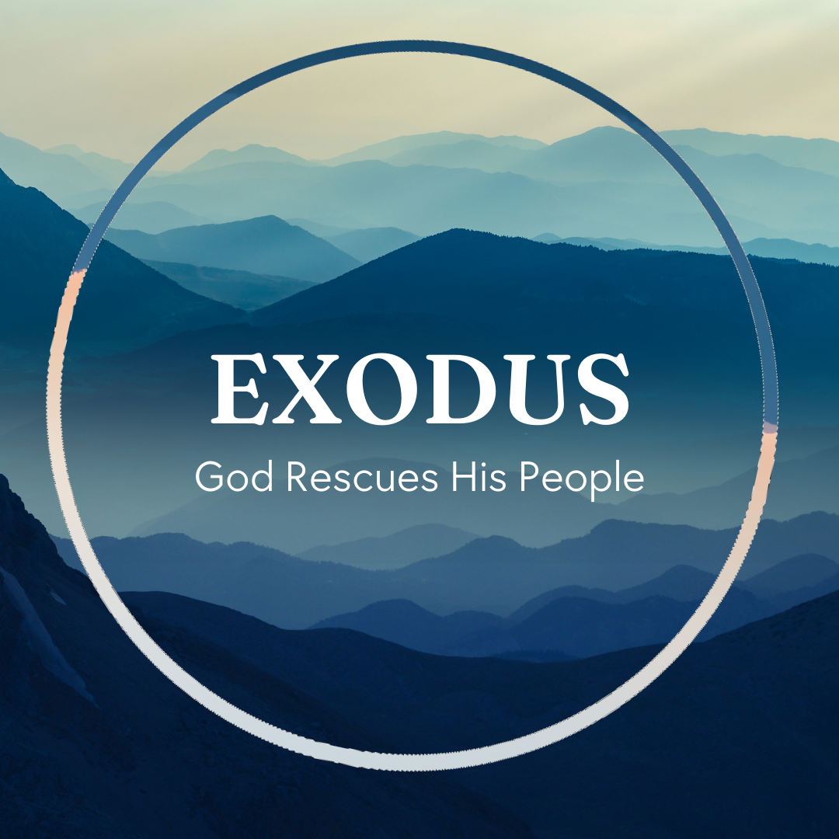

God tells us that Ezra read from the book of the Law,
day after day, and that the people of God were filled with joy!

These notes have been prepared by Rev. Philip Moffett, Cullybackey RPC Ireland.
Monday - Exodus 4:18-26 - God's Covenant Working.
Today's passage is difficult. It all seems very strange and difficult to understand, and this is before we ask what this has to do with us! But this is all to do with God's Covenant working. We see firstly that God punishes the Wicked. God will say to Pharaoh, "Let my son (Israel) go that he may serve me. If you refuse to let him, behold, I will kill your firstborn son." God is going to bring judgment on the wicked. This idolatrous, proud, wicked regime was holding Israel captive. So, God gives Pharaoh an opportunity. ‘Let my people go or remain in your sin and suffer the consequences of your sin.’ God's decision to harden the already unbelieving heart of Pharaoh leads to a deserving condemnation. The same is true for Moses and his family as they make their way back to Egypt. God is angry and seeks to put him to death. The problem is that Moses has not kept the covenant obligations of circumcision. Moses has failed God. All those who have broken any part of God's law deserve punishment.
Secondly, we see that God saves his people. Jacob and his descendants are God's firstborn. Firstborn is a title. It is the relationship between the Covenant God and His chosen one. The chosen one is in the position of a firstborn son, with his privileges and inheritance. Zipporah, aware that God judges the wicked but saves His people, circumcises her son, so that in obedience to the Covenant demands, he might be recognised as one of God's people, a firstborn son. Zipporah acknowledges that, apart from the shedding of blood, there is no relationship, no salvation. This strange event points us to Jesus Christ. He is the firstborn son, not created, but the eternal Son of God, who has been given a position of honour. And he is our bridegroom of blood. The one united to us because of his death on the cross. He is our bridegroom of blood, and we are his bride. There is no relationship with God outside of the cross of Christ. If we have not come to Him trusting in His way, then we are still enemies and deserving of wrath. Since the cross, there is no need for shedding of blood, and so the sign of the covenant has changed to baptism. God reminds us that we are either in His covenant community, His firstborn, or we are the wicked who deserve to die.

Q1. Why is it wrong to compare our 'goodness' to those around us?
Q2. How do Zipporah's actions reveal her understanding of God's covenant family?
Tuesday - Exodus 4:27-31 - Moses Returns to Egypt.
What is to be our response to the work of God? We have seen Moses' reluctance and his failure to keep the covenant obligations. Moses failed in these areas. Exodus would be a very short book if God was not gracious and forgiving! As Moses returns to Egypt, he meets with Aaron, and the first thing we are told is that “Moses told Aaron all the words of the Lord with which he had sent him to speak, and all the signs that he had commanded him to do.” Moses is now obedient and willing. The Covenant God has appeared to Moses, He has been gracious to Moses, He has equipped Moses, and now Moses is the obedient servant. We are to seek to be obedient, knowing that it isn't our obedience that saves us, but only the gracious working of the Covenant God through Jesus Christ our Saviour.
Our second response is to be one of worship. As the journey to Egypt continues, Aaron and Moses go to the elders of Israel. Aaron speaks all the words that the LORD had spoken to Moses, and he does all the signs in the sight of the people, and they believed; they bowed their heads, and they worshipped. This worship comes from the realisation that the Covenant LORD has seen and heard. In response to God's gracious covenant love and working, they bow their heads and worship.
God knows our suffering, our slavery, our affliction. God the Lord has paid attention, and He has brought salvation to us through Jesus Christ. In Jesus Christ, we have been set free, we have been adopted as sons and daughters, firstborn sons and daughters, with all the privileges and the inheritance of a firstborn child; and we have been united to Christ through his blood - we are his bride. God's covenant love has been set on us. The Covenant God remembers His promises, and He works salvation. So let us then be obedient and worship His great and glorious name.

Q1. Name some of the blessings that we have in God's Covenant family.
Q2. Spend time worshipping and thanking God for all He has given us in Jesus Christ.
Wednesday - Exodus 5:1-9 - Waiting Patiently.
As we come to the end of chapter 4 of Exodus, everything seems to be going well. God has chosen Moses, He has told Moses to set the people free from slavery, and He has promised that He will be with Moses. The people are ready. Moses is ready. Aaron is ready. Surely now is the time when God will set His people free. Now is the time when the Covenant LORD will act and deliver them out of slavery. Or is it?
Moses goes to Pharaoh, and Pharaoh refuses to let the people go! What a disappointment this must have been to the people of Israel. Later, Moses will even question God about this very thing (verses 22-23). He was being prepared for this moment for 80 years, and now, instead of God's people being set free, life will get harder.
Chapter 5 is about living in a culture of hostility. Patiently waiting for God is not easy. Trusting in God's providential ruling is not always comfortable.
Pharaoh mocks God's name (verse 2) and mocks the worship of God (verse 8). It is as if Pharaoh is saying, “There is no God, I don't have to obey him, and worshipping him is a waste of your time, and mine.” This sounds like the culture in which we live today; there is hostility to the Word of God. Pharaoh then makes life more difficult for God's people. They must gather their own straw to make bricks for Pharaoh. A time-consuming, difficult task.
Sometimes, when we are seeking to live for Jesus Christ, we find that the culture of the world is against us. But don't be discouraged because chapter 5 will be followed by chapter 6.

Q1. Why is Pharaoh's response to Moses a disappointing surprise for Moses?
Q2. In what ways have you found it hard to stand up for Christ and his truth?
Thursday - Exodus 5:10-19 - Life Keeps Getting Harder.
The culture of hostility that exists between Pharaoh and God's people becomes even more hostile and dangerous. Pharaoh expects more and more from the Hebrews, and all the while, he exerts harsher restrictions on them. They have to continue making the same number of bricks as before, but with harsher restrictions applied to them.
Pharaoh demands that God's people should be serving him first; they should be giving their time and energy to Pharaoh and his kingdom. And most of all, they should not have in their minds this notion that they are to go and worship the LORD (verse 17-18).
This again sounds very much like the society and culture in which we are living now. Our culture demands that we follow their rules and standards. Our culture seeks to restrict our worship and Christ-like living by saying to us, "keep your religious life to your own private time, and most of all, it is not to have any impact on your day-to-day living." It is becoming harder and harder to live for Jesus Christ.
And yet, in all of this, we should not be surprised. Jesus said to his disciples, even though he would be with them to the very end of the age, the world would hate them because it hates him.
We are not promised an easy life. Rather we will face a culture that is hardened to the truth of God's Word. We will face a culture that is set against Christ and his people. Our laws, rulers, bosses, family members, all those who say, "I don't know your God. I don't care for his worship. I don't believe his word. And I hate you, his people." But remember, chapter 5 will be followed by chapter 6.

Q1. What are some of the ways we face hardship from the world?
Q2. Why should we not be surprised by this opposition?
Friday - Exodus 5:20-23 - Questioning God.
It can be very confusing living for Jesus Christ and, at the same time, being hated by the world. Moses was confused. He was promised by God that He would set His people free from slavery in Egypt. Moses was promised that God would bring His people out to worship Him in the wilderness. God promised that He would be with Moses. But what does Moses experience? Hardship, difficulty, and confrontation from God's people! So, Moses questions God (verses 22-23), ‘Why have you done this?’
It is hard to understand why God doesn't work the way we expect or want Him to. It is hard to understand why God's plans are not our plans, especially when our plans seem so good!
Look at the difference between chapter 4:31 and 5:21. From bowing their heads in worship, the people confront Moses and question God's plan. Why? Because life is hard. Because they "stink" before the world. Because they live in a world that hates God's Word and will try to discourage them in their faith. Because Satan loves to try to make us doubt God's plan and purpose. Even Moses questions God.
There are perhaps times when you have questioned God. Is this really God's plan? Is this really what God wants for me, for our church? Like the people and like Moses, you are discouraged in the circumstances in which you find yourself. Churches or congregations can fall into this trap. When things aren't easy or things aren't going well, they blame the church leadership, or they question God's goodness. When we "stink" before the world, let us remember that chapter 5 is followed by chapter 6.

Q1. Why does Moses question God?
Q2. Why do we sometimes get disappointed by our circumstances?

