Family Worship Booklet
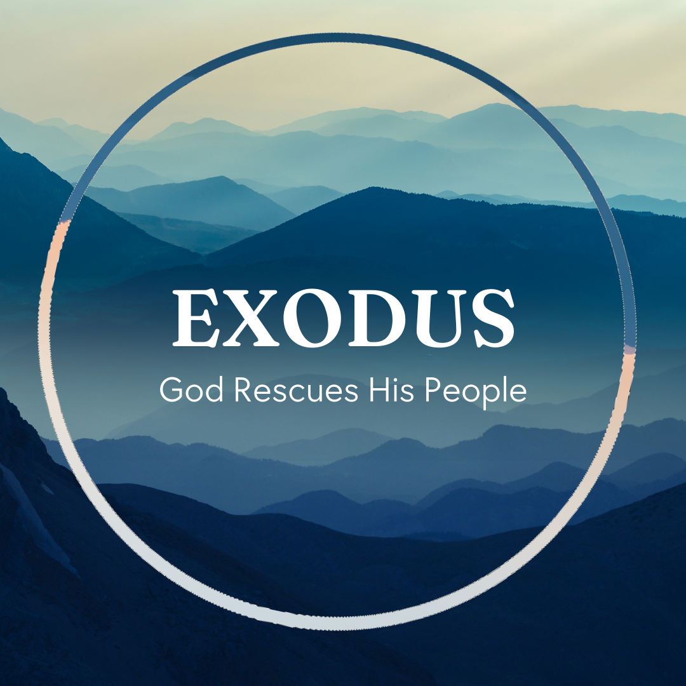

God tells us that Ezra read from the book of the Law,
day after day, and that the people of God were filled with joy!

These notes have been prepared by Rev. Philip Moffett, Cullybackey RPC Ireland.
Monday - Exodus 6:1-13 - God’s Perfect Promises and Plans.
What great comfort. Aren't we glad that chapter 6 follows chapter 5? God has His plans, His purposes, and His promises. And they are all perfect. There will be times when we are discouraged, times when we feel broken, times when we are unsure as to why God is working out circumstances in such a way. We may even question God's plan. Like Moses, we should make sure that we bring those doubts and questions to God, and then make sure that we listen to God's answer. God has His plans, His purposes, and His promises. And they are all perfect.
God doesn't explain to Moses why He was allowing His people to suffer; He doesn't tell Moses why he was chosen for this task; God doesn't justify Himself, but He does repeat the promise that He will bring His people up out of slavery. God is working all these things together for the good of His people, so that Pharaoh himself will drive them out of the land.
We must hold on to this truth. We must humbly cling to God's promises. "And we know that for those who love God all things work together for good, for those who are called according to his purpose." Romans 8:28.
John Calvin put it this way in his commentary on Exodus: "God wished to accustom his servants in all ages to patience, lest they should faint in their minds, if he does not immediately answer their prayers, and at every moment, relieve them from their distresses."
As we face discouragement, we have the covenant promises of God. God speaks again to Moses, and we can look beyond our disappointments and discouragements, and look to the promises that we have in Jesus Christ.
God has His plans, His purposes, and His promises. And they are all perfect.

Q1. What are some of the promises that God has for us?
Q2. What comfort does it bring to you, knowing that God always keeps His promises?
Tuesday - Exodus 6:14-30 - Pointing Us to Christ.
Sometimes we come to a passage in the Bible that makes us wonder, "why does God have this here?" That is how we might feel about today's reading; a list of names that seems to break up an exciting account of the confrontation between Moses and Pharaoh. But this list of names is not a pointless list. Like all of Scripture, it is here for our good, and to point us to Jesus Christ. Verses 26-27 tell us that this family tree is here so that we can be sure that Moses and Aaron were God's chosen servants, called to lead the people out of slavery. Before the final confrontation with the enemy, we are to be absolutely sure that this is God's chosen Servant. The servants are prophets in that they are bringing God's Word to God's people and to a fallen world.
Verses 26-29. The servants are also from the priestly family. The focus of the family tree is Levi and his family line. Down through Levi's family line and down through Aaron, who was set aside for the office of priest, we have the priestly family. Here are the intercessors for God's people before God. Even Moses can be considered a priest. Psalm 99 verse 6! God's unique servant, who will deliver His people from slavery, will be chosen by God, a prophet and priest, one who will bring truth and be the intercessor and sacrifice for sin.
When we come to the New Testament, we find that Jesus is this servant. And unlike Moses, who was unwilling (notice the pattern for verses 10-12 and 28-30), Jesus was completely willing. Psalm 40, "Here I am, I have come as written in the scroll. I delight to do your will, O my God." The purpose of this passage is to point us forward to Jesus Christ, and to give us confidence in knowing that he is the sufficient and unique saviour of his people. The one who will confront the enemy for us is this Jesus Christ. God's plans, purposes and promises come through Jesus Christ. There is no one else.

Q1. In what ways were Moses and Aaron God’s chosen servants?
Q2. How does Jesus perfectly fulfill the role of promised Saviour?
Wednesday - Exodus 7:1-13 - Hard Heart.
Before the plagues, we are given an insight into what will happen, verses 3-5. God will harden Pharaoh's heart. Even with the weight of overwhelming evidence to the power of God, Pharaoh will not listen. But God will deliver His people, and, in the end, all Egypt will know that He is the LORD. The heart of the wicked is hardened, but God will deliver His people. God's Word makes it clear that God is sovereign over death and life, including spiritual death and spiritual life. In Romans 9:14-18, Paul is commenting on Pharaoh's heart, "God says to Moses, 'I will have mercy on whom I have mercy, and I will have compassion on whom I have compassion.' So then it depends not on human will or exertion, but on God, who has mercy."
Pharaoh is a man who was unmoved by the Word of God. He is a man whose heart grew harder to the Word of God. By his continual rebellion and by his refusal to humbly cry out to God for forgiveness for his sin, he hardened himself against the truth. This is a warning for you if you are not a Christian. Every time you sit under the ministry of God's Word and refuse to come to Christ, you are hardening your heart.
Even with the hardness of Pharaoh's heart, God's plans of salvation cannot be undone. God will deliver His people. There will come a day when God will gather all His redeemed together.
The evidence of God's power to save is before us in Jesus Christ, who died and rose again. Our only hope is that God changes our hard hearts, and brings deliverance to us, before that day when all the world will bow the knee before Him and know that He is LORD.

Q1. In what ways can we harden our hearts to God's Word?
Q2. How can a hard heart be changed (Ezekiel 36.26)?
Thursday - Exodus 7:14-8:19 - The One, True God.
Before the plagues were sent, we are given an insight into what will happen, chapter 7:3-5. God will harden Pharaoh's heart, but in the end all Egypt will know that He is the LORD. The 10 plagues will display the delivering power of God. This is a key event in Scripture. We could divide the plagues into 3 groups of 3 climaxing with the 10th plague. In each group of 3, the first plague is announced early in the morning, the second plague is announced in the palace ("go into Pharaoh"), and the last plague in each group comes unannounced.
There is something very significant about these plagues. God is bringing His judgment on Pharaoh and is demonstrating his power over all the gods of Egypt. Numbers 33:4, "the Egyptians were burying all their firstborn, whom the LORD had struck down among them. On their gods also the LORD executed judgments." The plagues were deliberate judgments that struck at the heart of Egyptian worship and showed the LORD to be the one true God.
The first 3 plagues – the Nile turning to blood, frogs, and gnats (lice) - demonstrated God's power over the Nile gods and over the earth. The river turned to blood for 7 days and became a stench to the people of Egypt. God makes a stink out of the gods and goddesses who control the Nile. The Nile also brought fertility, and one of Egypt's goddesses, Heqet, the goddess of fertility, was often depicted with the head of a frog. But only God the LORD could bring forth and remove frogs. Geb was one of Egypt's earth gods, but the LORD turns the dust of the earth into gnats, or lice. God is showing the Egyptians, and the Israelites, that He, and He alone, is God. They have to say, "this is the finger of God." We serve the same God today. God is still in control, and all other gods are as nothing before Him.

Q1. What are some of the false gods which we can follow/worship today?
Q2. What confidence should the plagues give to us as we live in a world where people trust in false gods?
Friday - Exodus 8:20-9:12 - God’s People Spared.
There were about 80 different false gods and goddesses in ancient Egypt, and each one had a specific role and function, but generally they can be placed into 3 groups. These gods and goddess controlled various aspects of the Nile, the land, and the sky. In the next set of 3 plagues, we see God sending flies, the death of livestock, and boils. The earth is being brought under the judgment of God. God displays His power over Egyptian gods like Kepher (a flying beetle), Apis (a bull), and Imhotep (god of healing). Pharaoh, and all of Egypt, will know that God is "the LORD in the midst of the earth", verse 22. God, in His revelation, is giving an opportunity for the people of Israel to turn in repentance and faith. Although they will fail to take the opportunity.
God is also acting in the course of these events to show a distinction between Egypt and His own people in the land of Goshen (an area of Egypt). In verse 23 we are told that God is making a division between His people and the Egyptians. Where the Egyptians have suffered water turning to blood, frogs filling their houses, annoyance of gnats, infestation of flies, death of livestock, and horrible boils, God's people have been kept free from these. There is no judgment for the people of God. God alone has the power over life, livestock, and sickness. It is God alone who works out His great and mighty deeds on the earth. It is God alone who keeps and protects His people.
There is a distinction between those who belong to Christ and the world. We will not face the eternal judgment of Christ if we turn in repentance and faith. We are protected because he has already taken the punishment for us.

Q1. In what ways does God reveal that He is in the midst of the earth? Where do we find the full revelation of God?
Q2. Why do you think it was important that God was showing Egypt that there was distinction between them and God's people?

