Family Worship Booklet
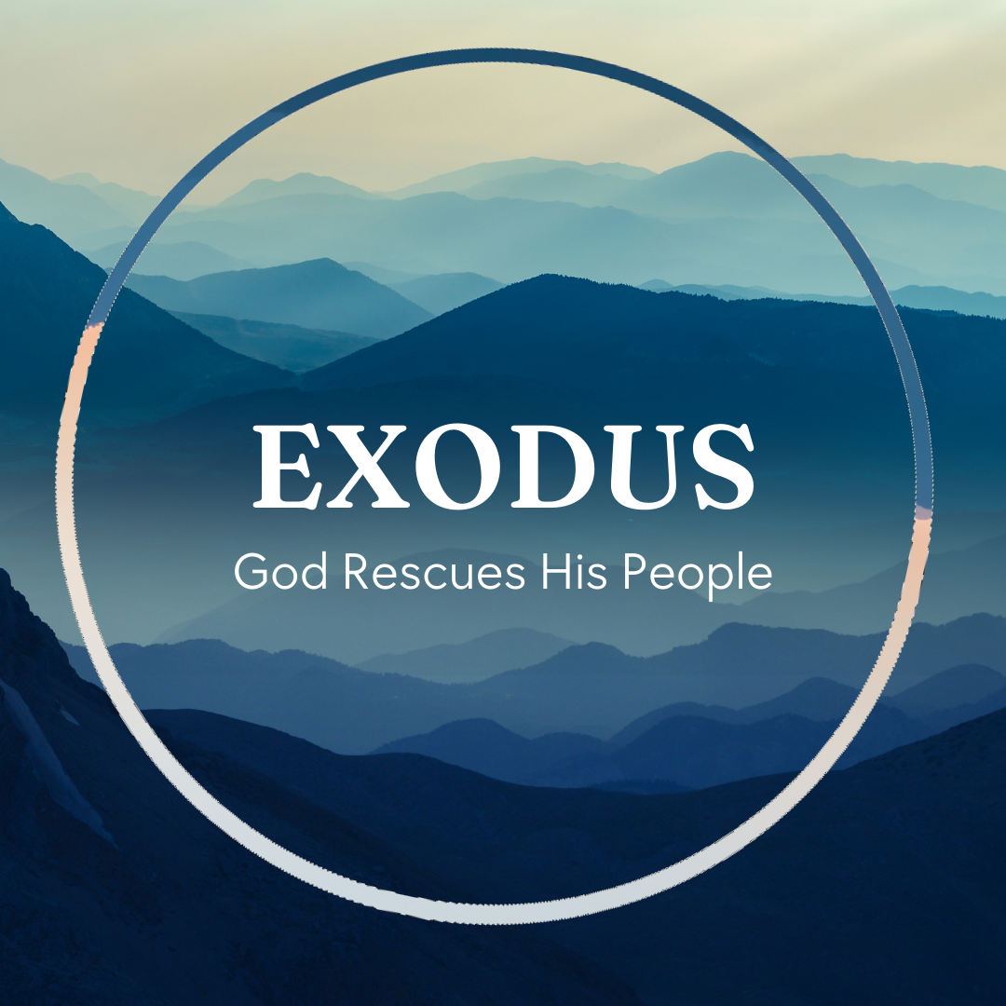

God tells us that Ezra read from the book of the Law,
day after day, and that the people of God were filled with joy!

These notes have been prepared by Rev. Philip Moffett, Cullybackey RPC Ireland.
Monday - Exodus 9:13-10:29 – The One in Control.
As the plagues continue there appears to be an increased intensity. But also, there appears to be a greater hardening of Pharaoh's heart. The god worshipped most by Egyptians was Pharaoh himself. He was believed to have the heart of a god, and his son was the son of god. Also, as Pharaoh, he was seen as the one who had control over the created things. When Pharaoh ruled, there was to be order and not chaos. But continually God shows that He is the one in control of all creation.
The next 3 plagues include hail, locusts, and darkness. The hail storm will show that there is no one like the LORD in all the earth; it will display His power, and cause His name to be proclaimed in all the earth. Not even the Egyptian weather gods could perform such wonders. The locusts devoured what remained after the hail storm. The Egyptians are in a desperate state. Pharaoh's servants even have the tenacity to question Pharaoh's reluctance to let the Israelites go! Egypt's gods, Min, Isis, and Anubis, the gods of fields and harvest, have no power. And then darkness comes over the land. A terrifyingly deep darkness. Amon-Re was the Egyptian god who was supposed to have life giving power when the sun rose every day. Pharaoh was considered the son of Re. But not even the biggest of all Egyptian gods could stand against the LORD. “the earth is the LORD's.” (9:29).
How wonderful when we come to the New Testament that we are told in Colossians 1:16-17, "For by him (Jesus Christ) all things were created, in heaven and on earth, visible and invisible…all things were created through him and for him. And he is before all things, and in him all things hold together." Jesus Christ is the one in whom the whole of creation holds together. He sustains the world by his word. This includes his power over all things, including the plagues of Egypt. All of this happens so that we may know he is the LORD in the midst of the earth.

Q1. What comfort do we find in knowing that Jesus Christ holds all things together?
Q2. Are there any areas in your life where you are trusting more in false gods than in the LORD?
Tuesday - Exodus 11 – Warning.
Each plague struck at the heart of Egyptian worship. The plagues hit at the heart of every area of life that was supposed to be protected by Egypt's gods. God was clearly showing that He, and He alone, is God. He is the LORD in the midst of the earth. Yet each time Pharaoh refused to obey and bow the knee. So, God acted as He had said He would. God does not make idle threats. God means what He says. However, there is one more plague that God will send. The plagues teach us that the mighty God does not lie. He does not make idle threats. God means what He says. It was now too late for Pharaoh; there was no request to let God's people go - only a statement of coming judgment.
Take warning. Listen. Respond. We need to tell people, make it clear to them that God's warnings of judgment are real warnings to be taken seriously. God is the LORD, and He will not share His glory with another. If we continue to prioritise our time, energy, and worship to anything or anyone other than God then we must see ourselves in the place of the Egyptians. However, as it is still today, there is still time for us to repent. The final judgment has not yet arrived.
As the last plague unfolds in Egypt, we are also pointed to the one who took the punishment for us, so that we might be saved and set free. In this last plague we will be pointed to Jesus Christ, the lamb of God, whose blood was shed for us. We must take a warning from these plagues. God does not give idle threats. Let us turn to the Father through Jesus Christ before the final judgment arrives. Do not harden your hearts.

Q1. How do God's mighty acts in Egypt encourage us when we are living in a world filled with false gods?
Q2. How does God's final pronouncement of judgment challenge us as we read his Word?
Wednesday - Exodus 12:1-28 - The Lamb That Was Slain.
The final plague is approaching, but before it is sent the instructions of the Passover are given. In fact, the instructions are given twice in this section. The LORD instructs Moses and then Moses gives the instructions to the people.
A lamb was to be taken for each household. It was to be a lamb without blemish, that is with no faults. The lamb was killed, roasted, and completely devoured; and the blood was spread on the door frames of the house.
God's people needed a perfect substitute and a perfect sacrifice. If they were to escape from the coming judgment of death, then this was the only way. They had to take shelter under the blood of the lamb.
The Passover was also to be a continual remembrance for God's people. They were to remember the wonderful works that the LORD had done for them.
The need for a perfect substitute reminds us of our own spiritual state. We cannot save ourselves. We cannot escape the coming judgment of God by ourselves. We need a perfect lamb, one that became a sacrifice for sin, one whose blood was shed; so one that becomes a substitute for us.
When Jesus began his public ministry, John the Baptist declared, "Behold, the lamb of God, who takes away the sin of the world." (John 1:29).
It is only in Jesus Christ that we find refuge from judgment. It is only because his blood was shed for sin do we find that judgment will pass over us.
Now we remember his death and our redemption, not through a Passover meal, but in the Lord's Supper. When Jesus instituted the Lord's Supper he said, "do this in remembrance of me." (Luke 22:19). Every time we take the cup and the bread, we do so in remembrance of him.

Q1. Why was it important for the people of Israel to remember this great event?
Q2. How are we commanded to remember the greater deliverance in Jesus Christ?
Thursday - Exodus 12:29-51 - Deliverance and Judgment.
"At midnight the LORD struck down all the firstborn in the land of Egypt, from the firstborn of Pharaoh who sat on his throne to the firstborn of the captive who was in the dungeon," (verse 29). These are terrifying words. God's judgment on Egypt shows just how serious sin is. Sin deserves death. And there is no distinction between the rich and poor. From the throne of Pharaoh to the lowest prison, all are guilty, and all deserve death. In chapter 4:22-23, God had told Pharaoh that Israel was His firstborn son, and that Pharaoh was to let His son go. If Pharaoh disobeyed, then God would kill Pharaoh's firstborn son. God has kept His word. God has brought His judgment on a sinful, wicked people.
But this judgment has also brought about a great deliverance. God's people have been set free, and set free with great blessing (verses 35-36)! The LORD kept watch over His people and delivered them through judgment.
Through the judgment of the cross, God the Father has provided deliverance for all of His people. Not just deliverance, but we receive an abundance of blessing. In Jesus Christ we have every spiritual blessing; forgiveness of sin, love of God, adopted into His family, access to the Father, the fellowship of His people, eternal security, and the list could go on and on!
Our sin deserves the punishment of death and everlasting wrath, eternal separation from God. Yet, how wonderful that God the Father sent God the Son to take the punishment that we deserve, so that we could be set free with an abundance of riches. The Father did not spare His own Son for us. The terrifying coming judgment for all who are guilty holds no terror for those who are in Jesus Christ. Where is your hope and confidence?

Q1. Why do we not like to think, or talk, about the final judgment of God?
Q2. What, or who, is our only hope and confidence?
Friday - Exodus 13:1-16 - Set Apart.
After the 10th and final plague, God tells Moses in chapter 13:1-2, to "Consecrate to me all the firstborn. Whatever is the first to open the womb…is mine." God had demanded the death of the firstborn, but through the sacrificial lamb the firstborn of Israel was set free. They belonged to God - not just freedom from punishment, but set apart by God as His treasured possession.
This practice of setting apart (consecrating) was to continue on into the Promised Land. The firstborn was to be set apart and redeemed with a sacrifice. A price had to be paid to set them free. They belonged to God.
The whole of Israel is described as God's firstborn son, so it is right to say that all of Israel belongs to God. All of Israel owe their lives to God. Through the sacrificial lamb, the price was paid to set them free from slavery, and now they are God's treasured possession.
As we come to the New Testament, we find that Jesus Christ, God the Son, became the firstborn for us, and this firstborn paid the price for all his people. In Jesus Christ, we are not just set free but also set apart. We are God's treasured possession. Paul says in 1 Corinthians 6:19-20, "We have been bought for a price, now we are not our own."
The Heidelberg Catechism asks in question 1, "What is your only comfort in life and death?"
The answer, "That I, with body and soul, both in life and death, am not my own, but belong unto my faithful Saviour Jesus Christ; who with his precious blood has fully satisfied for all my sins, and delivered me from all the power of the devil…and makes me heartily willing and ready, henceforth, to live unto Him."
We have been delivered and set apart that we might live unto Him.

Q1. What lessons do we learn from the consecration of the firstborn?
Q2. What is your only comfort in life and death?

