Family Worship Booklet
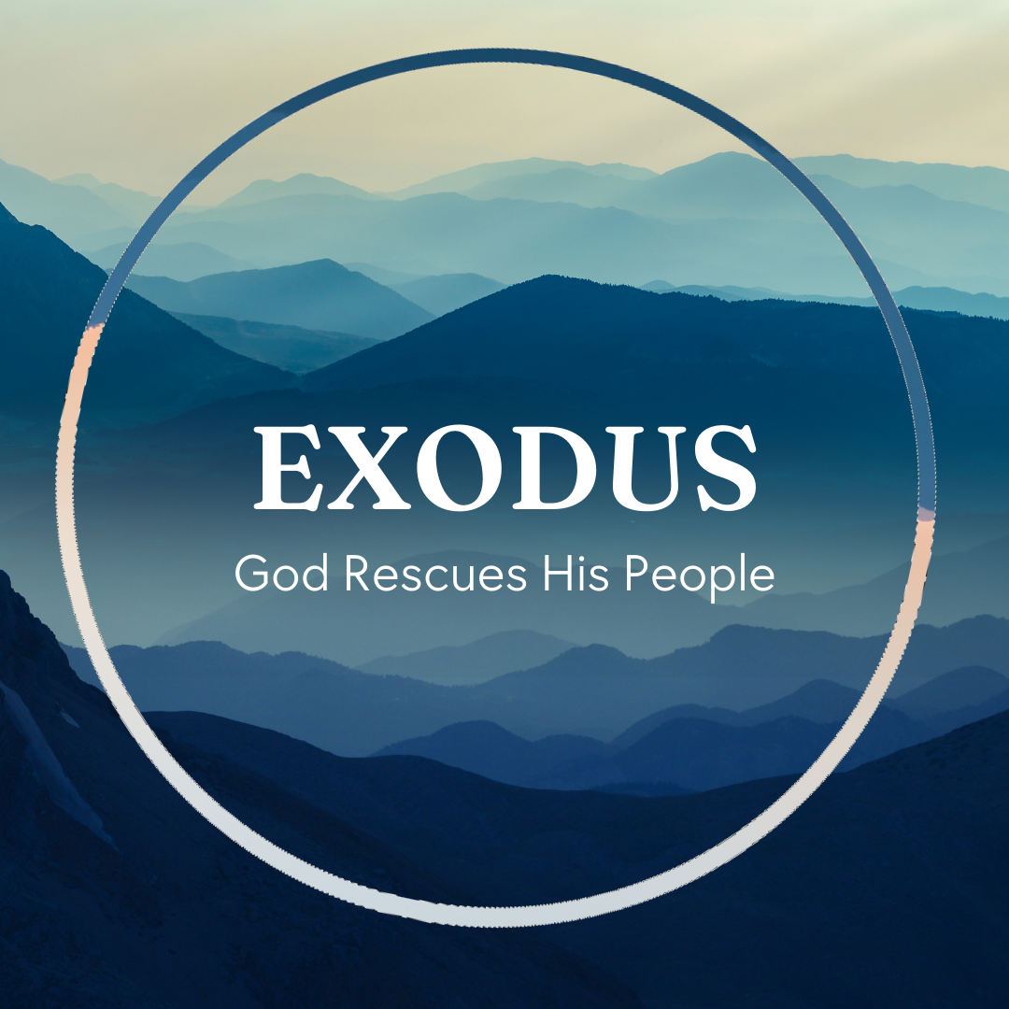

God tells us that Ezra read from the book of the Law,
day after day, and that the people of God were filled with joy!

These notes have been prepared by Rev. Philip Moffett, Cullybackey RPC Ireland.
Monday - Exodus 13:17-22 - God Plans the Journey
Now that Israel has been set free all they have to do is head north, for about a week's journey, and there will be the Promised Land. It is a short route to the place of promise. But God has chosen a different path. A path that will lead them through the wilderness for 40 years! A path that is going to be difficult. A path that will teach them some hard lessons.
As we walk with Jesus Christ and have our eyes fixed on our heavenward calling, we perhaps think God should take us on the short easy route, but often he doesn't. So, remember: God has planned the journey. God's plans are not necessarily our plans, and his ways are not our ways. God, for the good of the people of Israel takes them on a route that they would not have been expecting (verse 17). God knows what is best for the people.
God gives promises for the journey. Something strange happens in verse 19, "Moses took the bones of Joseph with him." Back in Genesis 50:24-26 we read that through Joseph God made a promise that Israel would be brought up out of Egypt and into the Promised Land. Hebrews 11:22 puts it this way, "By faith Joseph, at the end of his life, made mention of the exodus of the Israelites and gave directions concerning his bones." God does not break his promise. God is always trustworthy.
God's presence is with us in the journey. Verse 21-22, "The LORD went before them…the pillar of cloud by day and the pillar of fire by night did not depart from before the people." God is with his people.
What comfort to know that God has planned, God promises, and God is present with us in our journey to our heavenly home in Jesus Christ.

Q1. What are some of the circumstances in your life that you would not have chosen or expected?
Q2. What comforts do we find in today's passage?
Tuesday - Exodus 14 - Fear and Deliverance
The people of Israel are trapped between the Red Sea and Pharaoh's army. There seems to be no way out. In verse 10 we are told that they fear greatly. We can sympathize with that. Who wouldn't be afraid? And then they complain, verse 11-12. They complain to Moses. In fact, they blame Moses. Fear often leads to complaining or shifting the blame to others. This is because they have forgotten. Look again at verse 12, "It would have been better for us to serve the Egyptians than to die in the wilderness." Really? Would it have been better to serve in Egypt. Those years of slavery, the hardship, the killing of the infant boys, making bricks. Would that have been better than following God's commands? Sometimes when we are caught between the forces of darkness and our difficult circumstances we can fear, complain, and forget!
God now gives 3 commands to the people. Do not be afraid. Stand firm. Go forward. We are not to be rooted to the spot in fear, but we are to be firm, living for Jesus Christ.
The Sea parts in two. The pillar of cloud moves from the front to the rear to divide the people from the Egyptians. All the people of Israel cross over. Not one was left behind, not one was destroyed, not one was lost. God brings the people of Israel through the Red Sea and brings full and final judgment on his enemies.
This great deliverance is a picture of our salvation in Jesus Christ. For all who are in Christ we pass through. We cross over. God will fight for us. Do not fear, do not grumble, do not complain, do not forget. Stand firm and continue to walk with Christ. There is a triumphant deliverance for all who pass through in Christ Jesus.

Q1. Are there any times when you have been between 2 difficult situations?
Q2. How are we to respond when we find ourselves in such situations?
Wednesday - Exodus 15: 1-21 - The Song of the Redeemed
Today's passage is full of praise. It is the song of Moses and the people of Israel. God has triumphed gloriously and now his people rejoice.
Praise is a natural response to great works or great victories. Think of the supporters of a winning sports team - singing goes with victory.
This is also true spiritually. We sing songs of victory. We sing songs that speak of God's great work of salvation. We sing songs of praise and thanksgiving for the victory that God has won for us in Jesus Christ. He has triumphed victoriously and so we rejoice.
This song is the first and the oldest recorded song in the Bible, although God did not have it included in the Book of Psalms - the songs provided by God for his redeemed people. And yet although not added to the Psalter every theme contained in this song is included throughout the Psalms. The Psalms leave nothing out. They are complete.
In Revelation 15.3 it says about those in heaven, "they sing the song of Moses the servant of God, and the song of the Lamb, saying, 'Great and amazing are your deeds…"
We shouldn't think of the song of Moses in Revelation as one particular song but rather it is the song of the redeemed. It is the singing and worship of those who have been delivered from sin - those who have come through the greater Exodus in Jesus Christ.
The song in Exodus 15 is a foretaste of the worship that will come from the lips of all of God's redeemed, those saved through the Lamb. And the themes of this song are spread throughout the Psalms so that we can have a foretaste of that heavenly worship here on earth.

Q1. Go back through Exodus 15.1-21 and note down some of the key themes.
Q2. Why is singing in worship a suitable response to God's saving work?
Thursday - Exodus 15:22-17:7 - God’s Provision
There is a sanctifying work that has to be done in the lives of the people of Israel.
The next three accounts concern food and water. The people of Israel get hungry and thirsty, and they complain. Over and over again we will read about the complaining and grumbling of God's people. Note that complaining and grumbling are serious sins. All sins are of course serious, but nothing says, "I hate God's plans" like complaining and grumbling! Nevertheless, in the midst of complaining and grumbling we see the gracious provision of God.
At the bitter waters of Marah God graciously makes the water sweet. He is the God who heals and restores his people. God graciously provides both manna (bread sent from heaven) and quail to feed his people. God gives what is sufficient for his people. They had no need to gather on the Sabbath day because God provided enough. God gave what was needed. God graciously brings life giving water from a rock, showing the people that he is with them.
God's people needed to learn to rely on God, and trust in God. He will provide for and restore his people. God is with us.
When we come to the New Testament, we find that Jesus was tempted, or tested, in the wilderness. Unlike Israel Jesus passed the test (note that Israel was in the wilderness 40 years, and Jesus was in the wilderness for 40 days). Jesus did not fail. He has lived the life we cannot live.
Also, we are told that Jesus is the bread and the living water (John 6:44-51; 1 Corinthians 10:1-5). In Christ we have everything we need. In Christ we are restored. In Christ we have God with us. Remind yourself of this truth. Why should we complain and grumble?

Q1. In what ways can we complain and grumble about our circumstances?
Q2. What should we do when we are tempted to grumble and complain?
Friday - - Exodus 17:8-18:27 - The Covenant Community
In the next 3 accounts the people of Israel are being helped through intercession, being added to with foreigners, and they are being organized. This is the community of God's people growing and maturing.
First of all, they face a battle against the Amalekites. Moses is to remain in prayer as God's people fight. In the same way the church today is in a battle against the spiritual forces of darkness. But in this battle Jesus Christ is the great intercessor (Hebrews 7.25). He is praying for his church.
The covenant community also experiences the joy of seeing a foreigner come to worship God. Moses' father-in-law Jethro, on hearing all that God has done for his people, declares, "Now I know that the LORD is greater than all gods." God has worked in the life of this Midianite and has brought him to trust and faith. Through the testimony of Moses, a Gentile comes to faith. As the covenant community of God's people, we should pray and bear testimony to all that God has done for us. As we do this there should be an expectation that those who once were far off being brought near and added to God's number.
Finally, we see the covenant community being organized with elders. Israel already had elders, that is heads of every family and every tribe. But now Moses is to set aside some of these elders with the purpose of sharing the workload of looking after the people. God is organizing his covenant people and putting elders over them to care for them and lead them in God's Way. After such a great deliverance God is working in his covenant people, organizing them into the covenant community he would have them be.
The church is God's covenant community. What a great comfort knowing that we have a great intercessor, we have a gospel witness, and we have a gracious provision of elders for leadership.

Q1. From today's passage, in what ways has God provided for his covenant people?
Q2. How could these provisions help us to love the church more?

