Family Worship Booklet
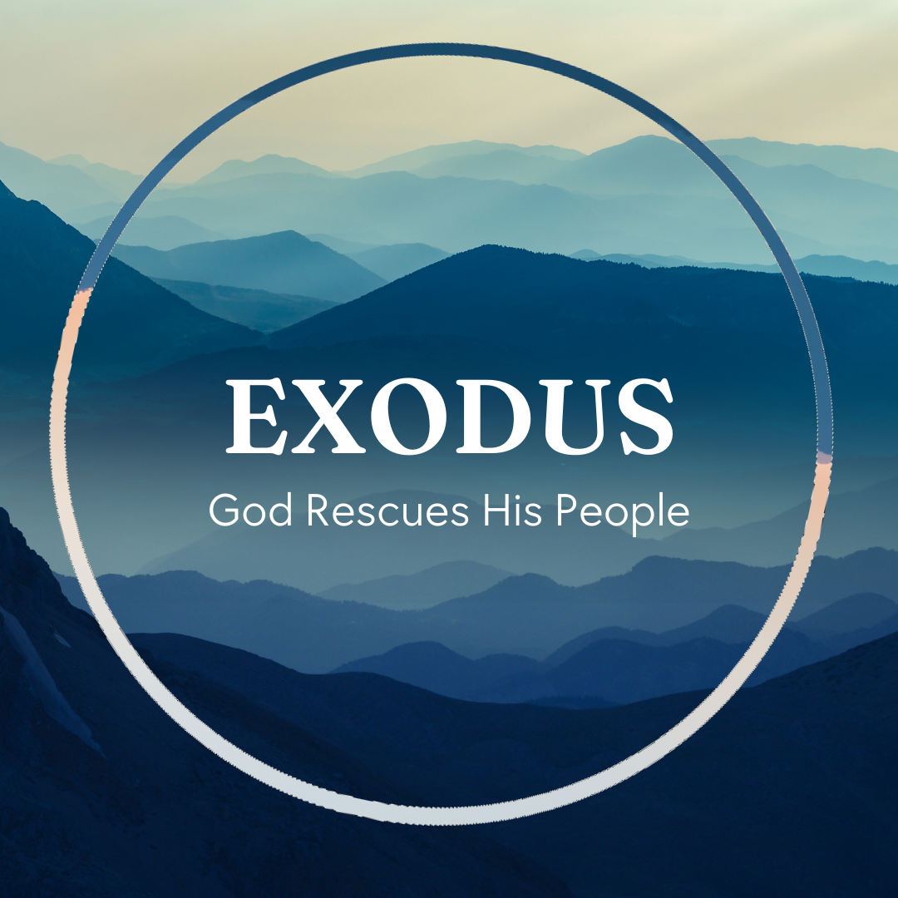

God tells us that Ezra read from the book of the Law,
day after day, and that the people of God were filled with joy!

These notes have been prepared by Rev. Philip Moffett, Cullybackey RPC Ireland.
Monday - Exodus 19:1-25 - The Covenant
The events at Mount Sinai are going to be the main focus of the rest of the book of Exodus. Back in Exodus 3:12, God promised that he would deliver Israel from Egypt. Mount Sinai would the sign that God had kept this promise. God would reinforce his covenant with his people. Verses 4-6 are the heart of the covenant. God has been so very gracious to them in saving a people for himself, and now he calls on them to obey that they might know the blessings of loving obedience.
We begin with the grace of God in his covenant. God has acted in mercy towards his people. He set them free from slavery and carried them to himself. The covenant is based on God's grace, his loving work of salvation towards his people.
There is also to be a correct response to the covenant. What God requires of us is to obey and keep his law. It is not the law keeping that saves, but because we are saved, we are to do what he commands. We respond with loving obedience.
Finally, we also have the unapproachableness of God. The holiness of God means that the people cannot approach God. So, where the people couldn't approach they needed an intercessor. Moses was that intercessor.
God has entered into covenant with us through his grace, calling us to a life of worship and holiness. But how may we draw near? Hebrews 12, "But you have come to Mount Zion and to the city of the living God, the heavenly Jerusalem, and to God, the judge of all, and to Jesus, the mediator of a new covenant, and to the sprinkled blood that speaks a better word than the blood of Abel."
In Jesus Christ we can approach. God has been gracious to us in Jesus Christ, calling us to be a holy nation, giving us access through our Saviour.

Q1. Is this a new covenant or a reinforcing of the covenant that is already in place? Why?
Q2. In what ways does Moses foreshadow what Jesus Christ will do?
Tuesday - Exodus 20:1-2 - Set Free
Our nations are calling what is good evil and what is evil good. Where the law of God was ignored, it was later rejected, today it is now declared as being wicked and will soon be persecuted.
For many the 10 commandments mean nothing, but for God's people, throughout history, they are of great importance and relevance.
The commandments are more than just a way of life for Christ's people; they also reflect the very nature of God. They show us something of who God is and what he requires of his creation. As his image bearers all people are to listen and obey. All men, women and children are to seek to live according to God's holy law. As creator he calls the whole creation to obey his voice.
We often call verses 1-2 the preface or introduction to the 10 commandments, but we are not to skip over it. The introduction concerns a truth that needs to be repeated over and over again. We have been saved by grace.
The law that follows doesn't save. It is a perfect law as it reflects the very nature of God. But it is a law we cannot perfectly keep. The law, outside of grace is a burden. Outside of grace it is a terror as it convicts us of sin. What we need is the loving forgiveness of a saving God. Verses 1-2 point us to this God. "I am the LORD you God who brought you out of slavery."
God has set us free.
By providing a law keeper God has set us free. One who was born under the law, and one who never broke the law, yet one who willingly came under the judgment of the law for us - Jesus Christ.
This is the loving, saving grace that God has shown to us. So let us, in loving obedience, live as he has called us to live.

Q1. What introduces the 10 commandments?
Q2. What does the introduction to the 10 commandments teach us?
Wednesday - Exodus 20:3-7 - Thoughts and Speech
The law shows us how we are to love the God who has been so gracious to us.
The first 4 commandments teach us how we are to keep the greatest commandment, Matthew 22:37, "You shall love the Lord your God will your heart and with all your soul and with all your mind. This is the great and first commandment."
We could group these commandments into our thoughts, words and deeds. Commands 1-2 have to do with our thoughts of God. Command 3 has to do with our words, and tomorrow we will see that the 4th commandment is to do with our actions.
Commandment 1 teaches us that we are to put nothing before God. God alone deserves our worship, our energy, our time. If something pulls us away from God, then we are to remove it out of our lives. We are prone to give our worship to work, to pleasure, to money, to sport, to family, to success. But if something, whether good or bad, starts to take the place of God, then we are to cut it out.
Commandment 2 teaches us that our hearts have a problem - we love to make idols. John Calvin called the human heart a perpetual factory of idols. However, God has called us to worship him alone and to worship in the way he has commanded. We are not left to ourselves to decide on how we worship. We are to have God alone as the seat of our affection and devotion and we are to worship him in his way.
Commandment 3 tells us that we are to speak rightly of God. How we address God matters. How we speak of God matters. What we say about God as Father, Son and Spirit matters. Be careful with your words.

Q1. What do these commandments require?
Q2. What do these commandments forbid?
Thursday - Exodus 20:8-11 - The Sabbath
The fourth commandment concerns what we do. Our actions.
We are to work and rest using the one day in seven pattern that God has provided.
It is a loving and gracious provision that God has given to us. This was a day set in place in creation, and so we are to remember the seventh day. It is interesting that Adam and Eve's first full day on earth was a Sabbath (created on the 6th day they then enjoyed a 7th day rest).
Probably no other command amongst evangelical Christians has been subject to the most discussion. Some believe that this day is no longer relevant to New Testament believers, or that God doesn't mind which day we keep.
However, we are to realize that Jesus didn't abolish the Sabbath rest. The problem in Jesus' day is that the Pharisees had surrounded the Sabbath with so many extra rules and regulations that the day was a burden and not a delight. Rather Jesus reminded people that this day was given to man for his good and for his rest.
The Sabbath as the seventh day changed to the first day of the week as on this day Jesus rose from the dead, signaling new life and eternal rest for his people. It was on the first day that the disciples, the church, would meet. This day became the Lord's Day, the day of rest. This day also points us to our eternal Sabbath rest. There will come a day when we will rest from all our labours. A day in which we delight in the very presence of our Saviour.
What a blessing to have this reminder every week. What a blessing to have a day of rest and enjoy the activity of worship.
Remember the Sabbath day.

Q1. Why has the Sabbath day been given to us?
Q2. How do we keep the Sabbath holy?
Friday - Exodus 20:12-17 - Love your Neighbour
We are to love God with all our heart, soul, mind, and strength, and we are to love our neighbour as ourselves. Commandments 5-10 deal with the second greatest commandment.
Commandment 5 begins with family. This is our first priority after God. Family as instituted by God is the way of blessing in the covenant. Just as we have a Father in heaven and we are to give him honour, so we honour those God has put in authority over us, giving the honour that is due.
Commandments 6-9 refer, not just to our actions but as Jesus taught in Matthew 5; we break these commands if our thoughts are wrong in these areas. Do not hate, be faithful and pure in relationships, respect property, and be honest.
Commandment 10 specifically concerns our thoughts. We are not to covet. Trust that God is sovereign and that he has given you what you need. Be content.
Just as God has shown us saving love in Jesus Christ so now here is the way we can live to reflect that grace, and to know the blessings of being in this covenant relationship. Love God and love your neighbour because God has been gracious to you.
Also, as we follow these commands, we are showing the world what God is like. These commands reflect his perfections. He is the faithful, loving, holy God who calls us to follow him.
We will still stumble and fall but remember that we have a great mediator who has kept the commandments for us. The law brings us back to Jesus Christ. It reminds us that we are to be trusting in Jesus Christ and not in ourselves. The commands don't save, but for those who are saved it is the most blessed way to live.

Q1. What do these commandments forbid and require?
Q2. In what ways do they show us God's nature?

