Family Worship Booklet
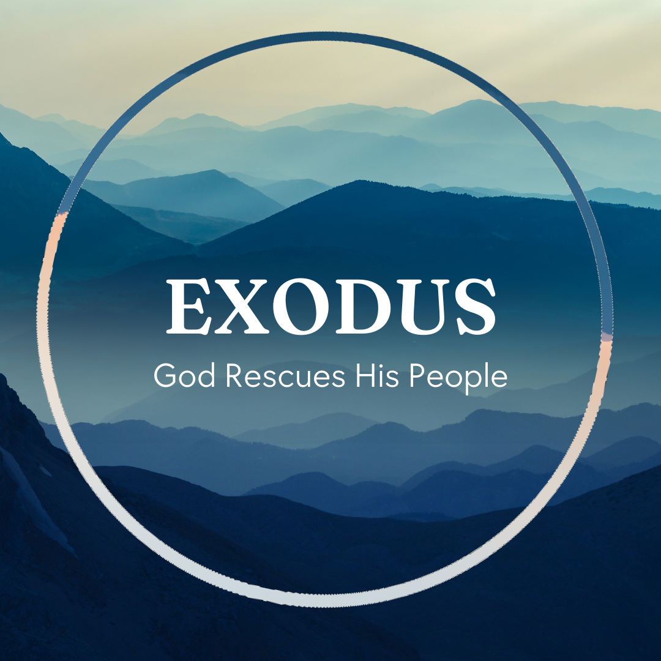

God tells us that Ezra read from the book of the Law,
day after day, and that the people of God were filled with joy!

These notes have been prepared by Rev. Philip Moffett, Cullybackey RPC Ireland.
Monday - Exodus 20:18-21 - Need for a Mediator
Chapter 20 repeats the description of chapter 19 concerning the shaking and terror of Mount Sinai. Like the law reflecting God's character so now at Mount Sinai we have a visible representation of the glory of the invisible God. His majesty, power and holiness are on display. God is a consuming fire. The people are terrified both by the standards of the law and by the judgment that this holy God would bring down upon them. This reminds us that we cannot approach God lightly. Especially in light of the law. We are guilty and unrighteous, sinners before a holy God. And so, we need a mediator to approach him.
Verses 19,21, "the people stood far off and said to Moses, "you speak to us, and we will listen; but do not let God speak to us, lest we die." "The people stood far off while Moses drew near to the thick darkness where God was."
What God provided for the people in Moses is a shadow of the greater provision of the true mediator - Jesus Christ.
Verse 21 is the climax in this section. Moses goes into the smoke, the thick darkness where God was. It was Jesus Christ who truly went into the darkness for us. He went into the judgment. He experienced the full wrath of the God the Father for our sin.
We can only approach God the Father through Jesus Christ. But unlike Mount Sinai we can approach with confidence because Jesus has opened up the new and living way.
We come to Mount Zion. We come not condemned by the law, because Jesus Christ has taken the condemnation. We come seeking to live the law in response to God's grace towards us. Hebrews 12:28-29, "…and thus let us offer to God acceptable worship, with reverence and awe, for our God is a consuming fire."

Q1. How would you answer someone who says that the God of the Old Testament is holy, but the God of the New Testament is gracious?
Q2. Why do we need a mediator?
Tuesday - Exodus 20:22-26 - Approaching God
In chapters 20:22-23:19 God is providing some of the practical applications that come from the 10 commandments; how his people are to approach him, how they are to love their neighbour, and the importance of the Sabbath day. We begin with approaching God. This is what the first 3 commandments teach.
The practical application for the people of Israel was that they were not to make idols, nor were they to make an altar of their own choosing. It had to be according to God's instructions.
Although today we do not have altars or sacrifices, because Jesus Christ was the once for all sacrifice for sin, the command to approach God in the way he instructs still stands. We can take the principles for altar making and apply them to our approaching God because the first 3 commandments of God are still in place.
The principles are these: we are not free to approach God in any way that we feel is suitable; we are not free to add to what he instructs us to do; we are not free to put our own personal preference into God's worship. The people of Israel were not allowed to use their tools to make the stones look nice just because they thought it would be a nice touch! There was also to be decency in worship. There were to be no steps up to the altar so no one might accidently be exposed due to a lack of under garments! We must approach God as he has given us direction because he is still the holy God.
Ultimately, we can only approach God through Jesus Christ. He is the only way permitted to come in worship. The one who became flesh for us, born as a baby, displaying no outward beauty to attract us to him, but was the perfect sacrifice. We can approach only by the way that God has permitted.

Q1. How would you answer the person who says we are free to worship God any way we would like?
Q2. In what way is Jesus like the earthen altar?
Wednesday - - Exodus 21:1-32 - Caring For Our Neighbour
Exodus is a book of the Covenant for God's people living in covenant relationship with the One who has set them free and living in Covenant relationship with one another. We are to love our neighbour. The 10 commandments begin. "I am the LORD your God who brought you out of the land of Egypt, out of the house of slavery." In light of who they were and what God has done for them God's people must treat one another with compassion and care. We have a responsibility for one another.
The verses on slaves might make us feel uncomfortable because of the wrongs of modern slavery, but for an Israelite living 3,000 years ago this is a passage full of grace and compassion. It is a passage about having responsibility for one another. An Israelite could sell himself into slavery, or service, for a time. This would allow them to be provided with meals, with income, and they could pay off debts while being looked after. God is giving compassionate and gracious laws to provide for the vulnerable in society, and they are not to be mistreated. There is a responsibility to care. Included in our responsibility to care for one other is honouring our fathers and mothers, and valuing life highly.
The Bible does not give us every possible application of the law, but it does provide a set of cases to help us understand the basic principles of responsibility to care. Where this is abused or lacking, we are told that punishments must fit the crime. Life is precious and so the punishment for taking life is severe.
And yet within the law we still see grace and mercy as God provides a place of refuge for his people. These laws, not only showing us how to apply the 10 commandments, continue to point us to Jesus Christ, who is the true servant, and our only refuge from the judgment we deserve.

Q1. What are some of the ways we can love our neighbour in light of these commands?
Q2. Why is human life so precious? In what ways can we respond to a nation that devalues this truth?
Thursday - Exodus 21:33-22:17 - Restitution
The law teaches us how we are to love our neighbour in the light of God's grace. There are 6 areas given in this passage where those who have been broken the law are to make restitution; where there has been irresponsibility in actions (v.33-36); where there has been theft (22:1-4); where there is negligence (v.5-6); where trust has been breached (7-13); where borrowed property is lost, broken or stolen (v.14- 16); where there has been sexual immorality (v.16-17). In all of these case studies the one who has broken the law has to take responsibility for their actions. Restitution must be made.
We live in a blame culture. People say, "whatever you do don't take responsibility for your actions!" From politicians to the playground, from palaces to prisons, from celebrity to the home, there is a reluctance to take responsibility for wrong actions. But God's Word and his Law is countercultural. We are told we are to take responsibility for our actions. Your sins are your sins. It doesn't matter if your circumstances weren't pleasant, or if you were tired, or if you were just not thinking - you are responsible for your actions. Therefore, we are to make restitution for our failings. Where we are guilty, we are to seek to make all things right, and we are to be generous in doing that. Justice demands that we make things right. As God's covenant people we should be ready to make restitution. Consider the example of Zacchaeus (Luke 19:1-10).
But also, we are to remember that the price to paid to God for our sin is far too great for us to pay. We can never make restitution by our own payment. Another payment had to be made. A wonderful, complete, and full payment - Jesus Christ.

Q1. Why are these laws on restitution so different to our society's view of responsibility?
Q2. Read Psalm 49. How does Psalm explain the restitution made for us in the Gospel?
Friday - Exodus 22:18-23:9 - Set Apart
As the people of Israel were going to settle in the land of Canaan God makes it clear to them that they were to be set apart from the surrounding nations. How God's people treated one another and how they conducted themselves was to be as a holy nation and as a priesthood of believers. When we come to the practical application of the law, we are not to copy every detail directly to our circumstances, but rather we are to see that the principle of being set apart is one that we are to take to heart. In Jesus Christ we have been chosen as a royal priesthood and a holy nation. We have been saved to holiness, and so now we are to live that out, including in the area of social justice.
The next set of practical applications deal with loving our neighbour through laws on social justice. We could group these in 4 categories:
Capital Crimes (verses 18-20): mixing what is unholy in society with our Christian lives is a very serious matter. For the people of Israel, it carried the ultimate consequence.
Compassionate Commands (verses 21-24, and chapter 23:9): look out for the needy and show them love. Just as Israel were foreigners in Egypt so they should show the same care to outsiders.
Duties of Respect (verses 25-30): just as we are to show reverence to God, we are to respect both the high and low in society, having compassion on the poor and having respect for those in authority.
Calls to holiness (22:31-23:8): God wants his people to be different from the culture around them. We are to be holy in our conduct, not show partiality, love our enemies.
We of course do not keep the law perfectly. But thanks be to God that there is one who did, and one who also took the punishment that breaking the law deserved - Jesus Christ.

Q1. How would you answer the person who says, "we don't have to obey God's commands because we are saved by grace"?
Q2. How do we fail in keeping the principles of these commands? How do they point us to Jesus Christ?. How do we keep the Sabbath holy?

