Family Worship Booklet
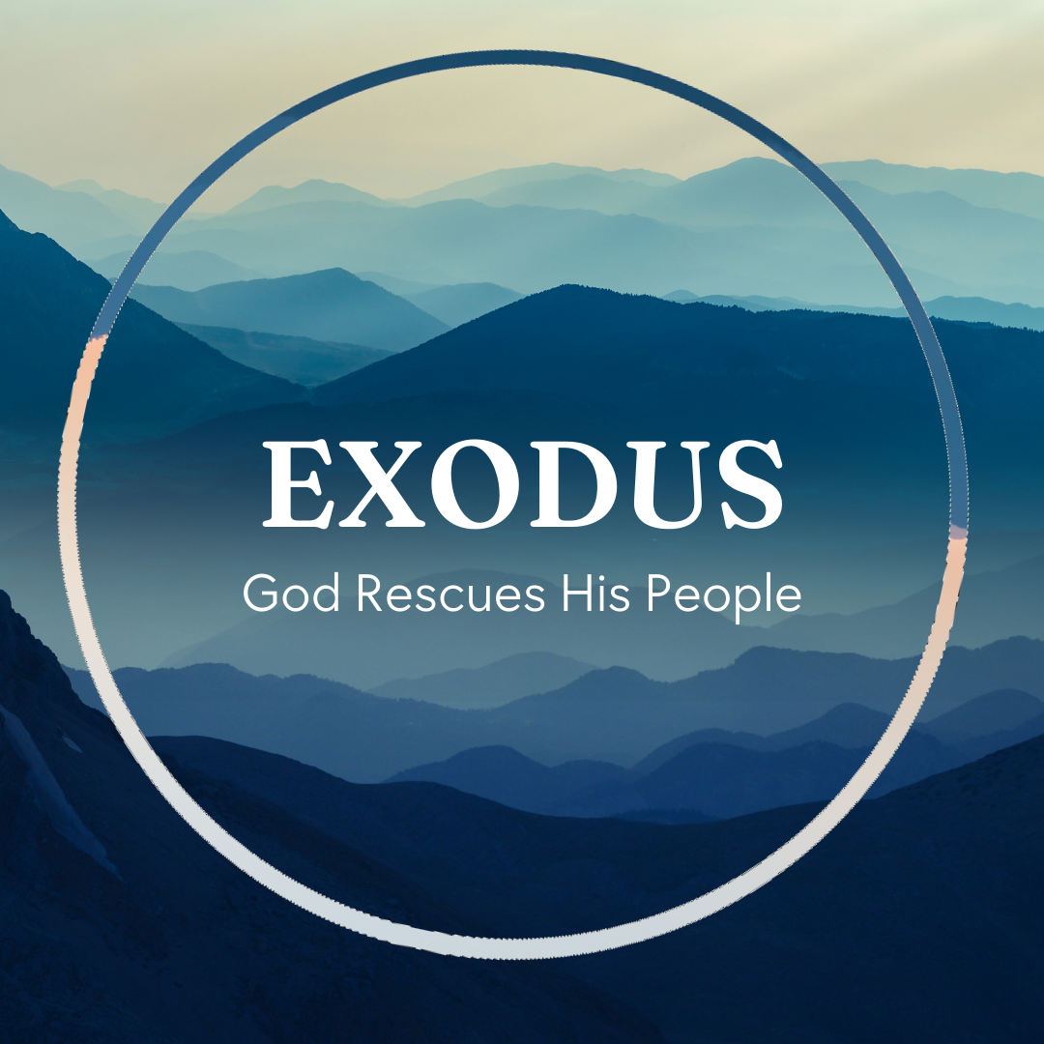

God tells us that Ezra read from the book of the Law,
day after day, and that the people of God were filled with joy!

These notes have been prepared by Rev. Philip Moffett, Cullybackey RPC Ireland.
Monday - Exodus 23:10-19 - The Sabbath
God's ways makes a distinction between God's covenant people and the surrounding nations. Probably where this is seen most clearly is in the law concerning the Sabbath day. The command is clear, keep the Sabbath. Exodus 20.8 Here are 4 helps to keeping the Sabbath holy.
Trust. v10-11. The Sabbath law was also for the land. You were to farm it for six years, but on the seventh year you were to leave it fallow. The farmer and the community had to trust that God would provide.
Rest. v12. We are commanded to work, to be productive, and to be creative. Six days you shall work. But on the seventh day you shall rest, and not only rest from your labours but by our decisions not require others to work on our behalf, so they too can rest. (The only exceptions being those who are engaged in acts of mercy and grace.) Here is a day that is given for our good. A day that also points us to the eternal rest that we have in Jesus Christ.
Worship. v13-17. Israel had 3 special feasts (later it would be 7) given to concentrate their worship before God: The leaven represented the corrupting influence of sin. Our worship includes a looking back considering what God has done in removing our guilt and punishment. The feast of the harvest. When the grain was ready the first sheaf of wheat was waved before the LORD. The first fruits was a promise of more to come. It is a picture of joy and celebration before God. The feast of ingathering (tabernacles). It was a time of joy and celebration because now the work is done, and it is time for rest. The harvest is in.
Purity. v18-19. We are to bring what God requires of us. We are to give God the fat of our worship, that is the best of our worship. And we are not to bring into our worship those practices that are seen in the world (boiling the goat in its mother's milk was likely a pagan practice).
Keep the Sabbath day holy. Keep your worship pure.

Q1. How do the 3 feasts point to the work of Jesus Christ?
Q2. Why is it important to keep the Sabbath?
Tuesday Exodus 23:20-24:18 - The Covenant
The practical application of the law finishes with a confirming of the covenant. These people are God's Covenant people. For generations they have held onto the promise that God is bringing them to a land of their own. There is a confirmation of God's Covenant with his people. It is a solemn, visual, intimate occasion. And it is an occasion for us. It is this covenant which is the basis for our relationship with God. It is this covenant that is the basis for our position of being God's Covenant people through Jesus Christ.
In chapter 23:20-33 we have the promise that God will go before his people. The angel who goes before his people has authority, a voice we are to obey and carries the name of God. This is Jesus Christ who goes before us and with us.
The promises are full of words of victory. God will drive the nations out. We will see the wicked brought down low. We will stand in the land of Promise. God has promised victory.
We are to be on our guard against sin. There is a danger of the surrounding culture influencing God's people. They were to completely destroy all idols and high places. Be warned that tolerating the sin and false worldviews of the nations will lead us into sin. Do not accommodate the sin in your life, don't give it a home, don't feed it, don't tolerate it.
In chapter 24 the Covenant is then confirmed by the shedding of blood. Moses takes the blood from the peace offering and throws it onto the altar, and onto the people. Breaking Covenant with God demands our life blood as payment. But look! God has provided the sacrifice. The blood of another is payment for breaking Covenant. Ephesians 2.13, "But now in Christ Jesus you who once were far off have been brought near by the blood of Christ."

Q1. How does the Lord's Supper compare with the confirmation of the Covenant?
Q2. What is the relationship between God's grace to us and our promise to obey him?
Wednesday - Exodus 25:1-9 & 35:4-29 - God Dwells With Us
There is a beauty to the structure of Exodus 25-40. Chapters 25-31 are the instructions for building the tabernacle and its furniture, beginning from the inside out and finishing with Sabbath rest. Chapters 35-40 the tabernacle is being built, beginning with the Sabbath regulations and finishing with the glory of God coming down. The middle section, chapters 32-34, show us the great need for an intercessor. The only way to dwell with God is, not by our own doing, but through God's provision. God is going to dwell with his people.
The tabernacle is like a picture book to help us understand what it means to dwell with God and enter his presence. Hebrews 8:5 and 9:24 tell us that these pictures are a copy and shadow of the true heavenly things. That is, the tabernacle and all its furniture is a copy of a heavenly reality.
The tabernacle was pointing God's people forward to the reality of Jesus Christ, his dwelling with us, our access through him, and our eternal dwelling with God. God says, "I will dwell in their midst." We are told of Jesus Christ, "The word became flesh and dwelt among us." John 1:14. God dwells with us.
Notice also that the people are to be involved in the work of building. The Israelites were called to serve. And in serving they are to have a heart for the work. Chapter 35 tells us that they gave willingly. Not only does God graciously dwell among us in Jesus Christ but he calls us to be involved in the building work of his kingdom. Just like the Israelites God provides everything we need to be involved in serving him. The Israelites were provided with the gold and silver from Egypt, the wood from acacia trees in the wilderness, the skins from the animals. Everything that the Israelites gave to God was already given to them first. Everything we have to serve is from the gracious provision of God who has provided the way for us to dwell with him.

Q1. How is the dwelling of God in the tabernacle a picture of Jesus Christ? John 1:14, Revelation 21:3.
Q2. In what ways can we be involved in the building work of Christ's kingdom?
Thursday - Exodus 25:10-22 & 37:1-9 - The Mercy Seat
The ark of the covenant is the most important item in the tabernacle. It is mentioned over 200 times in the Old Testament and the only item placed in the Holy of Holies, the inner part of the tent of meeting. It contained the 10 commandments, a sample of manna, and Aaron's staff that had budded, also it had a lid called the mercy seat. But one of the main purposes for the ark was that it represented the presence of God among his people. Like everything in the tabernacle God gave specific instructions on how it was to be made because it is pointing us to a heavenly reality - Jesus Christ and his kingly presence and mercy to approach.
The ark of the covenant is called the footstool of God (1 Chronicles 28:2). The picture is of the king of heaven on his throne resting his feet on this footstool. God's majesty and splendour and glory were present among the people of Israel with the ark. As they carried the ark into battle they were carrying the throne of the king. Their king went before them. The king of glory has stepped down. Jesus has come.
But how can we approach such a majestic holiness? The answer is found at the throne itself. On top of the throne is the mercy seat. The symbolism of the ark reaches its grand climax on the Day of Atonement. On that day, only once in the year, the High Priest went behind the curtain into the Holy of Holies and he sprinkled the blood of the sacrifice on the mercy seat. It was this blood being sprinkled on the mercy seat that propitiated or turned away God's anger at sin. The ark of the covenant pictures for us both majesty and mercy, power and pardon, greatness and grace. We don't need a box anymore because we have this reality in Jesus Christ.

Q1. In what two ways does the ark of the covenant point us to Jesus Christ?
Q2. What do you think happened to the ark of the covenant (Jeremiah 3:16-17)? Why is it not needed anymore?
Friday - Exodus 25:23-40 & 37:10-24 - Bread and Light
The next two items of furniture in the tabernacle were found in the Holy Place. This was the larger section of the tent of meeting, with the smaller inner section being the Holy of Holies. In the Holy Place only the Levites and Priests were free to enter. Here on either side, left and right, were the lampstand and the table for bread. There was one other piece of furniture in the Holy Place, the altar of incense, which stood in front of the Holy of Holies.
The table for bread was made from gold but the table isn't to be the focus, rather it is the bread. This bread of the Presence is pointing us to a greater reality. Firstly, it is pointing us to the nearness of God. God says, "set the bread of the presence on the table before me." Leviticus 24 tells us the bread is twelve loaves set in two piles, six on each pile, before the LORD and it is from the people of Israel as a covenant forever. The bread represented the people before God - it is from the people of Israel. All of God's people are before his face. This is the bread of presence. Every tribe has a place at the table of God. God is near us continually. Secondly the bread points us to nourishment from God. It is bread, provided by God, that is to be eaten. The God who is near to his people, gives satisfaction to his people. Leviticus 24:9 says the bread was to be for Aaron and his sons, and they were to eat it in the Holy Place. God was providing for the priests in his court. They shared fellowship with God. They ate the bread in the Holy Place. God was nourishing them before his face.
The lampstand, which stood opposite the table for bread was shaped like a tree, and it contains the various stages of life of a tree - budding, blossom and flower. The purpose of the lampstand is to give light. This light was necessary for the priests to go about their service in the tabernacle. Without the light they would be in darkness.
Both the bread and light point us to Jesus Christ who said, "I AM the bread of life" and "I AM the light of the world." In Jesus Christ we are in the presence of God, we are nourished, and we are given the light of life.

Q1. In what ways is Jesus the reality of the bread of presence?
Q2. What does it mean that Jesus is the Light?

