Family Worship Booklet
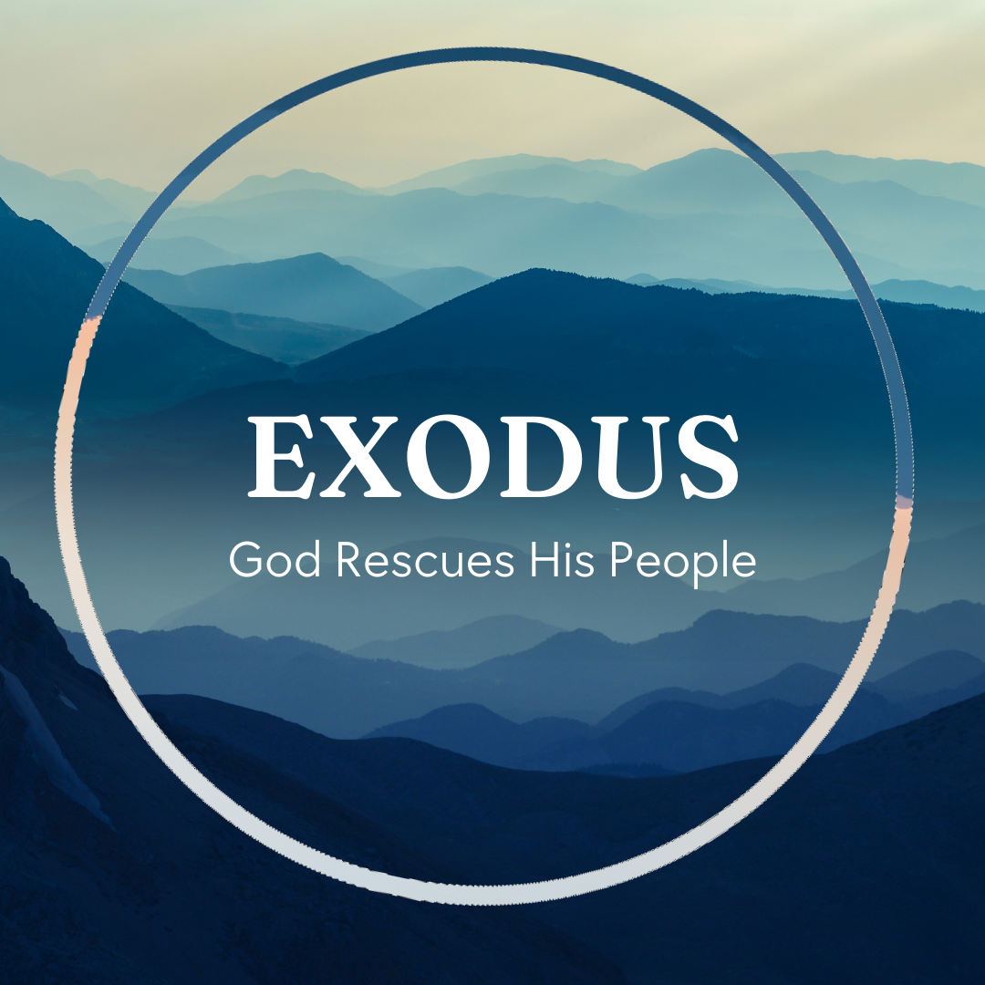

God tells us that Ezra read from the book of the Law,
day after day, and that the people of God were filled with joy!

These notes have been prepared by Rev. Philip Moffett, Cullybackey RPC Ireland.
Monday - Exodus 26 & 35:30-36:38 - A Way In
The construction of the tabernacle tent points us to the effects of the Fall in Genesis with the hope of restoration. There is restricted access to God's presence but also there is the hope of fellowship with God being restored.
The tent of the tabernacle has much beauty and structure. Furniture made of pure gold and the inner coverings of curtains with heavenly pictures and glorious colours is a reminder of the Garden of Eden. Beauty and structure. The tabernacle is a picture of close fellowship with God in his place and everything very good. But with the Fall came a broken relationship.
When we come to the tabernacle tent we find there is a covering that goes over the fine linen cloth. And this covering is longer than the inner covering, so that none of the inner covering can be seen. The inner beauty is hidden. Access is denied. The sign over the tabernacle tent would read, "You cannot enter." The cherubim guard the way. All of this is saying to the Israelite that access to God is denied, but there is hope. The Priests could go into the tabernacle tent, the Holy Place, and the High Priest could go into the Holy of Holies, but only once a year on the day of atonement. Yet they could go in. There was the possibility of access. A restricted access but still access. The ordinary Israelite could enter the tabernacle fence but could only go so far because the curtain was in the way. Access into the presence of God is denied.
This is our standing before God. Because of sin, access is denied. We cannot approach God, we cannot enter into relationship with God, we cannot look forward to the beauty and splendour of heaven and the heavenly throne room, because of sin. Nevertheless there is hope. The Priests could go in and the High Priest could go behind the curtain into the Holy of Holies. Our representative can approach for us. There is a way into the beauty and glory and majesty of his presence. There is a way for access to be restored. And this is what Jesus Christ has done for us. Matthew 27:50-51; Hebrews 10:19-22
Q1. How does the tabernacle speak of access being denied and access being opened for God's people?
Q2. How can we make better use of the access we have to God through Jesus Christ?
Tuesday - Exodus 27:1-8: & 38:1-7 - The Altar
Moving outside the tent into the courtyard of the tabernacle we find ourselves in an open space fenced in by a cloth wall. The only door was in the eastern side of the tabernacle. When you entered the tabernacle complex the very first thing you saw was a bronze altar. Exodus 27 & 38 speak of the instructions and construction of the altar. Leviticus chapters 1-7 speaks of how the altar was used. The altar itself was 7 ½ feet long and the same wide, and 4 ½ feet high. It was made from acacia wood, overlaid with bronze, and had four horns, one on each corner. The bronze altar was for burnt offerings; it was a hollow box, with a bronze grate on the top and around the sides, and the fire of the LORD burned inside and burnt up all the sacrifices. This fire was to be kept burning continually, Leviticus 6:13.
Why was this the first item that every Israelite saw on entering the tabernacle? The answer is because of sin. Because of sin we cannot approach God. The only way into the presence of God is to have our sin dealt with. The altar tells us that God is angry at sin and the punishment that sin deserves is God's fierce, hot, wrath. Hebrews 12:29, "for our God is a consuming fire." But the altar also tells us that there is a way to have satisfaction made with God - through a substitute.
All the sacrifices of the people of Israel were brought to the bronze altar. Without the shedding of blood there can be no remission of sin. And so for each person, or representative, each was to bring an animal without blemish for sacrifice. This points us to the reality that we have in Jesus Christ. He has satisfied the righteous anger of God at our sin. The consuming fire of God the Father fell on Jesus Christ as he willingly died, as our substitute, on the cross for our sin. Christ Jesus was tied to the horns of the altar for us.

Q1. Read Psalm 118:27. Jesus sang these words as he went out to the Garden of Gethsemane. What do they tell us about the altar and the sacrifice?
Q2. Why was it important that the altar was the first item that God's people would encounter in the tabernacle?

Wednesday - Exodus 27:9-19 & 38:9-20 - The Door
The instructions for the tabernacle begin with God's presence, and then work from the inside out. Chapter 27 is the court of the tabernacle. The large open area, fenced off from the wilderness, where every Israelite could come and worship God. The court is where God's people worshipped and served as they made their way through the wilderness to the land of promise. It was a place they loved, it was a place where they longed to be. (It was the place where Hannah was praying when Eli found her 1 Samuel 1). But it was also a place where a distinction was made. There is a distinction between the dwelling place of God where his people gather for worship, and the world outside. A curtain fence of fine twined white linen that went the whole way around this court said those on the outside were cut off. The whole tabernacle stands out against the dusty, dry bleakness of the wilderness. The gathering of God's people is distinct from the world. Not only is God separated from sinners but those who are brought near through the sacrifice are also made distinct. So how do we gain access? How are made distinct? The answer is through the door. The entrance is a beautiful gate made up of vivid colours.
The door is Jesus Christ. Jesus said in John 10:7, "I AM the door". And again in John 14:6, "I AM the way, the truth and the life. No one comes to the Father except through me." Paul says in Ephesians 2:12, "remember that you were at that time separated from Christ, having no hope and without God in the world. But now in Christ Jesus you who once were far off have been brought near by the blood of Christ. For he himself is our peace, who has made us both one and has broken down in his flesh the dividing wall of hostility." Through Jesus Christ we can approach God, and through Jesus Christ we are made distinct from the world. Through Jesus Christ alone we can worship and serve. There is no other way.

Q1. How does the tabernacle help us to see Jesus Christ as the door and the way?
Q2. Why do you think the courts of the tabernacle were so precious to an Israelite (Psalm 84:10)? Do you have this same joy and anticipation in coming in worship through Jesus Christ?
Thursday - Exodus 28 & 29; 30:22-33 - The High Priest
Chapters 28 & 29 move from looking at the tabernacle and its furniture to those who serve within the tabernacle - the priests. Here are the mediators between God and his people. The priests were set apart in their calling (28:1). God himself chose, called, and consecrated Aaron and his sons to serve as priests forever (29:9). They were called from among the people - they had to be like the people because they were going to represent the people (Hebrews 5:1-4). There are examples in Scripture where some tried to take to themselves the task of serving as priests eg. the sons of Korah (Numbers 16), King Saul (1 Samuel 13:8-14), King Uzziah (2 Chronicles 26:16-21). None of these ended well!
The garments of the High Priest are described for us in chapter 28. The ephod with the names of the 12 tribes on its shoulders shows that the High Priest carried the names of the people into the very presence of God. The breast-piece had 12 stones representing the 12 tribes of Israel and contained the Urim and Thummim to determine God's Will for his people. The High Priest had the people's names on his heart, and he declared the Will of God. The robe of the ephod had bells on it so that the people outside could hear the jingle and know that the High Priest was alive and ministering on their behalf. The turban and the plate read, "Holy to the LORD."
The image of the High Priest was speaking to the people of Israel of the representation that they needed before God the LORD - one chosen, one like them, one who carried their names into the presence of God, one who was alive and ministered on their behalf, one who knew and declared the will of God. Jesus Christ is the great High Priest. Unlike the old order of priests Jesus Christ is sinless and so he is the perfect mediator as he offered his own blood for our sin, and unlike the old order of priests he lives forever to make intercession for us, carrying our names into the presence of God the Father.

Q1. In what ways is Jesus like the priests in the Old Testament?
Q2. In what ways is Jesus greater than the priests in the Old Testament?
Friday - - Exodus 30:1-10; ch. 34-38 - Prayer
We move back into the tent of the tabernacle to the third item of furniture in the Holy Place - the altar of incense. We are given both the description of the altar, verses 1-5, and its function, verses 6-10. At this golden altar the priests were to take burning coals from the bronze altar outside, they were to place these coals on the altar of incense, and then put on specially made incense that would burn and fill the space with a sweet smelling aroma. This was to be done every morning and then again in the evening. The burning of incense is a representation of prayers that are made before God. Psalm 141; Revelation 5:8; 8:3-4 Notice that prayer is made in the presence of God, v6. The altar was so close to the mercy seat that it was sometimes called the altar that belonged to the Holy of Holies (1 Kings 6:22 and Hebrews 9:3-4) The writer to the Hebrews isn't mistaken about where the altar was placed, rather he is stressing that this altar is in the very presence of God. Prayer is offered before God's throne of grace and mercy. God delights in his children coming into his presence.
Prayer is offered up continually, v 7-8. Every morning and every evening the incense was burned. It never ceased. The priests lived in continually atmosphere of prayer. Day after day, week after week, year after year, generation after generation. Continual, constant, regular prayer. Prayer is through God's appointed means, v9 & 34-38. The priests could not offer incense in the way that they thought was best (Leviticus 10 - Nadab and Abihu!). They had to approach God the way that he had prescribed in his Word. Prayer is a privilege of communion with God, v10.
Jesus Christ perfects prayer for us. He continually offers up prayer for us as our great high priest, and our prayers come through him (Hebrews 7:25). We can have communion with God the Father only because of Jesus Christ.

Q1. What was Christ's attitude to prayer while he was on earth?
Q2. How can we follow Paul's command to pray without ceasing, 1 Thessalonians 5:17?

