Family Worship Booklet
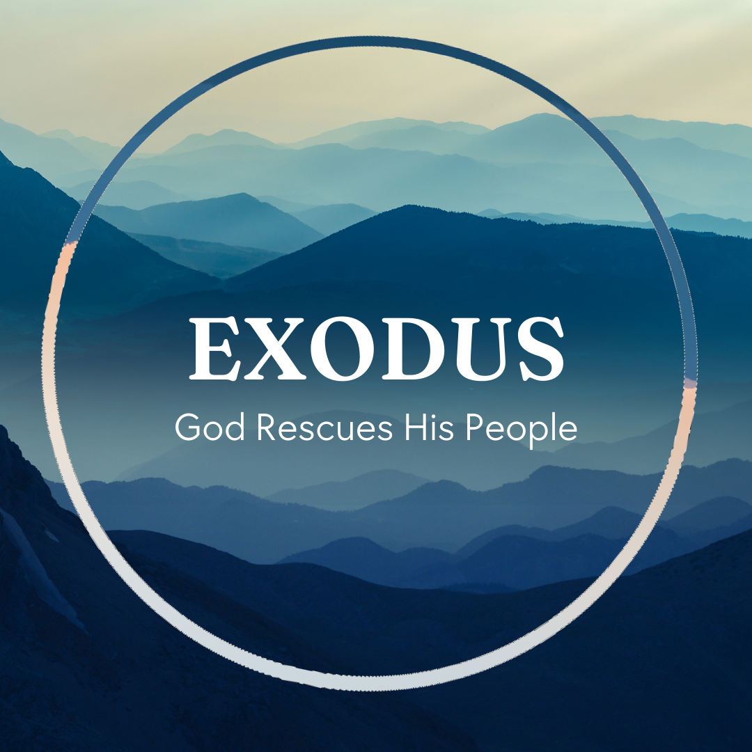

God tells us that Ezra read from the book of the Law,
day after day, and that the people of God were filled with joy!

These notes have been prepared by Rev. Philip Moffett, Cullybackey RPC Ireland.
Monday - Exodus 30:11-16; Matthew 17:24-27 - The Ransom Price.
In Matthew 17 there is a strange episode where the collectors of the temple tax ask Peter if Jesus pays this tax. Jesus tells Peter that sons of kings don't have to pay tax, but that Jesus will pay the tax for Peter and for himself.
To understand this passage, we need to go back to the instructions for building the tabernacle. God tells Moses that when he takes a census, he is also to take a ransom price of half a shekel from each man numbered and recorded. This money is then to be used in the construction and the maintenance of the tabernacle. God's dwelling place will, quite literally, stand on this ransom. When God numbers or orders anything to be numbered, He is saying, "these are mine." God has the right and authority to number that which belongs to Him. But to be numbered among God's people means that a price has to be paid - half a shekel/2 drachmas. Everyone needed the same price to be paid for them, showing that all were equal before God. In paying the price, no plague would come among them showing that all deserved God's wrath, but the ransom would set them free.
This is a picture of what Jesus has done for us. 1 Peter 1:18-19, "Knowing that you were ransomed from the futile ways inherited from your forefathers, not with perishable things such as silver or gold, but with the precious blood of Christ, like that of a lamb without blemish or spot." Jesus tells Peter that he will pay the ransom so that he does not have to pay. The Son of God will pay the ransom for his people.
Notice also that the money from the census tax was to be used in the building of the tabernacle (and later the upkeep of the temple). Every time they entered the tabernacle the silver was a reminder to the people that the ransom price had been paid. In the throne room of heaven is the Son of God, Jesus Christ, who paid the price. He is before the Father as a constant witness to what has been accomplished for our salvation. And because the price has been paid, we are numbered among God's people. We are included. Our names are written in His book.
Q1. What does it mean that Jesus has paid the ransom price?
Q2. What other remembrance do we have of the price being paid?
Tuesday - Exodus 30:17-21; 38:8 – Reflection.
For the priests serving in the tabernacle there was a continual reminder to them that they needed to be clean - the bronze basin. It was made from polished bronze and stood at the entrance to the tent of the tabernacle. The polished bronze came from the mirrors of the women who worshipped in the entrance to the tent of meeting. (Glass mirrors weren't used for another 1,500 years!) The duties of the priests were not clean duties. They sacrificed the animals, they walked about (probably barefoot), they trimmed the wicks for the candles, they carried oil, they burnt incense. At the basin God was teaching the people that He requires purity. To serve God they had to be clean before Him. They had to look in the mirror and then wash. Priests were to examine themselves and to make sure that their lives and walk were pure.
The reflection of the water and the reflection of the mirrors are pictures of what God's Word does for us (James 1:22-25). We need to make use of the mirror. We need to study it. We need to look into the face of Jesus Christ in Scripture and see our own stains, faults, and sins, and then seek cleansing.
The priests had to wash every time they carried out a sacrifice and every time they went into the tent of meeting. This washing was to be repeated again and again and again. There was a washing that didn't have to be repeated (at their ordination). They were bathed. The priest didn't need his whole body to be washed again to set him apart before God - just his hands and his feet. This is what Jesus is telling Peter in John 13.
We also are to keep a short account as we serve Jesus Christ. We are made clean in Christ, but we are also to continually confess our sin before God in the confidence that we have been forgiven. Jesus himself taught us to pray, "Forgive us our debts, our trespasses, our sins." We are to do this continually as we see our reflection in the word of God.
Q1. How is God's Word like a mirror?
Q2. Why is it important to continually confess our sin?
Wednesday - Exodus 32 & 33 - A Great Sin.
When we come to Exodus chapters 32-34, we come across an episode that seems to be out of place. Why does this event interrupt God's instructions for building the tent? The answer, outside of the fact that this is the way history happened, is that there is a barrier in our approaching God. There are more references to sin in chapters 32-34 than there are in the rest of the book of Exodus. We are prone to sin and so we need an intercessor - one to act on our behalf.
When the apostle Paul writes about this episode in 1 Corinthians 10, he says, "Now these things took place as examples for us, that we might not desire evil as they did. Do not be idolaters as some of them were; as it is written, 'The people sat down to eat and drink and rose up to play.' We must not indulge in sexual immorality as some of them did, we must not put Christ to the test as some of them did, nor grumble as some of them did. Now these things happened to them as an example, but they were written down for our instruction. Therefore let anyone who thinks that he stands take heed lest he fall."
Perhaps we are more like the people of Israel than we would like to think. Maybe, just maybe, our hearts are as inclined to wander, as inclined to make idols, as inclined to forget the saving grace of God. Just like the people of Israel, we must then surely need a great intercessor. Like the people of Israel when we sin we have sinned a great sin (32:31). Like the people of Israel when we sin we deserve to be blotted out (32:33). Like the people of Israel when we sin we need someone to take our place (32:30,32). Moses could not be blotted out instead of the people, he too would be guilty before God, but there is one who interceded for us and took the punishment we deserve. His name is Jesus Christ.
Q1. In what ways can we be like the people of Israel with the golden calf?
Q2. How was Moses like Jesus? How is Jesus greater than Moses?
Thursday - Exodus 34:1-9, 29-35 & 40:34-38 - The Glory of God.
When Moses pleaded with God on behalf of the people of Israel, God promised that Moses would catch a glimpse of God's glory. Moses could not see that fullness of God's glory, but in just catching a glimpse he was changed. His face shone.
But when the tabernacle was finished God came down in His cloud of glory and filled the tabernacle. God's glory was amongst His people in the tabernacle. Still Moses couldn't approach because of the glory of God, but God's glory was now present. God's glory is an unapproachable glory, it is a present glory, and it is a glory that changes us.
Ultimately the tabernacle points us to Jesus Christ. The true presence of God's glory among His people. The tabernacle has shown us how sinful men and women can approach God. We can only do so through the means that God has provided. We must approach through the door, by way of the sacrifice, being washed clean. We can only approach through the great high priest who has gone in to the holy of holies and presented before God the blood of the sacrifice for sin. We can only approach through the great high priest who intercedes for us having paid the ransom price for us, that we might be counted in. We cannot approach the glory of God without Jesus Christ.
Jesus is the Son of God who tabernacles among us. The glory of God took on human form and lived here on earth. It was a present glory. The glory of God was revealed in Jesus Christ. In Jesus Christ we know God as the LORD, a God merciful and gracious, slow to anger, and abounding in steadfast love and faithfulness, keeping steadfast love for thousands, forgiving iniquity and transgression and sin, but who will by no means clear the guilty, visiting the iniquity of the fathers on the children and the children's children, to the third and fourth generation.
And this is a glory that changes us in Jesus Christ. In Jesus Christ we are made clean, we are forgiven, we are adopted into God's family. And one day we will see that glory in its fullness, and on that day we will be changed, in a moment, in the twinkling of an eye.
Q1. What has stood out most for you about the tabernacle?
Q2. How has the tabernacle helped you to understand the work of Jesus Christ?
Friday – Psalm 16 - Preservation, Commitment, Contentment.
by Rev. Tom Donachie
Whilst it could be said that all of the psalms relate to Christ, there are some that are seen as being more especially Messianic, and Psalm 16 is often said to be one of those. Spurgeon says that the psalm speaks of the faith of the Saviour in all of the circumstances of his life and thus gives an example for his people to follow.
There is no doubt that the psalmist had great need for the preservation of God during many of the trials that he faced, and this was no less true of the Saviour. Even as Jesus was preserved from harm until his time was come and from the wiles of Satan in the temptations, and the weakness of the flesh in the Garden, so those who are 'in Christ' through faith will similarly be preserved.
The preservation called for in verse 1 was assured because of the commitment to the Lord that the psalmist, in some measure, and the Saviour in full measure, had. Commitment to God was shown by submission to His sovereign will (v2), love for the people of God (v3), hatred of false religion and idolatry (v4), and satisfaction in God (v5). The believer, too, can be assured of the preserving hand of God in the circumstances of his own life, as he trusts and commits himself daily to the Lord.
Commitment to God brings with it contentment with the path chosen by the Lord. Even although the pathway for the Lord Jesus led though pain and suffering, he was willing to accept it as the Father's will. So too the apostle Paul when he said, 'I have learned to be content in whatever circumstances I am'.
Commitment and contentment lead to a confidence for the future. Although Jesus faced an agonising death yet there was the glorious confidence and assurance of final victory. He could see beyond the grave to the glory of resurrection. The believer too, hears the words of assurance, 'because I live, you shall live also'.

Q1. How does this Psalm point to Christ?
Q2. What does commitment and contentment lead to?

