FAMILY WORSHIP BOOKLET

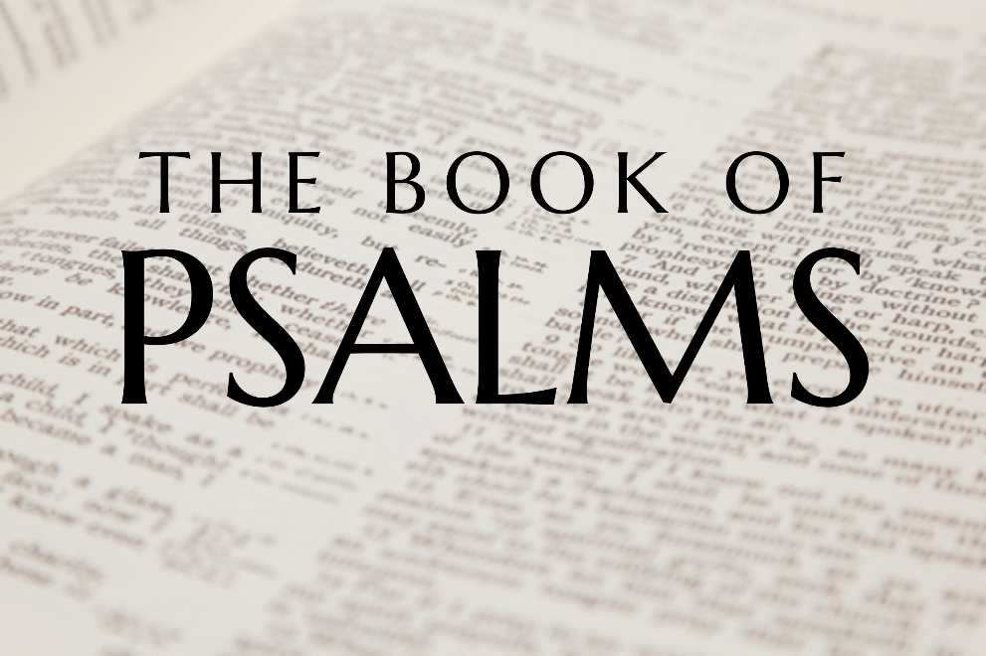

God tells us that Ezra read from the book of the Law,
day after day, and that the people of God
were filled with joy!
Westminster Shorter Catechism

Memory Verse of the Week

Psalm of the Week:

Pray for the Holy Spirit’s help as you read and study God’s Word.

Produced by Ottawa RPC to help you in your family worship.

Monday - Psalm 20 - Prayer in Times of Danger.
Psalm 20 gives no real indication about when it was written, but it does seem quite clear about why it was written. The purpose is well stated by Luther when he says, “It seems to me as if David had composed this psalm, that it might serve as a devout and pious battle-cry, whereby he might admonish himself and the people, and draw them to pray.” John Calvin considered that the psalm should be used as 'a common form of prayer', to be used when the church was threatened with any danger. It may be that David is repeating the prayers that the people are praying for him and for the kingdom.
The Church of God, in both Old and New Testaments was constantly under attack from the forces of evil, and such has been the lot of the people of God ever since; and so it is necessary for the church to know what to do in those circumstances. We shall look at three major things as we consider this psalm during this week: the prayer that is offered; the confidence that is expressed; and the trust that is confessed.
The first thing David asks for, as he offers this prayer, is for help in a time of trouble (vs 1-2). Such prayer is important personally, as the church, and nationally. In all trials and difficulties there is no better place to go than to the sovereign creator and sustainer of all things, for there is nothing that is too hard for the Lord, there is nothing more powerful than the Lord, and there is no-one who cares more for His people than the Lord. David recognises that it is only the covenant God of Jacob who can help him and deliver him, and so he pleads that God will hear him. So it is with the believer. It is only because the believer is in a covenant relationship with God through Christ that he can have the assurance that God will listen to his cry. When he pleads the name of God, he is calling upon God Himself, as He has manifested Himself in creation and the Word.

Q1. Why is the church constantly under attack?
Q2. Why does God listen to the prayers of His people?
Q3. Does God always answer the prayers of His people?

Tuesday - Psalm 20:2-3; Psalm 3 - Prayer For Acceptable Worship.
When the psalmist cries out to God for His help and protection, and asks that God would send him help from on high (v. 2), it is not a prayer in a vacuum. David and the people of Israel were able to approach God for help in time of trouble because they were accustomed to approach God regularly in worship. There are many who cry out to the Lord when they are facing difficulties or trials but have no thought of God at all when everything is going well. That was not the case with David, nor for the people who prayed for him. So, they ask that God would be pleased to look favourably on the faithful worship that had been offered and accept the offering of the required sacrifices that had taken place. When God is pleased to accept and bless the worship of His people, it is a good sign of His favour.
Not all worship, however, is acceptable to God, as the story of Cain and Abel aptly illustrates. Both of the brothers presented offerings to the Lord, and there is no suggestion in Genesis 4 that Cain brought anything other than the best of his produce; the problem was that God demanded a blood sacrifice for there to be an acceptable worship. Right from the earliest days of human history God has specified exactly how He is to be approached in worship. It has never been left up to man to come to God in whatever way best pleases him. The elaborate system of Tabernacle and Temple sacrifices were to be complied with in the smallest detail, if the sacrifices were to be pleasing to God. Following the one sacrifice for sin for ever, that the Lord Jesus Christ made on Calvary, there are laid down in the New Testament the elements that should be included in God-honouring worship, and it behooves the professing people of God to observe them, both in letter and in spirit.

Q1. Why is it important to worship God continually?
Q2. What are the elements of true worship?

Wednesday - Psalm 20:4; Proverbs 16:1-3 - Prayer for Direction in Life.
It is quite possible to translate Psalm 20:4 as 'May He grant you according to your heart'. This would seem to get to the root of what is being prayed for here, because it focuses attention upon the heart. If your heart isn't right, then to get the desires of your heart would not be beneficial, nor would it be God glorifying! This is a matter that is often dealt with in the Scriptures; Psalm 37:4 tells us that if we delight in the Lord, He will give us the desires of our hearts, and David prays that God would create a clean heart in him (Psalm 51:10).
The same emphasis is seen in the New Testament. The Lord Jesus Christ spoke about the need to have a pure heart; Matthew 5:8, “Blessed are the pure in heart, for they shall see God”, and warned that it was from the heart that all wickedness came (Matthew 15:19). He also taught in Matthew 12:34 that the desires of our heart are reflected in how we live, and our speech and our behaviour will be a reflection of our priorities.
So, for this prayer to be prayed correctly, we need first of all to deal with the condition of our own heart. We need to know ourselves and how we are so prone to sin, and to have a deep knowledge of the salvation purchased by Christ and the total dependence we have upon him for all good. It may be that when the people prayed that David's purposes would be fulfilled, they were thinking principally about his military campaign, but there is a much deeper significance to this prayer. The plans and purposes that we have may not always be those that God has for us, and that is why the first part of v. 4 is so important. If our heart is right with God, and we are seeking to know His will and to follow His guidance, then we can pray that our purposes may be fulfilled.

Q1. How can we be sure that our heart is right with God?
Q2. Why is it important to guard our hearts?
Q3. How can we know the will of God for our lives?

Thursday - Psalm 20:5; Proverbs 16:1-3 - Confident of Victory.
The psalmist expresses a great confidence in the God to whom he is praying; so much so, that he rejoices in the victory that will surely come. The trouble that David and his people faced was not over, as the first verse makes clear, 'The Lord hear you in the day of trouble'. But having placed their concerns and petitions before the Lord in prayer, they confidently expect that victory will be their’s; not because of their own great military prowess, but because they are fighting under the banner of the Lord God almighty.
Just like David, the child of God is constantly facing attacks from the world, the flesh, and the devil, and he is so often aware of his own inability to withstand the ferocity of the attacks; so, he needs to have something of the confidence expressed in this verse. Such confidence comes first of all because of the salvation of God. We will rejoice in salvation when we come to fully realise that salvation from sin is the most important thing that a person can have, and so, in times of trial or times of persecution, the believer is comforted as he remembers the words of his Lord, 'do not fear those who kill the body but cannot kill the soul. But rather fear Him who is able to destroy both soul and body in hell'.
There is also the assurance that comes from knowing that no matter what the circumstances or what the difficulties, the one who has received the salvation of God will always have the presence, power, and preservation of the Lord of Hosts, the captain of our salvation (Hebrews 2:10). Although often small and despised, and facing almost insurmountable odds, the Christian believer and the church of Christ will triumph over all enemies; the banner of the Lord God Almighty will fly victoriously over all the armies of Satan that seek to oppose, for the Lord Jesus Christ has given this wonderful promise, 'I will build my Church, and the gates of Hades shall not prevail against it'.

Q1. How does the knowledge of personal salvation help in times of trouble?
Q2. What means does Christ use to build his church?

Friday - Psalm 20:6; Psalm 28:6-9 - God Works for His People.
The psalmist continues to exalt God for the victory that He will give His people over their enemies, and states two things on which he bases this confidence. The first is the knowledge that God is working on behalf of His people. He says, 'Now I know that the Lord saves his anointed'. This knowledge could be based on what he knew of the being and the character of God, and how He had worked for His people in the past. How many times had David experienced the saving hand of his God upon him when everything seemed to be against him? Just think of the contest with Goliath. The king, the trained soldiers, and his brothers all thought that the venture was foolish, but David knew that 'the Lord saves his anointed'. So, the child of God should have the confidence that God is working out all things for the glory of His name and for the good of His people.
Second, just because we do not recognise or feel His working, does not mean that He is not doing so! The knowledge that God is working for His people is strengthened by the knowledge of the almighty power of God. The saving strength of His right arm is the sure guarantee of victory and success! No matter how subtle and powerful our enemies might be, their power is as nothing compared to the almighty power of the sovereign God. When we are tempted to despair and to feel powerless in the face of our enemy, we need to remember that the one who fights for us is the one who created all things, the one who upholds all things by His mighty power, and the one who ordains all things that come to pass.
This great God has not only saved His people from their sin and redeemed them from the power of the devil, He has also adopted them into His family. Will He not therefore care for them and protect them when danger lurks?

Q1. Why was David prepared to go and fight Goliath?
Q2. What encouragement can we take in times of danger?

Saturday - Psalm 20:7-9; Psalm 33:13-22 - Trust in the Lord.
The psalmist began with a prayer because he was facing a trial, and then continued to express the confidence that he had in the Lord; and he now finishes the psalm with a declaration of the trust that he placed in God. As he has been reflecting upon the majesty and the power of God, he comes to see things from a totally different perspective. The natural view of man and, in particular, that of kings having to go to war, is to amass the biggest army with the best and most sophisticated weaponry available.
But now, David sees that it is those who do not know the true and living God who rely upon their own strength and ability, and in the horses and chariots that they possess. This is true not just in terms of physical warfare but is especially true in the battle that the Christian has with indwelling sin, and in the struggle against the enemy of the soul. How often do we seek to resist temptation by attempting to reform our behaviour by our own effort? If David could not rely upon himself in his battles, no more can we in the daily spiritual battle with sin.
The name of God in Scripture represents the whole being and character of God, and so when David says that he will remember the name of the Lord, he is not just speaking about remembering words like Yahweh, he is simply speaking about God Himself. He will remember His majesty, he will remember His power, he will remember how God had delivered him in the past, he will remember God's covenant love and His gracious promises made to His people. It is only as the people of God 'remember the name of the Lord our God' in that way, that we can be sure that the enemy, no matter how powerful, will be defeated and the cause of God and truth be victorious. Such knowledge gives motivation and confidence to the believer as he seeks the face of God in prayer.

Q1. What weapons has God provided for our spiritual warfare?
Q2. How can the believer overcome temptation?
Q3. How can we 'remember the name of the Lord our God'?

