Family Worship Booklet
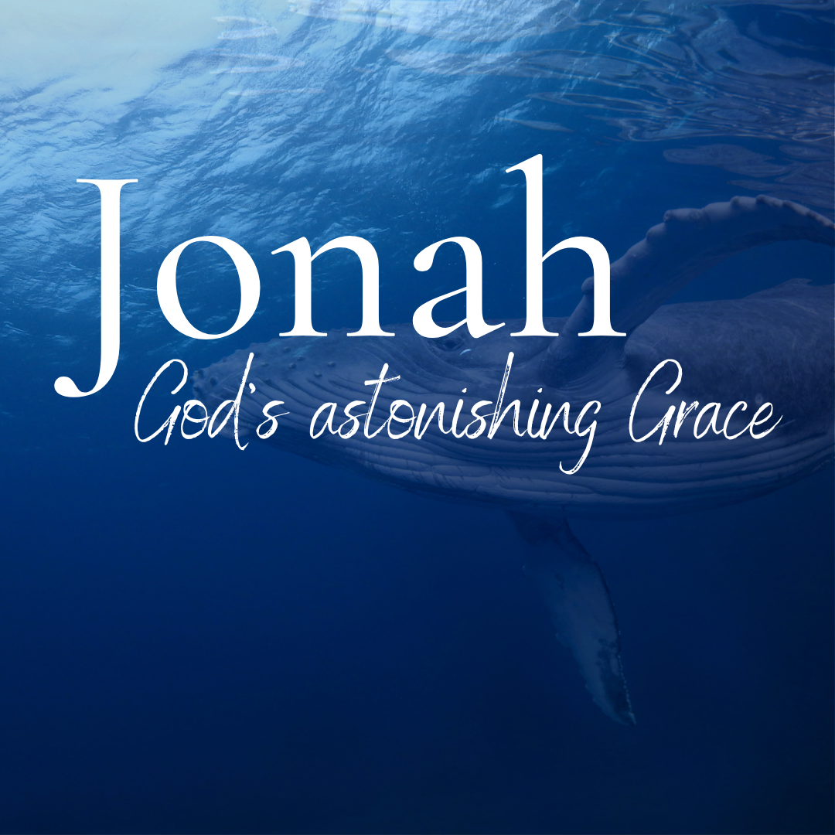

God tells us that Ezra read from the book of the Law,
day after day, and that the people of God
were filled with joy!

Monday – Jonah 1:1-4 – Jonah, how it’s viewed by many.
Produced by Ottawa RPC to help you in your family worship.
These notes have been prepared by Rev. Dr. Andrew Quigley.

We’re going to begin a short study in one of the best-known books of the Bible, the book of Jonah. It will be short because the book is only 48 verses, comprising 4 chapters, and just a couple of pages in most bibles. But what it concedes in length, it will more than make up for in dramatic content and resulting life lessons. One commentator writes, “with its unexpected twists and turns, the plot successfully retains our attention throughout.” Another says that “in the narrative, every phrase is vivid and graphic. There is not a word that does not advance the history. There is no reflection. All hasten on to the completion, and when God has given the key to the whole, the book closes with His words of exceeding tenderness lingering in our ears.” So, this will be an invigorating read and, hopefully, with the Lord’s help, a study that will bless the soul of everyone who engages with it.

It’s an account which has fascinated generations of children and adults, even though it has been much maligned and ridiculed. Since the second century, questions have been asked about whether it is historically true. In the eighteenth century, men like Voltaire, the French Enlightenment writer, historian, philosopher, and ruthless critic of the gospel, scoffed at the contents of the book of Jonah. Such attacks have influenced many with the result that the predominant view among religious scholars in the past 150 years has been that this Biblical book's content is nothing more than a simple allegory, a prophetic parable, a fictional satire. There are two reasons why the historicity of Jonah has been questioned. The first, and one could say the most obvious stumbling block for those who want to see it as such, is the fact that Jonah was in the belly of the great fish for three days. The second issue that has led to unwarranted doubt is the distinctiveness of Jonah. Unlike other Old Testament books, Jonah speaks to a pagan nation from within that nation, whereas when the other prophets speak to the surrounding nations, they do so from within the borders of Israel. There is also the issue of how Jonah portrays himself. Other prophets share their emotions and thoughts at times, but with this book, Jonah presents himself as the principal focus of the book; it’s about him, and it’s almost as though he is the message as well as the messenger. Tomorrow, we will see why this book is historically true.

Q1. How many verses and chapters are in the book of Jonah?
Q2. Why do some people think incorrectly that the book is not historically true?

Tuesday – Jonah 1:1-4 - Jonah is historically true.

Yesterday I said that many question the historicity of the book of Jonah, and I gave two reasons why they question it. First, because it’s written about a pagan nation from within that nation and second because Jonah dominates the book; here are some reasons why we can say it is historically true.
- The book begins as several other prophetic books do. That is with the words “the word of the LORD came to ….” Look at Joel 1:2, Micah 1:1, Zephaniah 1:2, Haggai 1:1, Zechariah 1:1, Malachi 1:1; they all begin with this sentence.
- The fact that it is written about a pagan nation is not unique; gentiles had been welcomed into the nation of Israel from its inception. In the covenant promise that God gave to Abraham in Genesis chapter 17, there was a provision made for foreigners to be part of the household of God (Genesis 17:27). The Psalms repeatedly state the fact of the engrafting of the nations into the family of God, for example, Psalm 82:8, “Arise, O God, judge the earth; for you shall inherit all the nations!” and Psalm 107:3, “Let the redeemed of the Lord say so, whom he has redeemed from trouble, and gathered in from the lands, from the east and from the west, from the north and from the south.” So, with God, it is true that He was clearly focused on the nation of Israel, it wasn’t at the absolute exclusion of all the other peoples of the earth.
- Like several other books within the collection of books known as the Minor Prophets (i.e., Obadiah, Nahum, Habakkuk), Jonah doesn’t explicitly state when it was written, but we do have a clue. In the first verse, we read that “the word of the Lord came to Jonah, the son of Amittai.” This is important because it not only identifies him as a real man with ancestral heritage but as the same prophet we read of in 2 Kings 14:25, which dates him during the reign of Jeroboam II (782-753 BC).
- There is another piece of information that underscores the historicity of the book of Jonah: Jesus references Jonah on two occasions, first in Matthew 12:38-42 and then in Matthew 16:1-4. Jesus would not have spoken of a man who did not exist to make his point.

Q1. Why can we believe in and accept the historicity of the book of Jonah?

Wednesday – Jonah 1:1-4 – An overview of the book.

If I were to characterize the book of Jonah in one word, I would say it is ‘symmetrical’. It has four chapters, and two events are played out within those chapters. Event or scene ‘one’ takes place in chapters 1 and 2, and scene ‘two’ is worked through in chapters 3 and 4.
Both scenes begin with God, which is no surprise as God is the originator of all things. And in both scenes, God gives Jonah, his prophet, the same command. Jonah is to go to Nineveh and declare a message God will provide him with. In scene one, Jonah refuses to fulfil the command and faces the consequences, and in scene two, he obeys the command and witnesses the reality of God’s mercy.
It’s helpful to get a sense of the central theme and content of the book before considering how God works in this man’s life. So, here is a graphic that will further lay down the structure of the book (and I have adapted this from someone else), so that you can see the parallelism between the two scenes.
Scene 1
1:1 God’s Word comes to Jonah
1:2 The message to be declared
1:3 The response of Jonah

1:4 God’s warning
1:5 The pagan’s response
1:6 The pagan leader’s intervention
1:7ff Jonah’s response

2:1-10 God’s grace
Scene 2
3:1 God’s Word comes to Jonah
3:2 The message to be declared
3:3 The response of Jonah

3:4 God’s warning
3:5 The pagan’s response
3:6 The pagan leader’s intervention
3:7ff Jonah’s response

4:1-10 God’s grace

The critical point is that it’s all about God’s grace and the salvation it brings. God’s grace and His plan of eternal redemption are inextricably linked, whether it involves an individual or a city of hundreds of thousands of people.

Q1. How would you describe how the content of the book of Jonah is presented?

Thursday – 2 Kings 14:23-27 – A successful previous ministry.

So, who is this man Jonah? Well, his name means dove in Hebrew, and as we read in the first verse, he is the son of a man called Amittai. We also know from 2 Kings 14:25 that he was from Gath-hepher, which literally means "wine-press of the digging”, and is mentioned twice in the Bible, here and in Joshua 19:13. A small village in Galilee, Israel, it was five kilometres north of Nazareth, where Jesus would grow up, and one kilometre from Cana, where Jesus would do his first public miracle at a wedding (John 2:1-12).

In terms of his early development, while we cannot say for certain that Jonah was one of them, he was probably of the same generation as the young men referred to in 2 Kings 2:3,5,7,15 and 2 Kings 4:1,38, 5:22 and 6:1 as the ‘sons of the prophets’. These were young men whom God brought into contact with Elijah and Elisha to be exposed to his Word through their prophetic ministries. If Jonah were one of these young men, he would have experienced many blessings.

Whatever the circumstances of his teenage years, with God’s hand upon his life, Jonah developed into a gifted prophet himself. We know from 2 Kings 14:23-27 that he was set apart and used by God during a dark period in the history of Israel. One of the Old Testament words from a prophet is a ‘seer’, a man to whom God had given insight into His purposes. Such men had both a divine calling and a commission from God to bring what they had received from Him to His people. From what we read in 2 Kings 14, a prophetic ministry that probably took place before his call to go to Nineveh, Jonah was both a servant-hearted and successful prophet. How can we tell? Well, he was remembered by the people because what he prophesied took place as he said it would. This was a clear sign that he was a true prophet sent from God (see Deuteronomy 13:1 ff).

Understanding this is more than just a point of general interest. It’s significant in terms of what is going to happen. Coming out of this successful period of prophecy, Jonah would have been filled with a sense of real purpose, even destiny. It will be interesting to consider the factors that contribute to the response he makes when God calls him to go to Nineveh.

Q1. Where did Jonah live?
Q2. What was the school of the prophets?
Q3. What sort of prophetic ministry did Jonah have during the reign of Jeroboam, and how would that have affected him?
Friday – Jonah 1:1-4 – The word of God comes to Jonah.
God comes and speaks to Jonah. God always speaks first. He spoke first in the Creation (Genesis 1:1). God spoke first to Adam and gave him the command not to eat of the fruit of the tree that was forbidden to him (Genesis 2:16). God spoke first to Cain, informing him of the danger that his anger towards his brother Abel posed to him (Genesis 4:16). God spoke first to Noah and told him what He was going to do, because every inclination of man’s heart was only evil all the time (Genesis 6:13). God spoke first to Abram and told him to leave the Ur of the Chaldees to the land He would show him (Genesis 12:1). And we could go on and on and on. God always comes and speaks first. Let’s be careful not to forget this when we feel sorry for ourselves and wonder where God is.

The words that tell us that “the word of the Lord came to Jonah” are not unique. This is a phrase that is used over 100 times in the Old Testament and informs us that the Word of God came directly to men who, in turn, declared them as such. Many attacks have been and are being made on both the historicity and authority of God’s Word; it is really important that we remember and repeatedly teach our children that whatever so-called ‘new evidence’ is found that questions the truth and integrity of God’s Word, it will never change the fact that God has spoken and that He has done so in His Word. Let the world laugh and scoff at our so-called ‘blind’ faith. We will hold the truth of God’s Word in our hearts and use its light to guide our path through life.

God does not engage in a long preamble about why He has chosen Jonah to deliver this message; that’s not relevant; Jonah is a servant, and servants are to do as they are told. The message God gives Jonah to take to Nineveh is concise. Jonah is to arise and go to Nineveh and call out against it. Why? Because the evil that pervades its streets has come up before God. Again, there is no detail in terms of what Jonah is to expect, how he will be received, or what the possible response will be to his prophetic declaration. God doesn’t share with Jonah how the events that will unfold in Nineveh will impact His covenantal dealings with His people and, ultimately, the world. Why? Because God doesn’t need to explain Himself to us. This a point we would benefit a lot from remembering, especially given our constant human craving to know, so that we can maintain some element of control of our lives that is slipping like sand through our fingers.

Q1. Who speaks first, God or Jonah?
Q2. How do we know the Bible is true?
Q3. What does God not tell Jonah, and what does He say?

