Family Worship Booklet
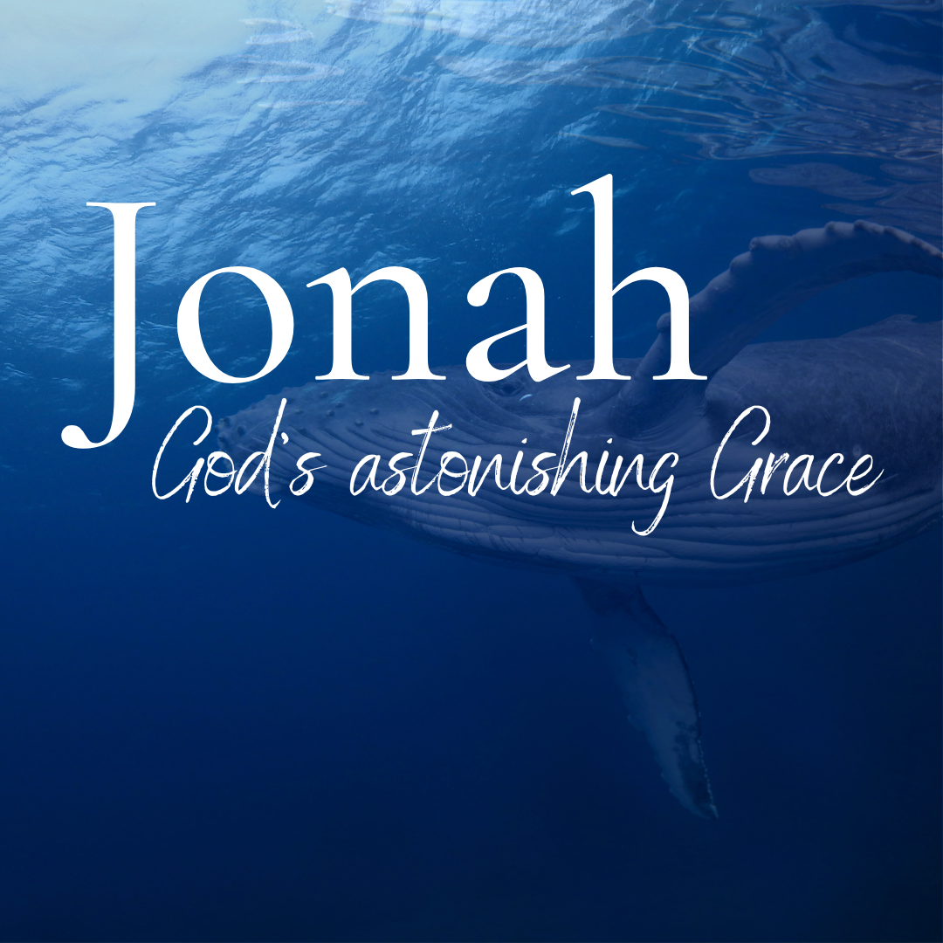

God tells us that Ezra read from the book of the Law,
day after day, and that the people of God
were filled with joy!

Produced by Ottawa RPC to help you in your family worship.
These notes have been prepared by Rev. Dr. Andrew Quigley.
Monday – Jonah 1:4-6 – The ship to freedom isn’t going to work.

Jonah, having received the command of God to go to the great city of Nineveh and call out against it, had decided he wouldn’t do that, and when you decide not to do what God commands, there is always the need to flee from God’s presence in some way or other. Jonah chose to flee as far as he could to Tarshish, which meant getting a ship from Joppa. Once on the boat, Jonah probably felt elated. He probably thought to himself that, at the very least, he had escaped a very difficult situation, and possibly he might even have read the fact that he had been able to get a ship going where he wanted to go in such a timely manner, as a sign of God’s mercy to him, a providential provision. It’s amazing how capable we are of seeing the Lord’s blessing in our lives when we are running from His presence and commands in our lives. It may be totally irrational, but we are much more prone to it than what we think.

Going below deck and obviously exhausted from the nervous tension of all that had happened, Jonah falls asleep, not knowing what is ahead, but at least consoling himself with the thought that he had preserved his safety. What he had sacrificed to attain that perceived safety was more than just the price of the fare, for Scripture tells us that only in God’s presence is joy to be found and only at His right hand are pleasures evermore (Psalm 16:11).

Whatever time he thought he might have to rest or reflect on his decision, though, was to be short-lived. As the ship sailed from the harbour and westwards across the Mediterranean Sea, God let it be known that there would be no escaping for Jonah. He’d paid the fare to get onto the ship to get away, but he was merely paying the fare to get into the instrument of God’s chastisement upon him.

How often does that happens in our lives? We get into something because we think it will be for our best, whatever it is; whether it’s a way of escaping from what God clearly wants us to do or it’s a decision to pursue something because we’re not pursuing God wholeheartedly, and before we know it, the thing we have set our hopes of freedom on, has become a net which has entrapped us.

Q1. Where does Jonah go when he goes on board the ship?
Q2. What are his thoughts likely to be?
Q3. What will the ship become to him?

Tuesday – Jonah 1:1-6 – The storm hits!

The Lord hurls a great wind upon the sea. When God uses language like ‘hurls’ and ‘great’ to describe the wind He sent on the Mediterranean Sea to deal with Jonah’s fleeing, you can be sure it wasn’t a little breeze. And note that this isn’t simply a climatic event; everything that happens on the earth is under the control of God, but this was a special supernatural intervention. It was a wind that was so fierce that it caused the sea to convulse into a terrible, horrendous storm, sending huge waves crashing down on the ship. Such was the violence of the storm that it was threatening to break up the ship.
The response of the sailors is fear. Note that this is one of three times they will fear during this event. We read in this verse that they are afraid, in verse 10 that they are exceedingly afraid and in verse 16 that they feared the Lord exceedingly. These sea-hardened sailors, drawn from different nations, as many mariners are, who have experienced numerous storms before, but nothing like this. They know their lives are on the line, so it’s not surprising to read that they cry out to their various gods for deliverance. In a time of desperate need, people turn to what is beyond themselves for help. But these sailors also do all they can to help themselves. They throw the cargo overboard to create greater buoyancy, that is, lift the ship higher in the water. This is their livelihood they are casting into the deep, but what’s money when your life is hanging by a thread?
The question, though, is, where is Jonah in all of this? On deck pleading with God to save him and the sailors? No, he’s down in the ship’s bowels, astonishingly still asleep. The Hebrew word describes a deep sleep. When fleeing from God, it is incredible how ‘asleep’ you can be to what is happening around you. Why does that happen? It’s because the conscience that would have once sounded the alarm has been turned down so low that it’s barely functioning. Jonah only wakens because the captain awakens him with an obvious question – how can you sleep? And then he commands Jonah to get up and call to his god with the expressed hope that Jonah’s ‘god’ might save them. The last thing Jonah wanted to hear when he was so rudely awakened was a command to call on God, but such is the mercy of God that He sometimes uses the challenge of the ungodly to arrest the attention of those He loves.

Q1. What does God do?
Q2. What is the sailor’s first response, then what two things do they do?
Q3. Where is Jonah, and what happens to him?

Wednesday – Jonah 1:7-10 - Jonah is asked a barrage of questions!

Yesterday, we saw how the Lord hurled a great wind on the sea, which battered the ship, seriously frightening the sailors. I don’t know if you saw it, but when the captain entered the ‘inner part of the ship’ and found Jonah asleep, he used the same word God had used when he told Jonah to go to Nineveh, ‘Arise’. Surely a reminder to Jonah, if he needed one, of why he was on the ship. When you seek to flee from God’s presence, you'll often find that He’ll remind you of why you are where you are. It’s a mercy when He does, and it should be well received as a prick to the conscience.
The sailors may not have known who authored the wind and the resulting storm, but they did know that it had happened for a reason, so they cast lots to find out why. The lot, unsurprisingly, falls on Jonah, which ushers in a list of questions. You can imagine this happening. There they are, all standing around Jonah, quizzing him about who he is, what his job is, where he’s from, etc. They want to know who this man is and why their are lives hanging by a thread because of him.
Jonah begins by citing his Hebrew ethnicity and his fear of the God of heaven, which I will return to in a second. But note that he ignores the question about his occupation. He is not in a place in his heart and mind where he can speak freely of the fact that he is a prophet of the Lord. The man called to speak the Word of God couldn’t even say what his job was. By contrast, the Apostle Paul, when caught up in a storm, on the same sea, under different circumstances, took a very different approach and proclaimed that all would be saved and that not one of the occupants of the boat would be lost (Acts 27:34-45). It’s amazing how faith and obedience can change things in God’s gracious sovereign purposes.

The news that Jonah fears the Lord leaves the sailors in no doubt as to who is behind this storm and it is news that, in turn, causes fear to descend on them. Why? Because it’s the God of the Israelites. And why should that terrify them? Because, while the violence of the storm is one thing, the knowledge that the God who had destroyed the Pharoah of Egypt and his vast army, as well as great cities like Jericho, is behind the storm is devastating. Even though they probably can’t see beyond their imminent death, they will do all they can to try and preserve their lives.

Q1. What word did the captain use that would have reminded Jonah of why he is on the ship?
Q2. What question did Jonah not answer, and why not?
Q3. Why were the sailors afraid when Jonah told them whom he feared?

Thursday – Jonah 1:7-12 – Jonah’s solution to calm the tempest sea.

The sailors were in a desperate state and bombarded Jonah with questions to try and get to the bottom of why this supernatural storm had descended on them. Jonah had been forthcoming with his answers but only partially so. However, telling them about his ethnicity and that he feared the God of Heaven only frightened them even more. Not simply because of their probably limited knowledge of the one true God but because Jonah had told them that he was fleeing from the Lord’s command. Interestingly, he characterizes it as the Lord’s presence.

We simply cannot run from the commands of God and not experience the consequences of his chastening hand. It’s just not possible. The writer to the Hebrews says, “For what son is there whom his father does not discipline? If you are left without discipline, in which all have participated, then you are illegitimate children and not sons. Besides this, we have had earthly fathers who disciplined us and we respected them. Shall we not much more be subject to the Father of spirits and live? For they disciplined us for a short time as it seemed best to them, but he disciplines us for our good, that we may share his holiness. For the moment all discipline seems painful rather than pleasant, but later it yields the peaceful fruit of righteousness to those who have been trained by it.” Hebrews 12:7-11. So discipline is part of our Christian life because our heavenly Father loves us very much.

Having identified who was behind the terrible situation they found themselves in, a plight that was getting devastatingly worse by the moment, they asked Jonah to tell them what to do. His response is heartbreaking to read. For we see a man who has descended into the pit of despair. “Pick me up and hurl me into the sea,” is Jonah’s response. His rationale is simple, I have caused this, and with my death, it will be ended. We will see that his conclusion is not wrong, well at least the hurling him over the side bit, but it’s so sad that he has got himself into this place in his life. Disobedience will always take us to that place where blessed assurance seems hard to lay hold of. Faith and such assurance come from hearing the Word of God, believing, and doing what He says.

Q1. Why are the sailors even more sacred when the hear what Jonah has done?
Q2. Why can we not escape the chastening disciplining hand of God?
Q3. What did Jonah tell the sailors to do and why?

Friday – Jonah 1:11-16 – The sailors and God.

Since God’s call on him to go to Nineveh, Jonah had been travelling in a state of spiritual disobedience, marked by prayerlessness. Fleeing from God, though, is futile, and on this occasion, God intervened to disrupt His established laws of nature and the elements to arrest Jonah’s flight. He hurled the great wind, and the sea was stirred into a tempest, engulfing everyone on the ship in a siege of terror. Our sin doesn’t just affect us; it always impacts those around us.
Once identified as the cause, Jonah makes himself vulnerable to these sailors, men who are strangers to him; yet now they hear all about his life. He’s telling them the very message he was supposed to take to Nineveh, effectively ‘you are condemned’ unless you listen to me. And what is he pleading with them to do – to throw him overboard! But having heard him open his heart to them, these men weren’t going to act quickly. Their attempts to row to the shore are valiant but destined from before the foundation of the world to fail; for they are not just facing the elements as they give themselves strenuously to the task, but the will of God. The harder they row, the more the volcanic-like sea erupts around them until they realize the futility of their efforts. And what a realization that is, for now, they call out to the ‘Lord’ – Yahweh, the eternal, self-existent God. They are moving from pagan unbelief to faith in the one true God. The demonstration of His power and the testimony of Jonah, albeit one recounting his flight from the Lord’s presence, has been used by God to open their minds and hearts to Him. Now they do what Jonah had failed to do; they cry out to the Lord in prayer. They plead their innocence in the matter of Jonah’s behaviour and acknowledge God’s sovereignty in dealing with it. Surely this is a manifestation of humble faith. And in acknowledgement of what God was obviously saying He wanted, through the relentless escalation of the storm, they pick Jonah up and throw him into the sea. Immediately the sea stopped its raging, we are told, and for a third time, we read of these men’s fear of the Lord, but this time it led to them offering a sacrifice to the Lord and making vows to Him. These men had set sail on this trip like they had done numerous times before, but they would end it as they had never ended a voyage before – as believers in God. What a testimony to God’s saving power through the elements and the confession of a fleeing backslider.

Q1. Did Jonah’s sin just affect him?
Q2. What did the sailors do when Jonah told them to throw him overboard?
Q3. What did the sailors do before they threw Jonah into the sea, and what did they do after it?

