Family Worship Booklet
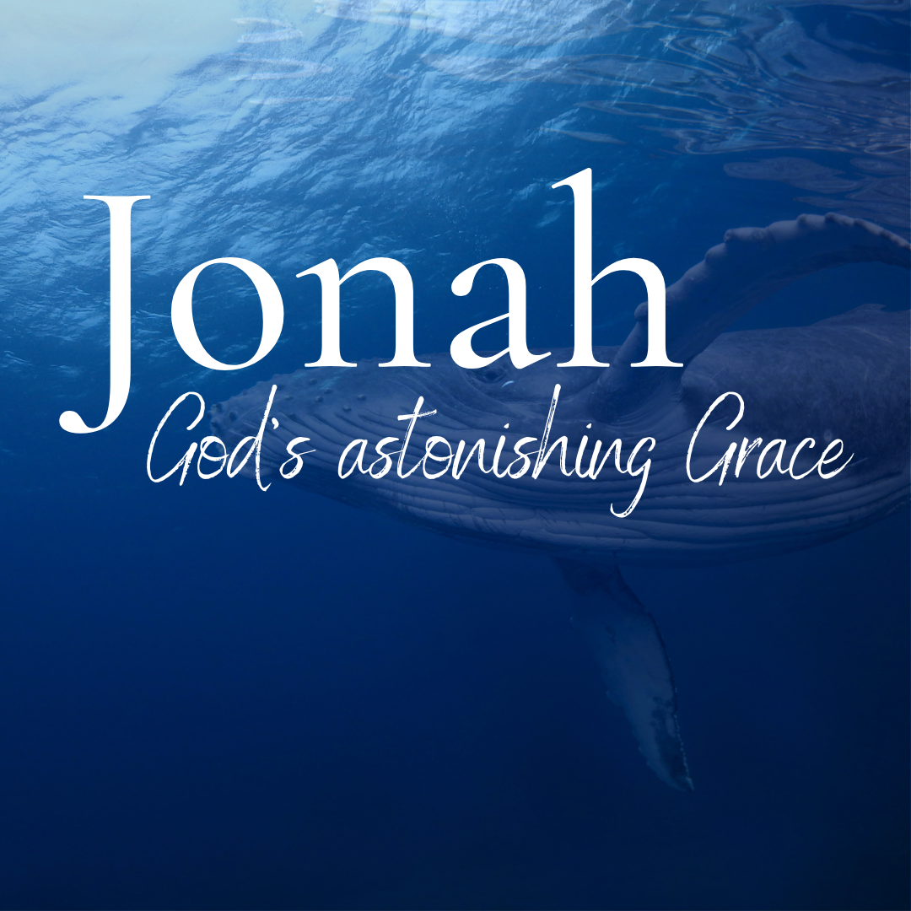

God tells us that Ezra read from the book of the Law,
day after day, and that the people of God
were filled with joy!

Monday – Jonah 3:1-5 – The power of God’s Word.
Produced by Ottawa RPC to help you in your family worship.
These notes have been prepared by Rev. Dr. Andrew Quigley.

Jonah’s message to the people of Nineveh is a predictive prophecy, the only one in the book. It’s also time-specific, which is very unusual, and the only such prophecy which is limited to 40 days. But it doesn’t take 40 days for the message to get through. On the day Jonah began preaching, the people began believing. They heard, they considered, and they fully accepted the truth of it. The word ‘believed’ is the same as the one used in Genesis 15:6 when it says that Abram, in response to God’s covenant promises to him, believed the Lord, which was counted to him as righteousness. Abram fully trusted in the promises of the Lord and, in doing so, declared his trust in the Lord. Upon hearing this message of judgment, the people of Nineveh began believing.
This is astonishing when you think about it. Here is this ‘exceedingly great city’ in the global power of the day, renowned for its brutality to foreigners, not only receiving this message of impending judgement at the hand of a foreign God but responding to it. It would be like someone going to Kabul in Afghanistan and publicly declaring a message of judgment against the Taliban. They probably wouldn’t get to see the dawn breaking on their second day in the city. And yet it happened in Nineveh. How? Because the voice of Jonah carried an exceptional power. Not a power intrinsic to him personally, but an unction, a filling of the Spirit of God which meant the voice of God Himself was being heard. It is the same power which makes the gospel powerful unto salvation today. It is a power which opens the eyes of the spiritually blind to see and the spiritually deaf to hear. It is a power that renews the mind, convicts the conscience, breaks and regenerates the heart, and gives the will a Godward desire. It’s a power that no soul can resist. It’s a wonderful, life-changing power and glorious in what it achieves.
I grew up in Northern Ireland, where there was a mighty outpouring of the power of God in 1859. There are numerous accounts of thousands of lives being changed for eternity in different villages, towns, and the city of Belfast. Yes, there were false professions and excesses of so-called ‘spiritual behaviour’, but nonetheless, a phenomenal work of God’s Spirit took place, deeply impacting the province for decades.
You should crave to see this power each Lord’s Day morning and evening when the Word of God is preached. It is a power you should give yourself to praying for each week (Ephesians 6:19,20, 2 Thessalonians 3:1).

Q1. What did the Ninevites do when they heard the message of judgment?
Q2. What does it mean to believe?
Q3. What should our attitude be to the power of the gospel?

Tuesday – Jonah 3:1-6 – The Ninevite response is seen in their actions.

The Spirit of God illuminated the truth of Jonah’s message to the mind and hearts of the Ninevites. No longer living in the blindness that the god of this world had cocooned them, they could now see the actual reality of their lives. The light of the truth had flooded into the black darkness of their hearts, and they were grieved to the core of their being as they stood at the bar of divine judgment. 800 years later, thousands of Jews in Jerusalem would experience the same thing when Peter preached on the Day of Pentecost.
The impact of this cutting to the heart of the Ninevites is seen in what they do. They call a fast; they intentionally stop eating and put on sackcloth; they remove their comfortable clothes and put on very uncomfortable coverings. One commentator writes, “This was a common means in the ancient world of expressing genuine grief, humility, and penitence – the hallmarks of true repentance. When denounced by the prophet Elijah, the Israelite King Ahab responded in a similar fashion: ‘he tore his clothes, put on sackcloth and fasted. He lay in sackcloth and went around meekly’ (1 Kings 21:27). The prophet Joel, possibly a contemporary of Jonah, demanded that his hearers should fast and don sackcloth as a sign of their repentance (Joel 1:13,14). The sackcloth used was a thick course cloth, normally made from goat’s hair; to war, it symbolized the rejection of earthly comforts and pleasures. The response of the Ninevites was unanimous, from the greatest to the least. No class or section of Ninevite society felt exempt from the need to humble itself before God.”
Inevitably, those in authority hear about what is happening in the city, and matters hit a critical point when news reaches the king. This is a significant detail because it gives life to Jonah’s statement from the greatest to the least. The king responds like the people, not because he is a political chameleon but because the Word comes to him. Now, this may have been the content of Jonah’s message or the reaction to it by the people. Whichever it is, he too is affected and responds by rising from his throne, acknowledging that One greater than himself is speaking to the city now; taking off his robe, he puts on sackcloth and sits down in ashes. What a phenomenal event. Imagine if those in power in our nation today were to humble themselves before the Lord in confession and repentance; what joy it would bring to us and what changes it would bring to our society.

Q1. What do the Ninevites do?
Q2. Why do they fast and put on sackcloth?
Q3. How did the King of Nineveh respond?

Wednesday – Jonah 3:6-10 – The people fear God and repent.

The king showed in a very real way that he had come under conviction by getting off his throne, taking off his royal robe, putting on sackcloth and sitting down in ashes. But he did more than present personal repentance; he instituted a reformation of the society and didn’t do it alone; the nobles endorsed his edict.
A number of scholars say that this edict proves that the book of Jonah didn’t happen in the 8th Century BC but must have been written much later. Their reasoning, the issuing of an edict like this, was what the Persians did, not the Assyrians (remember the saying of the law of the Medes and the Persians). Secondly, no historical evidence exists that the king of Nineveh issued such a decree. Both arguments sound credible; however, just because the Assyrians weren’t as famous as the Persians for giving non-negotiable rules doesn’t mean that they never did so. And to the point of a lack of historical evidence, how many nations keep on record events that show one of their prominent cities bending the knee, as it were, to a foreign God. News of what had happened in Nineveh would have been quashed throughout Assyria for fear of what others might have thought it could have led to. There is also the fact that, according to scholars, this is one of the most poorly documented periods in Assyrian history.
Interestingly, animals and people are included within the bounds of this edict, which shows the degree of seriousness with which the king and the nobles were taking this threat of destruction. Every man, woman, child, and beast had to be involved in seeking to appease the wrath of Jonah’s God. Further, the pronouncement about fasting contains two different verbs about eating. The first one, to ‘taste’, can be used when speaking about either humans or animals eating; while the second one, to ‘graze’, is used only when referring to animals feeding, particularly cattle and sheep. That’s an important thing to note because those who question the historicity of Jonah point to this reference about requiring the ‘animals to fast’ and say that makes no sense; but when the fact that a verb specific to ‘grazing’ is used, it indicates that it was a deliberate part of the proclamation and therefore verifies the veracity of the book.
Finally, and importantly, arising from a fear of God, there is the crying out to Him for salvation from impending judgment. Ultimately, there is no better thing we can do than to cry out to God for His deliverance of us.

Q1. What did the king do, and who joined him in it?
Q2. How can we answer those who argue a late authorship date for Jonah?
Q3. How do the verbs verify the truth of God’s Word?
Thursday – Jonah 3:6-9 – It must be real!

Yesterday we saw in verse 8 that both man and beast were to fast, put on sackcloth, and call out to God urgently for deliverance. But there’s more because a demonstration of a desire to repent is insufficient; there must be a genuine stopping of sin. While necessary, an outward manifestation of piety will not deliver Nineveh from the destruction promised by God; a genuinely radical change of behaviour is needed, for it is behaviour that speaks of what is going on in the heart. And that remains the case today. Many people talk about being a Christian and ‘attending’ church, but what shows whether a person is converted is their decisions and how they live their lives. Are they living as someone who truly loves the Lord Jesus with all their heart, all their soul, all their strength and all their mind? Or is it that they merely engage with God and His commands when it suits, and when it doesn’t suit them, they don’t? As Jesus says in Matthew 7:18, “A healthy tree cannot bear bad fruit, nor can a diseased tree bear good fruit.” And it's not just a matter of whether one receives some approval for the type of fruit produced; there are serious eternal consequences, for Jesus says in Matthew 7:19-20, “Every tree that does not bear good fruit is cut down and thrown into the fire. Thus, you shall recognize them by their fruits.”
The king of Nineveh knew this, as did his nobles; hence the reason for the edict that requires the ‘fruit’ of each person’s life is to be evidently clear. They knew that this God of Jonah, now their God, would be watching, and He could not be fooled by simply fasting, wearing sackcloth, and sitting in ashes if there was no radical change in their lives. The stakes were too high to be playing games with God. They knew that within a few days, their very existence would depend on it, and each had to do all they could to prove the reality of the change in their lives.
We must have the same mindset about the besetting sins in our lives. We need to understand that God does see them, and while our salvation is guaranteed in Christ, it is sealed in by the Holy Spirit; there are still consequences for us if we persist in them. We need to hear what the king of Nineveh and his nobles are saying and put away evil from our thoughts, hearts and lives. We need to stop doing violence to the new creature we are in Christ and make conscious decisions to live in Christ for Christ daily.

Q1. What do the king of Nineveh and the nobles tell the people to do?
Q2. Why must they turn from their evil?
Q3. What do they want God to do?

Friday – Jonah 3:10 – God sees and relents.

While God is never under any obligation to pardon, the prayers and the deeds of the people of Nineveh undertaken in response to the king’s edict were received with mercy, just as the pleading of the sailors when they were about to throw Jonah into the sea in chapter 1. God relents from punishing the city as He said He would. Note that God does not ‘repent’ here as some translations say He does. There is no turning of God from a wrong action to doing good. If God had fulfilled what He said and brought judgment on Nineveh, it would have been a good action because it would have brought glory to His name. In ‘relenting’, God is turning away from one course of good action to undertake another equally good course of action because He deems it appropriate. It is essential to understand that prophetic proclamations are not declared in absolute terms, that is, without conditions, as Jeremiah 18:7-9 makes clear – “If at any time I declare concerning a nation or a kingdom, that I will pluck up and break down and destroy it, and if that nation, concerning which I have spoken, turns from its evil, I will relent of the disaster that I intended to do to it.” And note that the conditions do not have to be cited in the heralding of the judgement; the wonderfully gracious promise stands regardless. In relenting, God is not saying He got it wrong; instead, He is being consistent with His holy character as a God who is merciful in the deliverance of wrath.
All of this may seem too unreal to be true. How could a city, renowned for its evil and violence, a fact acknowledged by its rulers, turn so quickly from its gods, repent of its evil, and seek deliverance from judgement at the Hand of the One true God? But that is to ignore the power of God to change the human mind and heart. As believers in Christ, we must constantly remind ourselves that the gospel is the power of God unto salvation. Without detracting from that in any way, we need to be careful, though, in speaking of the Ninevite’s repentance, that we don’t go on to assume that Nineveh became an important centre for the worship of the living God in the pagan world. Yes, many of the Ninevites may have turned to worship God, but it doesn’t say the city did, and that’s interesting, because we know that the pagan sailors did that. Remember how they, in chapter 1:16, offered a sacrifice to the Lord and made vows. So, we take from Scripture and learn from it, but we must be careful not to go beyond it.

Q1. What did God do when He saw the repentance of the Ninevites?
Q2. Can God repent? What does it mean when it says God relented?
Q3. Can we say that Nineveh became a centre for the worship of God?

