Family Worship Booklet
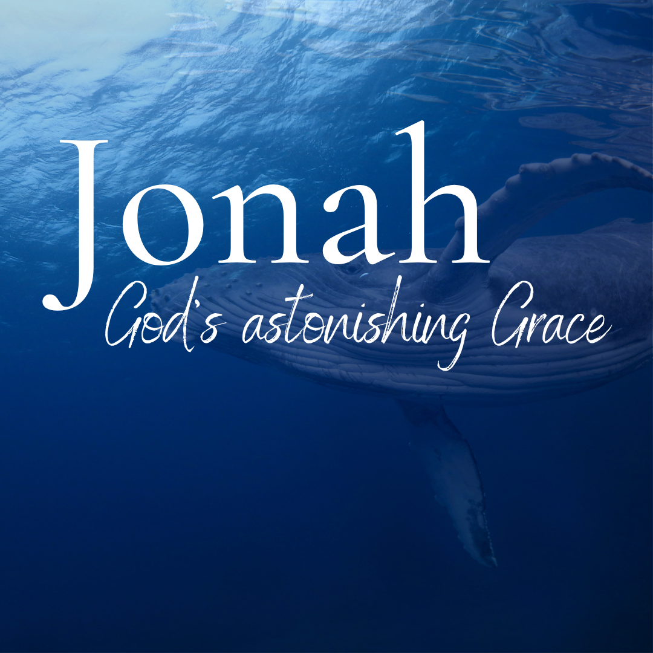

God tells us that Ezra read from the book of the Law,
day after day, and that the people of God
were filled with joy!

Monday – Jonah 4:1-4 – Jonah becomes angry.
Produced by Ottawa RPC to help you in your family worship.
These notes have been prepared by Rev. Dr. Andrew Quigley.

The people of Nineveh had heard and astonishingly, taken heed, to the message of judgement from God declared by the prophet Jonah. Their repentance was obvious and clear from what they did in fasting, putting on sackcloth and turning from their evil ways. As the days counted down to ‘day 40’, the stated destruction day, there must have been incredible tension in the city. However, when it came and went, and day 41 came and went, and there was still no destruction, joy would gradually have replaced the tension until everyone had come to accept that God had relented.
So, we come to chapter 4, where Jonah makes a reappearance, having been absent for most of chapter 3. And what a reappearance it is. Are you shocked by his reaction, “But it displeased Jonah exceedingly, and he was angry?” I certainly was the first time I read it. It makes no sense. Why would Jonah not be overjoyed at witnessing tens of thousands of men, women, and children being spared the horror of what occurred in Sodom and Gomorrah? Look at the contrast, God turns from his fierce anger (3:9), whereas Jonah becomes angry. To say that in their response to the Ninevite’s repentance, God and Jonah had two diametrically opposed views would not be an understatement. It is interesting, though, that even in his enraged state, Jonah does pray. It indicates that he is still in communion with God, unlike when he was fleeing from the Lord’s presence. And this prayer gives us an insight into what lies behind Jonah’s anger; it reveals the reason for his rage.
From the outset, it seems that Jonah was convinced that God was going to forgive the Ninevites. He says to God, ‘O Lord Is not this what I said when I was yet in my country?’ But how could he have known? A prophet wasn’t someone who could read the future. Yes, they were men who spoke into and about the future, but only because God gave them insight and the words to say. So how could Jonah have known what God was going to do in Nineveh? Jonah knew because he knew the character of God and note it was a knowledge he had before he fled from God’s presence. Jonah knew God to be a gracious God, merciful, slow to anger and abounding in steadfast love and relenting from disaster. Now I will pick up on this tomorrow, but I want you to think about how Jonah can tell what God was going to do simply because he knew God and ask yourself the question. “How good am I at assessing what will happen in the future based on my knowledge of the character of God?

Q1 What would have happened in Nineveh as the days passed?
Q2 How does Jonah respond to God’s relenting?
Q3 How did Jonah know what God was going to do?
Tuesday – Jonah 4:1-6 – The reason for Jonah’s anger.

So, Jonah was displeased exceedingly and angry (and remember, these are his words) why is he so angry? Because of what he knew of God’s character and how it would impact Nineveh. Jonah knew God to be a gracious God, merciful, slow to anger and abounding in steadfast love and relenting from disaster. There are a number of passages in the Old Testament which make this statement in similar words about God, for example, Exodus 34:5-7, Psalm 86:15, Psalm 145:8, Joel 2:13 etc. So, it was something that the people of God were taught. Jonah knew this about God before he was thrown into the Mediterranean Sea. He knew it when he was fleeing from home to Joppa. In fact, as he admits, it was the reason for his fleeing from the presence of God when God first spoke to him and told him to go and call out against Nineveh. So, Jonah refused to go to Nineveh the first time because he would not let God be God in his heart and mind. ‘Yes, God can be whomever He wants to be on paper, but when it comes to my life and what He wants me to do and how that will affect those whom I hate,’ well, that’s a different matter. This was the issue for Jonah. This was part of the reason for his being so exceedingly displeased and angry at God’s relenting. And look at how strongly he feels about this. It wasn’t that he was a bit annoyed at God; he wasn’t merely shaking his fist at God and saying in a petulant momentary rage, ‘this isn’t fair’. He tells us that such is the depth of his anger that he prayed and asked God to take his life. Incredible.
God doesn’t grant Jonah his prayerful desire, rather he responds with a simple question that pins Jonah’s heart to the wall. “Do you do well to be angry?” The power of the question in its directness and clarity. Jonah had just condemned God for not being angry, and now he is being condemned for being angry. There is something here we don’t want to miss. The word ‘anger’ is the same in Hebrew as the one for ‘hot.’ Jonah is now going to experience just how hot it can get.
Jonah leaves the city, travels east and finds a place from where he can observe Nineveh. Maybe he is hoping that, given time, the Ninevites will fall back into their former evil and violent ways, and he will yet see God’s wrath being poured out on them like Sodom and Gomorrah. As he waits, he builds himself a shelter because of the scorching heat. Remember, he’s in modern Iraq, and if it was the summer months, the temperature could soar to plus 40ºC. Tomorrow we’ll see how he gets on, but for now, ask yourself, ‘have I ever been angry at God for being God?’
Q1. How did Jonah know about God’s character?
Q2. How did his knowledge affect the decision he made?
Q3. What did he do when he left Nineveh?
Wednesday – Jonah 4:1-7 – God provides for Jonah!

“Do you do well to be angry?” – is the question ringing in Jonah’s ears as he leaves the city and goes to a place where he can sit down and observe what God is going to do next. He makes himself a shelter not to keep himself dry in the rain but to provide some shade in the day’s extreme heat. This tells us that there wasn’t much natural vegetation around for him to sit under. We are not told why God provided a plant and made it grow to a size that Jonah was able to either lie or sit under it and be shaded from the sun. What kind of plant it was, is also unclear. Throughout the centuries, it has been variously referred to as a gourd, an ivy, a castor oil plant and a vine. While ultimately, it doesn’t matter, the probability is that it would have to have been some form of climbing plant for its leaves to have provided the necessary shade. We can say that whatever uprooted vegetation Jonah used to construct his shelter must have died quickly in the heat. Something else worth noting is the fact that the Hebrew words in the term ‘save him from his discomfort’ can also mean ‘to deliver him from his wickedness.’ There are those who would argue that God was not only providing physical shelter from the sun for Jonah but also providing him with the means to address his anger. Whether it was just a physical cover for shelter purposes or a means of delivering him from his anger or a combination of both, its presence certainly made Jonah a happy man, for he tells us that he was ‘exceedingly glad.’ It was gladness, though, which was to be very short-lived.
The next thing God ‘provided’ was a worm. This is the third provision God has made for Jonah. (There will be another one.) The first was the great fish; the second was the shelter; now this worm is the third. Each has served a purpose in Jonah’s life. The first two have a very clear purpose, they are both evidently acts of mercy and compassion, but the purpose of the third isn’t as immediately clear to Jonah as we shall see tomorrow.
In general, what does this tell us about God? It tells us that He is completely sovereign in all his dealings with man. He can do whatever pleases Him when it pleases Him. He can choose to deliver, and he can choose to destroy. He tells us, “Jacob, I loved, but Esau, I hated” Romans 9:13, Malachi 1:2,3. He gives life and takes it away. What is our response to be to this sovereign choosing and acting by God? God tells us we are to respond by believing and saying, “blessed by the name of the Lord.” Job 1:21. The key to life is getting a hold of that truth and living in it. Otherwise, life can be an extremely difficult and hopeless experience.
Q1. What does Jonah make for himself, and what happens to it?
Q2. What does God provide for Jonah?
Q3. How are we to respond to God’s sovereign workings in our lives?
Thursday – Jonah 4:1-9 – The pain builds for Jonah!
While he had been angry at what God had done in relenting of His destruction of Nineveh, Jonah was at least happy about his physical circumstances sitting in the shade of the plant God had provided/appointed. That is until the next morning when the worm which God had appointed attacked and destroyed the plant. This wasn’t simply a setback for Jonah, for God wasn’t finished with His ‘appointing.’ The final thing God appoints is a scorching east wind, and its impact on Jonah is hard because now he doesn’t have anything to shelter under. Just as the worm had attacked the plant, so now, the sun attacks Jonah, and he becomes faint; he’s probably experiencing what we know as sunstroke.
This is all too much for Jonah, and like his predecessor Elijah under the broom tree (1 Kings 19:4), Jonah asks God to let him die. We shouldn’t trivialize this. Jonah, like Elijah, was a highly component, serious individual who had experienced some significant events in his life. Thoughts of his death wouldn’t have washed over him easily. This was no momentary, flippant fit of pique. Jonah was going through a real crisis in his faith and couldn’t see a way out other than death. This is serious stuff.
But why was Jonah in this state of mind and heart? It was because God had done exactly what Jonah had expected Him to do in Nineveh. That seriously unsettled Jonah because of who the Ninevites were. If God could treat the evil, violent, murderous Ninevites like this, then there would be no length He wouldn’t go to, to show His mercy and grace. Would Israel just become one of many nations God would favour? And now, God was playing with him, appointing a plant for shade one day, and a worm the next to destroy it, and then a scorching east wind to destroy him in the sun.
As previously (verse 4), God responds to Jonah’s death wish with a question about his right to be angry. But unlike previously, Jonah reacts this time, and he does so angrily, first asserting his right to be angry and then citing the strength of that right – ‘enough to die’. Jonah has had enough of God and His appointing deliverance one minute and destruction the next. It’s absurd; it’s not just being inconsistent it’s utter madness; how could anyone live with this?
While Jonah’s experience of God’s dealing with him may be extreme in terms of the short time frame, is the underlying question of what you are doing God?, and why?, a question unique to Jonah, or has it crossed your mind also on occasions? Tomorrow we’ll see why God’s dealings with Jonah and with us are perfect and solely undertaken for our good and His glory.

Q1. What does God do in the morning?
Q2. How does Jonah respond?
Q3. What does God say to Jonah, how does Jonah react and why?
Friday – Jonah 4:5-11 – Our merciful and gracious God.

God has done an amazing thing in sparing the lives of tens of thousands of men, women, and children in Nineveh, but Jonah is not happy. In fact, he is filled with rage. First, at what God has done in Nineveh, even though He has been wholly consistent with His character, the issue that lies at the root of Jonah’s anger and second, because of God’s treatment of him, in appointing a plant to provide shade for him and then appointing a worm to destroy that shelter and an east wind to compound the impact of the blazing sun. It’s all too much for him, and he asks God to take his life. God challenges his thinking, but Jonah stands firm; in his eyes, he has every right to be angry enough to die.

God has the last word, though. Man can never outthink God; it’s a fool who thinks he can. God contrasts Jonah’s attitude to the death of the plant with His attitude to Nineveh. Jonah is filled with compassion for the plant. How do we know that? Was it not wallowing in self-pity that caused him to be angry, after all, he had been left in the sun with an east wind intensifying its effects. We know because God tells us - “You pity the plant.” Jonah was annoyed; he was angry with God for what God had done to the plant, so much so that he wanted to die, and yet when God had shown compassion and relented from destroying the inhabitants of Nineveh, people created in His own image, Jonah had become ‘exceedingly displeased and angry’. You couldn’t make it up; it’s almost too unbelievable to be true, and yet are you not a Jonah, am I not a Jonah? How often have you been angry and jealous at what God has given to someone else who, in your estimation, didn’t deserve it? Has your response been any different from that of Jonah’s?

We could get into what the meaning of the 120,000 people who don’t know their left hand from their right, that is, whether it is referring to the number of children in the city or the fact that the people were so morally degenerate they couldn’t tell ‘right from wrong’, but at the end of the day this book is all about God’s mercy and grace. His mercy and grace to the sailors, His mercy and grace to the people of Nineveh but most of all, His mercy and grace to Jonah. When you think about it, what is astonishing is not the fruit of God’s mercy and grace in our lives it’s the glorious truth that He is a merciful God, slow to anger and anger abounding in steadfast love.

Q1. How does God react to Jonah’s response that he is right to be angry?
Q2. What was Jonah’s problem?
Q3. What characteristics of God are clearly revealed in the book of Jonah?

