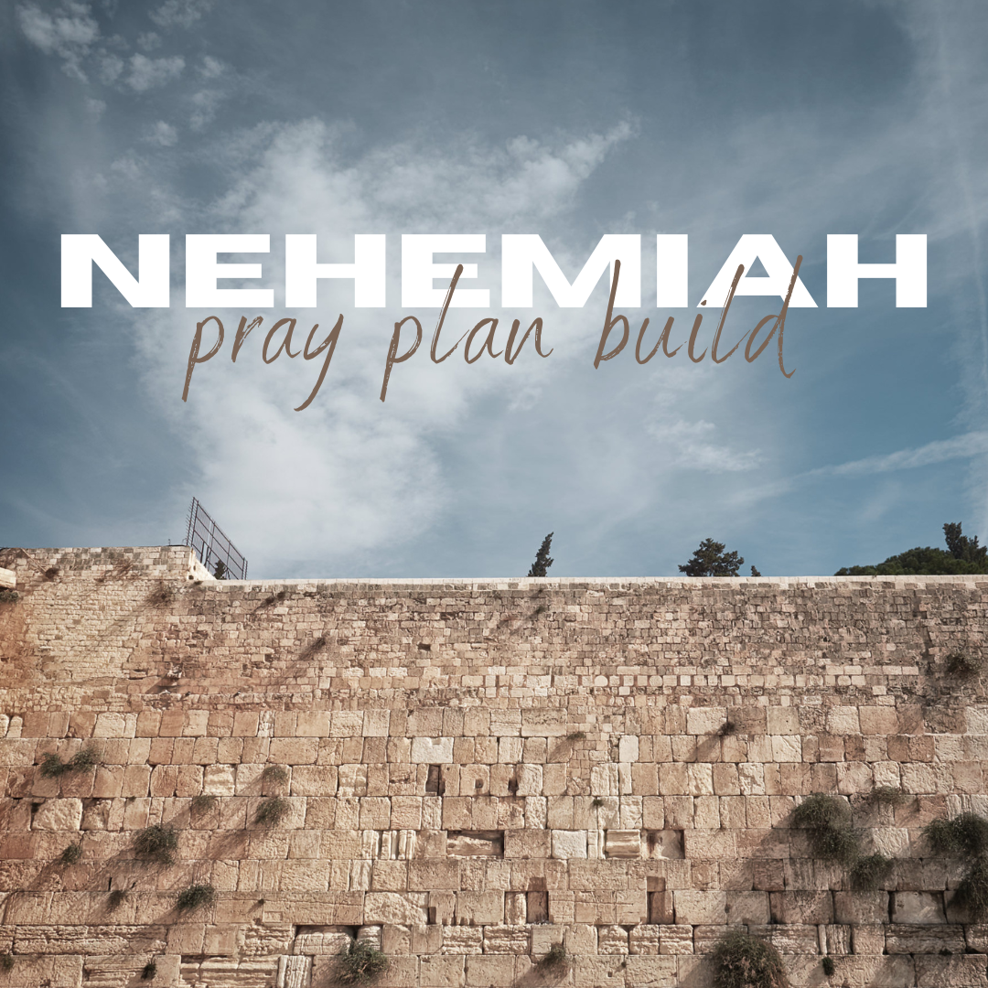

Daily Worship Booklet
Week 11

God tells us that Ezra read from the book of the Law,
day after day and the people of God were filled with joy!

Produced by the Ottawa RPC to aid the daily worship of God.
These notes were written by Rev. Dr. Andrew Quigley

The book of Nehemiah focuses on the work involved in labouring to see Christ build his church.

Monday – Nehemiah 8:9-13 - Leaders who are studiers of God’s Word.

As we saw last week, as the people assembled in a square before the Water Gate in Jerusalem, on the first day of the seventh month, Ezra ascended the steps of a purpose-built platform, the Law of God scroll in his hand, and he began to read from it. As the people stood listening, from early morning to midday, they gave their full attention to what they were hearing. However, it was not merely a case of hearing the Law, for the Levites moved among them, explaining the Law of God to them. The impact on the people had been overwhelming – many wept, convicted of their sin. Nehemiah, Ezra and the priests had intervened, though, not because they did not want conviction falling on the people, but seeing that it was real, they wanted the people to experience ‘grace’ – the promise of forgiveness, as would be manifested on the Day of Atonement, on the tenth day of the month. So they calmed the people and encouraged them to rest in the Lord's strength and rejoice in the Lord’s blessing upon them of granting them an understanding of His Word. Jerusalem had not seen a day like this in decades. A day that would live long in the memory of those present.
However, it was not a ‘one-off’; for the next day, there was another gathering. This time, a smaller one, but nonetheless significant. The participants, we are told, are the “heads of fathers’ houses of all the people” – these are the elders in the community. Men who had been granted a position of authority to rule at the discretion of God over His people. What have they gathered to do? It is essential to ask and know the answer to that question because men can be elected to office, but what they do when they get together informs one of the desires of their hearts. These men had come together to study the words of the Law with Ezra, the scribe. (Ezra, remember, is a scribe skilled in the Law of God, who, having set his heart on studying the Law, had given himself to the doing of it and the teaching of it to the people of God, Ezra 7:6, 10). So these men, understanding their role, realize that the only way they can fulfil it is to know the Law of God, and they understand that the best person to learn it from is a man who knows, keeps, and wants to teach the Law.
We want men who have evident gifts and are capable of utilizing those gifts to lead the church. We want leaders competent in conducting the business of the church's life who comprehend issues, reason, and discuss issues maturely. We want men who are courageous and who fear no one but God. However, above all, we want men who are studiers of God’s Word. Give thanks that we have elders who are students of God’s Word, and pray that the time they spend studying God’s Word will be ever-increasing.

Q1. What did the elders of the church gather to do?
Q2. Why did the elders of the church gather with Ezra?
Tuesday – Nehemiah 8:13-18 – Doing as God commands all ends in joy!

When the elders gather with Ezra to study God’s Word, they give themselves to it with serious intent. This was no skim-reading exercise to tick a box; this was focused, concentrated research to discern God's will and then do it. How can we know? Because they learned from what they read and studied. That is how you can tell the difference between skim-reading the Bible to tell yourself that you have read it, and studying the Bible. When you skim-read, you learn nothing; when you study, you learn what God would have you do.
So, what did these men learn from their study of God’s Word together? They learned about a Festival that had obviously been forgotten. Moreover, what a festival to have almost let slip out of annual remembrance, for at the heart of the Festival of Booths was ‘joy’. In Deuteronomy, Moses wrote, “You shall keep the Feast of Booths seven days, when you have gathered in the produce from your threshing floor and your winepress. You shall rejoice in your feast… For seven days you shall keep the feast to the LORD your God… because the LORD your God will bless you in all your produce and in all the work of your hands, so that you will be altogether joyful.” (Deuteronomy 16:13-15). So this was a celebratory festival, which had almost been lost because of the chase after the false joy associated with worshipping the fertility gods, gods who had, without fail, failed them. Now that the people are seeking the Lord and craving His Word in their hearts, God has led them to find true joy and a seven-day Festival filled with rejoicing. Those who preceded them had celebrated it, but you get the sense that it was merely a token gesture of acknowledgement (Ezra 3:1-4) without the actual building of booths. Now, the people will enter into the fullness of the Festival and all the joy that will come with that.
It is always the same: chase the world's joy, and it will always disappoint you. On the other hand, seek first the Kingdom of God, and everything will be given to you, including rejoicing and joy. Young people, please, please hear what the Word of God is teaching you to hear.
So, the elders rediscovered this Festival of Booths and told the people we would do as God commands and celebrate this Festival, which is what they did. The word was sent out to the surrounding villages and throughout Jerusalem, and during the two weeks between the second day and the beginning of the Festival, the people made their booths and lived in them for seven days. Moreover, as they looked back on the forty years of wilderness wandering and the subsequent provision of the Lord for them, they rejoiced, and, as they did so, they also rejoiced as they looked forward to the Kingdom that was promised and yet to be realized. Doing as God commands all ends in rejoicing.
Q1. What did the elders discover from their study of the Law?
Q2. What did the people experience as they did as God commanded?
Wednesday – Nehemiah 8:13-18 – Day by day, he read the Book of the Law.

In verse 17, we read that there was “very great rejoicing” as the people did as God commanded and celebrated the Festival of Booths. However, there is something significant here that would be easy to glide over – we need to be careful not to do so. In verse 18, we read, “And day by day, from the first day to the last day, he read from the Book of the Law of God. They kept the feast seven days, and on the eighth day there was a solemn assembly, according to the rule.” This is the keeping of the Festival of Booths as it should have been kept, with the reading of the Law daily as commanded in Deuteronomy 31:9-13. In these verses, we read that Moses commanded the Law to be read every seven years, at the Festival of Booths, so that the people “may hear and learn to fear the LORD your God, and be careful to do all the words of this law, and that their children, who have not known it, may hear and learn to fear the LORD your God, as long as you live in the land”.

The Law was read so that the people might hear and learn to fear the Lord and be careful to obey Him. What does Solomon write in Proverbs 3:7, “Be not wise in your own eyes; fear the Lord and turn away from evil”, and in Proverbs 9:10-12, “The fear of the Lord is the beginning of wisdom, and the knowledge of the Holy One is insight. For by me your days will be multiplied, and years will be added to your life. If you are wise, you are wise for yourself; if you scoff, you alone will bear it.” So, as the people heard the Word of God from the first day to the last day of the Festival of Booths, having heard it fourteen days earlier from the platform as Ezra had stood with fourteen priests beside him, seven on his left side, seven on his right side, now they were going to reap the wonderful harvest of doing so, and we will get into that tomorrow.

For now, I want to pause for a moment and give time to reflect on the fact that while fulfilling the commands of God out of a sense of obligation because of what God has done for us is a genuinely good thing, fulfilling them out of delight is a Blessed position to be in. Again, without downplaying the reality and necessity of doing what God commands us to do because He is God and we must obey Him, the fact is, as David says in Psalm 1, that man is blessed who ‘delights’ in the Law of the Lord. Delighting in the Law of the Lord will always take you further into obedience than a sense of appreciation-motivated duty. Matthew Henry, the well-known Bible commentator, put it this way, “Holy joy will be oil to the wheels of obedience.”

Q1. What was at the heart of the Festival of the Booths?
Q2. What should be the primary motivator for obedience?
Thursday – Nehemiah 9:1-4 – The Sorrow for Sin!

This is one of Israel's three great national prayers. The first is recorded in Ezra 9, this one here in Nehemiah 9, and the other in Daniel 9. Behind each of these prayers is the promise of 2 Chronicles 7:14, “if my people who are called by my name humble themselves, and pray and seek my face and turn from their wicked way, then I will hear from heaven and will forgive their sin and heal their land.”

Although this chapter is about the people’s response to God’s Word, one commentator writes, “Jehovah God is the main subject of this chapter—who He is, what He does for His people, and what His people must do for Him.” He goes on to say that this prayer “reviews the history of Israel and reveals the majesty of God and the depravity of man. Israel responded to God’s ‘steadfast love’ (verse 17), ‘great mercies’ (verses 19, 31), and ‘great goodness’ (verses 25, 35), with ‘great blasphemies’ (verses 18, 26), and that resulted in ‘great distress’ (verse 37).

So, with that brief overview, let us look at each section of this chapter; and we begin with:
The Sorrow for Sin - verses 1-4
Although the Festival of Booths may have ended, that does not mean people’s interaction with God’s Word has stopped. After the assembly on the eighth day, i.e., not of the month but the day after the Festival of Booths ended, there was a two-day ‘break’ before the people gathered again on the twenty-fourth day. During these two days, the people reflected on what they had continued to hear from the Law each day during the Festival and on the eighth day, and this time of being under the Word had a huge and serious impact on God’s people. The feasting and rejoicing had turned to the self-denying act of fasting, the representing of deep sorrow through the wearing of sackcloth, the remembering of one's mortality through putting of earth on the head, and the conscious separating from the world. These signs of serious, sorrowful remembrance of sin and its consequences and the need to separate from those who live wholly under its destructive dominion are a direct result of the Word of God bringing conviction and leading the people to confess their sins. This is the glorious work of the Word of God as the Holy Spirit works, and it is something we, the people of God, need today. It has made me think again about the undoubted benefit for the people of God of extended times of hearing and being attentive to the preaching of God’s Word.

Q1. How long after the Festival of Booths do these events take place?
Q2. How do the people respond to the preaching of God’s Word, and why?
Friday – Nehemiah 9:1-5 – Confession must lead to worship!

We simply cannot escape the constant exposure these people put themselves under to hearing God’s Word. It was as though they would not let go of God; having confessed their sins and the iniquities of their fathers. (And is not that interesting, given the attitude of psychologists today who are incessant advocates that the ‘sins of the fathers’ are the cause and the reason for the sins of the current generation – ‘it is the home you were brought up in, so it is not your fault, you’re a victim, and you should plead that case hard’). Here, the people are again listening to the reading of God’s Word for a quarter of the day, and the resulting confession is not merely for their sins but for those who preceded them.

Let me remind you of just how much hearing they have been doing, to impress upon you the sheer amount of time in this 24-day period these people spent listening to God’s Word being read and explained. Having stood from early morning to midday on the first day of the month to hear God’s Word, and the elders gathering on the second day with Ezra to study the Law, which led to the reading of the Book of the Law on each of the seven days of the correctly re-established Festival of Booths, here we find them again, after a two-day break, giving themselves to the Book of the Law for a quarter of the day. Have you ever experienced anything like this? I certainly haven’t. I have been at conferences where the Word has been preached five or six times, but I have never sat under God’s Word for such prolonged periods over so many consecutive days. I wonder if not experiencing such exposure to God’s Word has impacted my life; I am sure it has and not for the better. We live in a world of such ‘instantness’ that spending even a few hours listening attentively to the preaching of God’s Word at a conference seems unthinkable. Maybe that needs to change. Maybe we should be looking to develop our listening skills and asking God to enlarge our appetite for hearing His infallible and inherent Truth. As we shall see, it certainly had a phenomenally positive and tremendous impact on the lives of these people in Jerusalem.

Now we come to the Worship Of God – verses 4,5
Hearing the Law of God led to confession and worship. Confession of sin must lead us to God. It is not simply about saying ‘sorry’ for sin; it is acknowledging the wrong that sin is before God, and that must be done before God. That is why the Levites “cried with a loud voice to the Lord their God” and called on the people to “stand up and bless the LORD your God”.
Q1. What sense do you get of the people’s commitment to hearing God’s Word?
Q2. What did the people do?

