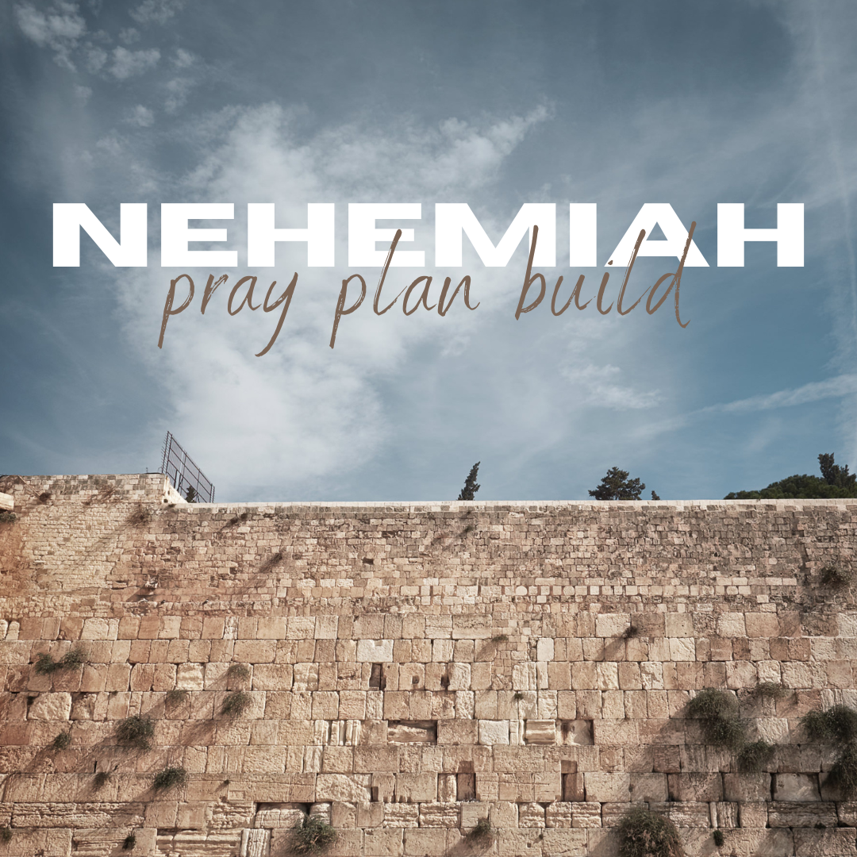

Daily Worship Booklet
Week 12

God tells us that Ezra read from the book of the Law,
day after day and the people of God were filled with joy!

Produced by the Ottawa RPC to aid the daily worship of God.
These notes were written by Rev. Dr. Andrew Quigley

The book of Nehemiah focuses on the work involved in labouring to see Christ build his church.

Monday – Nehemiah 9: 1-5 – The cry and the call!

Having been brought to a deep awareness of their sin, as we saw on Friday, the people are called to worship by the Levites.

The first thing that happens is the Levites call upon the Lord with a loud voice. The fact that Levites are standing on the stairs, probably of the pulpit built for Ezra to read the Law from 24 days earlier, shows that this is a public call or cry to the Lord. Interestingly, we read that it was a ‘loud’ cry. We have not read that the reading of the Law was done in a loud voice, so why do you think the Levites are now calling out to God in a loud voice? Could they be beseeching the Lord to forgive His people and condescend to be present with them? Asking God to come and dwell with us as we come into worship is so important. Worship of God is about our declaring to God our delight in and adoration for Him. However, our desire must be that, as we do so, God would be present Himself with us in a special way, as Father, Son and Holy Spirit.

The second thing that happens is the Levites calling upon the people to ‘stand up’. Why? Because to stand in someone's presence is to present an attitude of respect, and who greater can we demonstrate our respect to than the Living God when we come into His presence to worship Him? It is not that God has not been present with them; He has. There is nowhere we can go where God is not present (see Psalm 139:7-12); God is present everywhere, all the time (omnipresent). However, now they are entering into an act of formal corporate worship, so they “Stand up”.

Thirdly, the Levites call upon the people to “bless the Lord” and proclaim praise to Him. Why? Because of who God is—the everlasting God—and because of God’s glorious name, which speaks of His character. It is astonishing to think that we, whose world is so limited by time and space, have the phenomenal privilege of engaging with the one true and eternal God through worship, and doing so together corporately. Public worship is an amazing reality because of the One being worshipped. I think it is something we all need to continuously remind ourselves of when we gather on a Lord’s Day morning and evening for the act of corporate worship. When it descends into just ‘going to church’, and that is the perspective of the majority, then the church is teetering in a perilous place.

Q1. What do the people gather to do in these verses?
Q2. What three things happen and why?
Tuesday – Nehemiah 9:6-7 – Proclamation of praise!

Yesterday, we saw the Levites cry to God with a loud voice and call on the people to stand up and bless the Lord. Now, let us get into the proclamation of praise that the people bring to God.

First, the declaration that God alone is the Lord over all.
God has no comparison in heaven or on earth (Psalms 40:5, 113:4, Isaiah 40:18). He is unlike all the gods of the nations who surrounded Israel – gods who had mouths but could not speak; eyes but could not see; ears but could not hear; noses but could not smell. Idols made of the hands of men (Psalm 115:5-8). God is alone; He is unlike all the gods of the people who surround us today in our nation and beyond; and is to be believed in and worshipped exclusively as such.

Second, God is the Creator of the heaven of heavens with all their host.
The Levites remind the people that God has revealed himself in creation as the Creator of all things. God is the creator of the “heaven of heavens, with all their host”. Oh, to have the time to go into these things more deeply; here is but a snippet. There are at least seven references to the heaven of heavens in the Bible, including this one here in Neheamiah (Deuteronomy 10:14; 1 Kings 8:27; 2 Chronicles 2:6, 6:18; Psalms 68:33, 148:4, possible Psalm 115:16). So, what is the heaven of heavens? Well, it probably refers to the most distant reality of the physical heavens. (Heaven, where the souls of the departed are, is a real place, but in a parallel world to the one we live in.) So God made everything, including the most distant physical heavens and all they contain, including the galaxies of planets and stars and the host of angels. If you have a few minutes, look up the word ‘galaxies’ on the internet and be amazed at what you read, and then think – God made all that by the spoken words, “Let there be!” What does this tell us about God?

What a wonderful truth! By God's grace, we who believe must constantly remind ourselves of and rejoice in this truth. Moreover, we must be proactive in proclaiming it, for billions worldwide deny it. However, there is a day when they will all accept it because they will stand before Christ and have to give an account to him – the Last Great Day – the Day of Judgement.

Q1. What does God rule over?
Q2. What has God created?

Wednesday – Nehemiah 9:6-7 – God creates, sustains and is worshipped!
Third, God is the Creator of the earth, the seas, and everything in them.
One of the blessings of watching nature programs, although the vast majority of them speak either directly or indirectly of there being no Creator, is the window they open upon the world and the creatures that inhabit it. It is just incredible what God has done in creating the earth and seas and all the creatures, from the blue whale, weighing around 180 metric tonnes that swim in the world's vast oceans, to the single cell Myxozoans and everything in between. It is the fact that they all exist in an eco and life system that works. I was engaging with something recently that introduced me to ‘regenerative farming’, which advocates ideas like sowing various crops in the same field. Yes, it reduces the ultimate yield, but it is much more cost effective because there is no need for chemical sprays; it improves soil quality substantially and mitigates ‘climate change’ by drawing carbon from the atmosphere, sequestering it. No, I haven’t turned all green on you; here’s the point – one of the sources for many of the ideas found in regenerative agriculture initially came through observing the natural order, for example, the growth in uncultivated habitats like hedgerows. So, God knows best when it comes to that which He had made!
Fourth, God preserves and sustains everything He made.
While God made man and charged him with “dominion over the fish of the sea and over the birds of the heavens and over every living thing that moves on the earth” (Genesis 1:28), that does NOT mean that man sustains creation. God ordains the fall of a sparrow to the ground (Matthew 10:29). He gives food to the young ravens that cry for it (Psalm 147:9). He has counted and named every star (Psalm 147:4). Yes, man must be mindful of how his actions impact creation. However, it is God and God alone who has the power to sustain that which He has made, and He does so specifically through the person and work of the Son. Speaking of the Lord Jesus, Paul writes to the church in Colossae; “For by him all things were created, in heaven and on earth, visible and invisible… all things were created through him and for him. And he is before all things, and in him all things hold together.” (Colossians 1:16,17). It is important to remember that truth, given the age we live in.
Fifth, God is worshipped by the host of heaven.
The ‘host of heaven’ are the perfect angels. And surely, do we not have a far greater cause for worshipping God than the angels since we have experienced God's amazing mercy and grace, which they have only observed?

Q1. What has God created, and what does He do for His creation?
Q2. Why have we greater cause to worship God than the perfect angels?
Thursday – Nehemiah 9: 9-16 – God gives!

God is the God of creation, which He sustains, but He is more than that; He is the God who is faithful to His covenant promises, constantly sustaining those whom He set His love on before the creation of the world. And doing so in the face of man’s constant rejection. The key to verses 7 and 8 is found at the end of verse 8, and it cites the reason for this faithfulness of God to the promise that He has made – “You have kept your promise, for you are righteous.” All that will follow in the rest of this chapter hangs on these words.

These words look back to the promise that was first given in seed form in Genesis chapter 3:15; and then developed in the call to Abram, an idolater living in a pagan city (Joshua 24:2-3) in Genesis 12 to show faith in the One True God by leaving his home in the Ur of the Chaldeans and travelling to live in a land unknown to him. It is a promise which culminates, following the obedience of Abram to God’s command, in the covenant promises of Genesis 17 – namely that God will be God to him and his descendants (indicated in the change of his name from Abram to Abraham), and that a land would be given to them where he and his ethnic descendants will live and show forth the glory of God. Of course, the full culmination of that promise took place with the coming of the Lord Jesus Christ to earth, in His life, death, resurrection, ascension and session to the Father’s right hand, which, as Paul writes to the Church in Galatia, means that “if you are Christ’s, then you are Abraham’s offspring, heirs according to promise.” (Galatians 3:29).

God Gives!
As we work through the remaining verses in this chapter, verses 16-38, we will encounter the word ‘gave’ in various forms numerous times; God gave Israel a land (v15, 35), a law (v13), bread - manna - and water (v15, 20), the pillar of cloud by day and of fire by night to lead them (v19), His good Spirit (v20), kingdoms (v22), children (v23), judgement and then deliverers (v27, 30), and warnings (v34). All of this giving speaks to the love and caring provision God made for His people. Moreover, what was true then is also true now because, as Paul writes to Timothy and says of God, He richly provides us with everything to enjoy (1 Timothy 6:17). Sometimes, we will delight in His giving. Sometimes, His giving is a hard providence (James 1:2-4), but either way, we know that whatever God gives to us, it is always for our good and His glory.
Q1. What has God kept and why?
Q2. What are some of the things that we will see God gave His people as we study the remaining verses in this chapter?
Friday - Nehemiah 9:9-15 - God gives His people deliverance, food, water, the Law, and the Sabbath!
So, in verse 9 we move from Abraham in 2200 BC to Moses in 1500 BC and into God’s dealings with His people in Egypt. What unfolded in those days was breathtaking. There are the signs and wonders performed against Pharoah – ten in total – can you remember what they were? Look up Exodus chapters 7 – 11 to find out. Note that it was not simply a judgement upon Pharoah, but upon his servants and all the people of Egypt. The reason given by God for those judgements was because the people of Egypt had acted arrogantly against God’s people. Many in our nation today act arrogantly, the people of God, as though they are ignorant of what lies before them. One would think that the account of the ten plagues would be a clear warning to them, but, sadly, they are not interested. What do you make of the sentence – “And you made a name for yourself, as it is to this day.” I think it is a comment on the fear of God that had gripped the surrounding nations because of the ten plagues in Egypt, and the perishing of Pharoah and his army at the Red Sea. A fear that carried down through the centuries, even to this time, 450 BC (Nehemiah 6:15,16).
The ten plagues, culminating in the death of the firstborn in every family and herd of cattle in Egpyt, were followed by the astounding miracle of the dividing of the Red Sea before the very eyes of God’s people as they stood, facing apparent disaster in the face (Exodus 14). The deliverance was complete and final. Israel would have no further relationship with Egypt.
God then led His people by day and by night, giving them all they needed in terms of protection, food, and water. Note that it was not just for a few days, weeks, months, or even years. God, as we shall see later in this chapter (v31), would sustain them for forty years as they wandered around the wilderness, until all those who were above the age of twenty when they had left Egypt had died (except for the two faithful spies, Caleb and Joshua), because of the mass rebellion in not entering the land promised on oath by God to Abraham, Isaac and Jacob. However, we are getting ahead of ourselves. Before they got to their point of rebellion, God came down on Mount Sinai, spoke to them through His servant Moses, and gave them His Law (v13). He also gave them the Sabbath – I digress for a sad aside. In one of the commentaries I am using in this study, and it is a very good one, the writer says at this point, “The Sabbath was given as a special sign between God and His people (Ex 31:13-17), but there is no evidence in Scripture that the Sabbath law was given to the Gentile nations.” Was it not? What about the Creation ordinance in Genesis 2:2 referenced in Exodus 20:11? Indeed, this is a warning that no matter how well we think we know our Bibles and what God teaches, we can sometimes be blind to the truth.
Q1. What does God give His people?
Q2. What do we need to be careful of?

